Australia’s Disability Strategy
Implementation Report
1 July 2023 to 30 June 2025
Part 1

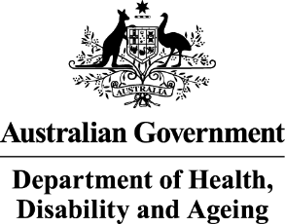 | The Australian Government Department of Health Disability and Ageing wrote this.  We say DHDA for short.  When you see the word we it means DHDA.
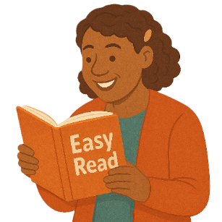 | We wrote this in an easy to read way.  We use pictures to explain some ideas.
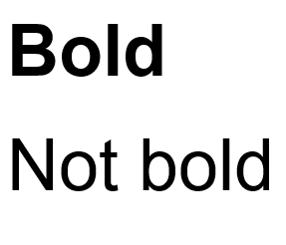 | We have some words in bold.  This means the letters are thicker and darker.  These are important words.
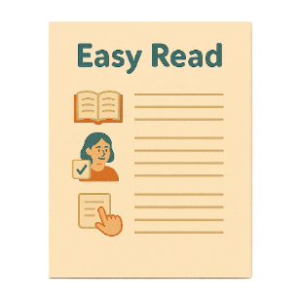 | This is an Easy Read summary of another document.  This means it has the most important ideas.
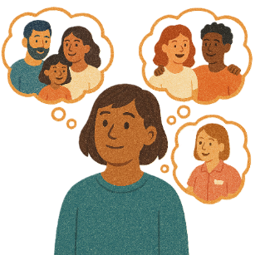 | You can ask for help to read this document.  You can ask  - A friend  - Family members  - A support person.
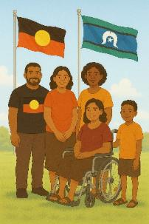 | We recognise Aboriginal and Torres Strait Islander people as the Traditional Owners of the land we live on.
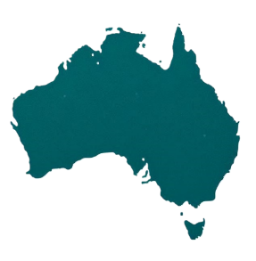 | They were the first people to live on and use the  - Land  - Waters.
Contents
Australia’s Disability Strategy | 5
About this document | 6
Outcome Areas | 7
1. Employment and Financial Security | 9
2. Inclusive Homes and Communities | 14
3. Safety Rights and Justice | 19
4. Person and Community Support | 24
5. Education and Learning | 28
6. Health and Wellbeing | 31
7. Community Attitudes | 35
Contact us | 37

Australia’s Disability Strategy
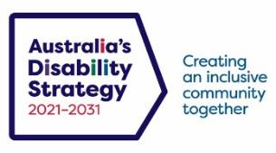 | Australia’s Disability Strategy is a plan to make life better for people with disability.  We call it the Strategy for short.  It is also called ADS.
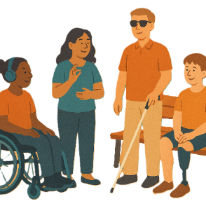 | The Strategy is important for Australia to be more inclusive.  Inclusive means everyone can take part.
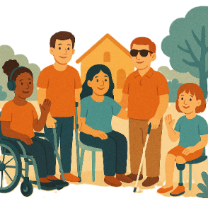 | This makes everyone in our community feel welcome.

About this document
 | This document has 2 parts.
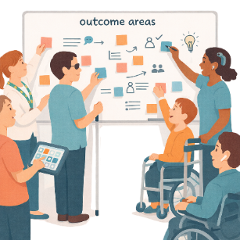 | Part 1 talks about  - 7 Outcome Areas.  Outcome Areas are the parts of the Strategy.  The work is split into smaller parts.  This makes it easier to work on.
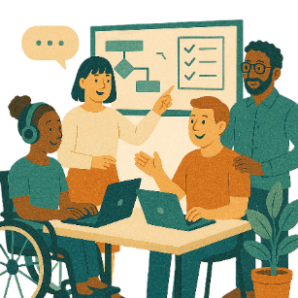 | Part 2 talks about  - Other work that has been done to support the Strategy.

Outcome Areas
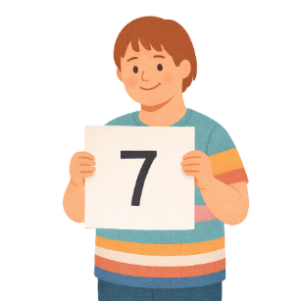 | There are  - 7 Outcome Areas being worked on.
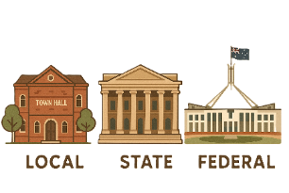 | There are lots of people working together on the Outcome Areas.  They are  - Local government  - State government  - Australian Government.  This is also called the Federal government.
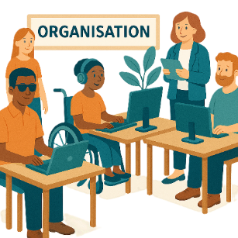 | - Community organisations
 | - Businesses.
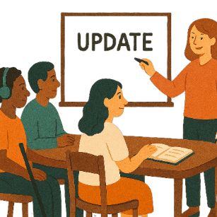 | This update talks about some of the work that has been done between  - 1 July 2023  - 30 June 2025
 | You can go to the website to read the report.  www.disabilitygateway.gov.au/ads/reporting-ads#the-implementation-reports

1. Employment and Financial Security
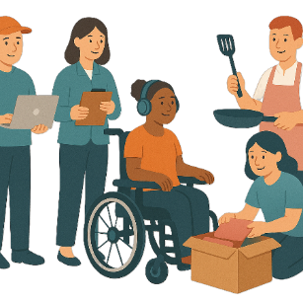 | Employment is  - Having a job  - Going to work  - Getting money for the work you do.
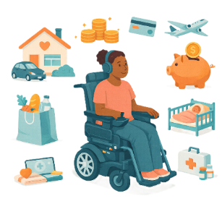 | Financial security means having enough money to live your life.
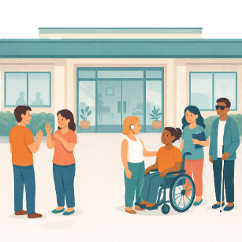 | There are new programs that aim to help people with disability get a job like  - The Centre for Inclusive Employment
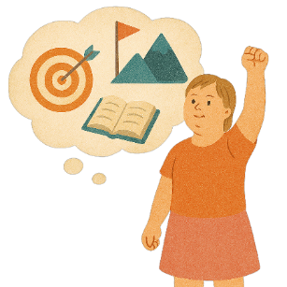 | Aims are things you want to do.
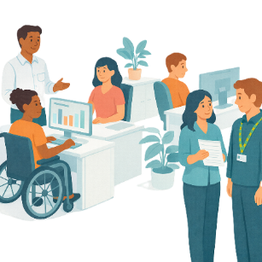 | - Inclusive Employment Australia.
You can go to the website to read more about Inclusive Employment Australia.
www.dss.gov.au/inclusive-employment-australia
It is in Easy Read.
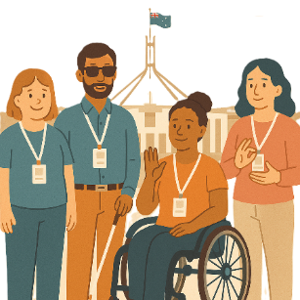 | All governments want more people with disability to be working for them.  Their goal is to employ a certain number of people with disability.  This is called a target.
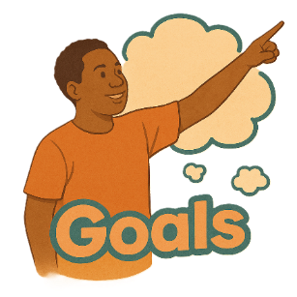 | Goals are things you want to do.
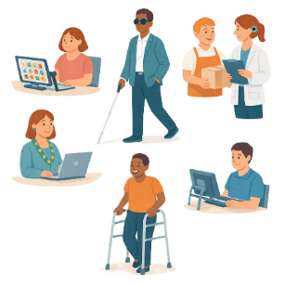 | Employ means to choose people to work for them.
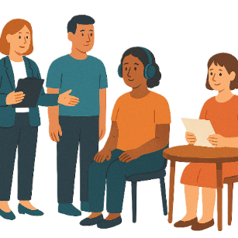 | There are plans that help with  - Inclusive ways to employ people
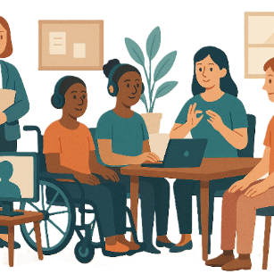 | - Workplace adjustments.  Workplace adjustments mean things that make it easier for people with disability to do their job.  They can also be called reasonable adjustments.
You can go to the website to read about the Neurodiversity Employment Toolkit used in Victoria.
www.vpsc.vic.gov.au/leading-public-sector-organisations/supporting-diversity-public-sector/people-disability/neurodiversity-employment-toolkit
It is not in Easy Read.
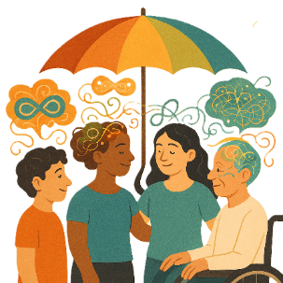 | Neurodiversity is the way peoples brains work differently.  Everyone thinks and feels differently.  They are normal differences.
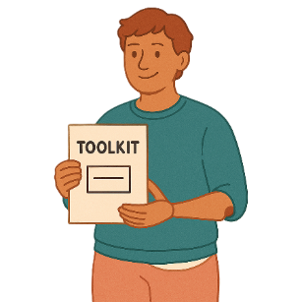 | A toolkit is  - Information  - Strategies  - Ideas.  All of them can be used to make a plan.

2. Inclusive Homes and Communities
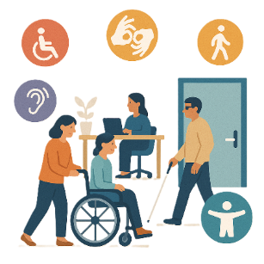 | We have made good changes with accessibility in many areas.  Accessibility means everyone can use it.
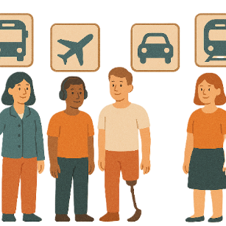 | Some of the areas are  - Transport  Transport is how people move from one place to another.  You can use  - Cars  - Buses  - Trains.
You can go to the website to read more about the changes to transport.
www.infrastructure.gov.au/department/media/publications/disability-standards-accessible-public-transport-changes-standards-text-only-easy-read-version
It is in Easy Read.
 | - Tourism  Tourism is people going to different places for holidays.
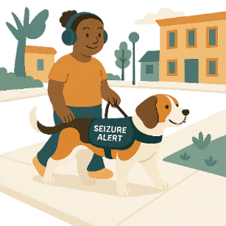 | - Public spaces  Public spaces are places that everyone can use.  They can be things like  - Libraries  - Streets  - Parks.
You can go to the website to read more about the changes to public spaces.
www.health.gov.au/our-work/accessible-australia
It is not in Easy Read.
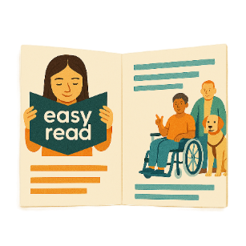 | - Communication.  This is information that everyone can use.  Like Easy Read.
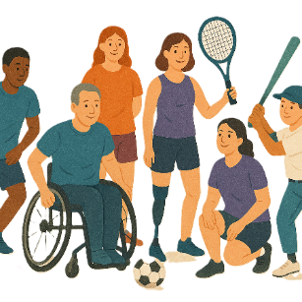 | Some local governments have been working on  - Inclusive sports
You can go to the website to read about inclusive sport in Newcastle.
newcastle.nsw.gov.au/community/our-community/disability-access-and-inclusion/count-us-in-2024
It is not in Easy Read.
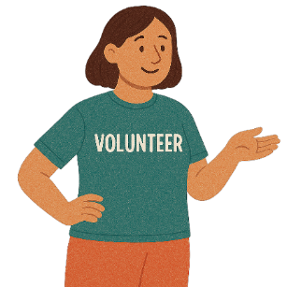 | - Volunteering.  Volunteering is helping someone but not getting paid.
You can go to the website to read about support for volunteering in Ryde.
www.ryde.nsw.gov.au/files/assets/public/v/1/community/volunteering/inclusive-volunteering_easy-read.pdf
It is in Easy Read.
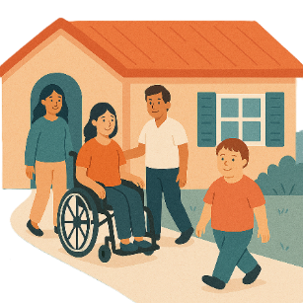 | Governments are working on making more accessible homes.  There are new rules when people build a house.
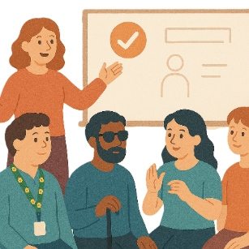 | The Strategy says fixing homelessness is a priority.
 | Homelessness means you do not have a home to live in.
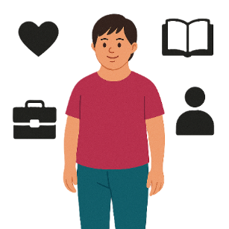 | Priorities are things that are  - Important  - Need to be done first.

3. Safety Rights and Justice
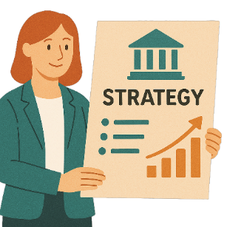 | State and territory governments are working on  - Strategies to support people with disability in the justice system.  These are different strategies to Australia’s Disability Strategy.
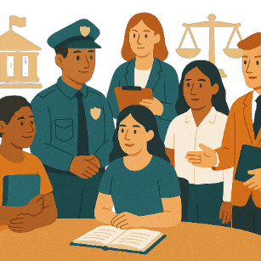 | Justice is  - The law  - Police  - The courts  - Prisons.
You can go to the website to read more about the Australian Capital Territory justice strategy.
www.act.gov.au/open/disability-justice-strategy
It is in Easy Read.
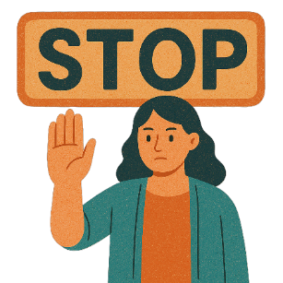 | They are also working on stopping family violence.
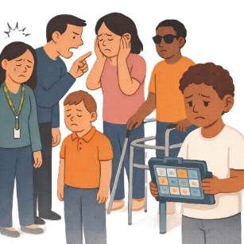 | Family violence is when someone in your family  - Hurts you  - Makes you feel scared.  It can happen between  - Partners  - Parents and children  - Brothers and sisters  - Carers and the people they care for.  It can also be called domestic violence.
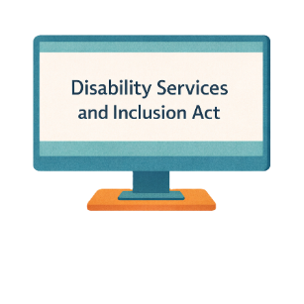 | There have been changes to the Disability Services and Inclusion Act.
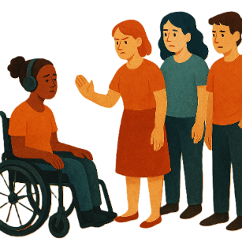 | The Disability Discrimination Act is being updated.  Discrimination means treating someone unfairly because of something about them they can not change.  Like they have a disability.
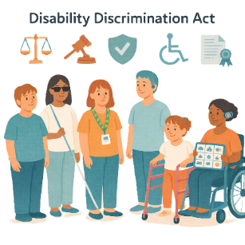 | The Disability Discrimination Act is the  - Law that says people with disability must have their rights met.  Laws are rules for how we live.
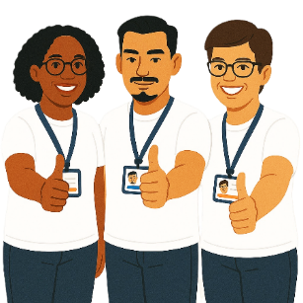 | Rights are rules about treating everyone  - Fair  - Equal.
You can read about the Disability Discrimination Act review on the website.
www.ag.gov.au/sites/default/files/2025-08/DDA-Review-Easy-Read.PDF
It is in Easy Read.
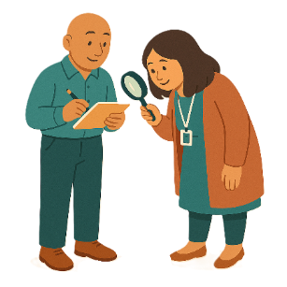 | A review is when you check what  - Works  - Needs to change.
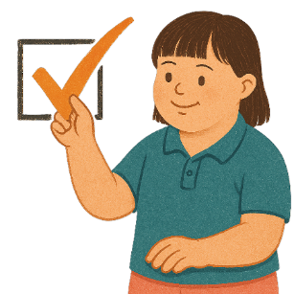 | The review is now finished.

4. Personal and Community Support
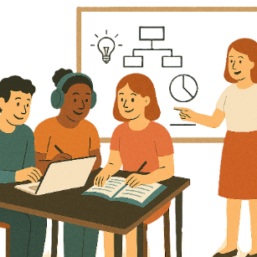 | There are new strategies to aim to have better services and support.  They are
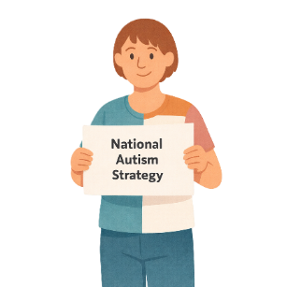 | - National Autism Strategy
You can go to the website to read more about the National Autism Strategy.
www.health.gov.au/resources/publications/national-autism-strategy-easy-read-information?language=en
It is in Easy Read.
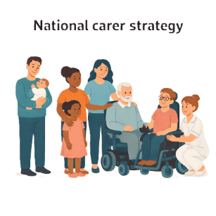 | - National Carer Strategy.
You can go to the website to read more about the National Carer Strategy.
www.health.gov.au/our-work/national-carer-strategy
It is not in Easy Read.
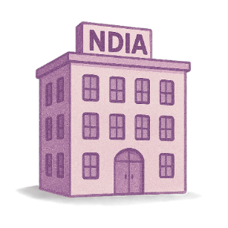 | The NDIS is working to support people with disability.  The National Disability Insurance Agency looks after the NDIS.  We call it NDIA for short.
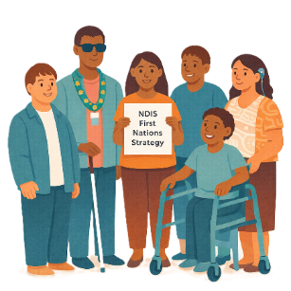 | The NDIA made the NDIS First Nations Strategy.  It is to make things better for First Nations people with disability.
You can go to the website to read more about the NDIS First Nations Strategy.
www.ndis.gov.au/strategies/first-nations-strategy
It is in Easy Read.
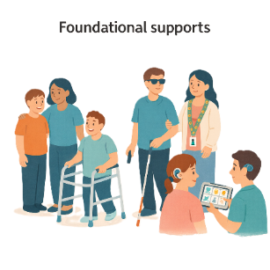 | Governments are working to make disability supports outside of the NDIS like  - Foundational supports  Foundational Supports are supports that are for all people with disability.
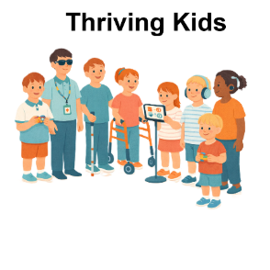 | - Thriving Kids.  Thriving Kids are new supports.  Thriving Kids will be different to the NDIS.  It will support children who  - Are 8 years old and younger  - Have developmental delay  - Have autism  - Need some support.
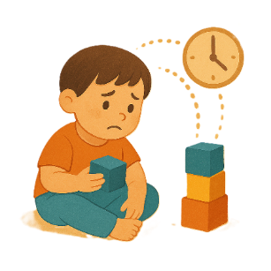 | Developmental delay is when someone learns slower than other people their age.  They might need extra help with  - Talking  - Moving  - Their emotions.

5. Education and Learning

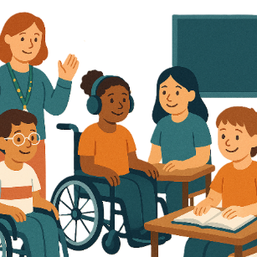 | State and territory governments  - Started programs to help students with disability learn in schools.  This is called inclusive education.  This will support students with disability.
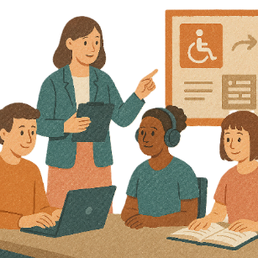 | Some state governments are training people who work in education.  They are  - New South Wales  - Western Australia.  This will help them support people with disability better.
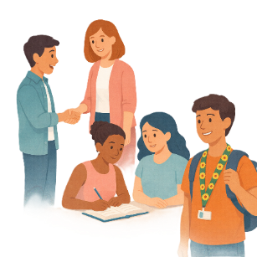 | Some have a program.  The program helps young people  - Do more education after school  - Get a job.  They are  - Northern Territory  - South Australia.
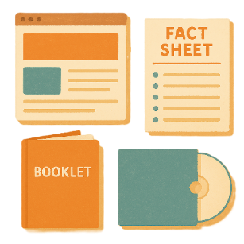 | The Australian Government have made resources.  Resources are information that tell someone a way to do something.  The resources support First Nations students.
You can go to the website to look at the resources.

www.education.gov.au/disability-standards-education-2005/resources/our-right-learn-and-play

It is not in Easy Read.

6. Health and Wellbeing
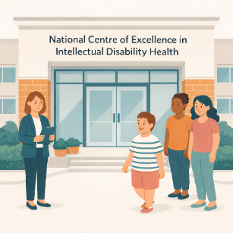 | The Australian Government gives funding to the  - National Centre of Excellence in Intellectual Disability Health.
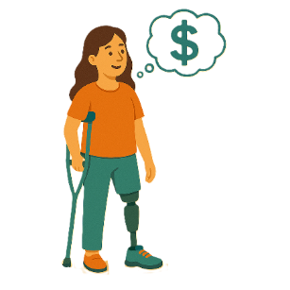 | Funding is money from the government to take part.
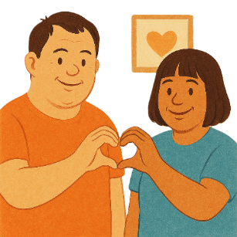 | An intellectual disability can make it difficult to  - Learn new things  - Solve problems  - Communicate  - Do things on your own.
You can go to the website to read more about the National Centre of Excellence in Intellectual Disability Health.
nceidh.org.au/
It is in Easy Read.
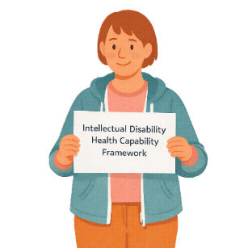 | The Australian Government has shared the  - Intellectual Disability Health Capability Framework.  A framework is how we will do something.
You can go to the website to read the Intellectual Disability Health Capability Framework.
www.health.gov.au/resources/publications/the-intellectual-disability-health-capability-framework-easy-read?language=en
It is in Easy Read.
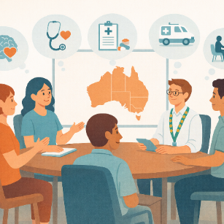 | State and territory governments are working on better  - Health services  - Mental health supports.
You can go to the website and read the Tasmanian Disability Health Strategy.
www.health.tas.gov.au/publications/disability-health-strategy-2025
It is in Easy Read.
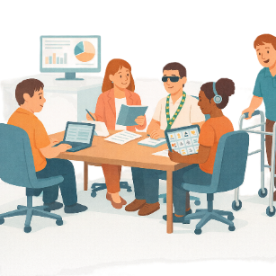 | The Queensland government also gave funding to the  - Queensland Centre of Excellence in Intellectual and Developmental Disability Mental Health.
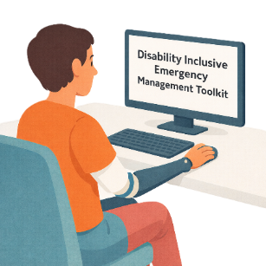 | The Australian Government made the Disability Inclusive Emergency Management Toolkit  It helps  - People with disability be ready for an emergency.
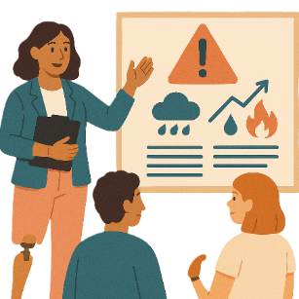 | An emergency is something dangerous that  - We do not expect to happen  - Can put your health at risk.
You can go to the website to read the Disability Inclusive Emergency Management Toolkit.
www.nema.gov.au/sites/default/files/2024-12/2055_DIEM%20Toolkit%20Easy%20Read_Embrace%20Access_final.pdf
It is in Easy Read.

7. Community Attitudes

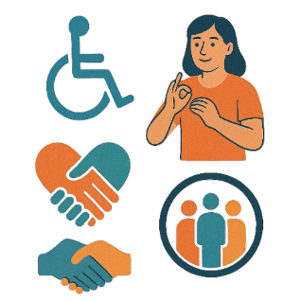 | All governments are working to improve community attitudes about people with disability.
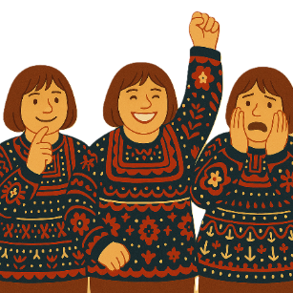 | Attitudes are what people  - Think  - Feel  - Believe.
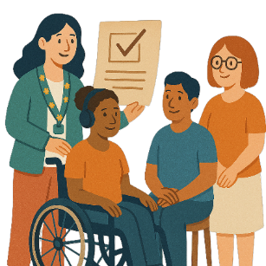 | Some governments gave grants to support local projects.  Grants are when  - You agree to do work for the government  - The government gives you money to do the work.
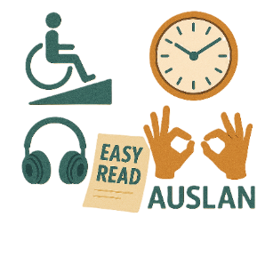 | The grants promote  - Accessibility
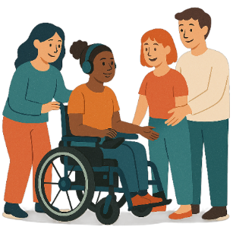 | - Thinking good things about people with disability.
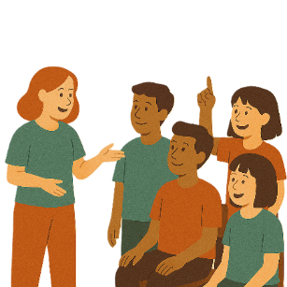 | Promote means to encourage other people to do something.

Contact us
 | You can contact us if you need more information.
 | You can look at our website.  www.disabilitygateway.gov.au/ads/strategy
Some images in this Easy Read were made using AI.
You must not share or copy any of the images without permission.
January 2026.

