

Australia’s Disability Strategy
2021–2031
Implementation Report
1 July 2023 – 30 June 2025

Copyright notice
© Commonwealth of Australia (Department of Health, Disability and Ageing) 2026
This document, Australia’s Disability Strategy 2021–2031 Implementation Report 1 July 2023–30 June 2025, is copyright and published with the permission from the third parties who have contributed third party material.
Creative Commons Licence - Attribution-NonCommercial-NoDerivatives CC BY-NC-ND

This document, Australia’s Disability Strategy 2021–2031 Implementation Report 1 July 2023–30 June 2025, is licensed under a Creative Commons Attribution-Non-Commercial-NoDerivatives 4.0 International Licence (the Licence). You must read and understand the Licence before using or relying on any material from this Report.
More information on this CC BY-NC-ND 4.0 license is set out at the Creative Commons website: https://creativecommons.org/licenses/by-nc-nd/4.0/legalcode

Restrictions
The Licence may not give you all the permissions necessary for your intended use. For example, other rights (such as publicity, privacy and moral rights) may limit how you use the material found in this publication.
The Licence allows you to download and share the publication with others for free but does not allow you to use it for any commercial purpose or allow you to alter or modify this Report for the purpose of you sharing that altered or modified Report publicly.

Enquiries
Enquiries regarding any other use of this publication should be addressed to:
Branch Manager, Corporate Communication Branch
Department of Health, Disability and Ageing
GPO Box 9848, Canberra ACT 2601
Or via e-mail to copyright@health.gov.au

Accessibility
Access Hub provides information about communication options (including the National Relay Service) for people who are d/Deaf, hard of hearing and/or have speech communication difficulty. For further information, go to https://www.accesshub.gov.au/
This Report is available online in multiple accessible formats. For further information go to Disability Gateway, https://www.disabilitygateway.gov.au/ads
Web links, telephone numbers and titles correct at the time of publication. They may have changed after publication.
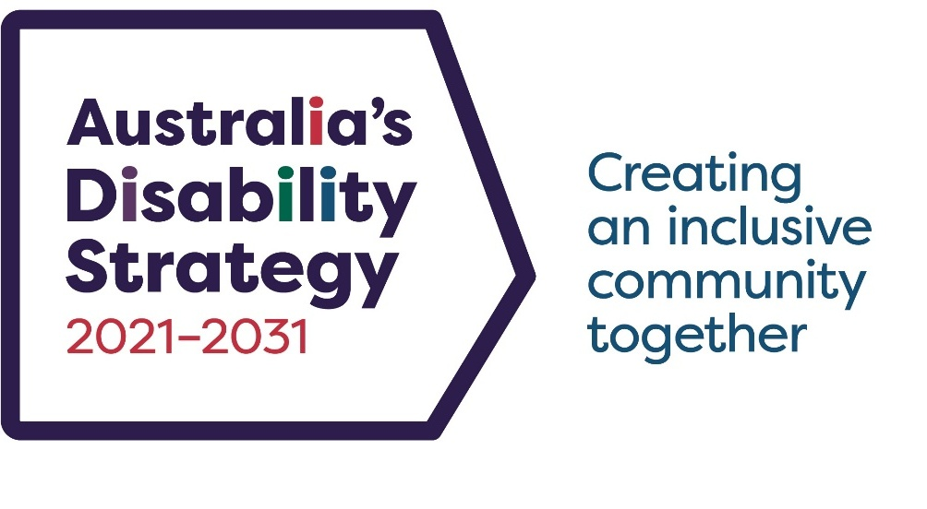

Australia’s
Disability
Strategy
2021–2031
Implementation Report
1 July 2023 – 30 June 2025

Contents

Acknowledgments v
Ministerial Statements 1
Executive Summary 11
Implementation Progress 14
Review of Australia’s Disability Strategy 15
Australia’s Disability Strategy Outcome Areas 17
Employment and Financial Security 19
Inclusive Homes and Communities 32
Safety, Rights and Justice 52
Personal and Community Support 63
Education and Learning 71
Health and Wellbeing 79
Community Attitudes 90
Implementing Australia’s Disability Strategy 98
Coordination 99
Australia’s Disability Strategy Guiding Principles 103
Engaging with People with Disability 110
Targeted Action Plans 119
Associated Plans 123
Outcomes Framework 129
Improving the Data 131
Evaluation and Research 137
Governance 144
Jurisdictional Overviews 146
Key Terms 155
Resources and References 160

Acknowledgments

Acknowledgement of Country
The Australian Government Department of Health, Disability and Ageing acknowledge the Traditional Owners and Custodians of Country throughout Australia, and their continuing connection to land, sea and community. We pay our respects to them and their cultures, and to Elders both past and present.

Language in this Report
We acknowledge that people use different words to talk about disability and that each person will have a way of talking about disability and about themselves that they like best. Some people like to use ‘disabled person’ (identity-first language), while some like to use ‘person with disability’ (person-first language), and some are fine with using either.
We use person-first language to talk about disability. This means we usually use the term ‘person with disability’ in this Report.
The language used in this Report is not intended to diminish an individual’s identity as a person with disability. We recognise that the appropriate use of language varies between individuals and disability communities. We acknowledge the importance of having conversations with individuals about their preferred language.

Acknowledgement of people with disability
This Report would not have been possible without people with disability, their families, carers, Disability Representative Organisations and Australia’s Disability Strategy Advisory Council who provided feedback on Australia’s Disability Strategy or took part in Australia’s Disability Strategy engagement activities. We want to thank them and acknowledge their meaningful contributions to this Report.

Ministerial Statements

Australian Government
I am proud to present the Australia's Disability Strategy 2021–2031 (the Strategy) 2025 Implementation Report. The report shows our commitment to building a more inclusive Australia. The Strategy is more than a policy framework. It is a promise that all people with disability can live with dignity and respect. This year's Implementation Report is an important milestone in delivering on this goal.
We have listened to people with disability, their families, carers, and advocates. We know meaningful change only happens when we work in partnership with people with disability.
The past 2 years have seen landmark reforms that have reshaped the disability landscape across Australia. The Disability Royal Commission and the NDIS Review final reports, and the 2024 Review of the Strategy gave us important insights. The Review of the Strategy gave people the opportunity to share their ideas and experiences, and to tell us what matters to them.
In response, the updated Strategy strengthens transparency, coordination, and accountability. We added a new policy priority to ensure homelessness prevention and support services include people with disability. We also created practical tools to help governments, businesses and communities apply the Strategy's guiding principles and support inclusive evaluations.
We launched 3 new Targeted Action Plans on:
- Inclusive Homes and Communities
- Safety, Rights and Justice
- Community Attitudes.
These plans were made with people with disability. They show what governments are planning to do, with the disability community, to make a positive difference in their lives.
The Australian Government is leading by example. We legislated the Disability Services and Inclusion Act 2023 to improve access to high quality and safe services. We are working with states and territories to reform the Information, Linkages and Capacity Building Program, and to establish additional supports outside the NDIS. We have commenced a comprehensive review of the Disability Discrimination Act to address discrimination and improve experiences of people with disability. We have strengthened specialist disability employment supports though the launch of the Inclusive Employment Australia program, and also launched Australia’s first National Autism Strategy and First Action Plan.
The NDIS now supports more than 739,000 Australians. We're working to make the Scheme fairer, so it delivers better services to the people that need it most. We know the best way to do that is to have people with disability at the centre of the reform process.
Looking forward, we will complete an independent review of the Strategy in 2026. This will make sure the Strategy's progress is transparent and informed by the experiences of people with disability.
Together, we are working to build a future where every Australian with disability can live the life they choose with dignity and respect, on an equal basis.
Senator the Hon Jenny McAllister
Minister for the National Disability Insurance Scheme

New South Wales
The New South Wales (NSW) Government continues its commitment to support the inclusion of people with disability in all aspects of community life across our state.
The NSW Disability Inclusion Act 2014, the NSW Disability Inclusion Plan (DIP) and the Disability Inclusion Action Plans of all NSW government agencies and 128 local councils provides the legislative and operational framework for translating disability policy in Australia’s Disability Strategy into actions that positively impacts lives.
NSW released our new DIP 2026–2029 on International Day of People with Disability 2025. The new DIP includes actions that reflect the significant disability reform agenda underway, as well as responding to issues which arose from extensive consultation with people with disability in NSW.
The NSW DIP 2026–2029 is aligned with the United Nations Convention on the Rights of Persons with Disabilities and Australia’s Disability Strategy.
NSW priorities include the safeguarding of people with disability, creating opportunities for meaningful employment and supporting access to the community and mainstream services.
The NSW Government continues to deliver the NSW Disability Advocacy Futures Program to provide targeted funding to organisations to deliver individual, systemic, and representative advocacy to people with disability to support their access to services.
NSW will continue to focus on the provision of accessible and inclusive services across all areas of government responsibility including health, housing, transport, education and other community supports.
Involvement of people with disability is critical, particularly as we work collaboratively with the Commonwealth and State governments to implement recommendations of the Disability Royal Commission and other key reforms. Australia’s Disability Strategy provides a solid base on which to build these reforms, ensuring that people with disability are central to the process, building on their lived experience and guiding government on the key priorities for the sector.
NSW looks forward to continuing this productive work with our national colleagues.
The Hon Kate Washington MP
Minister for Families and Communities
Minister for Disability Inclusion

Victoria
I am proud to highlight the progress Victoria has made under Inclusive Victoria: state disability plan
(2022–2026), which is Victoria’s implementation plan for achieving outcomes under Australia’s Disability Strategy.
Inclusive Victoria sets out the Victorian Government’s commitment to making all parts of the community accessible and inclusive for everyone and includes the Victorian Autism Plan. Both plans are directly shaped by the voices of Victorians with disability.
Inclusive Victoria sets out whole-of-government actions across all life domains, including community participation, transport, health, mental health, and housing with the aim of creating long lasting changes for people with disability.
The Victorian Government has made significant investments in improving accessibility and inclusion across sectors and we have also implemented legislative reforms to strengthen rights, protections, and safeguards for Victorians with disability. These and other significant achievements are detailed in Inclusive Victoria’s Midway Report, published in December 2024.
We have extended Inclusive Victoria and the Victorian Autism Plan to 2027 while we continue to take action in key areas and allow the national disability reforms that are underway to inform the new state disability plan.
The Victorian Government remains committed to creating a more inclusive and accessible community for all. We will achieve this by working alongside with people with disability to drive meaningful change.
The Hon Lizzie Blandthorn MP
Minister for Disability
Minister for Children

Queensland
The Queensland Government is proud to continue delivering on Australia’s Disability Strategy 2021–2031.
Over the past 2 years, Queensland has delivered significant reforms to advance the priorities of Australia’s Disability Strategy and respond to recommendations of the Royal Commission into Violence, Abuse, Neglect and Exploitation of People with Disability and the Independent Review into the National Disability Insurance Scheme.
The voices, rights, and needs of people with disability are at the forefront of our work. We continue to be guided by the annual Voice of Queenslanders with Disability Report, which provides a comprehensive understanding of the lived experiences of people with disability, their families, and carers.
In late 2024, we launched the Queensland Disability Stakeholder Engagement and Co-Design Strategy. This Strategy ensures people with disability are central to reform efforts, with initiatives including:
- a new advisory stakeholder committee to provide expert advice
- a Disability Engagement and Co-Design Hub to foster collaboration and build capacity
- community engagement activities, including forums and a community of practice
- enhanced data collection to inform decision-making.
These reforms and advisory functions reflect our commitment to genuine partnership with the disability community. By embedding co-design and lived experience at the heart of our work, we are building a more inclusive Queensland. Together, we will continue driving transformative change to ensure every Queenslander can thrive and participate fully in our society.
The Hon Amanda Camm MP
Minister for Families, Seniors and Disability Services and Minister for Child Safety and the Prevention of Domestic and Family Violence

Western Australia
A Western Australia for Everyone: State Disability Strategy 2020–2030 (State Disability Strategy) sets a vision for a Western Australia (WA) where 511,500 Western Australians with disability are treated fairly, can participate meaningfully in all parts of society and live the life they choose in a community where everyone belongs.
Since 1 July 2023, WA achievements include:
- Delivering 9 innovative projects to improve inclusion and participation through the $5 million State Disability Strategy Innovation Fund.
- Releasing the Disability Royal Commission WA Implementation Roadmap outlining WA’s whole-of-government approach and commitment to working with people with disability and their support networks.
- Reaching agreement with the Commonwealth on WA’s National Disability Insurance Scheme Full Scheme Bilateral Agreement, with commitments to strengthen Scheme governance through establishment of a WA Community Advisory Council, which will advise on improving the experience of Western Australians accessing the National Disability Insurance Scheme and exploring alternative approaches for regional and remote services to address service gaps in thin markets.
Over the next 2 years, 17 public and private agencies will implement 69 significant, impactful and measurable actions through the State Disability Strategy’s third Action Plan, launched in early 2025. Across WA, 210 public authorities will implement their Disability Access and Inclusion Plans embedding access and inclusion in local communities and government services.
With significant reform and investment occurring across the disability ecosystem, the WA Government is working hard to ensure the best outcomes for people with disability are achieved, underpinned by our commitment to accessible, inclusive and welcoming communities.
The Hon Hannah Beazley MLA
Minister for Disability Services

South Australia
This Implementation Report highlights the considerable achievements by South Australian Government agencies delivering against Australia’s Disability Strategy 2021–2031—building on the foundations of Inclusive SA: State Disability Inclusion Plan, our first state disability plan.
Inclusive SA was published in 2019 and updated in 2022 to improve alignment with Australia’s Disability Strategy 2021–2031 priority areas. Upon its conclusion in 2023, South Australia commenced extensive consultation with people with disability, their families, carers, advocates, and service providers to inform our new State Disability Inclusion Plan 2025–2029—launched on 22 August 2025.
The 5 domains outlined in our new State Plan will guide and shape our work, ensuring that policy changes are informed by, and responsive to, the perspectives and needs of South Australians with disability.
These domains and the corresponding outcomes framework have also been designed to maintain strong alignment with the Strategy, as well as South Australia’s State Autism Strategy 2024–2029—delivering a responsive, interconnected and ambitious disability inclusion framework for South Australia.
As Minister for Human Services, it is a privilege to steward both our State Plan and the implementation of Australia’s Disability Strategy 2021–2031 here in South Australia. The diversity of initiatives included in this Implementation Report highlight our commitment to this important work.
I look forward to continuing to work with my Ministerial counterparts across jurisdictions to further the implementation of Australia’s Disability Strategy 2021–2031 and to build a fairer and more inclusive community.
The Hon Nat Cook MP
Minister for Human Services

Tasmania
In Tasmania we are proud that our historic reform is delivering for Australia’s Disability Strategy
2021–2031 and working to make our State a safer and more inclusive place for people with disability.
Over the past 2 years we have taken major steps forward. From 1 July 2025, the new Disability Rights, Inclusion and Safeguarding Act 2024 (Tas) has come into effect. This important law has established Tasmania’s first Disability Commissioner, will lead to stronger protections around restrictive practices, and create a Disability Inclusion Advisory Council to ensure the voices of people with disability are at the centre of decision-making.
These changes build on other important work, including the Disability Health Strategy, the Emergency Preparedness Project, and reforms in education, youth justice and housing. Each of these initiatives was developed in partnership with Tasmanians with disability, their families and carers.
Our new Tasmania’s Disability Strategy 2025–2027 will continue this work across Agencies, with a clear goal to remove barriers and make sure every Tasmanian can participate fully in their community.
I thank all the people with disability, families, advocates, service providers and government staff who have helped shape this progress. Together we are building a future where every Tasmanian is valued, respected and supported to thrive.
The Hon Jo Palmer MLC
Minister for Disability Services

Australian Capital Territory
Yuma!
As Minister for Disability, I am proud to share the progress we’ve made in the Australian Capital Territory (ACT) towards building a more inclusive and accessible community. Over the past 2 years, our focus has been on meaningful engagement with the disability community to shape the policies and legislation that matter most.
In 2024, we launched the ACT Disability Strategy and First Action Plan, reaffirming our commitment to Australia’s Disability Strategy and strengthening the work already underway across the ACT—including the Disability Health Strategy, Disability Justice Strategy, and Inclusive Education Strategy.
The ACT Disability Strategy was co-designed with the ACT Disability Reference Group and informed by consultation with over 1,000 individuals and organisations. Their voices were central to every step of the process, ensuring the strategy truly reflects the views and experiences of people with disability.
Another significant milestone was the introduction of the Disability Inclusion Act 2024 (ACT). This landmark legislation, also developed in close collaboration with the ACT disability community, is grounded in human rights and the social model of disability. It provides a framework to challenge ableism and drive systemic change across the ACT Government.
As part of broader disability reform, the ACT Government continues to work with all Australian governments to respond to recommendations from both the Independent Review of the National Disability Insurance Scheme and the Royal Commission into Violence, Abuse, Neglect and Exploitation of People with Disability. The ACT Government has contributed to the first Disability Royal Commission Progress Report 2025, which outlines progress against key recommendations. In parallel, the ACT Government continues to engage with the Australian, state and territory governments on major National Disability Insurance Scheme Review reforms, including the development of Foundational Supports and changes to National Disability Insurance Scheme Rules to develop a supports ecosystem to meet the needs of people with disability.
Looking ahead, our commitment remains clear: we will continue to listen, co-design, and work alongside people with disability to ensure a more accessible and inclusive Canberra.
Suzanne Orr MLA
Minister for Disability, Carers and Community Services

Northern Territory
The Northern Territory Government is committed to improving the lives of people with disability and continues to strive for a society where the rights and dignity of people with disability are fully recognised, respected and protected.
I am honoured to represent the Northern Territory as the Minister for Disability and proud of the work underway across the Northern Territory Government through its commitments in Australia’s Disability Strategy 2021–2031 and through our own Northern Territory Disability Strategy 2022–2032 and associated action plans. But there is still a lot more work to be done.
The Northern Territory is unique, with a vast landscape and a high proportion of people living in regional and remote towns and communities. While this presents challenges in delivering services and supports, it also provides opportunities for new and transformative initiatives that place people with disability at the centre, values the importance of cultural safety, and promotes collaboration and co-design between people with disability and the sector.
The Northern Territory continues to work collaboratively with the Australian Government and states and territories to deliver the significant disability reform agenda arising from the findings of the Royal Commission into Violence, Abuse, Neglect and Exploitation of People with Disability and the Independent Review of the National Disability Insurance Scheme.
The diverse stories and experiences shared with me by Territorians highlight the critical importance of dedicated initiatives and place-based actions from remote communities to regional centres to make a meaningful difference to the lives and experiences of people with disability, their families and carers.
We acknowledge and thank the Territorians with disability, their families and carers who continue to provide their valuable feedback to government to ensure our policies, both locally and nationally, accurately reflect their lived experiences.
The Hon Jinson Charls MLA
Minister for Disability

Local Government
The Australian Local Government Association (ALGA) is proud to be a partner in Australia’s Disability Strategy 2021–2031.
Local councils across the country are working hard to make communities more inclusive and accessible for people with disability. Councils help ensure everyone can take part in community life by improving access to buildings, services, and information.
Councils also develop and carry out Disability Access and Inclusion Plans (DAIPs) or Disability Action Plans (DAPs), which guide their efforts to remove barriers and support people with disability. These plans often focus on creating welcoming and accessible spaces, encouraging positive attitudes about disability, and helping people with disability find meaningful jobs.
Importantly, councils listen to local people with disability when planning services and making decisions. This helps ensure that changes truly reflect the needs of the community.
ALGA supports councils with tools, resources, and guidance to help them include people with disability in all areas of local life.
Looking ahead, we are committed to doing more. We will work closely with councils, local government associations, and other partners to share knowledge, identify challenges, and promote practical solutions that make a real difference.
Together, we can build communities where everyone feels included, supported, and has the same chance to thrive.
Gladstone Regional Council Mayor Matt Burnett
President, Australian Local Government Association

Executive Summary
Delivering inclusion, accessibility, and opportunity for
people with disability
Between July 2023 and June 2025, governments across Australia have taken coordinated, practical steps to deliver on the vision of Australia’s Disability Strategy 2021–2031 (the Strategy); an inclusive society where people with disability are supported to thrive as equal members of the community. This period has been marked by significant reform, strengthened partnerships, and a renewed commitment to measurable progress.
The Strategy is not just a policy document; it is a national commitment to change. It reflects Australia’s obligations under the United Nations Convention on the Rights of Persons with Disabilities (UN CRPD), and it is being delivered through real action at all levels of government, in collaboration with the community, business, and people with disability.
Driving reform through evidence and experience
The past 2 years have seen a series of landmark reforms that have reshaped the disability landscape in Australia. These reforms have been informed by lived experience, driven by evidence, and guided by a shared aspiration for a more inclusive and just society.
The Royal Commission into Violence, Abuse, Neglect and Exploitation of People with Disability (the Disability Royal Commission) released its Final Report in September 2023. This comprehensive report laid out recommendations to improve laws, policies, structures, and practices to better protect the rights of people with disability and ensure their safety, dignity, and inclusion. It called for a fundamental shift in how disability is understood and supported in Australia.
In parallel, the Independent Review of the National Disability Insurance Scheme (the NDIS Review), released in December 2023, examined the design, operations, and sustainability of the National Disability Insurance Scheme (NDIS). It focused on ensuring the Scheme works effectively for the people who rely on it, and that it complements other disability supports. The Review highlighted the need for better integration, clearer pathways, and more responsive services.
Legislative reform followed, with the commencement of the Disability Services and Inclusion Act 2023 (Cth) on 1 January 2024. This Act modernised the way supports and services are funded, making it easier for people with disability to access what they need whether or not they are participants in the NDIS. It represents a shift toward more flexible, inclusive, and person-centred service delivery.
Governments accepted the Disability Royal Commission’s recommendation to review the Strategy, and in early 2025, released the updated Australia’s Disability Strategy 2021–2031: Building a More Inclusive Australia. This update reaffirmed the commitment of all governments to uphold the rights of people with disability and enable their full participation in everyday life.
The update introduced a new policy priority focused on addressing homelessness, and recognising the intersectional challenges faced by people with disability. It also committed to developing a Community Engagement Plan and a new Associated Plan to improve the accessibility of information and communications. These additions reflect the voices of people with disability, who consistently called for more ways to participate in shaping the policies and services that affect their lives.
In June 2025, the Australian Government moved responsibility for leading and delivering the Strategy from the Social Services portfolio to the Health, Disability and Ageing portfolio. This change supports a more integrated and joined-up approach to disability policy, programs, and services ensuring that health, wellbeing, and inclusion are addressed holistically.
Delivering tangible outcomes across the 7 Outcome Areas
Australia’s Disability Strategy identifies 7 Outcome Areas that are essential for building an inclusive society. These areas reflect the diverse aspects of life where people with disability seek equal opportunity, access, and respect. They are designed to respond to the barriers people with disability encounter and to promote full participation, safety, dignity, and economic independence.
Between July 2023 and June 2025, substantial progress has been made across all 7 Outcome Areas. These achievements are captured in the Strategy’s Roadmap, a living document that tracks milestones and guides future action.
In the area of employment, the commencement of the Inclusive Employment Australia program and the establishment of the Centre for Inclusive Employment are aimed at driving improvements in disability employment services. These initiatives focus on creating inclusive workplaces, supporting employers, and providing individual support to people with disability to help access and maintain meaningful work. State and territory governments have also led targeted actions, such as the ACT Disability Strategy First Action Plan and the Victorian Neurodiversity Employment Toolkit, which promote inclusive hiring practices and workplace adjustments.
Accessibility has been advanced through reforms in transport and tourism, making public spaces and services more inclusive. Legal protections have been strengthened with the commencement of the Disability Services and Inclusion Act and a commitment to review and modernise the Disability Discrimination Act 1992 (Cth) (the Disability Discrimination Act). These changes ensure that accessibility is not just a design feature, but a legal and social imperative.
The NDIS continues to support over 739,000 Australians, providing choice and control over the supports they receive. In January 2025, the National Disability Insurance Agency (NDIA) launched the NDIS First Nations Strategy 2025–2030, marking a major step towards improving access, equity and outcomes for First Nations people with disability. The strategy sets out a clear roadmap for embedding culturally responsive practices and tackling systemic barriers, both for those already on the Scheme and those who need support but are not yet receiving it.
In health, the establishment of the National Centre of Excellence in Intellectual Disability Health and the release of the Intellectual Disability Health Capability Framework reflect a commitment to quality care and inclusive practice. In education, states and territories have implemented inclusive education initiatives that support students with disability to learn, grow, and succeed in mainstream settings.
Efforts to shift community attitudes have been supported by national programs that promote real representation and leadership by people with disability. These programs challenge stereotypes, celebrate diversity, and foster a culture of respect and inclusion.
Strengthening implementation through governance and collaboration
Central to the success of the Strategy are its implementation mechanisms; a set of connected processes that turn aspiration into practical, measurable change. These mechanisms guide progress, foster accountability, and support continuous improvement.
The Disability Reform Ministerial Council (DRMC) has played a key role in commissioning and approving major initiatives, including 3 new Targeted Action Plans (TAPs), the comprehensive 2024 Review of the Strategy, and updates to data and reporting processes. These actions ensure that the Strategy remains responsive to emerging needs and grounded in evidence.
Australia’s Disability Strategy Advisory Council, chaired by Ms Jane Spring AM, has provided independent advice on the progress of implementation and the strengthening of evaluation activities. The Advisory Council ensures that the voices of people with disability are heard at the highest levels of decision-making.
The Disability Representative Organisations (DROs) Forum has contributed to the development of the Strategy Data Improvement Plan and the Guide to Applying Australia’s Disability Strategy, supporting consistent and inclusive implementation across jurisdictions. These mechanisms ensure that the Strategy is managed collaboratively, inclusively, and effectively turning plans into real and measurable achievements.

Building on reform and looking ahead

We share the Strategy’s aspiration
for an Australia in which all
disabled people can flourish.
— Disability Representative Organisation
The path ahead is informed by lessons learned, ongoing engagement, and the spirit of collaboration. With the Strategy Roadmap and updated policy priorities as our guide, we are well positioned to accelerate disability inclusion and achieve the vision and goals of the Strategy.
In 2025, an independent evaluator will be selected to assess the effectiveness of the Strategy. This evaluation will identify what is working, where improvements are needed, and how the Strategy can be strengthened. The Toolkit for Engaging People with Disability in Evaluation will be used to ensure that the process is inclusive, respectful, and grounded in lived experience.
Consultation and engagement remain central to our approach in implementing the Strategy. Throughout the 2024 Review of the Strategy, one of the strongest and most consistent messages from people with disability was the desire for more opportunities to participate in the Strategy. In response, governments have committed to developing and implementing a Community Engagement Plan, building on existing engagement commitments and creating new pathways for involvement.
Australia’s Disability Strategy affirms our national vision for an inclusive society. By honouring the lived experience of people with disability, fostering collaboration across sectors, and delivering practical reforms, we remain focused on building communities where people with disability are included, supported, and empowered to thrive.

Implementation Progress
Australia's Disability Strategy Roadmap reflects how and what we are doing to implement the Strategy. The Roadmap is a living document and is updated as milestones are completed, and as new Strategy activities and commitments emerge. The Strategy’s first Implementation Report (2023) provides further information about what we did to implement the Strategy from its launch to 30 June 2023.
This Report covers from 1 July 2023 to 30 June 2025. During this time, we delivered several Roadmap milestones. All milestones scheduled for 1 July 2023 to 30 June 2025 have been completed or are in development.
2025

September 2025
Toolkit for Engaging People with Disability in Evaluation released
In development
1st Strategy Major Independent Evaluation
2nd National Public Forum
The Strategy’s Community Engagement Plan
Accessible Information and Communications Associated Plan
2025 Review of the Disability Standards for Education
April 2025
Intellectual Disability Health Capability Framework and associated education resources released
February 2025
National Roadmap to Improve the Health and Mental Health of Autistic People 2025–2035 released
January 2025
Australia's Disability Strategy 2024 Update released
2nd Targeted Action Plans started
National Autism Strategy 2025–2031 released
2024
December 2024
Guide to Applying the Strategy released
Data Improvement Plan 2024 released
Review of the Strategy Report released
First release of National Disability Data Asset data
3rd Targeted Action Plans Report released
National Carer Strategy 2024–2034 released
November 2024
Equity: the Arts and Disability Associated Plan released
2022 Review of the Transport Standards report and Australian Government response released
August 2024
Public consultation for the Review of Australia's Disability Strategy
2nd Strategy State Forum held in Hobart, Tasmania
July 2024
ABS Survey of Disability, Ageing and Carers (2022) results released
June 2024
1st Targeted Action Plans end
January 2024
Disability Services and Inclusion Act 2023 (Cth) commenced
2nd Targeted Action Plans Report released
2023
October 2023
Good Practice Guidelines for Engaging with People with Disability released
National Centre of Excellence in Intellectual Disability Health opened
September 2023
Royal Commission into Violence, Abuse, Neglect and Exploitation of People with Disability Final Report released
December 2023
The Strategy’s 1st Implementation Report tabled in the Australian Parliament
NDIS Review Final Report released

Review of Australia’s Disability Strategy
The Disability Royal Commission released its Final Report on 29 September 2023. The report included a recommendation to review Australia’s Disability Strategy. This recommendation was accepted by the Australian, state and territory governments.
A Commonwealth-led review of the Strategy was conducted in 2024, in collaboration with state and territory governments, the Australian Local Government Association and Australia’s Disability Strategy Advisory Council.
The Review considered the issues raised and recommendations made in the Disability Royal Commission’s Final Report, as well as feedback from the first 3 years of the Strategy’s implementation.
The Review focused on identifying practical process improvements that could be made immediately. Some potential reforms were deferred for consideration until after the Strategy’s first Independent Evaluation in 2025–2026. This gives people with disability more time and opportunities to be involved in the development and implementation of future reforms.
Consultation provided an opportunity to test out our findings about the Strategy and where people with disability and the broader community could share their ideas and experiences. Public consultation for the Review offered an opportunity for people with disability, their families, friends and supporters, representative organisations, services and the broader Australian community to tell us what they thought about the Strategy and how it could work better.
One hundred and forty-six submissions were received during public consultation for the Review. People with disability and representative organisations consistently told us they want to see an improvement on how governments work together, more accessible information and communication, and more opportunities to participate and engage with the Strategy.
We heard what the disability community said and used this feedback to guide our actions. The Review Report, and accompanying Review Consultation Report, were released in December 2024.

An updated Strategy
Informed by what we heard during the Review of the Strategy, in early 2025 we released an updated Strategy, Australia’s Disability Strategy 2021–2031, 2024 update: Building a more inclusive Australia. In releasing this update, all governments reaffirmed their commitment, building on decades of community advocacy, increasing community awareness and government reform across Australia to uphold the rights of people with disability and enable their participation in everyday life.
The update includes a new policy priority focused on addressing homelessness, commitments to develop a new Community Engagement Plan and a new Associated Plan. The Associated Plan will focus on making information and communications more accessible.
Several supporting documents were released with the updated Strategy, including:
- Three new TAPs for the period 2025–2027, focusing on:
  - Safety, Rights and Justice
  - Inclusive Homes and Communities
  - Community Attitudes.
- Third TAPs Report
- Revised Data Improvement Plan 2024
- Guide to Applying Australia’s Disability Strategy 2021–2031

Australia’s Disability Strategy Outcome Areas
The Outcome Areas set out where governments at all levels,
working with the community, business, and people with disability
are focusing on delivering change







Australia’s Disability Strategy is rooted in a vision of an inclusive Australia where people with disability can participate fully and equally in all aspects of life. Central to achieving this vision are the Strategy’s 7 Outcome Areas, together with the 32 policy priorities. These Outcome Areas guide governments, community, and sector action to tackle ableism and promote inclusion, and are interlinked pillars supporting the rights, wellbeing, and aspirations of people with disability across Australia.

Community Attitudes

Health
and Wellbeing

Education and Learning

Personal and Community Support

Safey, Rights and Justice

Inclusive Homes and Communities

Employment and Financial Security
The Outcome Areas address the domains where systemic barriers persist, and where targeted action can create tangible improvements to daily life. For example, Employment and Financial Security aims to remove barriers to work and support economic participation, while Inclusive Homes and Communities focuses on accessible, affordable housing and neighbourhoods where everyone can thrive. Safety, Rights and Justice is focused on protection and fair treatment, and Personal and Community Support aims to support high-quality, person-centred supports. Education and Learning seeks to improve inclusion throughout all educational stages, Health and Wellbeing targets equitable access to healthcare, and Community Attitudes drives social change to reduce stigma and discrimination.
Activities detailed under each Outcome Area include government policies to strengthen collaboration across jurisdictions, enhance disability awareness and training in key sectors like teaching and policing, and improve affordability and accessibility in housing. Initiatives also address school-to-work transitions, increase support in mainstream systems such as healthcare and education, and advance proposals like legislative reform.
Some actions stretch over multiple Outcome Areas. For example, the Information, Linkages and Capacity Building (ILC) Program contributes to a range of national disability policies and programs, including several Outcome Areas of the Strategy. It funds community projects that provide information and capacity building supports for all people with disability, regardless of whether they are eligible for the NDIS. The Australian Government currently funds over 260 ILC grants, worth over $475 million.
People with disability and their representative organisations have been overwhelmingly supportive of the Outcome Areas, During the public consultation for the 2024 Review of the Strategy, 80% of respondents
agreed the current 7 Outcome Areas still represent what is most important.
Australia’s Disability Strategy Advisory Council advises Australian governments and disability ministers on the implementation of the Strategy. The Advisory Council notes some positive outcomes for people with disability; however, they noted a number of areas for improvement, including air travel accessibility, housing affordability and accessibility, discrimination, and social participation.
DROs have also recognised the success of local government and community-led initiatives but have called for the Strategy to improve alignment with other national reforms, such as Closing the Gap. Similarly, the Australian Human Rights Commission (AHRC) has expressed support for the Strategy to be implemented through a rights-based approach, and with greater alignment with the UN CRPD.
This report presents a small fraction of the work being undertaken by government, business and the community under the 7 Outcome Areas. It highlights work going on across Australia that is contributing achieving the policy priorities of the Strategy, and most importantly, improving outcomes for all people with disability.





Employment and
Financial Security
Outcome: People with disability have economic
security, enabling them to plan for the future and
exercise choice and control over their lives

Policy priorities
- Increase employment of people with disability.
- Improve the transition of young people with disability from education to employment.
- Strengthen financial independence of people with disability.

Employment is a cornerstone of independence for people with disability. Meaningful work fosters economic security, self-determination, and inclusion, allowing people to plan for the future, exercise choice and control, and build confidence. For people with disability, employment is not only a path to financial independence but also a vital contributor to wellbeing, community engagement, and breaking down barriers to social participation.

Young people with disability
continue to be one of the most disadvantaged cohorts on
the job market.
— Disability Representative Organisation
Since the launch of the Strategy, the proportion of graduates with disability from Vocational Education and Training (VET) who are employed at completion has risen from 52% in 2021 to 59% in 2024. In the Australian Public Service (APS), representation of employees with disability increased from 5.0% in 2021 to 5.4% in 2024, reflecting ongoing government efforts to create inclusive workplaces. Additionally, the NDIS has supported more participants into open employment at full award wage, with rates rising from 20% in 2021 to 24% in 2024.
People with disability and their representative organisations acknowledge some positive steps in the Employment and Financial Security Outcome Area, such as the establishment of pilot programs fostering inclusive employment and the Centre for Inclusive Employment. However, they also express persistent concerns citing the ongoing disadvantage faced by young people and First Nations people with disability in the labour market, limited progress in transitioning away from segregated employment, and incomplete or discontinued action plans. We have also heard their concerns around tokenistic hiring practices, employer attitudes, and barriers to employment.
The Australian Government is driving reform through targeted initiatives. The Disability Employment Services (DES) program was strengthened by the introduction of new Quality and Performance Frameworks, and the design of Inclusive Employment Australia that replaced the DES program from 1 November 2025 reflects extensive consultation with the disability community. The Centre for Inclusive Employment, launched in March 2025, will develop resources to support employment services, while the Structural Adjustment Fund and Disability Employment Advocacy and Information Program support people with high support needs and promote transitions into open employment.
Governments at state and territory levels are implementing strategies and setting ambitious targets to boost public sector employment of people with disability. States and territories have introduced tailored programs, accessible resources, and inclusive hiring practices to attract, support, and retain employees with disability. Notable initiatives include mentoring, workplace adjustment passports, career planning pilots, and awareness training.

Industry partnerships, such as the Career Pathways Pilot and programs targeting the tourism sector, showcase the commitment of organisations and employers to drive systemic change. These efforts are complemented by First Peoples Disability Network’s resources and advocacy for culturally safe employment pathways.
Collectively, these initiatives are advancing economic and employment outcomes, empowering people with disability.
The Department of Social Services’ recent consultation and review of supported employment settings provided a chance for the disability community to share their vision and ideal future for the employment of people with disability with high support needs, including young people with disability.
— Disability Representative Organisation

Employment and Financial Security
 |  | 2021 | 2024/25
 | VET graduates with disability employed on graduation | 52% | 59%
 | Australian Public Service workforce are people with disability | 5.1% | 5.5%
 | NDIS participants are in open employment at full award wage | 20% | 24%
 | NDIS young people (aged 15–24) in employment | 18% | 20%

Employment and Financial Security data, 2021 and 2024/25

Disability employment reforms
Australian Government
The period 1 July 2023 to 30 June 2025 saw significant progress in reforms to disability employment.
In July 2023 a new Quality Framework for the DES program was released. Extensive participant consultation was completed to get their views on what high quality employment services looked like and were incorporated into the Quality Framework for the DES program and the design of the new Inclusive Employment Australia program.
The focus on quality continued in July 2024 with the release of the DES Performance Framework. The Performance Framework measures service providers against quality and effectiveness measures, setting out expectations for both service standards and the achievement of participant employment. Both frameworks ensure that providers are consistently focused on driving meaningful and sustained improvements in delivering employment services. The Australian Government Department of Social Services monitors provider performance quarterly.
Work was also undertaken to develop a new specialist disability employment program, Inclusive Employment Australia, which replaced the DES program from 1 November 2025. The design reflects significant consultation over the past 2 years from people with disability, disability peak organisations, employment service providers and employers. It will improve outcomes for people with disability by removing access barriers, improving the quality of the service, and providing more tailored and flexible support. The reforms will be complemented by the Centre for Inclusive Employment, which commenced in March 2025. The Centre will contribute to improved outcomes for people with disability by developing best practice, evidence-based information and resources to help providers understand what works in delivering high-quality employment services and supports.

Supported employment plan
Australian Government
The Australian Government and state and territory governments have worked together to develop and implement the Supported Employment Plan (the Plan).
The Plan, which was first endorsed by the DRMC in 2023 and updated in 2024, includes a range of practical initiatives and actions related to employment for people with disability with high support needs.
The Plan is focused on providing people with informed choice and control about their employment, as well as genuine opportunities to work in a wide range of settings, be it in an Australian Disability Enterprise, social enterprise, in open employment, or in their own business.
Over the past 2 years, the Australian Government has invested in a range of initiatives to evolve the supported employment sector. One of these initiatives is the Structural Adjustment Fund, which supports the employment of people with high support needs and aims to create pathways from supported to open employment. Sixty-three organisations are receiving grants, with many projects having an intersectional focus, and supporting First Nations, Culturally and Linguistically Diverse and LGBTIQA+ people with disability with high support needs.
Another initiative in this space is the Disability Employment Advocacy and Information Program, delivered by Inclusion Australia in partnership with Disability Advocacy Network Australia. This program supports people with high support needs to understand their employment rights and options. Co-designed with people with disability, it offers individual advocacy and workshops to build confidence, support informed choice, and promote transitions into open employment.
There are also regular Disability Employment Expos to provide people with high support needs, and their families and carers, with information on a range of employment pathways and available supports. The expos are delivered by Impact Institute nationwide, including a virtual session, throughout the year to provide opportunities for as many people as possible to attend.
The Plan continues to be developed as part of the Australian Government’s ongoing commitment to improve employment outcomes and best reflect the needs of people with disability and their families to ensure an efficient and fit-for-purpose service. Public consultation was undertaken in March to September 2025 seeking views on the way forward for supported and open employment, particularly options for increasing inclusive employment, raising subminimum wages, and ending segregated employment. A discussion paper was released at the time of the consultation for consideration and comment which outlined the range of work already underway to improve employment outcomes for people with disability, particularly those with high support needs.

Boosting disability employment in the tourism industry
Australian Government
The Australian Government has worked to increase the employment of people with disability in the tourism sector, where workforce shortages are an ongoing concern for the industry.

Tourism Local Navigators Employment Pilot
In 2023, Austrade partnered with the Department of Social Services to deliver the Tourism Local Navigators Employment Pilot. The Pilot connected jobseekers with disability to jobs in tourism. Over 12 months, 12 providers engaged with recruiting small and medium tourism and hospitality businesses with jobseekers with disability. A key outcome among participating tourism operators was improved awareness of available support, including Australian Government disability services, employment information and guidance. The Pilot concluded on 30 September 2024.

Choose Tourism
The Choose Tourism program was an $8.1 million Government measure to help rebuild Australia’s tourism workforce. As a part of this package, Austrade delivered a Workforce Diversity communication campaign to encourage tourism operators to hire people with disability. As a part of the campaign, Austrade promoted the benefits of employing people with disability and government supports available directly to tourism operators.
Austrade also launched 5 video case studies featuring people with disability working in the visitor economy. The case studies demonstrate the talent of workers with disability and showcase people with disability working and thriving in the visitor economy.

Public sector employment across Australia
Across Australia, many governments are working towards increasing the representation of people with disability in the public sector.

Australian Government
Guiding its work, the Australian Government’s APS Disability Employment Strategy 2020–25 aims to boost employment opportunities for people with disability in the APS.
The Australian Public Service Commission will deliver 2 projects by the end of 2025 to support the employment of people with disability in the APS. The first is a Discovery Project, investigating the best way to implement the Disability Royal Commission’s recommendations around public sector employment of people with disability. The second project is establishing a Disability On-Boarding Project. This project is developing a suite of tools and resources to improve the experience of people with disability during on-boarding and induction.

Australian Capital Territory Government
Under the ACT Disability Strategy First Action Plan, the ACT Government has committed to an initial target of 9% of ACT Public Service (ACTPS) employees being people with disability. This commitment includes establishing disability employment targets in ACTPS senior executive staff performance agreements.
According to data from 2024–25 the State of the Service report, 3% of ACTPS employees (965 staff) have a disability which is an 8.8% increase from the previous year (888 staff as of June 2024).
By setting this target the ACTPS is demonstrating leadership in creating inclusive workplaces that support, value, and empower people with disability to access meaningful employment and pursue their career aspirations.

Queensland Government
The Queensland Government is providing accessibility and inclusion training across the public service in collaboration with people with disability. The training has been designed to raise awareness, build understanding, and equip employers and employees with the tools to foster an inclusive workplace culture. So far, 18 Queensland Government departments and statutory bodies have adopted the training.
In April 2025, the Queensland Public Sector Commission released practical resources to guide HR practitioners, employees, and managers in providing workplace adjustments that support employees with disability. Developed with input from people with disability, these resources promote a consistent and portable process across the sector, aiming to reduce barriers and improve recruitment, support, and career progression for all public sector employees.

Northern Territory Government
Released in June 2024, the Northern Territory Public Sector EmployAbility Strategy 2024–2027 identifies key initiatives to increase workforce participation of people with disability across the Northern Territory Public Sector (NTPS), including an employment target of 8% by 2027.
Actions have been developed to support retention of current employees with disability, improve reporting safety of existing employees with disability, and increase the number of new employees with disability by 2027 including:
- The EmployAbility Pilot program to support more opportunities for people with disability to work in the NTPS—6 participants engaged in the 2025 pilot delivered in partnership with Youthworx.
- Delivering the Disability Employment Program, offering temporary employment opportunities to people with disability as a potential pathway to ongoing employment.
- Partnering with the Australian Disability Network to offer online training modules to support a Disability Confident workforce, including a session on neurodiversity.

Victorian Government
The Victorian Government is committed to building a diverse and inclusive public sector. Through co-design, Victoria is implementing programs to attract and support diverse talent and upskill staff to be disability confident and inclusive.
Key initiatives led by the Victorian Public Sector Commission include:
- Neurodiversity Employment Toolkit—A co-designed resource to support recruitment and workplace adjustments.
- Disability pathway to the Graduate Program—13% of the total graduate cohort entered through this pathway.
- Mentoring for emerging leaders with disability—Tailored support through the ‘Leading together’ program in 2023–24.
In 2024, 9.4% of the Victorian Public Service said they have a disability. The Victorian Government is working towards a target of 12% employees with disability by the end of 2025.

New South Wales Government
NSW is making progress toward its goal of ensuring people with disability represent 5.6% of the public sector workforce, with the estimated proportion of employees with disability increased by 0.1% from 2.5% in 2022 to 2.6% in 2023. An additional source of data is the anonymous People Matter Employee Survey, which shows that 6.9% of respondents identified as having disability in 2024 compared with 6.7% in 2023.
This ambitious target is being actively pursued through departmental Disability Inclusion Action Plans, which serve as powerful drivers of change, as well as through targeted projects in and across agencies.
NSW is embedding inclusive hiring strategies across the public sector including accessible job advertisements, interview accommodations, and targeted recruitment programs ensuring equitable access to employment opportunities.
These efforts are further amplified by strategic, cross-sector initiatives led by the NSW Office of the Public Service Commissioner, in collaboration with all departments.

Tasmanian Government
The Tasmanian Department for Education, Children and Young People (DECYP) is committed to providing a work environment that allows all employees to contribute fully and reach their potential throughout their employment. DECYP has developed a range of supports and resources, including:
- A new Staff Wellbeing Hub which has comprehensive information on Disability Adjustments, resources, and support for DECYP staff.
- A new Disability Workplace Adjustment Guidelines and online Disability Workplace Adjustment Plan launched in May 2025.
- Comprehensive online training program available for all staff, and Disability Awareness Training for new DECYP staff is also included as part of DECYP’s induction program.

Western Australian Government
The Workforce Diversification and Inclusion Strategy for WA Public Sector Employment 2020–2025 and associated People with Disability Action Plan set a commitment for improving employment outcomes for people with disability.
Though the number of people with disability continues to grow since release of the strategy and action plan, employment remains below the 5% aspirational target.
Some of the resources and support provided by the WA Public Sector Commission includes:
- Amending recruitment rules to streamline processes for employment of people from diverse groups and publishing a good practice Guide for Hiring People with Disability.
- Publishing Workplace Adjustments and Customised Employment guidance to support agencies to build inclusive and accessible workplaces.
- Connected agencies with good practice learning tools and resources that help strengthen disability awareness.

South Australian Government
In December 2023, the South Australian public sector launched its Diversity, Equity and Inclusion Strategy 2023–2026, reaffirming its commitment to increasing the representation of people with disability employed in the public sector. The strategy outlines 8 targeted deliverables aimed at enhancing disability employment outcomes, including the establishment of a minimum disability employment target of 3% across the public sector by December 2026.
The 2024 People Matter Employee Survey indicated notable progress towards this target. A total of 2,295 survey participants, or 5.73% of respondents, voluntarily disclosed a disability, significantly higher than workforce data. The survey provided a valuable opportunity for employees to share their information anonymously, contributing to a more comprehensive understanding of disability representation across the sector. Efforts are continuing to strengthen employee confidence in disclosing disability status through formal HR and payroll systems.

Public Sector Employment
Governments have committed to increasing the number of employees with disability in their public service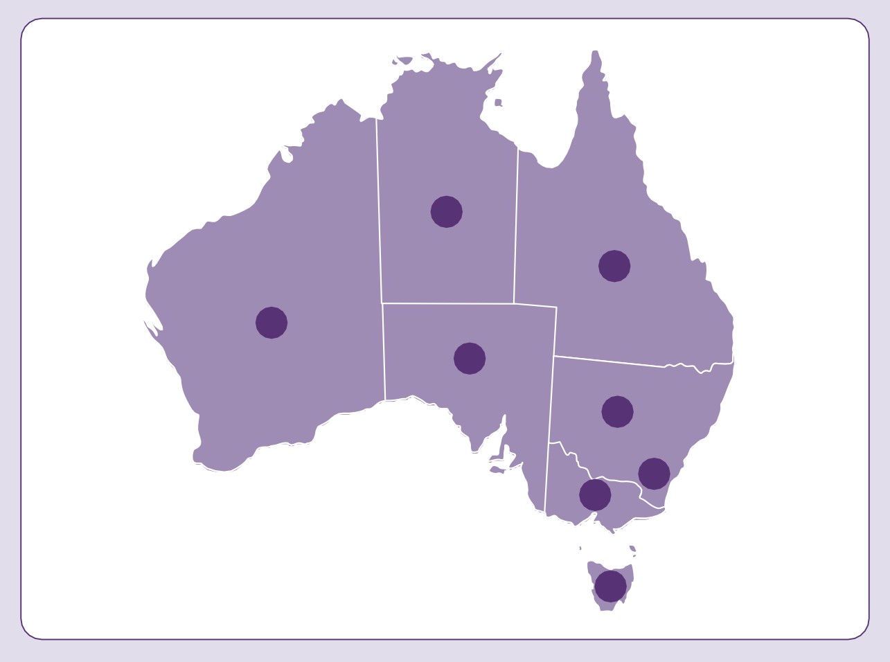
1
2
3
4
5
6
7
8
Public sector employment targets
Australian Government
Target: 7% employees with disability
Current rate: 5.8% (June 2025)
- Western Australia
Target: 5%
- Northern Territory
Target: 8% by 2027
Current rate: 1.9% (2025)
- Queensland
- South Australia
Target: 3% by December 2026
- New South Wales
Target: 5.6%
Current rate: 2.6% (2023)
- Australian Capital Territory
Target: 9%
Current rate: 3% (June 2025)
- Victoria
Target: 12% by 2025
Current rate: 9.4% (2024)
- Tasmania
Current rate: 8% (2024)
The target percentages and current rates of employees with disability use variable reporting frameworks and methods and therefore cannot be reliably compared across jurisdictions.

Fishcare program
South Australian Government
The South Australian Government Department of Primary Industries and Regions (PIRSA) proudly continues to elevate the inclusion of people with disability in its Fishcare Volunteer Program. Over 50 volunteers, including people with hearing impairments, acquired brain injury, and intellectual disability, were engaged in 2024.

More action in South Australia:
The South Australian Housing Trust’s Employment Pathways Program is a targeted initiative supporting financial security for social housing customers and tenants, including people with disability.
In 2024, 17.73% of all public housing allocations were to women head tenants with disability.
By embedding employment and training within the social housing system, the Trust is enabling people with disability to gain skills, secure income, and increase independence.
Fishcare volunteers play a key role in educating the public about sustainable fishing practices at jetties, beaches, boat ramps and community events. Volunteers also conduct patrols using Fishcare vehicles, attend fishing competitions and distribute educational materials to local outlets. PIRSA work to take a person-centred and flexible approach with each volunteer, adjusting activities to suit individual needs.
The program also partners with schools, including in special education settings, to create volunteering pathways for students with disability, supporting them to gain exposure to PIRSA’s work and opportunities for long-term employment. PIRSA’s data shows that volunteers with disability have used the skills and experience they have learned through the program to transition into paid employment following their involvement in the program.

Skilling Queenslanders for Work
Queensland Government
The Queensland Government is strengthening financial independence of people with disability through innovative workforce solutions. This includes targeted funding and support through the statewide Skilling Queenslanders for Work initiative.
MultiLink Community Services Inc delivered a Skilling Queenslanders for Work project in Logan in 2024, assisting 22 disadvantaged job seekers, including people with disability, to gain employment in the automotive industry whilst undertaking a Certificate II in Automotive Vocational Preparation and a first aid certificate. Over 77% of participants secured employment, including Dylan.

Sixteen-year-old Dylan, who has been diagnosed with Autism and ADHD, has overcome significant challenges. Struggling in school, Dylan decided not to return for Year 9 due to mental health issues and feelings of isolation. After facing housing instability with his mother, he moved in with his girlfriend’s family, where he found stability.
Honestly, I can’t imagine where I’d be right now if I didn’t have this course.
— Dylan, MultiLink participant
With a passion for cars, Dylan joined MultiLink’s project, which proved transformative. Initially struggling to focus, Dylan became a top student, completing assignments quickly and assisting his classmates. Dylan has since completed his training and successfully secured employment. His goal is to continue to work hard, accumulate hours towards his driver license, and eventually transition into an apprenticeship.

Enhanced My Career Insights Pilot
Victorian Government
The Enhanced My Career Insights Pilot commenced in Term 3, 2024 and provides intensive career planning support to students with disability and those experiencing disadvantage. The pilot is available to eligible Victorian Government school Year 9 and 10 students. They can access the program to explore potential pathways and unpack their career assessments in an interview.
More action in Victoria:
Between October 2023 and June 2025, the Jobs Victoria Mentors program supported over 100 jobseekers with disability into employment. Mentors provided tailored support to participants, helping them become work-ready and providing ongoing support for the first 6 months after commencing a job.
The Youth Employment Scheme Trainee Program Disability Stream provides a pathway for young people with disability into the Victorian Public Service and related public sector agencies.
Key details include:
- 59 schools are participating in the pilot across 17 areas
- 546 students with disability have participated as of 30 June 2025
- 4 individual sessions with a career practitioner offered for eligible Year 9 and 10 students experiencing disadvantage, including students with disability
- the pilot will be evaluated to identify opportunities for improvement and expansion.

Workplace adjustments
New South Wales Government
The NSW Department of Customer Service is progressing the development of the Workplace Adjustment Passport based on the NSW Government co-designed prototype, with a pilot scheduled within the department in 2025. Planning is in place to expand the pilot across NSW Government.
The NSW Office of the Public Service Commissioner issued a landmark directive requiring all NSW Government agencies to implement a workplace adjustments policy by 1 November 2025. This was supported by the release of a comprehensive model policy, including fact sheets, a conversation guide, and detailed information on adjustment types, recruitment practices, and funding mechanisms. Information on the full suite of resources to support this initiative can be found on the NSW Government webpage for workplace adjustments.

Regional employment opportunities
Western Australian Government
In May 2024, the WA Government announced the final phase of its $4 million investment to ensure the ongoing employment of people with disability who were affected by Activ Foundation's decision in 2022 to close its large workshops. Three Australian Disability Enterprises were funded to explore open employment opportunities and pathways in Albany, Busselton, Bunbury, Kalgoorlie, Northam and Geraldton.
More action in Western Australia:
The WA Government has partnered with the private sector to increase employment opportunities and employer confidence to employ people with disability.
The WA Chamber of Commerce and Industry WA delivered a 12-month pilot project to increase employment of people with disability in small to medium businesses.
Forty-six businesses registered as disability-friendly Industry Champions and 194 business representatives participated in targeted webinars.

Workpower delivered the Enhancing Regional Employment Opportunities for People with Disability project increasing the workforce participation of people with disability in Geraldton and Kalgoorlie. Workpower formed a key partnership with the WA Government Department of Education and the Eastern Goldfields Education Support Centre to deliver the Job Ready and Future Leaders programs to students with disability in Years 9–12. The program’s success led to it being expanded to students with disability in Years 7 and 8. Over 60 students have participated in the traineeship program. In recognition of this work, Workpower Kalgoorlie was awarded the Excellence in Regional and Remote Support Award at the WA Disability Support Awards 2025, which secured their place as a finalist in the 2025 National Disability Awards.

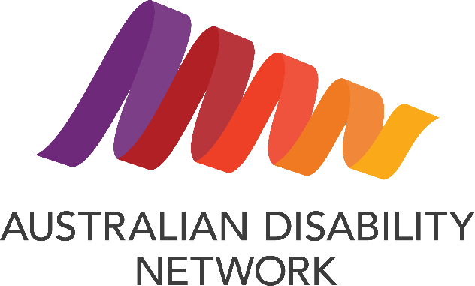
Career Pathways Pilot
Australian Disability Network
The Career Pathways Pilot (2023-2025), funded by Australian Government, was an innovative partnership between Australian Disability Network, Business Council of Australia, and four 4 major employers Coles Group, Compass Group Australia, Kmart and Target Australia, and Woolworths Group that addressed the
underrepresentation of people with disability in leadership positions
and career advancement opportunities.
The pilot took a comprehensive approach to fostering disability-inclusive workplace cultures and removing barriers to career progression. Through co-designed activities tailored to each organisation's needs, the pilot worked simultaneously with employees with disability, middle managers, senior leaders, and organisational systems.
Key activities included mentoring and coaching programs for employees with disability, disability confidence training for supervisors and managers, peer-to-peer networking opportunities, and reviews of organisational policies and frameworks that impact career progression. The pilot recognised that career advancement looks different across roles and industries, particularly for frontline workers who may face additional barriers to participation in professional development.
By embedding access and inclusion into business-as-usual practices, the pilot created sustainable change that extends beyond its delivery period. Resources and learnings developed through the pilot are being shared with Business Council of Australia members, multiplying its potential impact across Australian workplaces and advancing meaningful career opportunities for people with disability.

Disability business training modules
First Peoples Disability Network
The National Indigenous Australians Agency provides funding to the First Peoples Disability Network for the National Disability Footprint to strengthen the representation of First Nations people with disability across all policy areas to ensure their needs, expectations and priorities are responded to.
Through the National Disability Footprint, First Peoples Disability Network is designing a training package to enhance the understanding of inclusive models and frameworks around First Nations disability in the broader community-controlled service sector.
First Peoples Disability Network has created a disability business training module, called Staying Deadly, which aims to build foundational knowledge on First Nations disability perspectives, models of disability, human rights frameworks, and the culture of inclusion. The 3.5-hour module provides practical tools for life-stage planning in a culturally safe way using yarning-based principles and traditional art. Staying Deadly has been trialled with 9 community-controlled organisations over the past 12 months, with feedback leading to continuous improvement and a revision of the module. A revised shorter version of Staying Deadly with emphasis on practical tools and resources will be trialled from late 2025.
A second module that builds on the foundational knowledge from Staying Deadly is being designed and will commence implementation from early 2026. The new module will incorporate tools and knowledge to help embed accessible, inclusive and disability rights informed services within the community-controlled sector. The new module will focus on strengthening sectoral understanding of the culture of inclusion, the use of First Nations cultural therapies, the application of the UN CRPD in the workplace, and pathways for employment for First Nations people with disability.

First Nations artists
Australian Government
In 2024–25 Creative Australia has invested in opportunities for First Nations d/Deaf, disabled and neurodivergent artists to build networks and connections, and access funding and support.
In October 2024, Creative Australia investment supported the first national gathering of First Nations d/Deaf and disabled artists at Alter State Festival, including opportunities for First Nations artists to present work and connect within the Festival and Symposium. In May 2025, Creative Australia supported Yirramboi to host a gathering and present new work by First Nations d/Deaf and disabled artists. In April 2025, Creative Australia launched a new First Nations d/Deaf and/or Disabilities Project fund, which will provide grants to support projects and professional development opportunities across all art forms.

Apollo Neurodiversity Program
Australian Government
The Apollo Neurodiversity Program (Apollo) commenced in 2023 and is a Department of Home Affairs’ initiative, that provides an opportunity for the department to embrace neurodiversity as one of the inclusive workforce strategies. This strategy leverages the diverse experiences, views and the unique talents that neurodiverse people bring to the workforce to enable us to deliver better outcomes for the department and the Australian community.

The Australian Public Service is working to improve understanding and acceptance of neurodiversity in its workplaces.
In the 2024 APS Employee Census,
8.8% of respondents considered themselves to be neurodivergent. Another 9.3% of respondents considered that they may be neurodivergent.
Apollo is a 12-month program offering meaningful employment and career pathways for neurodivergent participants. Participants are recruited through a unique Affirmative Measures recruitment to highlight their strengths and remove traditional interview barriers that often leads to under employment. Participants are matched to roles based on their skills, experiences and qualifications.
Apollo provides training and neurodiversity consultancy support to managers and participants from the outset to the completion of the 12-month program. Each participant develops an Individual Success Plan/Passport outlining their traits, strengths interests, support needs, coping strategies, sensory preferences and mental health considerations. The passport informs tailored training for supervisors to equip them with strategies to communicate, support and manage participants effectively and implement reasonable adjustments for inclusive workplaces. The program coaching boosts participant outcomes by improving confidence, morale, job satisfaction, productivity and retention.
In 2024, the Australian Border Force (ABF) joined the Apollo program following the successful completion of its first pilot program. Through this initiative, the expanded inclusion into operational and uniformed areas has introduced new skills to the ABF and fostered a stronger culture of belonging.
Since its conception in 2023, the program has placed 20 participants across the Technology Group and the ABF in various roles and has maintained a 100% participant retention rate.
The Apollo Program enhances the lives of its participants, providing them with a sense of belonging and empowering them with a fulfilling career in the Department of Home Affairs and the ABF.
The Apollo program was recognised at the 2024 ACT Chief Minister’s Inclusion Awards, where it received the award for Excellence in Inclusive and Innovative Employment Practices.


Inclusive Homes and
Communities
Outcome: People with disability live in
inclusive, accessible and well-designed homes
and communities

Policy priorities
- Increase the availability of affordable housing.
- Housing is accessible and people with disability have a choice and control about where they live, who they live with, and who comes into their home.
- People with disability are able to fully participate in social, recreational, sporting, religious and cultural life.
- The built and natural environment is accessible.
- Transport systems are accessible for the whole community.
- Information and communication systems are accessible, reliable and responsive.
- People with disability have access to services and supports to prevent and reduce homelessness.
Inclusive Homes and Communities underscores the critical importance of creating accessible, affordable, and well-designed homes and communities for people with disability. This Outcome Area lays out policy priorities essential to ensuring that people with disability can participate fully in society: increasing affordable housing, ensuring choice and control over living arrangements, improving participation in community life, making environments and transport accessible, and providing timely supports to prevent homelessness.
During the 2024 Review of the Strategy, people with disability and their representative organisations expressed their strong support for governments to act on housing through the Strategy. A common theme during the Review was the need to increase the availability, accessibility and affordability of housing for people with disability. In response, we developed a new policy priority under the Inclusive Homes and Communities Outcome Area focused on preventing and reducing homelessness of people with disability.
People with disability and their representative organisations acknowledge that the Inclusive Homes and Communities Outcome Area has received increased political attention with the development of new TAPs, marking positive steps toward greater accessibility. However, they highlight ongoing challenges, such as public-transport, slow progress in accessible infrastructure, and insufficient housing that meets the needs of people with disability. People with disability and their representative organisations have urged government to implement a more coordinated approach in addressing the Outcome Area’s policy priorities. Looking ahead, they also call for future efforts to embed intersectionality, cultural inclusion, and evidence-based planning, ensuring that all people with disability can live safely, independently, and meaningfully connected to their communities.
The significance of these priorities is highlighted by contemporary data. Households that include a person with disability face much longer wait times for social housing, waiting an average of 547 days for public housing in 2023–2024, up from 413 days in 2020–2021. For First Nations households with a person with disability, the wait for state-owned Indigenous housing rose from 389 days to 811 days in the same period. The national housing crisis has led to longer wait times and fewer allocations, with those without disability typically experiencing shorter waits, underscoring the urgency for targeted action.
Governments and organisations at all levels are responding with a diverse range of initiatives. The Australian Government is committed to increasing the supply of social and affordable housing, including through:

Social housing is a form of housing assistance. Social housing programs are rental housing owned or managed by the government, such as public housing or state owned and managed Indigenous housing, or by a community organisation (community housing, or Indigenous community housing.

- Crisis and transitional accommodation for women and children experiencing violence or homelessness, ensuring new builds meet Livable Housing Australia’s Silver-level accessibility standards.
- The $10 billion Housing Australia Future Fund supporting the delivery of 30,000 new homes.
- The Social Housing Accelerator Payment is providing $2 billion to states and territories to deliver around 4,000 new and refurbished social housing homes.
- The National Agreement on Social Housing and Homelessness, providing $9.3 billion over 5 years from 1 July 2024 to state and territory governments to help people who are experiencing, or at risk of, homelessness and supports the effective operation of Australia’s social housing and homelessness services.
Further, the Younger People in Residential Aged Care Toolkit is helping younger people explore alternatives to aged care, while the Accessible Australia initiative and Changing Places facilities are improving community infrastructure nationwide.
State and territory governments have introduced measures such as implementing liveable housing design requirements, enhancing the accessibility of community facilities, and increasing inclusive recreational opportunities. Local government projects, like City of Newcastle’s inclusive sport program and City of Ryde’s accessible volunteering initiative, further support social participation. Together, these coordinated actions aim to deliver genuinely inclusive communities, enabling people with disability to live independently, participate fully, and enjoy equal access to opportunities across Australia.
Inclusive Homes and Communities
Inclusive Homes and Communities data, 2021 and 2024/25

 | 2021 | 2024/25
Average time waited for social housing where a household includes a person with disability | 413  days  (2021) | 547  days  (2024)
    Average time waited for state-owned Indigenous housing where a household includes a  person with disability | 389  days  (2021) | 811  days  (2024)
  NDIS participants spend free time doing activities that interest them | 65.5%  (2021) | 66%  (2025)

Crisis and transitional accommodation
Australian Government
The Australian Government is investing more than $270 million in new crisis and transitional accommodation for women and children experiencing domestic violence as well as older women at risk of homelessness, through the Crisis and Transitional Accommodation Program (CTAP) and the Safe Places Emergency Accommodation Program (Safe Places).

Family and domestic violence is one of the leading causes of homelessness for women and children in Australia.
Access to safe accommodation is fundamental to the immediate safety of women and children experiencing family and domestic violence.

CTAP and Safe Places are capital works programs. They fund building, renovation or purchase of accommodation for women and children experiencing family and domestic violence or older women experiencing homelessness. The Safe Places Inclusion Round focuses on providing specific accessible supports to meet the housing needs of:
- First Nations women
- women and children from culturally and linguistically diverse backgrounds
- women and children with disability.
All new-build housing for the Safe Places Inclusion Round is required to meet Livable Housing Australia’s (LHA) Silver-level accreditation and CTAP new builds are required to meet this accreditation, where practical. Applicants who proposed to remodel or purchase existing buildings under both programs were also encouraged to consider LHA Silver accreditation or equivalent—particularly for CTAP projects supporting older women and Safe Places projects with a disability focus. Outcomes of the Safe Places Inclusion Round were announced in July 2024, while CTAP outcomes were announced in February 2025.

Younger people in residential aged care toolkit
Australian Government
As of 31 March 2025, there were 959 people under the age of 65 living in residential aged care in Australia.

Through the Australian Government Budget 2023–24, the Australian Government Department of Social Services was funded to develop education and resources aimed at younger people in residential aged care (YPIRAC), family members, carers, guardians and other supporters in non-clinical settings.
The YPIRAC toolkit is designed to help younger people consider their housing options and understand the steps involved in moving out of residential aged care.
It includes fact sheets, guides, practical tips and links to resources to support people at different stages of their housing journey. It’s intended to help YPIRAC to consider how living outside aged care could look for them and support them to take the steps required to achieve their goals.



Accessible Australia
Across Australia, many governments are working towards improving the accessibility of their community facilities and infrastructure.

Australian Government
The Australian Government is investing $17.1 million from 2024–25 to 2027–28 to increase inclusion in community spaces across Australia. Accessible Australia builds on the Changing Places initiative announced in October 2022. Funding is delivered through Federation Funding Agreements between the Commonwealth and states and territories. Tranche 1 of Accessible Australia has been finalised, while Tranche 2 is scheduled for 2025–26.
Under the initiative, funding of up to 100% of the build cost is offered for accessible amenities that improve access for people with disability to both the built and natural environments across Australian communities. Up to 100% of the total build cost is available for: inclusive beaches (for example, beach wheelchairs, accessible matting), inclusive national parks (for example, all-terrain wheelchairs and accessible paths), and portable Changing Places facilities. Up to 50% of the total build cost is available for inclusive play spaces (for example, liberty swings, all-access spinners) and fixed Changing Places facilities.

Australian Capital Territory Government
As a part of the ACT Disability Strategy First Action Plan, the ACT Government is improving access at public spaces and events by delivering more Changing Places facilities in the ACT. During reporting period, the ACT Government built its first permanent Changing Places facility within the Canberra Hospital as part of the Canberra Hospital Expansion Project. In 2024, the ACT Government purchased its first Portable Changing Places facility. This Portable Pod will be used at major ACT festivals and events.

Tasmanian Government
Tasmania has committed funding to existing Australian Government funding to assist in the planning and delivery of new Changing Places amenities in Tasmania.
Following Tranche 2 of the Australian Government Changing Places Initiative, Tasmania had a total of 5 accredited Changing Places amenities, with a sixth under development. Tasmania is currently in negotiation through the Australian Government Accessible Australia Initiative to progress up to 8 additional Changing Places amenities across Tasmania.

Western Australian Government
In 2021, the WA Government committed $2 million to expand WA’s network of Changing Places, resulting in 12 Changing Places being constructed across the State including regional locations such as Broome, Kununurra, Margaret River and Mandurah.
In August 2023, funding was provided to construct a 13th Changing Places at the Perth Zoo. Over 700,000 people visit this iconic tourism and education attraction annually. Construction commenced in 2024 as part of a significant upgrade to Perth Zoo to complement other accessibility improvements and was completed in April 2025. There are now 52 registered Changing Places across WA, with 37 in metropolitan Perth and 15 in regional areas.

Reform of the Transport Standards
Australian Government
The 2022 Review of the Transport Standards report and Australian Government response were published in November 2024 following extensive consultation with people with disability. The Review identified 6 opportunities for action to improve the Transport Standards. This was a deliverable committed to under the Strategy as per the Roadmap. The Australian Government will continue to work with people with disability and public transport operators and providers to address the opportunities for action, including through reforms to the Transport Standards and through implementation of accessibility initiatives announced in the Aviation White Paper.

The Disability Standards for Accessible Public Transport 2002 (Transport Standards) are made under the Disability Discrimination Act.
The Transport Standards set requirements for public transport operators and providers to make their services accessible for people with disability.
.

In March 2024, the Australian Government announced a package of reforms to the Transport Standards. The reforms were developed in collaboration with people with disability, public transport operators and providers, and state and territory governments. The reforms will improve accessibility across the whole public transport journey. This includes new training requirements for public transport workers and making it easier to find and understand information to plan a journey. The Australian Government is now updating the Transport Standards to implement the reforms and working with the disability community, state and territory governments, and public transport operators and providers to progress unresolved areas of reform.

New aviation-specific disability standards
In 2024, the Australian Government released an Aviation White Paper. It includes ways to improve how people with disability are treated when they travel by air. The Australian Government is working on:
- Co-designing new aviation specific disability standards with people with disability. The new requirements will be a schedule to the existing Transport Standards.
- Requiring airlines and airports to coordinate how they help people with disability across their aviation journey.
- Requiring airlines to offer ‘passenger assistance profiles’, so people with disability don’t have to say repeatedly what help they may need when they book flights.
- Informing people with disability about their rights when travelling by air.
- Improving how people are compensated if their wheelchairs are damaged or lost by airlines.
Three co-design workshops were held with people with disability during July and August 2025. The workshops identified solutions to the accessibility issues people with disability often face when travelling by air. The workshop outcomes are being used to draft the new aviation disability standards. Public consultation on options for the new standards is planned for late 2025.

Disability Standards for Accessible Public Transport
South Australian Government
In 2024, the South Australian Government Department for Infrastructure and Transport continued to contribute to the national inclusion efforts through its participation in the reform of the Disability Standards for Accessible Public Transport (the Transport Standards). Under an additional reform process, led by the Australian Government, which involved 5 national working groups tasked with addressing unresolved areas of Transport Standards reform. These groups included representatives from state and territory governments, public transport operators, disability advocates, and subject matter experts.
The department representatives served as subject-matter experts within the ‘Reporting’ working group, which progressed the development of a prioritisation tool and framework. This tool is designed to help transport operators and providers improve Transport Standards compliance and promote functional accessibility outcomes across jurisdictions.
This collaboration highlights the importance of aligning national accessibility standards with lived experience and operational expertise and reaffirms the South Australia’s commitment to improving transport accessibility for people with disability, while contributing to consistent, inclusive policy outcomes across Australia.

Liveable housing design requirements
Northern Territory Government
The Northern Territory Government has implemented liveable housing design requirements for all government housing and ensures all new remote community housing dwellings are designed to achieve silver standards of the Livable Housing Design Guidelines (2017) and requirements of AS 4299–1995 Adaptable Housing Standards.
The Livable Housing Design Standard was introduced as part of the National Construction Code 2022. This standard provides a set of technical provisions that if complied with will enable dwellings to better meet the needs of the community, including older people and people with mobility limitations.

All new houses, through their compliance with the design guidelines, will be accessible, as well as ‘visitable’, and allow basic provisions for ramp access, level thresholds to wet areas and living areas, and ease of use within toilets and showers.
Liveability works to address a range of accessibility needs and includes alterations and modifications to homes to support disability or medical requirements. Improvements to accessibility, particularly in remote communities, can have profound implications and allow a person with disability to remain in their community longer, increasing connection and positive health outcomes.
Since 1 July 2023 to 31 May 2025, 514 homes have been built in accordance with the Livable Housing Design Guidelines. Recent construction of 6 new homes in Canteen Creek included grab rails in all the bathrooms, with one home fully equipped with an accessible toilet and shower seat.

Implementing housing standards
Tasmanian Government
From 1 October 2024, new residential dwellings in Tasmania must be designed and built to comply with Part H8 of the National Construction Code, that includes Livable Housing Design features, including:
- clear opening width for entrance doors
- requirements for at least one shower to be hobless and have step free access and a lip of not more 5mm
- reinforcement of bathroom and sanitary compartment walls.
Additional standards will be introduced in coming years.
The ‘voluntary’ Australian Building Codes Board standard refers to the gold and/or platinum Livable Housing Design standards. Some dwellings delivered by Homes Tasmania do meet these standards.
Homes Tasmania will conduct a review of its social housing policy in 2025–26. This will include consultation on a revised social housing policy to ensure the prioritisation of social housing and collection of applicant information continues to prioritise contemporary housing need effectively and efficiently. Updated policies will replace those currently available online, including in accessible easy to read guides.

Housing ACT
Australian Capital Territory Government

More action in the ACT:
Implementing the National Construction Code (NCC) in the ACT:
Since 15 January 2024, 100% of Building Approvals have complied with NCC Silver Level Livable Housing Design Standard. This data includes both private and social housing.

The implementation of the ACT Disability Strategy First Action Plan has affirmed the ACT Government’s commitment to improving the accessibility of public housing services. The ACT Government has established a disability liaison officer position in Housing ACT to support enhanced communication, reasonable adjustments and staff confidence in supporting people with disability. Housing ACT is also working to ensure staff are informed and educated on the systemic barriers faced by people with disability. Of the 93 staff in the Housing ACT tenant engagement team, 88 have attended disability awareness training.
In addition, Housing ACT continues to make home improvements to its asset base. Across 2023 and 2024 more than 470 homes had a disability modification made. This supports wellbeing and has improved the living standards for older tenants and/or tenants with disability.

First Nations housing
Australian Government & Northern Territory Government
The Australian Government is investing in housing for First Nations people with disability as part of the joint Australian Government and Northern Territory Government investment of $4 billion in housing and homelands in remote communities across the Northern Territory over the next 10 years, from 2024 to 2034.
Remote Northern Territory communities have the highest levels of overcrowding in the country. Programs such as the new 10-year Northern Territory Remote Housing Agreement will deliver up to 2,700 houses. Delivery will be informed by a Partnership Agreement between Land Councils, Aboriginal Housing NT, and the Australian Government and Northern Territory Government that embeds shared decision making.
The Australian and Northern Territory Governments are each contributing 50% of the costs associated with each house, including the work required to make sure each house provides disability access for tenants.
Disability supports and accessibility are also included as part of a $200 million measure for repairs, maintenance and improvements of housing in remote Indigenous communities under the Housing Australia Future Fund.
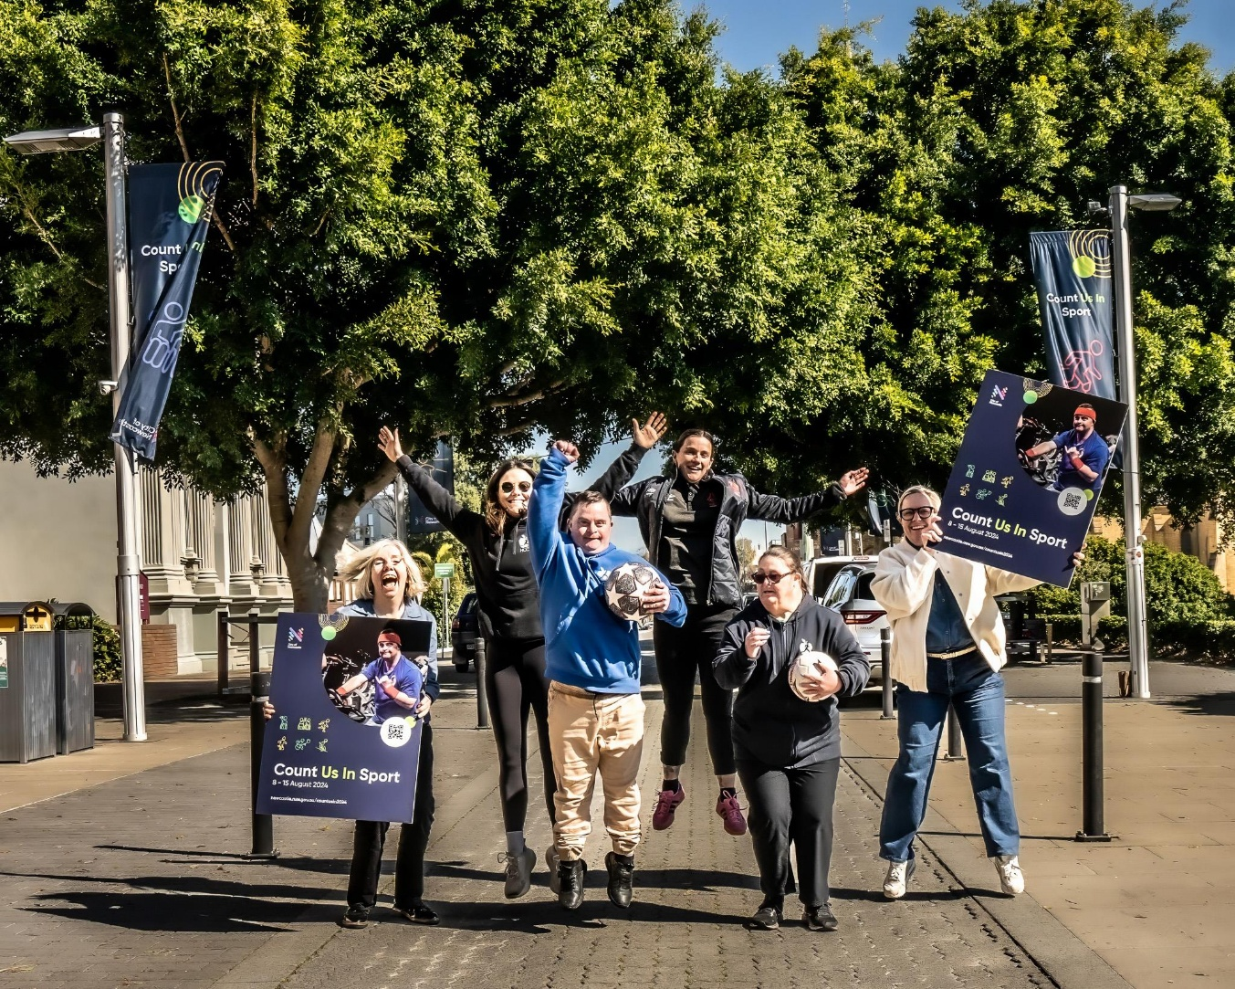
Count Us In participants, City of Newcastle, NSW

Count Us In Sport 2024
City of Newcastle, NSW
City of Newcastle's Count Us In Sport 2024 program promoted inclusive sport and recreational opportunities, encouraged sports and recreational providers to increase the participation of people with disability within their clubs/activities, and celebrated both elite level and grassroots participation.
City of Newcastle also provided resources to clubs, associations, and others to upskill through training on how to make their sport more inclusive, and the benefits of having a more diverse membership/volunteer group. The 2024 program included:
- An Inclusive Sports Forum with high profile guest speakers for clubs, associations and recreation providers.
- Installation of street banners depicting people with disability participating in sport.
- A funding pitch night where organisations pitched for $2,500 each to help them improve inclusion at their club with 7 successful pitch activities being funded and delivered over a 12-month period.
- Come and try inclusive sports activities held to attract school-aged participants and general public participation.
- A Paralympics Watch Party in association with a community disability advocacy organisation.
- A base line survey of local sports and recreation providers on inclusion.
- Development of promotional videos to share stories of sports inclusion.
Sport was used to leverage the message of inclusion, that everyone can play.

Sport participation
Australian Government
Between 1 July 2023 and 30 June 2025, the Australian Government, through the Australian Sports Commission (ASC), supported initiatives to increase the participation of people with disability in sport across Australia. This includes:
- Through the 2024–25 Federal Budget the Australian Government committed $54.9 million for the ASC to support Paralympic athletes and sports, doubling the existing funding to Paralympic sport.
- Approximately $37 million has been provided to Paralympics Australia across 2023–24 and
2024–25 to support Australia’s elite Paralympic sport programs (including high performance, pathways, and participation outcomes as well as specific support for the Australian team’s participation at the Paris 2024 Paralympic Games).
- Approximately $52 million in high performance funding to National Sporting Organisations and National Sporting Organisations for People with Disability across 2023–24 and 2024–25 to support Paralympic sport programs.
- Approximately $5 million across 2023–24 and 2024–25 in participation growth and other funding grants across 11 National Sporting Organisations for People with Disability to increase participation in sport.
- $10.9 million across 2023–24 and 2024–25 has been provided to para-athletes through the ASC’s direct athlete support scheme which provides athletes with financial support to achieve their best at Olympic, Paralympic and Commonwealth Games.
- Approximately $725,000 through the Local Para Champions program providing eligible young athletes, coaches, officials, and support staff individual grants to support their attendance at state, national and international sporting championships.
- $10.3 million over 4 years, commencing 2022–23 to Get Skilled Access to deliver the Sport4All – First Nations Program expansion.
- $0.98 million to provide one-off medal incentive payments to eligible athletes following the Paris 2024 Paralympic Games.
- $1.2 million over 2 years from 2024–25 to support the delivery of the VIRTUS World Athletic Championships and the 2025 World Boccia Challenger.

Accessible tools to help people manage their tax
Australian Government
The Australian Taxation Office (ATO) have published resources to support all people manage their tax obligations with confidence. Specialised help and support is available on the ATO website for taxpayers, including tailored tax and super information for people with disability.
The ATO resources are available in accessible formats, including:
- easier to read guides on popular topics for people with lower literacy or reading difficulties
- video guides with transcripts you can download, in Auslan and community languages
- tax return instructions in accessible formats.

Accessible Books Consortium and Right to Read Conference
Australian Government
The Accessible Books Consortium (ABC) aims to increase the number of books worldwide in accessible formats—such as braille, audio, e-text, large print—and to make them available to people with print disability, including people who are blind or have low vision.
The Australian Government provided funding for ABC’s ‘Right to Read’ Conference held in Australia from 30 October to 2 November 2024. The conference brought together accessibility specialists, ABC members, disability advocates, government representatives from 9 Pacific Island countries and Australian Government representatives.
The conference increased participants’ knowledge of best practices for the creation and distribution of accessible books for people with print disability and identified further opportunities where the ABC could implement training and technical assistance projects in the Pacific Islands.
The Australian Government continues to support the goals and ongoing work of the ABC.
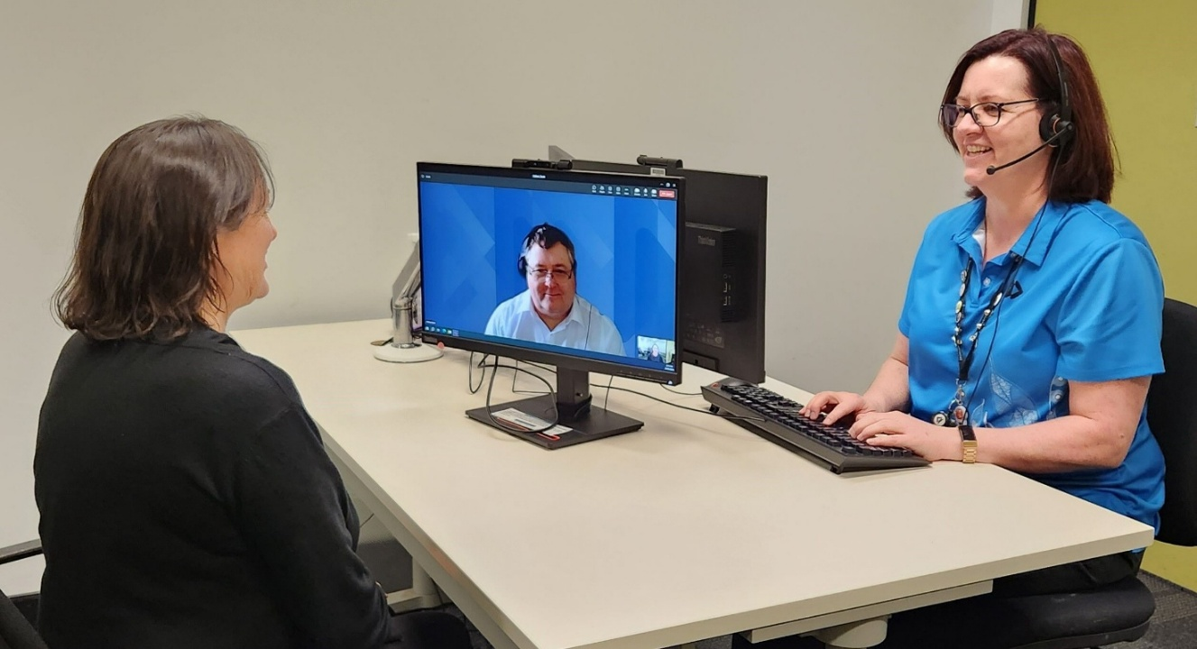
Services Australia

Accessible information
Australian Government
Services Australia is reimagining and improving customer experiences across face-to-face services through human-centred design. This includes transforming service centre environments to ensure inclusive and accessible service delivery, for example identifying video chat capability and physical design improvements.
Services Australia is focused on ensuring accessible information and communication for people who are d/Deaf or hard of hearing. Access to interpreters is being expanded across Services Australia through the implementation of a new service, enabling access to an Auslan interpreter within 30 minutes via video chat without the need for a booked appointment. This service aims to deliver improved equity of access and increased choice and control for people who are d/Deaf or hard of hearing about the way they engage with Services Australia. Critical information currently available in readable format on the Services Australia website is now also offered via a series of Auslan interpreted videos. This aims to ensure customers can receive accurate and timely information to support informed decision making and autonomy.

Accessible tourism across Australia
In 2024, 22% of all trips in Australia were by travellers with accessibility needs.
The total trip spend of travellers with accessibility needs was $29.2 billion in 2024.
Accessible tourism ensures that people with disability can participate fully in travel, leisure, and community life. By removing barriers to tourism and improving facilities, accessible tourism not only empowers people with disability to explore and engage with their surroundings but also enriches the experience of all travellers and strengthens social inclusion across the broader community. This section highlights a range of initiatives undertaken nationwide. Together, these efforts demonstrate Australia’s commitment to making tourism more welcoming, enjoyable, and accessible for everyone.

Australian Government
  - WELCOME Framework
Launched by Tourism Ministers on 20 May 2024, the WELCOME Framework is a practical guide that outlines easy steps tourism operators can take to improve their accessibility. The WELCOME Framework champions access and inclusivity for all travellers and encourages tourism operators to view accessibility and inclusivity as a universal approach to business.
The WELCOME Framework brings together important aspects for tourism operators to consider in making their products and services more accessible. It sets out easy-to-follow guidance for operators to better understand the needs of, and promoting their business to, people with disability, encouraging a shift in attitudes towards how people with disability are viewed in their community.
Through supporting businesses to make their offerings more accessible, the WELCOME Framework aims to make sure people with disability feel respected and valued in their community.
  - Caravan Parks Grant Program
The Caravan Parks Grant program saw a $10 million funding boost to support upgrades and new facilities in caravan parks and visitor amenities around Australia. Improved accessible amenities supported by the Caravan Parks Grant program help to make destinations more attractive to travellers with accessibility needs. Closing in June 2024, 58 successful applicants used grant funding to install accessibility features.
For example, the Caravan Parks Grant Program helped the Berry Riverside Holiday Park in South Australia upgrade its accessible amenities, meaning that more park apartments can accommodate wheelchair users. Accessibility improvements also included upgrading the park’s playground to be fully accessible, including a wheelchair carousel and basket swings. Improving visitor amenities and the built environment of Australian tourism regions supports travellers and locals with disability to participate in their communities.
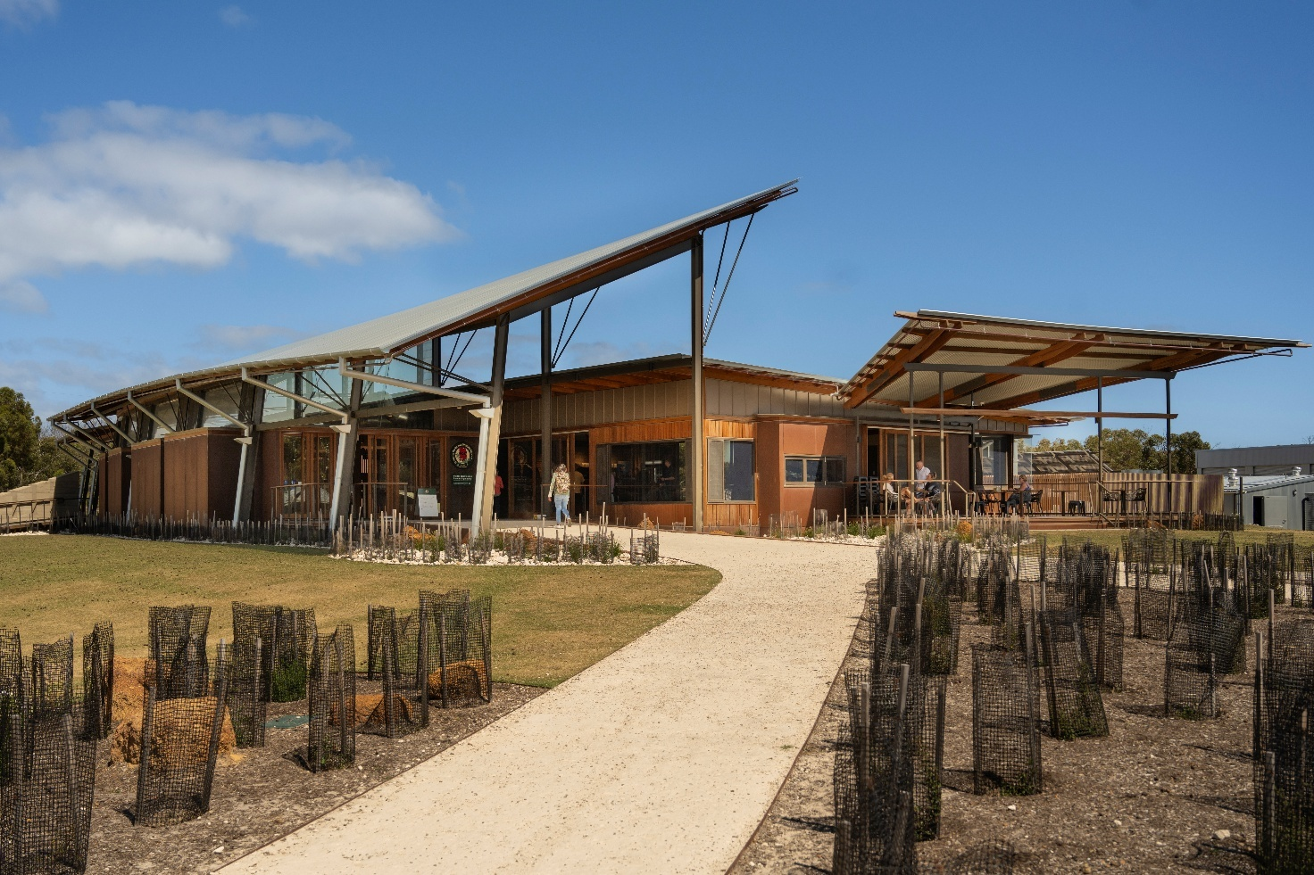
Flinders Chase National Park Visitor Centre, South Australia

South Australian Government
The South Australian Government Department of Environment and Water delivered several accessibility upgrades across South Australian parks in 2023–2025. This included:
- Opening of the new Flinders Chase National Park Visitor Centre. It was designed with accessibility in mind, including push-button entry, sensory touch tables for children with disability, and accessible signage.
- Redesign and upgrade of parts of the Platypus Waterholes Walk to enhance accessibility.
- Opening of a Changing Places facility at Glenthorne National Park in November 2024.
- Updating public information about accessibility features for 19 national parks, and the production of a new video resource highlighting accessibility features on Kangaroo Island.

Queensland Government
In the heart of Outback Queensland, the Qantas Founders Museum in Longreach is redefining inclusive tourism with immersive digital experiences that make aviation history accessible to all. Thanks to support from the Queensland Government’s Accessible Tourism Elevate Fund, the museum has launched cutting-edge virtual and augmented reality experiences, a new augmented reality minigame that invites users to assemble a De Havilland DH50 plane, and a new interactive tour guide optimised for screen readers.
This initiative brings aviation heritage to life and unlocks more of the Outback to people with disability, helping more travellers experience the richness of regional Queensland. It is a proud example of the Queensland Government’s commitment to boosting inclusive tourism with the vital support of tourism operators.

Active in nature
Victorian Government
Parks Victoria implemented co-design with people with disability and disability organisations to guide the design and implementation of programs. The Active in Nature program 2023–24 was initially run as a pilot aimed at engaging young people who face challenges in accessing nature and outdoor activities, due to social, physical or cultural reasons. Key results:
More action in Victoria:
Victoria’s Next Generation Trams (G Class) set a new standard for modern public transport by delivering a more comfortable, accessible and energy-efficient journey for passengers. The Government collaborated with approximately 1,000 passengers, accessibility advocates, tram drivers and technical experts to design the tram. This included 20 consultation sessions with accessibility groups.
Homes Victoria is improving housing outcomes by delivering social housing to meet a range of accessibility standards, including Livable Housing.

- The program, in partnership with VicHealth and Outdoors Victoria, successfully engaged 265 young people (aged 16–24 years) who were less active in nature-based activities. Active in Nature participants 31% advised they had a disability (20% had an intellectual disability and 11% had a physical disability).
- Attendees learned outdoor skills like hiking, abseiling, mountain biking, while other groups participated in activities like learning bush skills, camping, nature education and indigenous cultural activities.
- The program boosted happiness, more confidence in nature and social connection among participants.
Active in Nature proved so successful that funding was extended for a further 2 years, which means more young people including those with disability can participate and connect with nature.

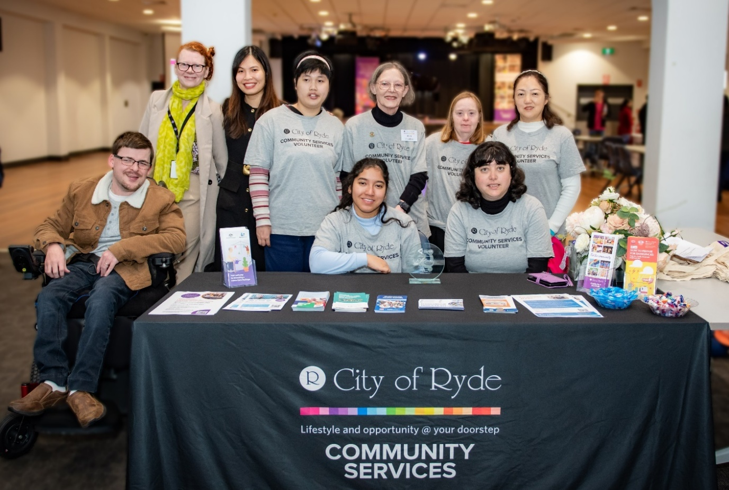
Photo of City of Ryde Council staff and volunteers at the Ryde Disability Forum, 2 July 2025

Supporting inclusive volunteering
City of Ryde, NSW
People with disability often face barriers to accessing suitable volunteering opportunities. To address this, the Supporting Inclusive Volunteering project was developed in 2023 as part of the City of Ryde (Council) Disability Inclusion Action Plan. It has since evolved into an ongoing program supporting people with disability, who live, work or study in the City of Ryde area.
Council formed a working group, including people with disability, carers, and local disability providers to co-design an accessible volunteer information booklet, available in English, Easy Read, Simplified Chinese, Korean, and video formats. Over 550 copies have been distributed, alongside a dedicated webpage.
Volunteering opportunities have been available year around. Ten volunteers with disability contributed to over 170 Council events, including the Seniors Festival, Youth Week, Social Inclusion Week, and the International Day of People with Disability. Bi-monthly meetups have been held regularly to build connections between volunteers and Council staff and provided tailored training to volunteers’ needs. Volunteers feedback highlighted increased confidence, stronger social connections, and valuable skill development. As a result, 3 volunteers have gained paid part-time employment outside of Council.
The program also led to simplify Council’s Volunteer Code of Conduct and Events Volunteer Handbook. Nine disability awareness training sessions were delivered to 45 community organisations and 141 Council staff. Council staff reported feeling more confident and better equipped to support people with disability.
Additionally, in 2024, Council created 3 identified roles specifically for people with disability to promote inclusive employment pathways.
The program received a ‘Highly Commended’ award at the 2024 Local Government Excellence Awards. Council continues to support and expand this important program.
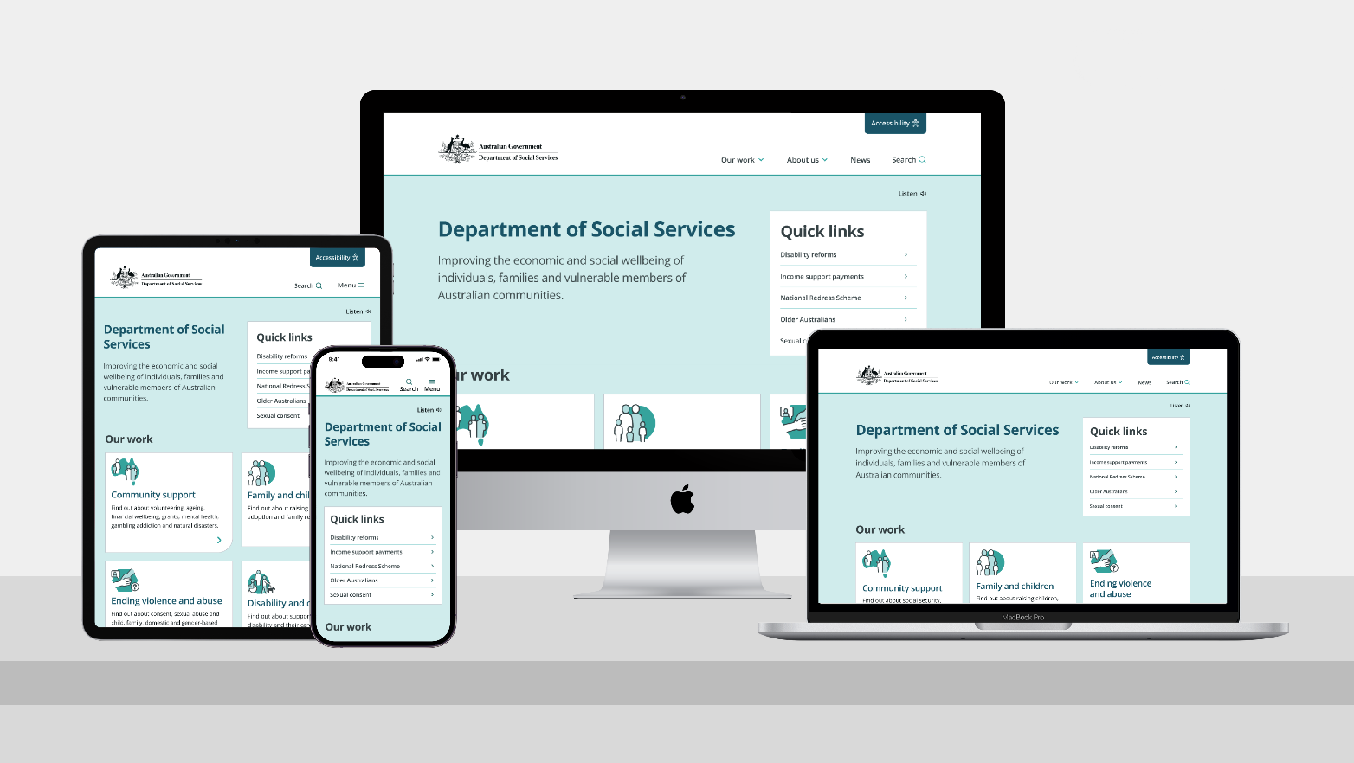
Department of Social Services website

Website redevelopment
Australian Government
In December 2024, the Australian Government Department of Social Services updated its old website with a new, easy-to-use site that everyone can access. Inclusive design, best-practice techniques and accessibility were a priority and focus throughout the project.
The Digital Transformation Agency’s Digital Experience Policy and the Strategy were important guides for the project. The project involved user research and testing, which included people with disability and people from diverse backgrounds.
The new dss.gov.au website meets Web Content Accessibility Guidelines standards. The usability focus ensured the site provides equal access for all users.
The improved search and navigation help users easily find information. The website’s simple design works well for everyone, including people using phones and people with disability.
The new website features:
- documents in different accessible formats like Auslan videos and Easy Read
- a layout that works well on different devices
- options to choose different fonts
- Plain English content, with new content aiming for a Year 7 to 9 reading level.
The project won the best government website award at the 2025 DrupalSouth Splash Awards. It was recognised for its focus on inclusive and accessible design. The website sets a high standard for other government agencies to follow when updating their digital services.

Accessible and inclusive service delivery
New South Wales Government
NSW is committed to creating inclusive environments, ensuring people with disability have equitable access to government services, workplaces, and events, whilst also influencing future standards for accessibility.
More action in New South Wales:
The NSW Department of Planning and Environment has commissioned an Accessibility Review with the Centre for Inclusive Design.
The Accessibility Review will identify opportunities for enhancing disability inclusion across housing, parks, public spaces, planning, procurement, and customer service.
The findings are informing the department’s next Disability Inclusion Action Plan for 2025–2029.

The NSW Government is setting new standards for accessible and inclusive digital services through initiatives under its Digital Strategy and Digital Inclusion Strategy. The state’s approach focuses on reliable, responsive, and accessible information systems across government—driven by innovation and best practice.
The NSW Government is undertaking a range of initiatives to deliver inclusive services, including:
- Quiet Hour at Service NSW centres, creating a low-sensory environment for people with hidden disabilities such as Autism.
- NSW Procurement and Customer Service NSW developed targeted training modules to equip staff with the knowledge to purchase digital products and services that are accessible to all.
- Updated buy.nsw guidance, driving greater uptake of accessibility requirements in procurement processes.
- NSW Australia Day 2023 events featured multiple accessibility measures, such as safe viewing areas, Quiet Rooms, tactile tours, tactile vests, accessible amenities, Auslan interpreters, and accessible communications. Australia Day 2023 has been the model for accessibility in subsequent major events across the state, and informed the NSW Government Toolkit for Accessible and Inclusive Events that was released in June 2023.

Sensory bus
South Australian Government
In designing the South Australian Autism Strategy, the community emphasised the need for supports at festivals and events, acknowledging the differences in processing sensory stimuli experienced by Autistic and neurodivergent people. In 2024, the South Australian Government Office for Autism commenced a partnership with Kelsian (owner of Torrens Transit), to convert a retired Torrens Transport bus into a bespoke therapeutic sensory space which can provide sensory relief to Autistic people at community events. The bus will attend 15 South Australian community events per year and will be available to hire by the community when it is not in use at these events.

National Portrait Gallery of Australia
Australian Government
The National Portrait Gallery of Australia (NPGA) is committed to enabling people with disability to participate in its programs, exhibitions and workplace. In 2025, NPGA presented the exhibition The Immersive World of Thom Roberts, a major monograph of the Sydney-based artist. Roberts works with Studio A, a supported studio that creates professional pathways for artists with lived experience of intellectual disability. Profiling the work of this innovative visual artist, the exhibition championed the visibility of artists with disability in contemporary Australian culture.
NPGA has enhanced its visitor service offerings through introduction of new programs:
- visual stories
- sensory-friendly kits
- over 100 Audio-described portraits available online
- tailored experiences for people with dementia.
Increased staff training and focused capability uplift has supported more inclusive experiences for visitors and collaborators. The NPGA has also hosted interns from the Ripple: Disability and Culturally Diverse Internship Program, in 2023 and 2025, in partnership with Accessible Arts.
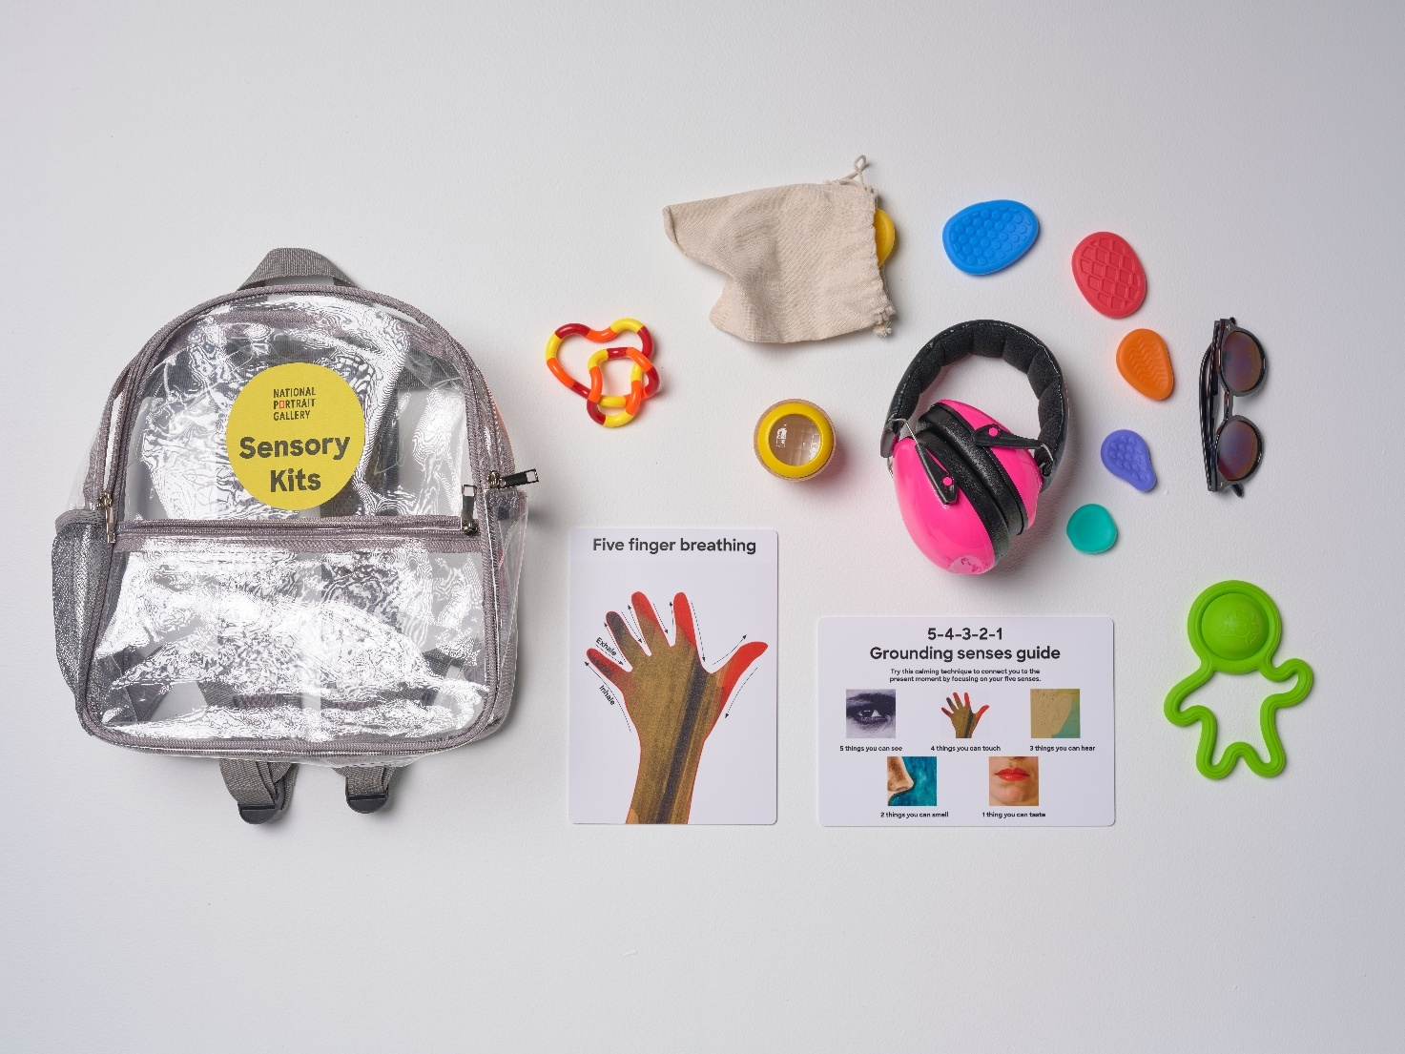
Sensory kits from the National Portrait Gallery of Australia, 2025.
Developed in collaboration with Aspect (Autism Spectrum Australia)


Safety, Rights and Justice

Outcome: The rights of people with disability
are promoted, upheld and protected, and
people with disability feel safe
and enjoy equality before the law

Policy priorities
- People with disability are safe and feel safe from violence, abuse, neglect and exploitation.
- Policies, processes and programs provide better responses to people with disability who have experienced trauma.
- Policies, processes and programs for people with disability promote gender equality and prevent violence against groups at heightened risk, including women and their children.
- The rights of people with disability are promoted, upheld and protected.
- People with disability have equal access to justice.

- The criminal justice system responds effectively to the complex needs and vulnerabilities of people with disability.
Safety, rights and justice are foundational to the wellbeing and social participation of people with disability. This Outcome Area works to ensure people with disability are protected from violence, abuse, neglect, and exploitation, and fully enjoy and exercise equal treatment before the law. Without robust protections and equitable access to justice, people with disability are subjected to heightened likelihood of risk of harm and exclusion.
People with disability and their representative organisations acknowledge that while the Safety, Rights and Justice Outcome Area aspires to equal protection and upholding the rights of people with disability, progress remains limited and, in some domains, concerning trends persist. DROs have raised concerns about limited funded supports in the justice system, that do not reflect the barriers to justice, and the continued over-representation of First Nations people with disability in the criminal justice system, including adult incarceration and youth detention, and in out-of-home care. Some representative organisations have called for a structural reset—recommending whole-of-government coordination, earlier intervention, and culturally safe, community-led approaches—to strengthen safeguards, and to ensure the rights and safety of all people with disability are genuinely protected and advanced into the future.

Recent findings, such as those from the Royal Commission into Institutional Responses to Child Sexual Abuse, reveal that children with disability are at significantly greater risk of abuse in institutional settings. The NDIS Quality and Safeguards Commission’s (the NDIS Commission) 2024 Stakeholder Sentiment Survey underscores the importance of trust in safeguarding measures: 83% of people with disability and their representatives report confidence in the Commission’s support for participants, carers, and advocates, while 96% of providers indicate improved understanding of quality and safety standards. These data points illustrate growing awareness and capacity but also highlight the ongoing need for systemic improvement.
Around the country, jurisdictions are
using punitive youth justice measures
to manage disability in
First Nations young people,
rather than tackling the complex factors which so often lead to contact with the justice system.
— Disability Representative Organisation

To address these challenges, all levels of government and a range of organisations have initiated a strong response. The Australian Government’s $6.9 million commitment to review and modernise the Disability Discrimination Act 1992 (Cth) is a direct response to recommendations from the Disability Royal Commission, aiming to strengthen legislative protections. The Crimes Amendment (Strengthening the Criminal Justice Response to Sexual Violence) Act 2024 (Cth) enhanced court supports for vulnerable witnesses in Commonwealth criminal proceedings, such as people with disability, including allowing for pre-recorded evidence and interpreter access.

State and territory governments are enacting tailored strategies to respond to the needs of their communities. For example, the ACT Disability Justice Strategy’s Second Action Plan (2024–2028) builds on earlier progress by improving entry points and experiences in the justice system, supported by Disability Action and Inclusion Plans across justice agencies. In Victoria, initiatives such as Family Violence and Disability Practice Leaders bridge gaps between family violence services and disability support, applying intersectional approaches to address compounded risks.

Legal aid funding is stretched and requires expansion to support people with disability from CALD backgrounds effectively.
— Disability Representative Organisation
Collectively, these efforts reflect a nationwide commitment to ensuring people with disability are safe, their rights are protected, and justice is accessible. With continued data analysis, stakeholder engagement, and policy innovation, Australia is progressing toward a society where people with disability can live with dignity, security, and full participation.






Safety, Rights and Justice

NDIS participants feel able to advocate for themselves | 37.3%  (2021) | 35.1%  (2025)
National Disability Advocacy Program clients reported improved choice and control to make their own decisions | 62%  (2021) | 66%  (2024)
Proportion of complaints alleging disability discrimination that progressed to AHRC conciliation successfully resolved | 48%  (2020–21) | 61%  (2023–24)
Proportion of all complaints accepted by AHRC alleged discrimination on the grounds of disability | 17%  (2020–21) | 43%  (2023–24)

Safety, Rights and Justice data

Disability legislation
Australian Government
The Disability Services and Inclusion Act 2023 (Cth) (DSI Act) commenced on 1 January 2024, repealing and replacing the Disability Services Act 1986 (Cth). The DSI Act establishes a contemporary and streamlined framework to facilitate funding for supports and services that will assist people with disability, whether or not they are a participant in the NDIS.
The DSI Act improves quality and safeguarding arrangements of services for people with disability. This includes requiring service providers to comply with a code of conduct and placing additional requirements on providers who deliver higher risk activities.
In conjunction with other laws, the DSI Act gives effect to the UN CRPD. It requires that services delivered under the Act meet the needs of people with disability, including those who may experience compound disadvantage.
The DSI Act was developed through 2 rounds of public consultation with people with disability, DROs and service providers.

Disability Discrimination Act review
Australian Government
On 31 July 2024, the Australian Government published its response to the Final Report of the Disability Royal Commission. This included accepting in principle the 15 recommendations related to the Disability Discrimination Act.

The Disability Discrimination Act 1992 (Cth) is national legislation that makes discrimination based on disability unlawful in a broad range of areas of public life. This includes education, and access to premises, goods, services and facilities.

As part of the Australian Government Response to the Disability Royal Commission, the Australian Government committed $6.9 million to the review and modernisation of the Disability Discrimination Act. The Review will consider options to implement the 15 recommendations from the Disability Royal Commission, as well as further changes to improve the experiences of people with disability.
The Australian Government Attorney-General’s Department conducted public consultation on the Disability Discrimination Act Review from 1 August to 14 November 2025. Stakeholders were able to participate in the consultation by making a submission in response to an Issues Paper, responding to a shorter, community survey, or attending an engagement event.
During this period, the Attorney-General's Department conducted:
- Eight hybrid community forums in all state and territory capital cities.
- Four themed public online roundtables focused on employment, education, community safety, and access and inclusion.
- One online roundtable with small business stakeholders.
- Focus groups with small-medium enterprises, people with intellectual disability, rural and remote people, women and girls, people from culturally and linguistically diverse backgrounds, young people, First Nations people, people with complex communications needs, LGBTIQA+ people with disability, and people with autism.
- Additional targeted consultation sessions.
Following the public consultation, the Attorney-General’s Department will analyse all stakeholder feedback to inform the next steps of the Review.

NDIS legislative reform
NDIS Quality and Safeguards Commission, Australian Government
The National Disability Insurance Scheme Amendment (Getting the NDIS Back on Track No. 1) Act 2024 (Cth) made important changes to the National Disability Insurance Scheme Act 2013 (Cth). These changes protect the rights and safety of NDIS participants by embedding clearer access pathways, creating early intervention options, and enhancing safeguards by:
- Strengthening the framework for approval of approved quality auditors under the NDIS to enhance the quality and integrity of NDIS audits, including new conditions and requirements to become an approved quality auditor.
- Strengthening the NDIS Commissioner’s ability to take regulatory actions by delegating certain compliance and enforcement powers and functions.

Stakeholder sentiment survey
NDIS Quality and Safeguards Commission, Australian Government
The NDIS Commission is an independent agency that oversees the quality and safety of NDIS supports and services. It registers and regulates NDIS providers. It also works with people with disability to improve the quality and safety of their NDIS support and services.
.

Almost 11,000 people completed the NDIS Commission’s Stakeholder Sentiment Survey between 7 June and 10 July 2024. The survey measured key stakeholders’ awareness, understanding and trust of the Commission’s role and functions. According to the results of the survey, 83% of people with disability and their representatives said they trust the Commission to support participants, carers and advocates if there are issues with NDIS services. Furthermore, 96% of providers surveyed said training had increased their understanding of what quality and safety mean to NDIS participants.

Own motion inquiries
NDIS Quality and Safeguards Commission, Australian Government
The NDIS Commission completed 2 own motion inquiries (OMI) in the reporting period that collectively considered more than 4,000 stakeholder submissions, interviews, complaints and reportable incidents.
The OMI into Platform Providers was published in September 2023. It examined how Platform Providers operate in the NDIS market, including participants’ experience when accessing services through these providers and the adequacy of services, quality and safeguarding arrangements. The Inquiry showed that innovation in the digital age can support an improvement in the lives of people with disability. However, more was needed to be done to safeguard participants and improve service quality, and to better reflect the human rights framework that embodies the purpose of the NDIS. This included addressing worker suitability checks, providing clarity over how Platform Providers operate in the NDIS market, improving safety of participants’ personal information and addressing the overpricing of services offered.
Part One of the NDIS Commission’s OMI into Support Coordination and Plan Management was published in August 2023. It investigated whether the NDIS Commission should change how it regulates support coordinators and plan managers. Part Two outlines actions which aim to improve the quality and integrity of support coordination and management.
The Home and Living Supports team was created in April 2024, following the allocation of $10.4 million in government funding (over 2 years) in November 2023 as a direct outcome of the NDIS Commission’s OMI into supported accommodation. The team strengthened regulation of Specialist Disability Accommodation and Supported Independent Living providers.

Strengthening the criminal justice response to sexual violence
Australian Government
The Crimes Act 1914 (Cth) provides protections for vulnerable persons in Commonwealth criminal proceedings, including by allowing the court to declare a person to be a ‘special witness’ if they consider that the person is unlikely to be able to satisfactorily give evidence in the ordinary manner because of a disability. Special witnesses are afforded protections when appearing before the courts, including protections against inappropriate or aggressive cross examination and the provision of alternative arrangements for giving evidence.
These protections were strengthened through amendments made by the Crimes Amendment (Strengthening the Criminal Justice Response to Sexual Violence) Act 2024 (Cth). These amendments include allowing a special witness’ evidence to be pre-recorded, reducing the number of times a special witness needs to give evidence, and requiring the court to arrange an interpreter for a special witness if they are unable to understand, or have a disability that would prevent them for exercising reasonable fluence in the English language.

ACT Disability Justice Strategy Second Action Plan (2024–2028)
Australian Capital Territory Government
The ACT Disability Justice Strategy a 10-year plan which aims to ensure people with disability in the ACT have equal access to justice. It is part of the ACT Government’s vision for an inclusive society that gives everyone the chance to participate in community life and leaves no-one behind.

More action in the ACT:
The ACT Corrective Services Disability Framework provides a guide to what best practice looks like in the correctional environment correctional facilities.

The First Action Plan (2019–2023) laid foundations for achieving equitable access to justice for people with disability in the ACT. An independent evaluation of the First Action Plan found significant progress had been achieved, including through establishing 11 Disability Liaison Officers, increased collaboration between justice agencies, and increased disability awareness and resources to support equitable access.
The Second Action Plan (2024–2028), launched in 2024, presents a range of actions to be implemented over 4 years that aim to build on the success of the First Action Plan, supporting the experiences of people with disability within the justice system and influence organisation and system change.
During this reporting period the implementation of the ACT Disability Justice Strategy has supported the development and implementation of Disability Action and Inclusion Plans (DAIPs) to improve access and participation of people with disability within the justice system. DAIPs set out an organisation’s commitment to improving access and inclusion for people with disability in contact with that organisation, whether as a user of services or as a staff member. The following DAIPs are now being implemented:
  - Legal Aid ACT DAIP 2023–2026
  - ACT Corrective Services 2nd DAIP 2024–2026
  - ACT Courts and Tribunals 2nd DAIP 2025–2027
  - Canberra Community Law 4th DAIP 2022–2025.

Domestic and family violence
Addressing domestic and family violence is vital for ensuring the safety, dignity, and inclusion of people with disability, who often face heightened risks and additional barriers to accessing support and justice. Action in this area not only safeguards individuals with disability but strengthens the fabric of the broader community by fostering equity, accountability, and respect for all. This section details the collaborative and targeted initiatives underway across Australian jurisdictions to prevent and respond to domestic and family violence. By strengthening service responses, building sector capability, and centring the lived experiences of people with disability, these activities play a critical role in delivering real change.

In 2021–22, 11% of women with disability had experienced family or domestic violence.
In 2021–22, 1 in 25 (4%) women with disability reported experiencing sexual violence in the last 2 years.

Australian Government
The Australian Government is committed to achieving the goal to end violence against all women and children in one generation, including women and children with disability. The Activities Addendum Update provides government progress against implementing the 10 actions of the First Action Plan 2023–2027 under the National Plan to End Violence Against Women and Children 2022–2032. Example of activities under the First Action Plan include:
The National Plan to End Violence against Women and Children 2022–2032 is the overarching national policy framework that will guide actions towards ending violence against women and children in one generation.
.

- Providing national educational resources on sexual violence prevention to help the family, domestic and sexual violence service sector better support women with disability.
- The launch of the digital platform ‘neve’, which provides accessible resources that aim to reduce violence against women and girls with disability and improve service responses when violence occurs.

Victorian Government
The Victorian Family Violence and Disability Practice Leader Initiative, which has been in place from 2021 to the present, strengthens access to family violence and sexual assault support for victim–survivors with disability through:
- Nine Family Violence and Disability Practice Leaders (FVDPLs), providing secondary consultation, capability-building, and support across Victoria.
- Intersectional approaches building the capability of both family violence and disability services to recognise and respond to the unique risks faced by people with disability.
- No wrong door approach, ensuring all services can provide appropriate support regardless of entry point. FVDPLs work to increase understanding of how ableism and gender-based discrimination contribute to violence and limit access to safety and justice.
FVDPLs also work with Aboriginal Community Controlled Organisations, schools, police, multicultural services and LGBTIQA+ specialist services in their areas, to connect with marginalised groups in the disability community and build their capability as specialists.

Tasmanian Government
The Tasmanian Department of Premier and Cabinet’s Prevention of Family and Sexual Violence Policy Unit is leading Tasmania’s input into national work to develop a Disability Lens to support the First Action Plan 2023–2027 under the National Plan to End Violence against Women and Children.
Now in its final consultation phase, the Disability Lens will support inclusive, equitable, and effective action across all 4 domains of the National Plan: prevention, early intervention, response, and recovery and healing.
Tasmania continues to strengthen disability-inclusive responses to family and domestic violence through targeted initiatives, engaging Local Support Coordinators to provide tailored support for women with disability experiencing family and domestic violence, including case coordination, advocacy, and service navigation. In addition, the Tasmanian Government is funding Uniting (Tasmania and Victoria) Ltd to develop a toolkit for workers supporting clients with neurodivergent needs.

Information sharing
South Australian Government
The South Australian Government plays a critical role in upholding the rights and safety of South Australians with disability. During 2023–2025, the South Australian Office of the Public Advocate delivered 98 information sessions on topics such as decision-making capacity, advance care planning documents, the Consent Act, and safeguarding and rights for people unable to make decisions themselves. A supplementary suite of Easy Read documents and Auslan videos were also developed to increase accessibility of legal information, especially information relating to guardianship and administration.

Queensland Intermediary Scheme
Queensland Government
Queensland is committed to ensuring equal access to justice for people with disability by providing tailored communication solutions. The Queensland Intermediary Scheme (QIS) addresses communication barriers faced by vulnerable witnesses, helping them provide evidence that might otherwise go unheard.
Intermediaries—qualified professionals in fields like speech pathology, psychology, social work, and occupational therapy—facilitate communication between witnesses, police, and the court.
The Queensland Government has extended funding for the QIS until 30 June 2029.

Disability Advice and Response Team
Victorian Government
More action in Victoria:
The Youth Justice Disability Advisory Team provide expert clinical disability advice and support to Youth Justice staff.
This assists them to understand and provide inclusive and responsive individual support to young people with disability.

The Disability Advice Response Team (DART) is a court-based service response to young people with a known or suspected disability. It provides disability screening, service linkage and court advice to better engage young people with disability. DART is delivered by a non-government disability organisation in partnership with an Aboriginal Community Controlled Organisation in select locations.
A young person was referred to DART through the Koori Children’s Court support coordinator. The individual was supported by his mother, a proud First Nations woman who was searching for appropriate supports for her son. It was the first time the person was involved in the criminal justice system.
The DART worker:
- identified some characteristics consistent with Autism Spectrum Disorder and supported access to an assessment
- helped the young person re-engage with school
- worked with the young person, providing emotional regulation strategies and court support.
Positive outcomes:
- no reoffending for the past 7 months
- referrals made to family support services for holistic support
- lawyers and Magistrate noted the young person’s willingness to engage with supports.

Raising awareness and capacity building
New South Wales Government
The NSW Government’s response to the Disability Royal Commission has prioritised the safety and rights of people with disability. The NSW response was shaped through close consultation with the community, including people with disability and Aboriginal organisations. Three major forums—held on 23 October 2023, 1 February 2024, and 3 June 2024—brought together over 100 participants each, both in person and online. These forums ensured diverse voices were heard and embedded into NSW’s strategic direction.
NSW has committed to safeguarding people with disability in custody and ensuring access to vital supports within the justice system.
Targeted initiatives, such as the Disability Advocacy Futures Program, provide funding to empower people with disability and strengthen advocacy across the state. The NSW Ageing and Disability Commissioner enhances protections by raising awareness and building community capacity through education and outreach programs. Abuse Prevention Collaboratives, now active in 19 regions, play a crucial role in preventing abuse and neglect, supporting safer environments for people with disability.
These efforts work together to protect rights, promote independence, and ensure that people with disability are supported to live safely and participate fully in their communities.

Disability rights legislation
Tasmanian Government
The Tasmanian Disability Rights, Inclusion and Safeguarding Act 2024, commencing on 1 July 2025, promotes the human rights of people with disability and implements processes and procedures to protect those rights.
More action in Tasmania:
Tasmanian Government agencies are introducing whole-of-government, systemic improvements to better support children with disability across out-of-home care, youth detention, and therapeutic services.
Key actions include the recruitment of specialised disability staff and enhanced health assessments.
In youth detention, reforms focus on inclusion and empowerment and through a new therapeutic case management system.

It is designed to create a society where people with disability can live free from violence, abuse, neglect and exploitation and have the same right of access to services as all Tasmanians.
It includes principles that align with the UN CRPD, with a strong focus on promoting inclusion of people with disability through inclusion planning, which all Tasmanian Government agencies and Government Business Enterprises are required to complete.
It creates a Tasmanian Disability Commissioner and lifts the role of the Office of the Senior Practitioner to decision maker for the authorisation of restrictive practices used by disability services providers. These roles, and their respective offices, will safeguard the rights of people with disability using the powers and functions appointed to them under the Act.

Communication Partner Program
Western Australian Government
The Communication Partner Program is a WA initiative under the Criminal Law (Mental Impairment) Act 2023 (WA) designed to support communication access for individuals with mental impairments involved in legal proceedings. Its goal is to ensure these individuals can understand and take part meaningfully in court or tribunal processes.
Communication Partners are accredited allied health professionals—such as speech pathologists, psychologists, social workers, or occupational therapists—who assess a person’s communication needs and provide practical recommendations to the court. They are impartial and do not act as advocates, interpreters, or expert witnesses.
The program enhances procedural fairness by helping individuals with cognitive or communication difficulties navigate the justice system more effectively.


Personal and
Community Support

Outcome: People with disability have access
to a range of support to assist them to live
independently and engage in their communities

Policy priorities
- People with disability are able to access supports that meet their needs.
- The NDIS provides eligible people with permanent and significant disability with access to reasonable and necessary disability supports.
- The role of informal support is acknowledged and supported.
- People with disability are supported to access assistive technology.
Personal and community support is central to advancing the rights, agency, and wellbeing of people with disability in Australia. This Outcome Area works to ensure people with disability can live independently, participate fully in community life, and exercise choice and control over the supports and services they receive. Access to appropriate supports not only improves individual quality of life but also fosters community and social connections and ensures that people with disability can pursue their goals.
People with disability and their representative organisations recognise some positive developments in the Personal and Community Support Outcome Area, such as increased numbers of NDIS First Nations participants and local efforts to promote person-centred supports, though more work is still needed to embed these practices consistently across disability-related service systems.
DROs have highlighted persistent challenges, including ongoing issues with inaccessible or uncoordinated services, particularly in remote areas, and that too many people are without safe or culturally appropriate options. Looking ahead, they would like to see a shift toward models that emphasise choice, control, holistic support, and cultural inclusion.
Contemporary Australian data underscores the ongoing need for robust personal and community support. According to the NDIS Participant Outcomes Report (2024), 80% of NDIS participants agree that the NDIS has helped them have more choice and control in their lives. The NDIS now delivers opportunities and support to over 739,000 Australians with disability, reflecting the NDIS’ broad reach and impact.
This section outlines a wide range of initiatives to strengthen personal and community supports. This includes the development of Foundational Supports, informed by the many insights and ideas contributed by people with disability, their families, carers, service providers and other experts through the NDIS Review and dedicated national consultations on Foundational Supports.
The Queensland Community Support Scheme and the Miyalk Kitchen in Arnhem Land exemplify local and culturally safe approaches. Advocacy initiatives, such as those funded in the Northern Territory and NSW, further empower people with disability and their carers to access services and exercise their rights.
Professional development in areas like augmentative and alternative communication in Victoria, and new strategies such as the National Autism Strategy and the NDIS First Nations Strategy, are also advancing more inclusive, holistic support systems.
Overall, Personal and Community Support remains a pillar of Australia’s Disability Strategy, aiming for choice, independence, and genuine inclusion for all people with disability, as evidenced by both contemporary research and the breadth of activities now underway.
Personal and Community Support
Personal and Community Support data, 2021 and 2024/25
NDIS participants agree the NDIS helped them to have more choice and control in their life | 75%  (2021) | 80%  (2024)
NDIS participants in the Northern Territory that are of Aboriginal and Torres Strait Islander descent compared to the average of 6.9% (2021) to 7.7% (2025) for other jurisdictions | 49.7%  (2021) | 51.7%  (2025)
People who can access mainstream support services when they need them | 89%  People without disability (2024) | 80%  People with disability (2024)



National Disability Insurance Scheme
National Disability Insurance Agency, Australian Government
The NDIS continues to make a positive difference to NDIS participants, their families and carers. The NDIA is delivering significant reform to the NDIS with a focus on outcomes and elevating the voices of participants. It now provides opportunity and choice for more than 739,000 Australians and their families.
Actions being taken today are making the NDIS stronger and are helping to ensure current and future Australians with disability continue to receive the supports they need.
Reforms enabled by the National Disability Insurance Scheme Amendment (Getting the NDIS Back on Track No. 1) Act 2024 (Cth) are addressing concerns that not everyone was experiencing benefits equally. These reforms are essential in facilitating better outcomes for people with disability. Significant Government investment in the NDIA’s workforce emphasises the importance and collective focus on improvement.

National Autism Strategy 2025–2031 and First Action Plan 2025–2026
Australian Government

In July 2024, new reporting on data about Autistic people with disability were added to the Strategy’s Outcomes Framework webpages.
25 measures now include data on Autistic people.

The National Autism Strategy 2025–2031 (the strategy) and its First Action Plan (2025–2026) were launched on 14 January 2025. The strategy is an Australian Government initiative. It is a whole-of-life plan for all Autistic people living in Australia—not just those eligible for the NDIS. It will:
- improve services and supports to achieve better outcomes for Autistic people
- address whole-of-life needs for all Autistic people living in Australia
- develop a coordinated national approach across the Commonwealth to supporting Autistic people.
The Australian Government has committed $42.3 million through the 2024–25 Mid-Year Economic and Fiscal Outlook to implement the strategy and First Action Plan, including:
- $19.9 million over 4 years to deliver a tailored peer support program.
- $12.2 million over 5 years to establish a dedicated knowledge translation body to bridge the gap between academic research and real-world practices.
- $3.7 million over 2 years to progress a number of reviews to scope what works, where there are gaps, and best practice to inform change.
- $2.8 million over 4 years to conduct a comprehensive epidemiological study to identify the true prevalence of Autism in Australia.
- $2.3 million over 2 years to initiatives to reduce stigma and change attitudes around Autism, support the diagnosis of Autism journey, and improve employment opportunities and supports.
- $858,000 over 2 years to establish an evidence and evaluation framework.
- $366,000 over 7 years to establish a Reference Group to oversee the strategy’s implementation, consisting of members of the Autistic and autism community, researchers, and government officials.
Work is progressing on the establishment of a Reference Group made up of Autistic people, their families, and researchers and professionals to guide implementation of the strategy. Work is also underway to progress reviews that will inform other actions under the First Action Plan.

NDIS First Nations Strategy 2025–2030
National Disability Insurance Agency, Australian Government
The NDIA released the NDIS First Nations Strategy 2025–2030 (the strategy) in January 2025—a key step to improving the lives of First Nations peoples with disability. The strategy provides a roadmap to improve NDIS access, equity and outcomes, and embed culturally safe practices.
The strategy will address systemic barriers and challenges for First Nations people with disability who are already on the Scheme, and those who need supports but may not yet have them.
Actions, such as the NDIA Organisational Cultural Safety Initiative, are underway and from November 2025 the NDIA will undertake national engagements to identify further ways to implement the strategy—ways that are culturally safe, sustainable, and place-based.

Community Support Scheme
Queensland Government
The Queensland Community Support Scheme continues to play a significant role in enabling Queenslanders with disability to build meaningful connections and participate more fully in their communities.
The Queensland Community Support Scheme received $8 million in 2025–26 to provide low intensity supports to assist people to live independently, increase connections and participate in the local community, thereby reducing social isolation. Supports are designed to increase independence, develop skills, and enable people to live in their community. Individuals are supported to:
- improve capacity to self-manage and live as independently as possible in their home
- reduce social isolation through increased connection and opportunities for active and independent participation in their community

- support linking and engagement with formal and informal supports and/or services to address long term and emergent needs.

Advocacy support
Northern Territory Government
The Northern Territory Government funds 3 organisations to provide information, advocacy and support to people with disability, their families and carers. These organisations also raise awareness of disability amongst the broader community through information and education sessions and promotional opportunities. Funding is recurrent with services reviewed every 5 years to ensure they continue to meet community need.
These organisations are:
- Integrated Disability Action Inc., providing advocacy services including one-on-one individual advocacy, information and education supporting self-advocacy and skill development, as well as systemic advocacy.
- Darwin Community Legal Service Ltd., providing legal advice and advocacy for people with disability, their families and carers.
- Disability Accommodation Service Inc., servicing the broad Central Australia and Barkly regions, providing advocacy to individuals and families that supports and empowers them to exercise their own rights.
Carers NT are funded to provide information, education and support for carers to empower self-advocacy, capacity building and carer wellbeing. This support may be provided through one-on-one personal sessions to navigate issues or in group settings or workshops with peers that focus on topics of interest and wellbeing strategies. The success of these events is demonstrated through carer feedback after their sessions and the flow through effect on carer capacity and overall mood noted by Carers NT staff.

Augmentative and alternative communication support
Victorian Government

More action in Victoria:
The 2023–24 Victorian State Budget committed $21.2 million to introduce NDIS Navigators at all Victorian government specialist schools.
NDIS Navigators support parents and carers to understand, navigate and access supports available to their children under the NDIS.
As of October 2025, all Victorian Government specialist schools have funding for a NDIS Navigator.

The Victorian Department of Education ran 2 rounds of grant funding open to Victorian government schools during 2023–2024. Forty-nine schools received grants to purchase augmentative and alternative communication (AAC) software for 329 students not funded for AAC by the NDIS.
The department also funded the Cerebral Palsy Education Centre to deliver a suite of professional learning workshops to build school workforce confidence and capability to better support students with complex communication needs who require AAC. From July 2023 to June 2025, there were 740 participants across 17 workshops.
The department also partnered with the Cerebral Palsy Education Centre to co-design and develop a new blended learning course, Supporting Students with Complex Communication Needs. The course launched in July 2024 and is free to all Victorian government school staff. As of June 2025, 181 participants have successfully completed the course, facilitated by AAC experts from the Cerebral Palsy Education Centre.

Mappa
Western Australian Government
Mappa is a free online platform designed to improve access to culturally appropriate health and disability services for both Aboriginal and non-Aboriginal communities, especially those living in remote areas. Developed by the Aboriginal Health Council of WA, the platform helps people navigate the health and disability system.
The WA Government funded enhancements to Mappa include:
- the development and implementation of searchable NDIS and disability service provider categories
- the introduction of a cultural assessment tool to support disability service providers and other community organisations assess whether their services are culturally appropriate.
Mappa provides information about 305 culturally secure NDIS registered service providers across WA. The type of information available includes where service providers operate, what services they provide, and service contact details.

Championing disability advocacy
New South Wales Government
More action in New South Wales:
Since its introduction in 2019, the NSW Companion Card Program has grown to support over 65,000 cardholders and more than 1,000 affiliate businesses.
The program enables people with significant and permanent disability to participate in community life by allowing their support person free entry to participating venues and events.
The NSW Government has streamlined access through a new online application form, making it easier for people to apply.

The NSW Government values disability advocacy, ensuring that the voices of people with disability are heard and embedded in policy and community initiatives. A significant investment of $28 million has been allocated to deliver the NSW Disability Advocacy Futures Program between 2023 and 2025; empowering individuals and strengthening advocacy networks across the state.

Carer strategy
Australian Government
In December 2024, the Australian Government launched the National Carer Strategy 2024–2034 (the strategy) and a 3-year Action Plan 2024–2027. The strategy delivers a national agenda to better recognise, value and support Australia’s unpaid carers. The strategy was co-designed with carers across Australia to reflect their vast diversity, needs and challenges. The strategy aims to improve awareness of unpaid carers and the services available to them, such as those offered through Carer Gateway.
The Action Plan 2024–2027 aims to address priority areas, through initial actions designed to deliver practical additional support for carers. Over the next 3 years, the Australian Government will work with the carer community to implement these action items. This includes reviewing and improving services offered through Carer Gateway so that carers can access supports, services and programs at the right time, right place and in the right way.

Foundational Supports and reform of the Information, Linkages and Capacity Building Program
Australian Government
The Australian Government is actively working with states and territories to design additional, co-funded supports outside the NDIS.
The Australian Government is working with states, territories, experts and the community with an initial focus on the design and implementation of reforms for children with developmental delay and/or autism with low to moderate support needs and their families. The reforms are focused on ensuring children and their families are well supported and able to thrive.
The Australian Government has announced its commitment to contribute $2 billion, matched by states, towards a program for Thriving Kids. Thriving Kids roll out will commence on 1 October 2026, with full implementation by 1 January 2028.
Design is being informed by the many insights and ideas contributed by people with disability, their families, carers, service providers and other experts through the NDIS Review and dedicated national consultations on Foundational Supports between September and December 2024, and the House Standing Committee on Health, Aged Care and Disability inquiry into Thriving Kids, and design work being undertaken by individual states and territories.
The national model of Thriving Kids has been informed by the Thriving Kids Advisory Group led by Minister Butler and Professor Oberklaid OAM, and the Parliamentary Inquiry led by Dr Mike Freelander and Dr Monique Ryan.
Governments are continuing to work together to finalise the national and local services to be delivered to support children and their families in each jurisdiction.
In the 2025–26 Budget, the Australian Government committed a total of $364.5 million over 5 years from 2024–25 to reform the Information Linkages and Capacity Building (ILC) program. The reformed ILC provides the building blocks for General Foundational Supports as envisaged by the NDIS Review. This reform seeks to improve consistency, quality and national coverage of community projects to support people with disability, their carers, and families. A further $150 million has been committed annually from 2029–30 to provide these supports on an ongoing basis.
The reform responds to community feedback received through the NDIS Review, reviews of the existing ILC program, and 2024 public consultations on General Foundational Supports, to maximise the effectiveness and improve the reach and impact of information and capacity building supports across Australia. It will form part of a more robust, equitable ecosystem of general supports for people with disability, their families’ carers and kin, outside of the NDIS.
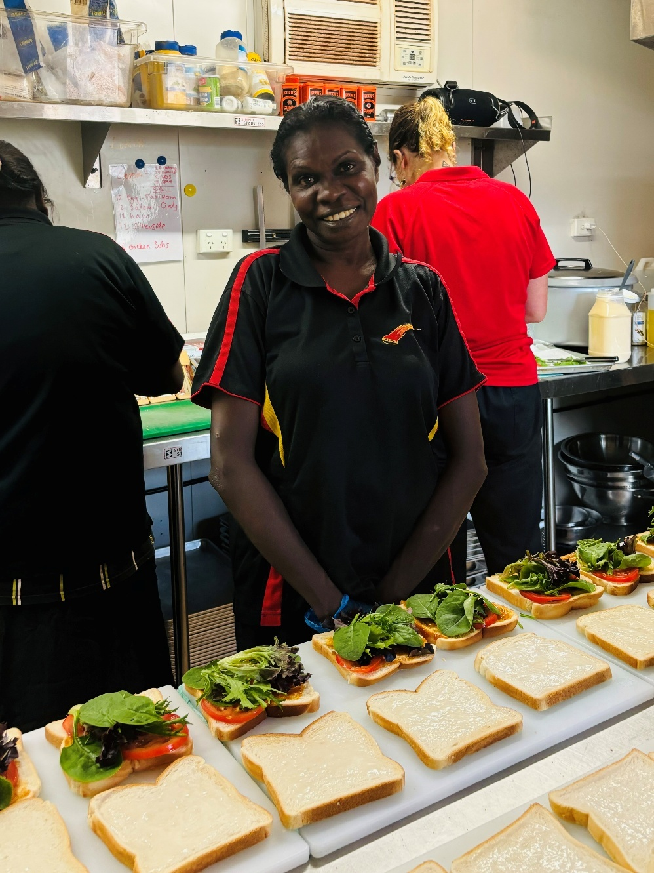
Miyalk Kitchen

Miyalk Kitchen
Arnhem Land Progress Association
In the remote Northern Territory community of Galiwin’ku, Beverly Bayumbi Dhurrkay, a Djambarrpunyngu woman, is employed in the Miyalk Kitchen to prepare lunches and dinners for NDIS participants.
The Miyalk Kitchen was established by the local Community Development Program (CDP) provider the Arnhem Land Progress Association and is funded through the Australian Government’s CDP Trial Projects.
“We help make NDIS meals and I like working here in this kitchen,” says Beverly. “I think they really enjoy and love what we cook for them.” While creating employment opportunities for Galiwin’ku CDP participants like Beverly, this project also enables people with disability to access more culturally safe supports.
Building local workforces, especially in remote areas with thin markets, ensures that people with disability can access supports that meet their needs.


Education and Learning
Outcome: People with disability achieve their
full potential through education and learning

Policy priorities
- Children with disability can access and participate in high-quality early childhood education and care.
- Build capability in the delivery of inclusive education to improve educational outcomes for school students with disability.
- Improve pathways and accessibility to further education and training for people with disability.
- People with disability have increased opportunities to participate in accessible and inclusive lifelong learning.
The Education and Learning Outcome Area underscores Australia’s commitment to ensuring that people with disability are empowered to reach their full potential through equitable access to education at every stage of life. This section highlights our policy priorities for Education and Learning, which are vital for addressing barriers and fostering inclusive environments where all students can thrive.

In 2022, the Australian Bureau of Statistics found that 946,300 (12.1%) children and young people had disability.
This is up from 8.3% in 2018.

People with disability and their representative organisations acknowledge some encouraging developments in the Education and Learning Outcome Area, such as steps toward more inclusive education and improvements in Year 12 completion rates among students with disability.
However, concerns remain about the slow pace of transformation toward a national coordinated roadmap to inclusive education and away from segregated education, and persistent high rates of bullying, exclusion, and restrictive practices. People with disability and their representative organisations have called for a more coordinated, whole-of-government approach, and the development of a comprehensive inclusive education TAP with specific indicators for children and young people with disability.

People with disability in Australia are still less likely than their peers to complete secondary schooling or gain post-school qualifications. Students with disability continue to report barriers to participation, with ongoing challenges in accessibility, reasonable adjustments, and inclusive practices.

There are still high rates of bullying, segregation, discrimination and restrictive practices against children and young people with disability in education settings at all levels.
— Disability Representative Organisation
All governments share a vision for more accessible and inclusive education for students with disability and have initiated a suite of reforms to support this. For example, the Australian Government has released information resources for education providers and educators to help them understand and carry out their legal and professional obligations to students with disability. This includes advice on consultation and setting up reasonable adjustments.
In addition, the Australian Government is providing funding for evidence-based teaching and targeted and intensive supports, such as small-group or catch-up tutoring, as part of the Better and Fairer Schools Agreement 2025-2034 and the Better and Fairer Schools Agreement – Full and Fair Funding 2025–2034 (collectively known as the BFSA). The Australian Government, with states and territories, will also consider a new national measure of access, participation and outcomes for students with disability to better understand education experience and outcomes under the BFSA. The BFSA also commits all parties to a future review of the Schooling Resource Standard base and loadings methodology (including the student with disability loading) to ensure it remains a relevant tool, including consideration of possible changes. Students with disability are identified as a priority equity cohort under the BFSA. In vocational education, resources are being developed to help Registered Training Organisations better support students with disability.
State and territory governments are also advancing inclusion. The ACT has launched its Inclusive Education Strategy, while South Australia expanded its Transition Program, connecting students with disability to tailored career pathways. The Northern Territory’s Transition from School team has supported over 185 students with individual transition plans and provided work experience placements, with a significant number securing employment. Victoria’s Disability Inclusion initiative now supports over 1,500 schools, and Tasmania continues to allocate resources to ensure both physical and educational accessibility.
There have been efforts to make
education more inclusive. This can be seen in improvements to
high school completion rates, as well as participation rates in vocational education and training and tertiary education.
— Australia’s Disability Strategy Advisory Council

Collectively, these initiatives are building more inclusive learning environments and reducing barriers to access and participation, helping ensure that people with disability are welcomed, supported, and given equal opportunities to excel across Australia’s education systems.



Education and Learning
Education and Learning data, 2021 and 2023/24

Proportion of children enrolled in a preschool program in the year before full-time schooling who have disability | 6.2%  (2021) |  | 7.4%  (2024)
Proportion of undergraduate students that were people with disability | 10%  (2021) |  | 13%  (2023)
Proportion of University students with disability who complete their qualification | 54.9%  (2021) |  | 55.3%  (2023)
Proportion of VET students that were people with disability | 4.4%  (2021) |  | 3.9%  (2023)
Proportion of VET students with disability who complete their qualification | 40%  (2021) |  | 42%  (2023)

Schooling resource to support First Nations students with disability and their families
Australian Government
In January 2025, a resource was released to help First Nations school students with disability and their families understand and exercise their rights under the Disability Standards for Education 2005. Our right to learn and play was co-designed by and for young First Nations people with disability, with the help of First Peoples Disability Network Australia and Children and Young People with Disability Australia. It talks about students’ rights and what schools must do to support all students to join in and learn. Stakeholders have praised the collaborative development of the resource and have been keen to help get the resource to First Nations students and their families. An Auslan version is also available on the Australian Government Department of Education website.

Vocational education and training
Australian Government
The Australian Government Department of Employment and Workplace Relations engaged the Australian Disability Clearinghouse on Education and Training to create resources that help training organisations better support students with disability in VET. These resources, expected to be available by the end of 2025, will give practical advice and examples to help training providers understand their responsibilities under the Disability Standards for Education 2005. Topics include how to offer support for students with or without formal evidence of disability, how to make training and assessment more inclusive, and how to design courses that do not unfairly exclude students with disability.

ACT Inclusive Education Strategy
Australian Capital Territory Government
The ACT Inclusive Education Strategy 2024–2034 (the strategy) and First Action Plan 2024–2026 were launched in December 2023 and are part of the ACT’s Future of Education strategy. The development of the strategy and First Action Plan involved significant engagement with stakeholders over a 2-year period, outlined in its Community Conversation Summary Report.
The strategy and First Action Plan aim to deliver greater inclusion for students with disability across all ACT public schools by making sure schools have the support they need to meet the needs of all learners. The First Action Plan outlines tangible actions which intend to strengthen and embed inclusive practices across the ACT public school system. The ACT Government’s vision is that every child and young person is welcomed, valued and can access quality education designed to meet their needs at their local ACT public school. This means that all students can learn and participate in education on the same basis as their peers, and that the views of students and their families are considered in designing learning options that meet their needs.

Career education and pathways
South Australian Government
Through the Career Education and Pathways Strategy, the South Australian Government is taking a contemporary whole school approach to career education, ensuring each secondary school has a career education and pathways plan that is inclusive of all students. Secondary schools have access to a Pathways Advisor or Disability Transition Advisor that provides advice, guidance and support to the school to embed career education, develop pathway programs, and engage with industry.

More action in South Australia:
TAFE SA has made significant progress in creating an inclusive learning environment for students with disability.
The Inclusive Education Roadmap and Framework embeds Universal Design for Learning principles across all courses and teaching practices.

In 2024, as an initiative within the Career Education and Pathways Strategy, the South Australian Department for Education expanded the Transition Program for students with disability. This Transition Program provides students with disability tailored career education and connects students to the essential services needed to support a successful transition from school to a pathway of meaningful employment, further education or training.
The Transition Program connects students, their parents/caregivers, industry stakeholders, and the community through a career education program.

Digital learning
Queensland Government
The Queensland Government is committed to bridging the digital divide through its Digital Learning and Support (DLS) website.
The DLS website provides a centralised platform offering easy access to digital inclusion programs and resources.
It is designed to help Queenslanders stay digitally connected by providing training, support, online tools, and short courses aimed at improving digital skills and confidence.

Transition from school
Northern Territory Government
The Northern Territory Department of Education and Training continues to improve transitional support for students with disability, including transition out of school, in partnership with community organisations and industry. The Transition from School team works with schools across the Northern Territory. During 2023 and 2024, the Transition from School team supported students through the development of 185 new and reviewed individual transition plans (ITP). Seventy students have been allocated to the Transition from School team for the development of new and reviewed ITPs in 2025. The team also mentors and upskills key school staff in the development of individual transition planning for students with disability in their school.
More action in the Northern Territory:
Northern Territory schools and students continue to receive support to complete the Northern Territory Certificate of Education and Training (NTCET) through the modified NTCET pathway.
Modified subjects allow for reasonable adjustments to the curriculum and assessments.
Students can also earn credits towards their NTCET through transitional work experience programs and the flexible options offered by the NTCET.

In 2024, 16 students from the Darwin region participated in the Transition from School Supported Work Experience (SWE) program. The SWE program offers supervised learning opportunities for students to develop broad employability skills, including proper workplace behaviour, attitudes, and foundational capabilities essential for future employment success. The work experience placements required students to attend the host work site one day per week for a semester. Seven students successfully secured employment with their host SWE employers upon completion of their placement.
School staff continue to receive professional development training through programs such as Understanding and Supporting Behaviour, Safe and Supportive De-escalation of Behaviour, Introduction to Autism, and Attachment and Trauma. In 2024, a total of 782 school staff participated in training to support the inclusion and engagement of diverse learners.

Inclusive education
Victorian Government
More action in Victoria:
The Victorian Pathways Certificate introduced in 2023 provides a supportive pathway for students not able to participate in the Victorian Certificate of Education due to disrupted education, social and emotional wellbeing needs or disability. The pathway offers student support, alternative assessment options and an enriched curriculum.
The 2023–24 Victorian State Budget invested in the Gordon’s Centre of Excellence in Disability Inclusion. The Centre aims to drive systemic change, promoting inclusive education, and shaping a more accessible TAFE network statewide.

Disability Inclusion is the largest investment in disability support in Victorian government schools. Rolled out from 2021 to 2025 it features a strengths-based funding and support model for students with disability and workforce capability-building initiatives.
Key features of Disability Inclusion include:
- the new strengths-based Disability Inclusion Profile
- a facilitator workforce to administer the profile in schools statewide
- new school-level and student-level funding allocations.
More than 1,500 schools have transitioned to Disability Inclusion, with over 17,000 profile meetings completed as of June 2025.
Other key initiatives include the Inclusion Outreach Coaching program—now working with over 400 mainstream schools—and the Diverse Learners Hub, which offers evidence-based resources and coaching for schools by a regional workforce to support students who have characteristics associated with Autism, ADHD and learning difficulties, such as dyslexia and dyscalculia. Both continue to improve staff capability and inclusive practices, with positive impacts on student learning and wellbeing statewide.

Driving inclusive education
New South Wales Government
The NSW Department of Education continues to lead in fostering inclusive education and amplifying student voices. Through its support of the Minister for Education and Early Learning’s Student Council (DOVES), the department ensures students are directly shaping education policy. The establishment of the DOVES Disability Subcommittee is a standout achievement, capturing the lived experiences of students with disability and embedding their perspectives into decision-making.
More action in New South Wales:
In September 2023, the NSW Education launched its Diversity, Inclusion and Belonging Strategy 2023–2026, a bold commitment to celebrating workforce diversity and fostering a culture where every staff member feels valued, represented, and empowered to perform at their best.

The NSW Inclusive Education Policy for students with disability clearly defines roles and responsibilities for inclusive education delivery and reinforces the rights of students with disability and their families. A suite of practice resources is supporting schools in creating inclusive learning environments.
Building on the success of the Inclusive Practice Hub, the department has released a suite of new resources co-designed with students with disability, their families, educators, allied health professionals, and experts. These tools are being actively promoted across the system, equipping staff with practical strategies to create inclusive learning environments.

Education resourcing
Tasmanian Government
The Tasmanian Department for Education, Children and Young People (DECYP) is committed to providing high-quality inclusive education, ensuring all students have access to and participate in their learning in a way that meets their needs.
More action in Tasmania:
In 2020, DECYP implemented the Educational Adjustments Disability Funding Model.
This model has provided additional resources to schools to assist them in making educational adjustments required for students with disability.
In 2023, a review of the Model made 12 recommendations to ensure the Model remains responsive to the needs of students with disability.
In response, DECYP has undertaken a range of actions to improve awareness and capability to support students with disability within school contexts, including improved guidance materials.

The Tasmanian Government education system is based on a premise that all students with disability are welcome to enrol in their local government school. Students with disability who wish to enrol in one of the State’s 3 Support Schools can apply through an application process.
In 2025, DECYP undertook a mailout to all educational sites promoting resources to help families and educators understand their rights and obligations for students with disability. These resources were created by Children and Young People with Disability Australia and published by the Australian Government, and include Advocating for your child: The Early Years and Working Together: Moving through secondary school.
DECYP continues to implement programs and processes to ensure that resources are allocated and opportunities provided to address diverse needs of all children and young people. This includes the Disability Access Minor Works program for school sites to ensure physical accessibility, as well as other programs and initiatives to ensure other educational adjustments are considered and implemented to enable access and participation in education.

School of Special Educational Needs: Disability
Western Australian Government
The WA Government Department of Education’s School of Special Educational Needs: Disability strengthens opportunities for inclusion through the implementation of research and evidence-based practices, and improvement of outcomes for students with disability to participate on the same basis as their peers.
To build staff capability to support students with disability, public schools in WA have access to professional support and a range of professional learning and resources. The School of Special Educational Needs: Disability builds the capacity of public schools to ensure students with disability can access the curriculum on the same basis as their peers.
This included the Key Support Teacher (KST): Autism program, that delivered a targeted coaching program to teachers in regional areas of WA about strategies to effectively address the diverse needs of Autistic children. Recognising that learning outcomes for children with disability can be adversely impacted in regional or remote settings:
- In 2023 the KST: Autism program was delivered to 12 schools in the Pilbara region.
- In 2024 the KST: Autism program was delivered to 12 schools in the Wheatbelt region.
All professional learning developed by the School of Special Education Needs: Disability goes through a thorough consultation process, including student voice, subject matter experts and community feedback.


Health and Wellbeing
Outcome: People with disability attain the
highest possible health and wellbeing
outcomes throughout their lives

Policy priorities
- All health service providers have the capabilities to meet the needs of people with disability.
- Prevention and early intervention health services are timely, comprehensive, appropriate and effective to support better overall health and wellbeing.
- Mental health supports and services are appropriate, effective and accessible for people with disability.
- Disaster preparedness, risk management plans and public emergency responses are inclusive of people with disability, and support their physical and mental health, and wellbeing.

The Health and Wellbeing Outcome Area highlights our commitment to ensuring people with disability achieve the highest standards of health throughout their lives. This Outcome Area reflects the experiences of people with disability, who have historically faced barriers to quality healthcare, leading to significant health disparities compared to people without disability.
People with disability and their representative organisations acknowledge that the Health and Wellbeing Outcome Area has seen some constructive developments, such as the National Aboriginal and Torres Strait Islander Health Plan and growth in Indigenous health workforce numbers, alongside the expansion of telehealth services which has notably increased access for people in regional and remote communities. However, they also raise persistent concerns about slow progress in improving mainstream health systems, disability awareness and attitudes of health workers, the need for culturally safe health settings, and more disability health services.
While there are improvements in reported data, such as with healthcare and hospitals, this does not necessarily reflect the lived experience of all people with disability.
— Australia’s Disability Strategy Advisory Council
Our policy priorities are particularly important given people with disability are more likely to experience poorer health outcomes, higher rates of chronic conditions, and lower rates of preventive health service use than people without disability. For example, 68% of adults with disability rated their health as good or better, compared to 95% of people without disability. Research also reveals that people with disability encounter barriers such as inaccessible services, lack of provider knowledge and negative attitudes, compounding these health inequities.
In response, governments and organisations have implemented a range of initiatives. The Australian Government have released the Intellectual Disability Health Capability Framework and the National Roadmap to Improve the Health and Mental Health of Autistic People 2025–2035, both developed in close collaboration with people with disability, Autistic people, families and sector stakeholders. In the states and territories, the ACT Disability Health Strategy aims to ensure equitable access to healthcare, while Tasmania’s Disability Health Strategy is working to ensure access to the right care, in the right place, at the right time.

There are about 450,000 people with intellectual disability in Australia.
Compared with the general population, people with intellectual disability have:
- more than twice the rate of avoidable deaths
- twice the rate of emergency department and hospital admissions
- substantially higher rates of physical and mental health conditions
- significantly lower rates of preventive healthcare.

On the ground, programs such as accessible cancer screening in South Australia, and outreach services for early intervention in the Northern Territory, are improving both access and quality of care.
A key focus under the Health and Wellbeing Outcome Area is preparing and responding to emergencies, and ensuring these responses are inclusive of people with disability. Preparing for and responding to emergencies is essential to protect lives and support recovery—especially for people with disability whose needs are often overlooked—as Australia faces a growing number of disasters driven by climate change. The new Disability Inclusive Emergency Management Toolkit and preparedness projects across jurisdictions ensure people with disability are considered in all stages of disaster responses.
Collectively, these activities reflect a whole-of-government approach to addressing the health and wellbeing needs of people with disability, supported by data, research, and strong collaboration with people with disability.
Health and Wellbeing

People with disability who are satisfied with the quality of care provided by community allied health care sector | 89%  (2024)
  People with disability who accessed preventive and early intervention health care services without difficulty in the last 12 month | 66%  (2024)
  People with disability reporting satisfaction in the accessibility of emergency, disaster preparedness and response information and services | 86%  (2024)

Curriculum development in intellectual disability health
Australian Government
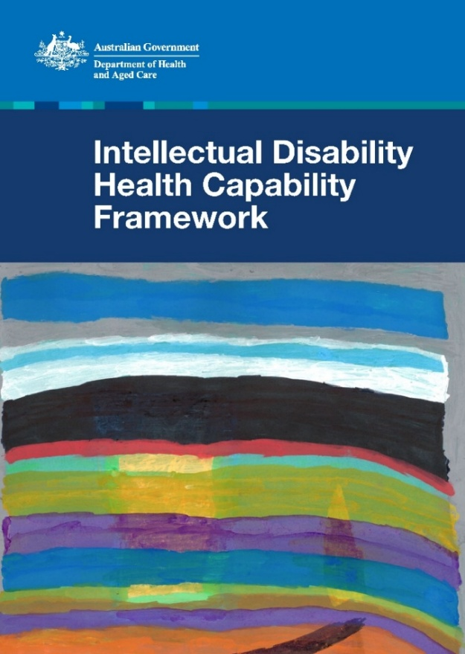
As a priority action under the National Roadmap for Improving the Health of People with Intellectual Disability, the Australian Government published the Intellectual Disability Health Capability Framework (the Framework) in April 2024. The Framework outlines key capabilities, learning outcomes and guidance to support universities and accreditation authorities to improve health education and accreditation standards for future health professionals. It aims to equip health students with the right skills, knowledge and attitudes to provide quality healthcare for people with intellectual disability.
The Framework was developed in collaboration with people with intellectual disability, their families, supporters, carers, and education and accreditation providers. People with intellectual disability provided input on the Framework’s content and design, and consultations included an Easy Read consultation paper for people with intellectual disability.
Intellectual Disability Health
Capability Framework
In May 2025, the Government published a suite of education resources to support health educators to embed core capabilities of the Framework into their course curriculum. Educators can use the resources to teach students studying health-related disciplines about intellectual disability health. The resources include case studies, lecture plans, tutorial activities and more. The resources can be adapted to suit different health professions.

National Centre of Excellence in Intellectual Disability Health
Australian Government
Opening in October 2023, the National Centre of Excellence in Intellectual Disability Health (National Centre) is an important step in improving the health of people with intellectual disability. The National Centre brings together experts, resources and research on intellectual disability healthcare.
In the October 2022 Budget, the Australian Government allocated $15.9 million for a total commitment of $23.9 million over 4 years from 2022–23 for the National Centre. Funding will continue beyond those 4 years. After an open competitive grant process in early 2023, grant funding was award to a group of 9 organisations led by the University of NSW.
The work of the National Centre includes:
- improving the capability of health services to meet the needs of people with intellectual disability
- resources and information to improve health care for people with intellectual disability
- conducting research, identifying research gaps and helping train researchers.

Health strategies

Australian Government
The National Roadmap for Improving the Health of People with Intellectual Disability aims to address serious health inequities faced by people with intellectual disability. The Australian Government has invested a total of $47 million, to date, to support priority actions under the Roadmap. The Roadmap is an Associated Plan of the Strategy.
The Australian Government released the National Roadmap to Improve the Health and Mental Health of Autistic People 2025–2035 (Autism Health Roadmap) on 25 February 2025. The Autism Health Roadmap aims to address the serious health inequities faced by Autistic people. Its short, medium and long-term actions outline how high-quality health care can be delivered which will enable Autistic people to lead healthy and fulfilling lives.
The Autism Health Roadmap was developed in close collaboration with Autistic people and members of the Autistic and autism community. This was done through the Autism Health Roadmap Working Group, co-design consultations with key stakeholder groups, and a public consultation process.
The Autism Health Roadmap forms the fourth pillar of Australia’s National Autism Strategy 2025–2031, which sets out the broader vision for a safe and inclusive society for all Autistic people.

Australian Capital Territory Government
In December 2023, the ACT Government launched the ACT Disability Health Strategy 2024–2033 and ACT Disability Health Strategy 2024–2033: First Action Plan 2024–2026.

More action in the ACT:
Canberra Health Services continue to implement their Disability Action and Inclusion Plan (DAIP). The DAIP was launched in 2022, with the aim of improving the experiences and outcomes of people with disability, their families, and carers. The DAIP has an Implementation Steering Group made up of both staff and consumers with disability, and representatives from Canberra Health Services.
Canberra Health Services are embedding accessibility best practices into their facilities and communications.

The Disability Health Strategy is a 10-year plan that aims to make sure people with disability have equitable and appropriate access to healthcare in the ACT.
The First Action Plan is a 3-year plan which sets out actions and activities to meet the goals, principles, and focus areas in the Disability Health Strategy.
The Disability Health Strategy and First Action Plan were developed in collaboration with the Office for Disability and the ACT Disability Health Strategy Steering Committee.
The ACT Disability Health Strategy builds on previous work, including the ACT Council of Social Service 2019 report, Imagining Better – Reflections on access, choice and control in ACT health services for people with disability, and the Women’s Health Matters 2022 report, ‘I have to ask to be included…’, which documents the views of ACT women with disability about their health and health needs, access to services, supports and information, and barriers to maintaining health.

Tasmanian Government
The development of the Tasmanian Department of Health’s Disability Health Strategy (released in February 2025) included community consultation with a broad range of groups and individuals across 2023 and 2024. A key theme throughout the consultation was the quality and accessibility of Tasmania’s health services. In progressing the strategy, the department is working to ensure that all Tasmanians, including those with disability, have access to the right care, in the right place, at the right time.
Key examples include providing a specialist pathway to support people who are experiencing cognitive difficulties (such as changes in memory or problems with language, attention, personality and behaviour) and providing dental assessment and treatment for patients with complex medical needs including people with disability.

South Australian Government
In 2024, the South Australian Government Department of Health and Wellbeing (DHW) launched its Diversity, Equity and Inclusion Strategy 2024–2026. This strategy builds on the broader South Australian public sector plans, Diversity, Equity and Inclusion Strategy 2023–2026 and the Anti-Racism Strategy 2023–2028.
The DHW Diversity, Equity and Inclusion Strategy recognises that people will have different needs based on their different intersecting identities and experiences. The strategy aims to embed inclusive practices across the department, directly contributing to improved outcomes for people with disability. The strategy does this by addressing systemic barriers and promoting equity in both workforce and service delivery by centring diversity, equity and inclusion, empowering all voices, reflecting the community they serve and advancing disability employment.

Accessible screening
South Australian Government
Preventive Health SA worked in partnership with Community Accommodation and Respite Agency to improve access to cancer screening for people with disability, training 24 disability support workers as ‘screening champions.’ These champions have been equipped with the knowledge to guide clients through the cancer screening process and support informed consent for cervical and bowel cancer screenings.
More action in South Australia:
South Australia is working to improve autism assessments.
In 2024, the South Australian Office for Autism engage Solasta to expand autism assessment and diagnostic services for children.
The South Australian Autism Assessment and Diagnosis Advisory Group was established by the Premier in November 2024. The group brings together representatives from key assessment providers and relevant government agencies. Its focus is on identifying barriers to accessing autism assessments, from referral through to the assessment experience. The group is expected to deliver its first set of recommendations in late 2025.

Preventive Health SA also partnered with SHINE SA to provide better access to cervical screening for people with limited mobility or those living in regional or remote areas. This program provides free cervical screening to priority groups, including people with disability, either in-person or via self-collection following a telehealth consult and postage of a test kit to the person’s home.

Early identification and intervention
Northern Territory Government
NT Health are committed to delivering the Healthy Under 5 Kids Partnering with Families Program to all families with children up to 5 years of age. This program includes anthropometric assessment, developmental screening, anticipatory guidance and health promotion education for parents and provides a crucial starting point for identification of developmental delay or disability.
More action in the Northern Territory:
In 2025, NT Health, in partnership with Correctional Services, commenced work to better support clients of Correctional Services with identification and access to appropriate disability support both within custodial settings and on transition to the community.

In addition, early childhood intervention programs have been expanded across the Northern Territory. This has seen more timely access to services which have included ‘drop-in clinics’, open to children and their families in urban settings. There has also been increased services and community engagement in remote communities where historically there has been poor access and long wait times to receive support. These outreach services, planned and delivered in partnership with local health, education, and disability services also provide links to appropriate assessment and advocacy programs.

Accessible healthcare
New South Wales Government
The NSW Government is delivering transformative change in healthcare accessibility and inclusion through strategic partnerships, infrastructure innovation, and community engagement.
More action in New South Wales:
In 2024, Sydney Local Health District updated its disability accessibility audit tool, with all inpatient and community health facilities conducting annual audits.
These reviews, informed by consultations with people with disability and building experts, drive ongoing improvements and ensure that facilities meet the needs of all users.

Partnerships between NSW Health and organisations such as Get Skilled Access have led to policy reviews, in-person and online training for hospital staff, and the creation of modules aimed at increasing disability confidence among health professionals.
Physical access to healthcare remains a key priority. NSW has invested in implementing accessibility standards in new capital developments. Recent updates to the Wayfinding for Healthcare Facilities and the Design Guide for Health are shaping inclusive infrastructure across the state. Collaboration with universal design specialists, design teams, and end users ensures that new facilities reflect the principles of the Disability Discrimination Act.
Capacity building extends beyond infrastructure to encompass broader health literacy and trauma-informed care. The Health Literacy Hub is equipping the entire NSW Health system with evidence-based tools and resources to create accessible health information for patients, families, and carers.
In mental health care, South Eastern Sydney Local Health District’s Mental Health Service has recruited 6 paid consumers and carers with lived experience of psychosocial disability to co-design the district’s Clinical Services Plan for the next decade.
Furthermore, targeted funding and training initiatives are addressing access to sexual assault services. This includes:
- Funding Survivors and Mates Support Network with $750,000 (2022–2024) to strengthen trauma-informed services for adult male survivors of child sexual abuse with disability.
- Development of the Access Strategy for People with Disability by NSW Health’s Sexual Assault Services and New Street Services, providing a robust framework to improve service access for people with disability affected by sexual violence or harmful sexual behaviours.

Outreach Neuro-Clinics project
Western Australian Government
The WA Government funded Huntington’s Australia to pilot Outreach Neuro-Clinics in the Kimberley region, providing educational and medical support to remote communities. The project has:
- delivered multi-disciplinary, outreach clinics in 4 remote communities
- mapped at-risk individuals in the Kimberley
- provided education sessions for service providers and support workers
- partnered with Lyfe Languages to develop animated videos about medical terms and Huntington’s Disease.


The Outreach Neuro-Clinics were initiated only after community-led conversations determined when the clinics should be held and what specialist services were needed. The program has led to improved outcomes for Aboriginal people with neurological conditions in areas of the WA with limited access to adequate medical services.

Foetal Alcohol Spectrum Disorder
Australian Government
Foetal Alcohol Spectrum Disorder (FASD) is the leading non-genetic disability in Australia. The prevalence is expected to be higher in certain vulnerable populations, including in youth detention, out-of-home care, and some remote First Nations communities.
The Disability Royal Commission heard about the devastating impact of alcohol use during pregnancy for First Nations communities, particularly children being born with FASD. The National Indigenous Australians Agency currently funds 2 FASD related activities under the Indigenous Advancement Strategy:
- Marninwarntikura Fitzroy Women’s Resource Centre Aboriginal Corporation has developed online resources, delivered mental health first aid training, and run a therapeutic camp in Broome supporting families with complex needs to build knowledge, understanding and trauma-informed capacity amongst educators, families and services providers.
- Central Australian Aboriginal Congress, through the Safe and Sober Alcohol and Other Drugs Program, is providing cognitive evaluation, support and education on how to prevent and manage different causes of brain dysfunction, including early alcohol exposure. Additionally, they are delivering a child and youth program that focuses more specifically on FASD diagnosis and management.
In Alice Springs, the Central Australian Aboriginal Congress Aboriginal Corporation (Congress) provides cognitive evaluation and support to people living with the impacts of alcohol and other drugs on brain function via their Safe and Sober Alcohol and Other Drugs treatment program. Neuropsychological assessments are being provided through a senior neuropsychologist. The service also provides education on how to prevent and manage different causes of brain dysfunction, including early alcohol exposure. They recently hosted a successful brain awareness event, promoting brain health and connecting community members with experts and lived experience speakers. This will be a yearly event moving forward. Congress also has a child and youth program that focuses more specifically on FASD diagnosis and management.
Marninwarntikura Women’s Resource Centre in the Kimberley region of WA, is the provider for the FASD Marulu Strategy (Marulu means ‘precious worth nurturing’ in Bunaba Language). These FASD programs focus on building trauma-informed capacity among educators, families, and service providers. Highlights over the last 12 months include mental health first aid training, a therapeutic camp in Broome supporting families with complex needs, and the development of online resources to equip professionals with knowledge and understanding, so they can respond more effectively to vulnerable children.
- The Bigiswun Kid Project has been awarded the 2025 Tarn-doon-nonin Award for Outstanding First Nations Health Research.
- The Marurra U team have been building the capacity of teachers, families and Aboriginal educators in Kulkarriya, Yakanarra, Yiyili and Fitzroy Valley District High School. These targeted schools are learning about trauma, receiving coaching to enable them to respond to ‘real life' challenges.
- The Marurra U Camp, held in Broome, worked intensively with families, allied health professionals from Royal Far West Allied Health and community navigators/family support workers—building relationships, collecting evidence, modelling therapeutic ways of working with young people with very complex needs and with parents/carers to build knowledge and understanding.

Disability Inclusive Emergency Management Toolkit
Australian Government
The Australian Government National Emergency Management Agency (NEMA) launched the Disability Inclusive Emergency Management (DIEM) Toolkit in 2024 to address the increase risk that people with disability face during disasters. The Toolkit has been co-designed with people with disability, all levels of government, and the emergency, disability, and community sectors.
During disasters, people with disability face a higher risk of death, injury and neglect.

The DIEM Toolkit is a series of documents that support emergency planners, governments, and disability and community organisations to ensure disability inclusion is part of their emergency preparedness planning.
The Toolkit guides organisations and emergency planners through assessing their capability in disability inclusion and building their maturity to enhance their practices. The Toolkit has 4 components:
- The Overview provides essential background information, and explains who the Toolkit is for and how its components work together to facilitate self-assessment, encourage collaboration and guide tailored action planning.
- The Principles and Practical Action Guide translates 7 foundational principles into actionable steps for emergency planners.
- The Organisational Emergency Preparedness Profile enables disability and community organisations to self-assess and strengthen their emergency readiness, ensuring continuity of support and safeguarding rights.
- The Resource Map shares good practice resources for disability inclusive emergency management developed in Australia.
Essentially, the DIEM Toolkit transforms policy into practice, ensuring that emergency management systems uphold the rights and safety of people with disability—not just in theory, but in every stage of action.
NEMA has collaborated with the University of Sydney to develop eLearning modules to support implementation of the Toolkit. These modules are free and self-paced, and each module includes interactive activities, videos and case studies.
NEMA and The University of Sydney team are also working with state and territory governments to deliver 37 Disability Inclusive Emergency Planning forums (5 per jurisdiction with 2 in ACT) across 2025. These forums will build capability of emergency planners to utilise the DIEM Toolkit.

Emergency preparedness
Tasmanian Government
In 2024, Tasmania introduced a new People with Disability Emergency Preparedness Project. This is a 3-year initiative running through to 2026, with the aim of improving emergency preparedness, response and recovery outcomes for people with disability, and to embed the Person-Centred Emergency Preparedness (P-CEP) approach into planning at the individual, provider and systems levels.
The project delivers one-on-one and small group P-CEP planning sessions for people with disability, emergency planning workshops for disability support providers, and tailored local hazard information. It has also produced a redesigned SES Home Emergency Plan using Easy English and visual elements.
The project directly engages with people with disability through targeted community activities. People with disability are also actively involved in the project’s governance and delivery. While time-limited, the project is designed to inform long-term emergency planning policy and practice across sectors.

Queensland Centre of Excellence in Intellectual and Developmental Disability Mental Health
Queensland Government
Queensland Health has supported the establishment of the Queensland Centre of Excellence in Intellectual and Developmental Disability Mental Health (QCE IDD MH) delivered by Mater Research Limited. The QCE IDD MH provides clinical advice to 12 Intellectual and Developmental Disability Mental Health teams being rolled out across Queensland Health’s Hospital and Health Services from 2024–25 to 2026–27. It also provides education, links to training and capacity building to the Hospital and Health Services and education to the broader health and service system as capacity allows, and research.
The Centre of Excellence is focused on improving the health and wellbeing of adults with intellectual and developmental disabilities. It reflects Queensland’s commitment to building inclusive, responsive, and evidence-informed mental health care systems that uphold the rights and wellbeing of people with disability.


Community Attitudes
Outcome: Community attitudes support
equality, inclusion and participation in
society for people with disability

Policy priorities
- Employers value the contribution people with disability make to the workforce and recognise the benefits of employing people with disability.
- Key professional workforces are able to confidently and positively respond to people with disability.
- Increase representation of people with disability in leadership roles.
- Improved community attitudes to positively impact on Policy Priorities under the Strategy.
Community attitudes are crucial in shaping a community where people with disability are valued, included, and actively participate in all aspects of life. Australia’s Disability Strategy recognises this through its Community Attitudes policy priorities that seek to foster equality, inclusion, and opportunity for people with disability. These priorities emphasise the need for employers to value employees with disability, for professional workforces to respond positively and confidently, and for increased representation of people with disability in leadership roles.
While people with disability and their representative organisations have welcomed the inclusion of Community Attitudes as an Outcome Area of the Strategy, they have expressed concern that efforts to date have largely centred on public awareness campaigns without sufficiently addressing deeper systemic biases, and the intersection of other forms of disadvantage and disability, particularly for First Nations people and those from culturally and linguistically diverse backgrounds.
During the 2024 Review of the Strategy, there was strong support for improving community attitudes and increasing disability awareness in the broader community. People and organisations told us about the importance of community attitudes and disability awareness in their communities, and how this affects all Outcome Areas of the Strategy. There was also strong support for improving community attitudes through authentic representation of people with disability in the community, in the media and the arts, and to lift awareness and visibility of the Strategy throughout the community.
Looking ahead, people with disability and their representative organisations have told us they want to see coordinated, systemic action to challenge ableism at every level, ensuring that changes in attitudes are matched by real-world improvements in accessibility, respect, and the full inclusion of people with disability across Australian society.
Governments and organisations across Australia have undertaken a range of activities to improve outcomes for people with disability by addressing community attitudes through leadership initiatives, community grant programs, promoting accessible and inclusive communication, and community facilities and infrastructure accessibility upgrades. A standout example is Bus Stop Films, a social enterprise driving change in employment and attitudes through inclusive filmmaking, achieving national impact and recognition.
In July 2024, as part of the Disability Royal Commission response, the Australian Government committed $19.6 million to establish an Inclusion and Accessibility Fund (IAF). This will support grassroots efforts to improve community attitudes towards disability and projects to increase the disability capability of key professional workforces.

Ableism refers to attitudes and behaviours that label people with disability as different, less than or inferior to people without disability, incapable of exercising choice and control and a burden on society. Ableism, like other forms of discrimination, can manifest both personally and structurally.
.

For example, the IAF is supporting the Achieve Foundation to develop evidence-based approaches to reframing the way people think and talk about disability and engage with people with disability within the community. The IAF is also supporting the Australian Council of Learned Academies (ACOLA) to apply findings from the Enhancing Disability Responsiveness of Professionals project, such as in health, education, justice and social services workforces. This builds on the Australian Government’s initial engagement of ACOLA, in 2022, to determine how to enhance training of occupations to respond to the needs of people with disability.
Collectively, these initiatives demonstrate a national commitment to changing attitudes, building capacity, and creating new opportunities for people with disability. By embedding inclusive practices and supporting leadership, employment, and representation, Australia is working towards a future where community attitudes fully support equality, inclusion, and participation.
 | 2022 | 2024
Employers value the contribution and benefits of employing people with disability | 77% | 74%
Proportion of people with disability who report feeling represented in leadership roles | 19% | 23%
Proportion of people with disability who report feeling valued and respected in their community | 54% | 53%

Community Attitudes
Community Attitudes data, 2022 and 2024

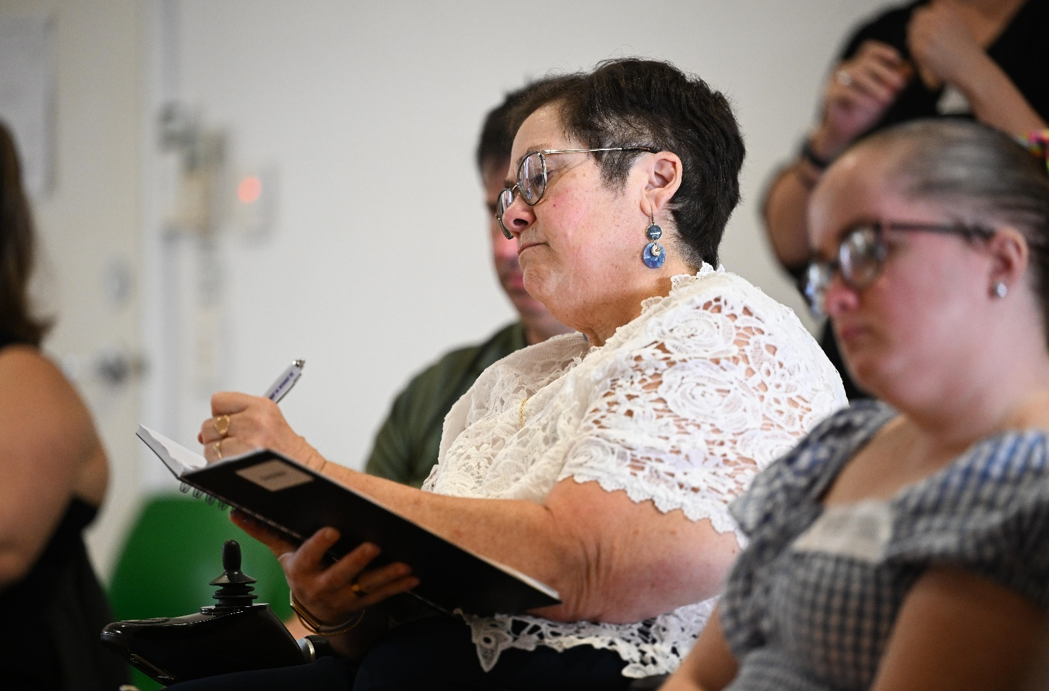
Queenslanders with Disability Network Emerging Leaders event

Emerging Leaders
Queenslanders with Disability Network
The Queenslanders with Disability Network (QDN) Emerging Leaders Program is a free, 9-month leadership development initiative designed to empower people with disability in Queensland to take leadership roles in their own lives, communities, and systems. Offered annually, the program supports up to 25 participants with diverse lived experience including those from culturally diverse, LGBTQIA+, First Nations, rural and remote backgrounds.
Running from March to November, the program combines 2 in-person workshops in Brisbane with monthly online interactive sessions. Travel and accommodation support is provided for participants living outside South East Queensland. Underpinned by QDN’s 4 pillars—Inform, Connect, Lead, Influence—it invites participants to build critical thinking, reflect on leadership theory and systems change, practice leadership techniques, engage in peer and mentor-supported learning, hold inquiring conversations, and build networks with established disability leaders and community stakeholders.
Delivered in a safe, inclusive environment, the program helps graduates develop skills to support themselves and others, influence policy and drive systemic change toward equality, rights and inclusion. Funded by the Australian Government’s ILC grant, it fosters emerging leaders to lead inclusive change in Queensland and beyond.

Grants and support for International Day of People with Disability
Australian Capital Territory Government
The ACT Government has continued to fund the Disability Inclusion Grants. These grants fund activities that remove barriers and support people with disability to have better access to participating in community life. Grants up to $20,000 are available for local clubs, groups, community organisations and small business to promote social inclusion for people with disability. In 2025, 13 projects received a total of $159,000 (excluding GST).
International Day of People with Disability (IDPwD) is a United Nations observed day held on 3 December each year. It’s a day to promote community awareness, understanding and acceptance of people with disability.

Additionally, as a part of the ACT Disability Strategy First Action Plan, on International Day of People with Disability (IDPwD) 2024, ACT Government formally handed over the management of IDPwD to people with disability in the ACT. An IDPwD Steering Committee developed a Charter to ensure Canberrans with disability are in real and practical control of the direction of future IDPwD celebrations, campaigns and events.

Autism Works in the Community Grants program
South Australian Government
Delivered by the South Australian Office for Autism, the annual Autism Works in the Community Grants provided 17 grants in 2024 to South Australian organisations to increase knowledge, understanding and belonging for Autistic people and autism communities in South Australia. A further 17 grants were awarded in 2025. This Grant Program aims to support organisations to provide contemporary facilities, equipment and opportunities to meet the needs of Autistic people and promote genuine autism inclusion in South Australia.

Inclusive language
Queensland Government
The Inclusive language and communication toolkit was launched as part of Disability Action Week (24 November to 1 December 2024) in line with the theme ‘Accessible communication: connect, include and empower.’ The toolkit is part of the implementation of Queensland’s Disability Plan 2022–2027: Together, a better Queensland and was designed to provide practical information and guidance on how to use inclusive language and communicate in an inclusive way.
The toolkit is publicly available and invites all levels of government, employers, industry, individuals, education and training providers, and communities to rethink their communication and language to remove barriers to participation, shift community attitudes and grow opportunities for inclusion.
It includes an inclusive communication guide; 4 training modules with accompanying fact sheets; tips on how to be more inclusive; and a series of 9 videos.
The toolkit was developed through a collaboration between QDN and the Department of Families, Seniors, Disability Services and Child Safety’s Disability Proud Network, which provides a platform for employees with disability.

Darwin Airport redevelopment
Northern Territory Government
The Northern Territory Disability Advisory Committee (DAC) continues to make significant strides in advocating for people with disability and focus on key issues and opportunities to drive positive change for Territorians with disability and their families.
The DAC has worked closely with the Darwin Airport Development Group, providing input and feedback on the enhancements for the Darwin International Airport redevelopment and broader airport precinct.
The newly renovated terminal includes an adult changing facility, sensory upgrades to security screening processes, and adjustments have been designed to improve the experience of all travellers with disability.
The introduction of the Hidden Disabilities Sunflower Lanyard initiative and training program enables airport staff to identify and interact confidently with people with hidden disability, better understanding their needs and requirements.
The Airport Development Group are committed to improving accessibility and ease of navigation for people with disability within its precinct and conveyed their appreciation to the DAC for the opportunity to provide a lived experience contribution to support these enhancements.

All Abilities Workforce and Sector Support
Victorian Government
The Victorian Government All Abilities Workforce and Sector Support program (2024–2027) aims to educate and upskill the sport and active recreation workforce in regional Victoria, providing more participation opportunities for people with disability. The program focus is on increasing ‘off the field’ participation in roles such as coaching, officiating and in the paid workforce in regional Victoria.
The delivery of the program includes:
- Co-design with people with disability, including a lived experience consultation group established as part of the program governance and advisory framework.
  - The lived experience co-design consultation group commenced in June 2025 with 12 members and is co-chaired by 2 Paralympian athletes.
- Increased employment and volunteering opportunities for people with disability, including 8 prioritised Inclusion Coach roles based across key locations in regional Victoria.
- Accessible communications including a web platform (currently under development) which will house online training and evidence-based resources to support sporting and active recreation organisations to embed best practice disability inclusion.
  - Significant consultation, design and development activity has been undertaken to support the creation of the Learning and Development hub with a launch expected mid-2026.
- Establishment and activation of new and existing place-based networks in regional areas to ensure local needs are understood and addressed through sustainable and innovative program delivery.
- Upskilling the existing sport and active recreation workforce to build their capability and capacity to implement disability inclusive practices in delivery of sport and recreation activities.

Disability confident health workforce
Tasmanian Government
All Tasmanian Department of Health staff are encouraged to complete the Disability Confident Workforce Training, which provides information on disability, communication, and creating inclusive and enabling environments. This training package was developed by the Australian Disability Network, in partnership with the Tasmanian Government.
The department has also partnered with Primary Health Tasmania to support the delivery of the Primary Care Enhancement Program. This Program supports health professionals in caring for people with intellectual disability, provides practical training and resources to general practitioners and other primary healthcare professionals to improve their capability in this area.

LeadAbility
Leadership WA
Supported by the WA Government, Leadership WA delivers 2 LeadAbility courses each year, comprised of 6 days of leadership development over 3 months.
A core aspect of the LeadAbility course is empowering participants to lead community change through Community Projects that support and improve the lives of people with disability.
Several of Leadership WA's LeadAbility graduates have been appointed to boards and advisory groups including the Ministerial Advisory Council on Disability, Consumer Advisory Committee, and the Board of People With disabilities WA.
During 2023–2024, LeadAbility graduate Clare Gibellini became Chair of the WA Ministerial Advisory Council on Disability and along with fellow graduate, Deggi Altangerel, presented at the United Nations 68th Session of the Commission on the Status of Women. In 2023, LeadAbility graduate Tom Monks was acknowledged as the Law Society WA’s Lawyer of the Year and became Chair of Avivo.
LeadAbility graduates receive monthly Leadership WA newsletters which promote diverse opportunities for leadership, influence and impact, including Board positions. Leadership WA have produced promotional videos highlighting the significant impact the LeadAbility course has had on graduates.

Bus Stop Films

Inclusive filmmaking
Bus Stop Films
Bus Stop Films is delivering transformative outcomes for people with disability, driving significant change in employment opportunities in the screen sector and community attitudes through inclusive filmmaking.

Employment Impact: Since 2023, the Bus Stop Employment (BSE) service expanded dramatically, supporting over 100 people with disability into more than 300 employment opportunities in the screen industry, generating BSE candidates over $250,000 in direct income. Bus Stop Films achieved groundbreaking partnerships with Netflix (Heartbreak High, The Survivors), Fremantle (This is Going to be Big), ABC (Headliners, The Assembly), with Nine on the coverage of Paralympic games and major commercial productions for brands including Bonds, Qantas and Kia. Each opportunity unlocking employment and changing attitudes to disability employment in front and behind the camera.
Bus Stop Films
Program Growth: Bus Stop Films’ Accessible Filmmaking Program expanded from 10 to 16 locations nationally with a program partnership in every capital city and several regional towns, growing from 170 to over 220 participants attending in 2025. The program is changing the lives of people with intellectual disability through capacity building, social connections, creative expression and skills development. Bus Stop Films also launched an Accessible Acting Program in partnership with Actors Centre Australia and the PLACES program focusing on camera, screenwriting and directing skills. Both programs are supported by an Australian Government Strong and Resilient Communities grant. Bus Stop Films now employs over 90 people nationally, with over 30% of staff being people with disability, cementing its position as a disability-led social enterprise.
Industry Transformation: The sold-out Driving Change: Disability Employment Summit in 2024 brought together over 250 industry participants. The inaugural event was opened by the Governor-General Sam Mostyn AC and included speakers from Hollywood and across Australia’s screen, media, disability and policy sectors. Never had the sector met to elevate and celebrate disability employment in the screen industry. The post-event Impact Report revealed that 77% of industry professionals had heard of Bus Stop Films, with 91% choosing Bus Stop Films’ services. This groundbreaking event generated practical solutions for inclusive practices and authentic representation.
Community Attitudes and Creativity: Through its programs and partnerships, Bus Stop Films has produced over 45 inclusively made film productions and reached over 1,500 people at its National Showcase Tour. Bus Stop Films’ productions have been screened across over 98 international screenings and won 15 awards, fundamentally changing perceptions about disability capability and representation in media. Finally, with the support of Screen Australia and a Building Employer Confidence Grant, in June 2025 Bus Stop Films produced Boss Cat, a fully inclusive feature film and a suite of resources to support employer confidence in the screen industry on disability employment.
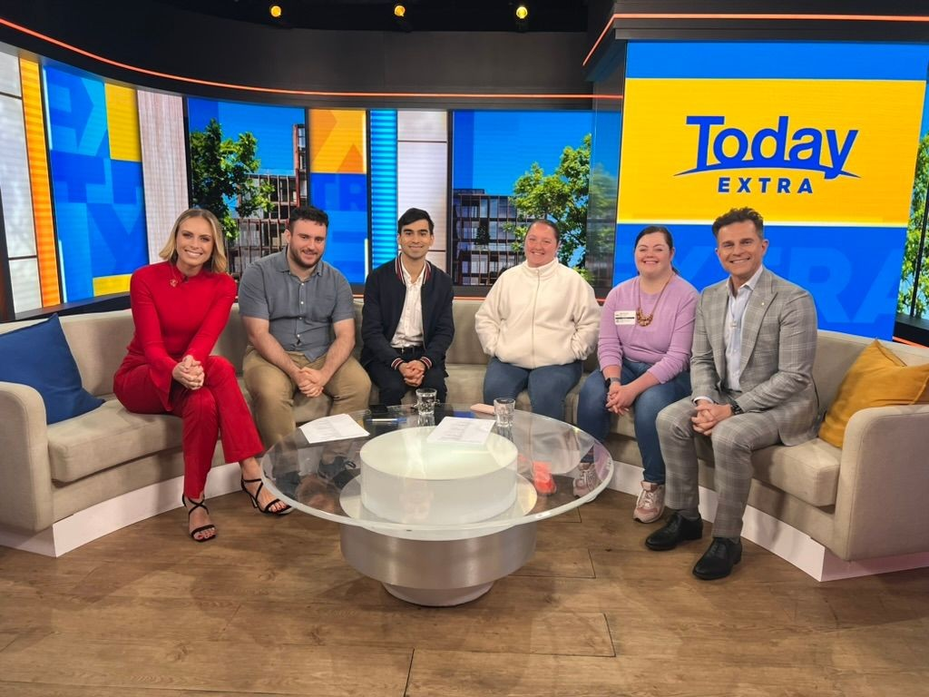
Bus Stop Films

Implementing Australia’s Disability Strategy





Strengthening Australia’s Disability Strategy through effective implementation

Governance

Evaluation and Research

Improving the Data

Outcomes Framework

Associated Plans

Targeted Action Plans
Engaging with People with Disability

Guiding Principles

Coordination
The Strategy aspires to create a nation where people with disability participate fully and equally in all facets of life. Central to realising this vision are the implementation mechanisms of the Strategy—an interconnected suite of actions that ensure the Strategy translates from aspiration to practical, measurable change. These mechanisms are the backbone of the Strategy, guiding progress, fostering accountability, and supporting continuous improvement. They are vital not only for governments and service providers, but for people with disability whose rights, experiences, and aspirations form the heart of the Strategy.
Each implementation mechanism plays a distinct role in embedding inclusion, driving reform, and ensuring that the voices of people with disability shape the direction and impact of the Strategy.
Coordination strengthens collaboration across governments and agencies, ensuring unified and coherent delivery. The Strategy’s Guiding Principles anchor all decisions in human rights and respect for diversity. Engagement mechanisms create space for lived experience and genuine co-design, while the Strategy’s TAPs and Associated Plans focus efforts on priority areas and sector-specific needs. The Outcomes Framework provides accountability through rigorous measurement, tracking progress on key indicators like employment, housing, health, education, and more. Data improvement initiatives are building a robust evidence base, making visible the diverse experiences of people with disability and informing policy response. Evaluation and research underpins continuous learning, adapting strategies to meet emerging challenges. Governance structures—such as the Strategy’s Advisory Council—strengthen oversight and transparency.
Together, they ensure the Strategy is not merely a statement of intent, but a living commitment to transformative, inclusive change for people with disability across Australia.

Coordination

Delivering on Australia’s Disability Strategy
through collaboration across government
Effective coordination is fundamental to the successful implementation of the Strategy. With wide-ranging objectives that touch every level of government and sector, the Strategy depends on seamless collaboration, communication, and alignment across jurisdictions and organisations. Coordination ensures that program and policy responses are cohesive and responsive to the real-world needs of people with disability. By strengthening partnerships and forging clear roles and responsibilities, coordination supports the delivery of improving outcomes for all people with disability across Australia.
Throughout the 2024 Review of the Strategy, people with disability and their representative organisations told us to improve coordination across all levels of government in implementing the Strategy. More recently, the Strategy’s Advisory Council have said that governments should prioritise better coordination between states and territories, including agreement on nationally consistent approaches to the Strategy’s implementation, reporting and measurement. This could be done, for example, by developing baseline levels for progress for states and territories.
The cross-government development of new TAPs is positive progress of coordinated implementation of the Strategy. However, people with disability and their representative organisations note their concerns over persistent fragmentation, inconsistent approaches, and a lack of leadership, which can result in slow progress and patchy outcomes across jurisdictions.


The strengths of the Strategy are that it is agreed to by all levels of government and it spans multiple areas of government responsibility.
—Australian Human Rights Commission
Governments and organisations have taken action to embed coordination at the heart of system-wide reform. Central to these efforts is the establishment of dedicated units and cross-government working groups—such as the Central Coordination Unit—to facilitate information sharing, policy alignment, and joint problem-solving.
Coordination mechanisms foster a whole-of-government approach, breaking down silos and enabling a strategic response to complex challenges across the disability sector. For example, the National Indigenous Australians Agency works collaboratively across Australian Government agencies to support genuine and purposeful consideration of First Nations people, and First Nations people with disability in their work.
Advisory groups, sector leaders, and people with disability have been actively involved in the Strategy’s coordination initiatives, ensuring that the Strategy remains grounded in the needs and aspirations of the disability community. Together, coordinated activities represent a robust and dynamic approach to realising the vision of the Strategy—a more inclusive, equitable, and participatory society for all Australians with disability.

Central coordination of Australia’s Disability Strategy
Australian Government
In the 2023-24 Budget, the Australian Government provided $10.2 million over 4 years (2023–24 – 2026–27) for the Central Coordination of Disability Policy (the Central Coordination Unit). The Central Coordination Unit supports Australian Government agencies to implement the Strategy, driving better outcomes for all Australians with disability. It has worked to embed the Strategy in the policies, programs and services that impact people with disability, including collaborating with:
- NEMA on development and publication of the Disability Inclusion Emergency Management Toolkit.
- Australian Electoral Commission on accessible options for people with disability who cannot vote in person or require assistance to vote at a polling location.
- Office for Impact Analysis on improving government processes to ensure decision makers have the necessary evidence at the early stages of policy development that will best support people with disability.
- Department of Infrastructure, Transport, Regional Development, Communications, Sport and the Arts to update the Disability Standards for Accessible Public Transport 2002 and, in response to the Aviation White Paper, creating new aviation-specific disability standards.
- Attorney-General’s Department to review the Disability Discrimination Act. The review will look at ways to implement recommendations from the Disability Royal Commission and make further changes to improve things for people with disability.
- Office for Sport ahead of the Brisbane 2032 Olympic and Paralympic Games to ensure they are inclusive and accessible for all athletes, staff and attendees with disability.
The Central Coordination Unit completed the Review of the Strategy following the release of the Disability Royal Commission report (released December 2024), in addition to 3 new TAPs (released January 2025).

Closing the Gap
Australian Government
Only by placing First Nations voices
at the centre through an empowered First Nations Disability Forum and redesigning systems around a Cultural Model of Inclusion can Australia transform the Strategy from a statement of intent into a driver of justice. We stand ready to work in genuine partnership to realise that future.
— Disability Representative Organisation

Under the Commonwealth Implementation Plan for Closing the Gap, the Australian Government recognises disability as a cross-cutting outcome area across the National Agreement on Closing the Gap’s Priority Reforms and socio-economic targets. The Strategy is a key mechanism to improve outcomes for First Nations people with disability, their families, carers, and communities.
The Closing the Gap Disability Sector Strengthening Plan (Disability SSP), to build the community-controlled disability sector, is a key link between Closing the Gap and the Strategy. The Australian Government works with key stakeholders, including First Peoples Disability Network, on the Disability SSP.
First Peoples Disability Network have been funded to implement the National Disability Footprint as a key action of the Disability SSP. The Disability Footprint includes 7 elements:





In July 2024, all governments accepted in principle Disability Royal Commission recommendation 9.10 to establish a First Nations Disability Forum (Forum). The Disability Royal Commission also recommended that, once established, the Forum work in partnership with governments to revise the Disability SSP (recommendation 9.11).

Capacity Building

Data and Research

Strengthening the Policy Representation Footprint
Strengthening a Culturally
Inclusive Workforce and Training
Strengthening Community Disability Rights Footprint

Evaluation

Communications Strategy
Building on feedback from a public consultation held between December 2024, February 2025, (the Department of Social Services) and September 2025 (the Department of Health, Disability and Ageing) and National Indigenous Australians Agency, in collaboration with First Peoples Disability Network and state and territory officials, are developing options for a Forum or other shared decision-making mechanism for a future decision of governments.
In 2025, the Australia Government committed funding for First Peoples Disability Network to test and implement resources that build upon the Cultural Model of Inclusion, through the Inclusion and Accessibility Fund.

ACT Disability Strategy 2024–2033
Australian Capital Territory Government
The launch of the ACT Disability Strategy 2024–2033 in 2024 represents a whole-of-government commitment to advancing the rights and meeting the needs of people with disability. This strategy outlines priorities that influence both mainstream and targeted services, supports, and infrastructure systems across the ACT.
The strategy also provides overarching framework for the suite of pre-existing interconnected disability strategies across the ACT, including the ACT Inclusive Education Strategy, the ACT Disability Health Strategy, and the ACT Disability Justice Strategy. Taken together, these strategies aim for the ACT to be a more accessible and inclusive society where people with disability can fully participate in all aspects of community life.
These strategies provide a whole-of-government response to identifying and responding to priority areas of reform across systems and settings. The strategies also assist the ACT Government to meet its obligations under the UN CRPD and drive progress against Australia’s Disability Strategy outcomes.

Australia’s Disability Strategy
Guiding Principles
The foundation for creating a more inclusive
community for people with disability
The Guiding Principles of Australia’s Disability Strategy are grounded in the human rights framework of the UN CRPD, ensuring that dignity, autonomy, respect for difference, and full participation are at the core of all policy and program development. Their importance lies in providing a consistent and unifying set of values that drive decision-making and implementation across all levels of government and organisations, shaping reforms that respond to the diverse needs and aspirations of people with disability.

United Nations Convention on the Rights of Persons with Disabilities (UN CRPD) is an international human rights convention which sets out the fundamental human rights of people with disability. Its purpose is to promote, protect and ensure the full and equal enjoyment of all human rights and fundamental freedoms by all persons with disabilities, and to promote respect for their inherent dignity.

People with disability and their representative organisations uphold the importance of the Guiding Principles underpinning the Strategy, noting that they set a strong foundation for an inclusive, rights-based approach to implementing the Strategy. However, there is concern that the implementation of these principles remains inconsistent and at times superficial—particularly in translating commitments into concrete reforms, ensuring genuine co-design, and embedding cultural safety and intersectionality across all levels of government.

The AHRC proposes that the Strategy should be framed around a human rights model and be closer aligned with the UN CRPD. The AHRC contends that without aligning the Strategy to the UN CRPD, the Strategy will not achieve its vision for greater inclusion of people with disability in Australian society.
Throughout this section are highlights from a broad range of activities governments have undertaken to embed the Guiding Principles within their systems and services. These include the development of guides and tools to support the application of the Strategy’s Guiding Principles, the co-design of policies and programs with people with disability, targeted investment in advocacy and inclusive employment initiatives, and systemic reforms in areas such as communication, universal design, and workforce capability. Collectively, these efforts demonstrate a shared commitment to translating the Guiding Principles into tangible outcomes, ensuring the voices and experiences of people with disability are central to the ongoing transformation of Australia’s disability landscape.

As Australia’s national disability policy framework, the ADS should be driving implementation of the CRPD.
—Australian Human Rights Commission

Guide to Applying Australia’s Disability Strategy
Australian Government
The Guide to Applying Australia’s Disability Strategy (the Guide) was published on 3 December 2024. A commitment under the Strategy, the Guide was developed in consultation with people with disability to assist governments, business and the non-government sector apply the Guiding Principles in their work.
Consultation included working with DROs, the Strategy’s Advisory Council, Australian Government agencies, state and territory governments, and the broader public.
The Guide includes descriptions of each Guiding Principle, steps to consider when applying the Guiding Principles, and questions to prompt readers on practical action they can take. These questions are broad and open-ended, designed to make people think about their environment and the challenges and opportunities that exist in their own context to improve disability responsiveness and inclusion.
The Guide and Guiding Principles recognise that people have different life experiences, needs, goals, responsibilities and relationships, and that the disability community is built on solidarity and acceptance of these differences as part of life.

Implementing the Guiding Principles
Australian Government
Services Australia’s 2030 Vision sets out its commitment to make government services simple so people can get on with their lives. It describes what success looks like for Services Australia, centring their progress around improving the future experience for its customers, staff and stakeholders.
Services Australia is committed to putting people at the centre of everything they do. This is the basis of Services Australia’s Customer 360 model that highlights priority customer experience goals, such as delivering services that are accessible and inclusive. The Customer 360 Strategy and Customer Experience Standard embeds the Strategy’s Guiding Principle of accessibility by anticipating accessibility, supporting universal design, and driving responsive, accessible systems to improve the experience of people with disability when engaging with Services Australia.

Disability employment reforms
Australian Government
All disability employment reforms have been informed by the Strategy’s Guiding Principles. Inclusive Employment Australia is a new specialist disability employment program that replaced the DES program from 1 November 2025. The design of Inclusive Employment Australia included reference to the Strategy’s Guiding Principles:
- Principle 3 Full and effective participation and inclusion in society
- Principle 5 Equality of opportunity.
It includes expanded eligibility, to those with the highest needs, and removal of the 2-year service limit. These changes focus on ensuring people with disability who need it will benefit most from a specialist employment service and will be able to receive support for as long as it’s needed.
The new program will also focus on meaningful engagement between providers and participants to build positive relationships. This partnership-based approach to goal setting and participation in activities supports more flexible servicing that aims to meet individual needs and recognise diverse pathways to find and keep a job.
Supported employment reforms adhere to the Strategy’s Guiding Principles by seeking to provide greater access to a wider variety of inclusive employment opportunities for people on supported wages. Consultation on the future of the sector also supports the Strategy’s Guiding Principles. These activities demonstrate respect to make choices with dignity (Principle 1); full and effective participation and inclusion in society (Principle 3); respect for difference and acceptance of people with disability (Principle 4); and equality of opportunity (Principle 5).

Embedding the Guiding Principles
South Australian Government
South Australia continues to embed the Guiding Principles of Australia’s Disability Strategy across government systems, with a strong focus on inclusive design, lived experience, and intersectionality.
This is driven through the delivery of the Inclusive SA – State Disability Inclusion Plan, which was updated in 2022 to feature the Strategy’s Outcome Areas and Guiding Principles. This review refined and updated actions to ensure the work delivered under Inclusive SA, within South Australian Government Agency and Local Council DAIPs, progressed implementation and accountability against the Strategy. This will be further embedded through the new South Australian State Disability Inclusion Plan 2025–2029.

State Disability Plan
Queensland Government
Australia’s Disability Strategy Guiding Principles are operationalised through Queensland’s Disability Plan 2022–2027: Together, a better Queensland. Queensland’s Disability Plan drives policies, programs and initiatives to ensure Queensland is contributing to the national vision of a more inclusive Australia while addressing the unique needs of its diverse communities. The plan aligns with the Human Rights Act 2019 (Qld) and adopts a person-centred approach, ensuring policies and services respect the rights of people with disability and are co-designed to meet their individual needs.
In recognition of the Strategy’s Guiding Principles, which reflect the UN CRPD, the Queensland Government increased investment in the Queensland Disability Advocacy Program to ensure these rights are being protected with an enhancement of $1.6 million over 2023–2025 for increased service provision, particularly in underserved areas.
This funding boost was made in addition to the existing $4 million annual investment in the Queensland Disability Advocacy Program, and a time-limited additional $5 million in 2024–25 and 2025–26 in recognition of the significant ongoing reforms being progressed following the Disability Royal Commission and the NDIS Review.

Applying the Guiding Principles to policies, services and programs
Northern Territory Government
The Northern Territory Government is committed to applying all the Guiding Principles of the Strategy in the development and implementation of its policies, services and programs, that also reflect the human rights principles of the UN CRPD.
This is demonstrated through the Northern Territory’s whole-of-government commitment to the Northern Territory Disability Strategy 2022–2032. The Guiding Principles of Australia’s Disability Strategy are reflected in the following principles of the Northern Territory Disability Strategy that were developed in close consultation with people with disability, their families and carers:
- Promote the dignity, autonomy, and freedom of people with disability.
- Champion the key role of those who support people with disability: families, kinship families, carers, guardians, and significant persons.
- Ensure people with disability are not disadvantaged because of personal circumstances, such as age or home location.
- Recognise the important role of Aboriginal people in achieving the outcomes of the Strategy.
- Value the importance of culture to improving life outcomes.
- Create environments that are culturally safe for Aboriginal people.
- Make people with disability the key decision makers in decisions that affect them, including by promoting collaboration and co-design between people with disability and other stakeholders.
- Recognise that disability is only one part of someone's story.

Inclusive Victoria
Victorian Government
Australia’s Disability Strategy Guiding Principles are reflected in the 4 priority areas of Inclusive Victoria and the 6 areas for systemic reform. Victorian government departments have embraced these systemic reform areas.
- Co-design with people with disability: All Victorian Government departments are seeking to actively involve people with disability in shaping new or revised policies, programs and services.
- Aboriginal self-determination: Victoria is committed to ensuring First People with disability have power, control and decision making over policies and programs that affect them. For example, Sport and Recreation Victoria involved First Peoples with disability as part of a pilot and sought their input to sport and recreation policy and program design.
- Intersectional approaches adopted by Victorian Government departments include training for women and other health professionals to provide suitable and safe sexual and reproductive health services for women with disability.
- Accessible communication and universal design are being incorporated into Victorian Government ways of working. For example, Parks Victoria provided training for up to 80 staff to highlight good practice and embed universal design principles in park project planning.
- Disability confident and inclusive workforce: Policies and programs to increase disability confident workforces include the Family Safety Victoria’s Gender and Disability Workforce Development Program. This program builds the capability of the family safety prevention workforce to deliver interventions which meet the needs of women with disability and empowers women with disability to lead this work.
- Effective data and outcomes reporting: Victoria is making it easier to collect and report information about people with disability to help create better policies and programs. For example, the Victorian Public Sector Commission collects data about people with disability employed in the Victorian public service.

Embedding the Guiding Principles in policies, programs, and services
New South Wales Government
The NSW Government has embedded the Strategy’s Guiding Principles across its policies, programs, services, and systems. These principles—focused on inclusion, accessibility, respect, and co-design—are actively shaping how government delivers for people with disability.
Through a whole-of-government approach, NSW has:
- Co-designed initiatives with people with disability, their families, carers, and representative organisations to ensure lived experience informs every stage of development.
- Promoted inclusive and accessible services, from education and healthcare to transport and justice, ensuring equitable access and participation for all.
- Strengthened accountability and transparency, aligning departmental Disability Inclusion Action Plans with the Strategy’s Guiding Principles and reporting progress against measurable outcomes.
- Invested in inclusive infrastructure and digital transformation, ensuring new developments and online platforms meet universal design standards.
- Built workforce capability, delivering targeted training and resources to embed disability confidence and inclusive practice across the public sector.

National Portrait Gallery of Australia Disability Inclusion Planning
Australian Government
The National Portrait Gallery of Australia Disability Inclusion Action Plan 2023–2025 was designed to align with Australia’s Disability Strategy Guiding Principles by embedding inclusive design, dignity, and participation.
The principles guide service delivery, staff training, and infrastructure improvements. Programs like audio described tours and sensory friendly spaces at events reflect co-designed, person-centred approaches and ensure equitable access and meaningful inclusion.

Disability Access and Inclusion Plans
Western Australian Government
In WA, public authorities implement Disability Access and Inclusion Plans (DAIPs) as a requirement of the Disability Services Act 1993 (WA) (the Act).
DAIPs support people with disability to achieve full and effective participation and inclusion and uphold principles underpinned by the UN CRPD, including accessibility, respect, non-discrimination, and equality of opportunity.
The Act’s intent is for public authorities to provide opportunities for people with disability, their support networks and other stakeholders to provide input into DAIP reviews, which must be undertaken at least every 5 years. In alignment with the social model of disability, public authorities plan and implement actions that provide accessible and inclusive facilities, information, services and workplaces.

Engaging with People with
Disability
Centring the voices of people with disability
in policies, programs and services
Genuine engagement with people with disability is at the heart of the Strategy, underpinning its vision of a more inclusive and equitable nation. By ensuring that the voices of people with disability inform policies, programs, and services, the Strategy acknowledges the value of diverse perspectives and harnesses the expertise of those who best understand the barriers and opportunities within society. This commitment to engagement is not simply an implementation detail—it is fundamental to realising the rights, aspirations, and full participation of people with disability.

Nothing About Us, Without Us must be more than a slogan; it must shape budgets, laws and data systems.
— Disability Representative Organisation
People with disability and their representative organisations broadly acknowledge the value of the Strategy’s commitment to engaging with people with disability, highlighting increased opportunities for participation and the development of more accessible communication methods as positive steps forward. However, there is still concern that engagement is too infrequent, lacks genuine co-design, and often fails to reach diverse groups—particularly First Nations people, culturally and linguistically diverse communities, and children and young people with disability.
Throughout the 2024 Review of the Strategy, one of the strongest and most consistent themes among people with disability was that they want more ways to take part in the Strategy. Consistent feedback pointed towards offering participation and engagement opportunities that meet people where they are and offering a range of opportunities to meet the needs and interests of people with disability. Both people and organisations raised the need for genuine co-design as a meaningful process and genuine intent to work together. In response, government committed to develop and implement a Strategy Community Engagement Plan, in addition to the existing Strategy engagement commitments.
Co-design is a design process where stakeholders are equal partners and take leadership roles in the design of products, services, systems, policies, laws and research.

Throughout the implementation of the Strategy, governments and organisations across the country have embraced a wide range of activities and structures to embed lived experience into decision-making. These include the establishment of advisory councils, co-design initiatives, sector-wide forums, and targeted consultation mechanisms, ensuring that people with disability are active contributors at every stage. The disability employment and NDIS reforms, and the Play Well Disability Sport Advisory Group exemplify how engagement is being woven into systemic advocacy, service access, and inclusive community participation.
In addition, the Australian Government Disability Representative Organisation Program provides funding to 11 peak organisations to support systemic advocacy and representation for Australians with disability. These organisations represent the diversity of people with disability.
The DROs participate in a range of engagement activities with government, to ensure that disability issues and a diversity of voices are represented in decision-making, legislation, policy development and implementation of programs and policies that may affect people with disability.
Getting more
lived experience involved is important. Getting different people coming together to hold discussions. Making sure
people with lived experience not only have a seat at the table, but the capacity to influence what’s on the menu. That’s what drives progress.
— Young person with disability

By fostering collaboration with people with disability, governments have strengthened accountability, transparency, and the effectiveness of reforms. Activities highlighted in this chapter—ranging from inclusive policy development and accessible information campaigns to the co-creation of emergency management tools and sport participation strategies—showcase the breadth and depth of engagement underway. These efforts demonstrate a shared commitment to ensuring that the Strategy is shaped by people with disability, driving meaningful change now and into the future.

Toolkit for engaging people with disability in evaluation
Australian Government
Australia’s Disability Strategy sets out a vision for an inclusive Australian society that makes sure people with disability can fulfil their potential as equal members of community. Achieving this vision requires a whole-of-community response, inclusive of government, business, the non-government and services sectors, community and individuals.
The intent of this Toolkit is to support people with disability to be confident to engage in evaluation and make sure evaluations are accessible and inclusive. The Toolkit talks about why people with disability need to be involved in evaluation activities. It aims to help anyone commissioning, funding or conducting an evaluation to remove barriers to equal participation, support the vision of the Strategy and uphold the rights of people with disability.
To make this Toolkit, the Australian Government worked with the disability community to understand how to create inclusive and accessible evaluation. This included people with disability, their representative organisations, academics, the public and government colleagues. A report on consultation activities and findings has been published as a companion to this Toolkit.
This Toolkit will support greater inclusion of people with disability by providing guidance and advice. There are 2 primary audiences for the Toolkit:
- people with disability who would like evaluation to include their experiences and understand what is involved in an evaluation
- anyone funding or planning an evaluation to be confident in undertaking inclusive evaluation and to take action to make evaluation activities accessible.
This Toolkit can also be used as a resource to assist families, carers and allies of people with disability to understand evaluation and support the voices of people with disability to be heard. People who run evaluations of Australian Government programs should also refer to the Commonwealth Evaluation Policy and Evaluation Toolkit.

Disability Gateway
Australian Government
The Disability Gateway continues to engage with and support people with disability across Australia. The Disability Gateway helps people with disability, their families and carers to locate and access services across Australia. Between 1 July 2023 and 30 June 2025 over 550,000 people used the Disability Gateway website and nearly 35,000 people were assisted by the 1800 telephone information service. The Disability Gateway participated in 15 conferences and expos around Australia and engaged with over 100 sector representative and peak organisations nationally, developing information and engagement pathways and promoting the assistance available through the Disability Gateway.
The Disability Gateway worked with Inclusion Australia and the NDIA to co-design and implement the Supported Decision Making Hub, which provides information and resources to help people with disability to make or act on their own decisions and remain in control of their lives. The Supported Decision Making Hub went live on 20 March 2025.

Developing the Disability Inclusive Emergency Management Toolkit
Australian Government
The National Emergency Management Agency (NEMA) develops, leads and coordinates Australia’s connected and collaborative approach to emergency management.
.

Launched in 2024, the DIEM Toolkit was co-designed with people with disability and their support networks to ensure relevance, accessibility, and lived experience integration. The NEMA partnered with the University of Sydney’s Centre for Disability Research and Policy and convened a national Expert Advisory Panel that included approximately 40% people with lived experience of disability, sector advocates and relevant government representatives. In delivering the Toolkit, engagement that provided platforms for dialogue and collaboration have included:
- Thirteen Expert Advisory Panel meetings held between November 2023 and December 2024 regarding development of the Toolkit. There was also out-of-session feedback provided by the group on the Toolkit documents.
- First Peoples Disability Network provided detailed support in writing the sections on First Nations and Disability Inclusion.
- Consultations and field testing to evaluate the Toolkit’s effectiveness and refine its components based on community feedback. A total of 27 consultative forums were conducted nationally with a total of 846 participants of which 26% had lived experience of disability.
- Two live field tests were conducted with Adelaide Hills and Singelton Councils which also included multiple online sessions. There were a total of 113 participants including the online sessions. The 2 in-person live field tests included 36 participants of which 14% were people with lived experience of disability and also included one carer. Five online surveys were conducted totalling 1,214 participants which comprised of 31% community-based health and social care organisations, 30% were people with disability, 21% were informal carers and 17% were from the general population.
- Webinars and forums, such as the December 2024 DIEM Toolkit launch co-hosted by NEMA, the University of Sydney and the Australian Institute for Disaster Resilience, included 40 in person participants and 800 online registrations.
- In June 2025 a webinar to launch the DIEM Toolkit e-learning co-hosted by NEMA, the University of Sydney and the Australian Institute for Disaster Resilience, drew 650 registrations and 300 online attendees.
Stakeholder workshops with states and territory governments are taking place throughout 2025 to further promote inclusive best practices and gather input from diverse communities.
This collaborative approach is ensuring that the Toolkit reflects the real-world needs of people with disability and supports nationally consistent, inclusive emergency planning.

Commitment to co-design
National Disability Insurance Agency, Australian Government
The NDIS is a key part of the ecosystem of supports Australians with disability rely on.
The NDIA is committed to working with the disability sector to improve the NDIS and help people with disability get what they need from the supports and services they use.
The NDIA’s commitment to co-design was enshrined in legislation on 1 July 2022 and is reflected in the shared statement on co-design and NDIA Engagement Framework.
The NDIA works closely with Disability Representative and Carer Organisations, the NDIS Independent Advisory Council, NDIS participants through Participant First, the NDIA Industry Chief Executive Forum and other key advisory groups, to ensure improvements to the Scheme are informed by the voices of participants and the disability community. Since June 2024, the NDIA has delivered more than 200 co-design and consultation activities with over 1,500 participants and members of the disability community. In addition, the NDIA engaged with more than 7,000 people on NDIS legislation changes.
The NDIA continues to work with the community to design and implement its Culturally and Linguistically Diverse Strategy, First Nations Strategy, and refresh its LGBTIQASB+ Strategy, to support improving Scheme access and participation from people with disability in these communities.
Australian Disability Strategy Forums: Tasmania State Forum
Tasmanian Government
The Tasmanian Government worked with the Australian Government Department of Social Services to host the second Australia’s Disability Strategy State Forum with the key theme, ‘Your Say, Your Way’. The Forum was held in Hobart, Tasmania on 30 August 2024.
The Forum brought together people with disability, disability organisations, governments, service providers and community representatives. They discussed how Tasmanian and Commonwealth Governments are implementing the Strategy and explored good practice in disability-inclusive communication and engagement.
The Forum emphasised the need to use best practice principles in consultation and engagement. This is so that people with disability are not only heard, but play a significant role in shaping the policies, programs, and decisions that affect their lives.
The experiences and information shared and heard in the Forum identified the following themes:
- accessibility of events
- finding out about events and consultations
- be clear about the terms of engagement
- leadership of people with disability
- physical spaces
- getting the right people involved
- have an engagement calendar
- communication partners.
Key learnings from the Forum included:
- The importance of accessibility and inclusivity: There is no one-size fits all approach. The Forum highlighted the need for practices that genuinely consider the diverse experiences of people with disability in urban, regional, and remote communities.
- Collaboration and community: Building trust and engaging early is crucial to strengthen relationships between community and to advocate for accessibility and inclusion.
- Advocacy and engagement: Ongoing efforts and proper renumeration of people with disability are key to driving systemic changes that support the rights and needs of people with disability.
- Clear communication and the importance of feedback loops: Providing timely, clear, and accessible information is essential. Establishing feedback mechanisms helps understand the effectiveness of programs and enable continuous improvement.
A report summarising the outcomes of the Forum is available via the Strategy's Hub on Disability Gateway.

Play Well
Australian Government
Throughout 2023, the Australian Sports Commission (ASC) led the development of Australia’s first co-designed and sector-owned Sport Participation Strategy – Play Well. The strategy has been developed to create great sporting environments and experiences, where individuals of all ages, backgrounds, genders and abilities can come together to access the benefits of sport. With a vision of ‘everyone has a place in sport’, the strategy will support the creation of safe, welcoming, inclusive and fun sporting experiences.
In 2025, the ASC established a Play Well Disability Sport Advisory Group to help identify, connect and align organisations to expand opportunities for people with disability to participate in community sport. The Advisory Group will advise the ASC on disability inclusion in sport, lead the development of a national Disability Sport Action Plan, and bring sporting bodies, governments and communities together to expand opportunities for people with disability to participate, coach, volunteer and lead.

Disability Reference Group
Australian Capital Territory Government
The ACT Disability Reference Group (DRG) is an advisory group which works to ensure the ACT Government is aware of the issues which affect people with disability in the ACT, including ways in which the ACT can be a more inclusive community. The work of the DRG is underpinned by Australia’s Disability Strategy and actively supported by the ACT Office for Disability.
Members of the DRG draw on their own professional and personal experience and expertise, and their broader engagement with people with disability and the sector, to provide that advice.
The DRG has been extensively involved in the development of the ACT Disability Strategy including co-designing and leading consultation, and consultation for other ACT Government strategies and priorities. The DRG host Disability Yarning Circles which provide a culturally safe opportunity for Aboriginal and Torres Strait Islander people with disability and their families to come together and discuss disability related topics.
With the commencement of the Disability Inclusion Act 2024 (ACT) in March 2025, the DRG will be replaced with the establishment of the Disability Advisory Council (DAC). The DAC is due to commence in the second half of 2025 and will continue the important work of the DRG in advising the ACT Minister for Disability on issues important to and affecting people with disability in the ACT.

Stakeholder engagement and co-design
Queensland Government
In late 2024 the Queensland Government engaged QDN to develop and implement the Queensland Disability Stakeholder Engagement and Co-design Strategy. The strategy ensures people with disability, their families and carers, and the disability sector are engaged as co-designers of disability reforms.
Queensland’s Disability Reform Implementation Stakeholder Committee oversees implementation of the strategy and provides advice to the Queensland Government. Membership includes people with lived experience of disability alongside representatives from government and the disability sector.
To further strengthen engagement, 21 community forums were held in February, May and June 2025 across metropolitan, regional, rural and remote locations, as well as online. These forums sought the views of people with disability to shape reform directions, with further forums planned.
Additional elements of the strategy will be rolled out in 2025–26, including co-design initiatives and capacity building activities.

State Disability Plan development
Northern Territory Government
The Northern Territory Office of the Commissioner for Public Employment engaged people with disability, their carers and families through disability service providers and peak representative bodies to provide feedback during the development of the Northern Territory Public Service (NTPS) EmployAbility Strategy 2024–2027 (the strategy).
Consultation included:
- one-on-one interviews with individuals with disability and carers
- workshops co-facilitated with disability advocacy organisations
- roundtable discussions with peak bodies and service providers.
As the largest employer in the Northern Territory, the NTPS has a responsibility to lead by example. This includes creating more employment opportunities for people with disability, promoting the benefits of inclusive workplaces and improving understanding of accessibility across the NTPS workforce.
The Employability Community of Practice will be established in 2025 and will oversee implementation of the strategy. It will include representatives from NTPS agencies, employees with disability and workplace disability advocates.

Disability advisory groups
Victorian Government
The Victorian Disability Advisory Council offers independent advice to the Victorian Minister for Disability, supporting the inclusion and participation of Victorians with disability. Established under the Disability Act 2006 (Vic), the Council consists of members with lived experience of disability, serving 3-year terms and overseeing the development and execution of Victoria’s state disability plan.
Additionally, the Victorian Committee for Families of Children with Disability provides feedback on policies and services, focusing on improving outcomes, for children with disability. Commencing in November 2024, parents and carers will meet at least twice a year until 2027.
The LGBTIQA+ Disability Inclusion Expert Advisory Group, formed in 2023, advises the Minister for Equality, comprising 5 LGBTIQA+ members with disability to enhance wellbeing and inclusion.
The Department of Transport and Planning’s Accessibility Transport Advisory Committee and the Chief Accessibility Advocate ensure people with disability have a direct voice in transport policy, offering expert advice to improve accessibility and accountability within the transport network across Victoria.

Embedding lived experience in inclusive policy and service design
New South Wales Government
The NSW Government continues to lead in disability inclusion by actively engaging people with disability in shaping policies, programs, services, and systems. Through strong advisory partnerships and inclusive consultation mechanisms, NSW ensures that lived experience is at the heart of decision-making.
The Disability Council NSW, the state’s official advisory body on disability inclusion, plays a pivotal role in promoting inclusive practices across government. The Council provides expert advice to public authorities on the development and implementation of Disability Inclusion Action Plans and guides the NSW Minister for Disability Inclusion on the State Disability Inclusion Plan, ensuring that government strategies reflect the needs and aspirations of people with disability.
Transport for NSW continues to strengthen its engagement with the disability and ageing sectors through the Accessible Transport Advisory Committee (ATAC). Throughout the year, ATAC hosted regular forums involving over 20 peak organisations from across NSW. These forums have been instrumental in informing transport projects and policy initiatives, ensuring accessibility improvements are grounded in community insight and lived experience.

State Disability Strategy Year Three Process Evaluation
Western Australian Government
Targeted focus conversations were held with people with intellectual and cognitive disability as part of WA’s State Disability Strategy’s Year Three Process Evaluation. An Easy Read version of the survey was produced, allowing participation by people who have complex communication needs, for whom an online plain English survey was not accessible. The WA Government Department of Communities invited people with disability to a facilitated session to give their views on the State Disability Strategy, with participants supported by Workpower and Developmental Disability WA. Participants expressed that their priorities were advocacy services to help them speak up about their rights, access and inclusion planning to ensure places are accessible and everyone feels welcome, and getting help to find work.

Targeted Action Plans
A coordinated approach to taking
action on our priorities
The TAPs are a cornerstone of the Strategy, translating national commitments into focused, tangible outcomes that improve the lives of people with disability. Developed collaboratively across government, TAPs provide a structured framework for coordinating action across key priority areas. By setting clear objectives over short, defined periods, these plans ensure that progress is measurable and that governments remain accountable to the disability community. Their design enables a timely response to emerging needs and ensures that lived experience informs every stage of the policy process.
Australia’s Disability Strategy Advisory Council has told us the Strategy’s reporting, including on the TAPs, needs to focus on the positive impact of the Strategy on the day-to-day lives of people with disability, rather than its impact on government policy, and that reporting should include whether or not actions are resulting in positive outcomes or harm.
Some DROs acknowledge that while the TAPs demonstrate positive intent and have led to some isolated achievements—particularly where actions are community-driven or address intersectionality—overall implementation has been hindered by fragmented efforts and low completion rates.
This section details the diverse range of activities undertaken under the TAPs. Governments across Australia have implemented practical initiatives such as launching inclusive recruitment training, strengthening community attitudes, promoting early childhood development resources, and advancing emergency management strategies. These efforts reflect a commitment to embedding inclusion and accessibility into everyday services, policies, and community life. The collective achievements highlighted here demonstrate how TAPs drive meaningful change.

Targeted Action Plans 2025–2027
The Strategy’s TAPs include targeted actions for a period of one to 3 years. They are designed to achieve specific goals to improve outcomes for people with disability. Each TAP is developed in consultation with all governments and endorsed by all Australian disability ministers.
Governments designed and released 3 new TAPs in January 2025. These TAPs are being implemented from 2025 to the end of 2027. The focus areas of the new TAPs are aligned with the Outcome Areas of the Strategy and are based on evidence and feedback about what is important to people with disability.
The new TAPs commissioned for 2025 to 2027 are:
- Inclusive Homes and Communities TAP 2025–2027
- Safety, Rights, and Justice TAP 2025–2027
- Community Attitudes TAP 2025–2027.
Governments respect what the disability community has said. TAPs design improvements are based on feedback and advice from people with disability, their families, carers, DROs and the Strategy’s Advisory Council.
Key differences from previous TAPs include:
- A reduction in the number of TAP actions to increase the focus on each action.
- The addition of national actions to better align implementation between Australian, state and territory governments.
- Indicators focused on demonstrating improvement rather than arbitrary targets. This will improve reporting to reflect that states and territories may be starting at different baselines and have different levels of resources.
- An acknowledgement that some actions may be extended or become ongoing services and therefore continue beyond the TAP end date.
Governments remain committed to improving TAPs with the guidance of people with disability. Responsible governments are working in partnership with local government and disability organisations to ensure community contexts inform the implementation of each TAP.
TAPs reports will continue to be released annually and report on a financial year basis. The first report on the new TAPs was released in December 2025.
In 2025–26, the first major Independent Evaluation of the Strategy will look closely at how well the TAPs are working and how they are being carried out.

Targeted Action Plans 2021–2024
The first set of TAPs commenced in December 2021 and ended on 30 June 2024. These TAPs focused on:
- Employment
- Community Attitudes
- Early Childhood
- Safety
- Emergency Management.
These TAPs concluded in 2024 but provided a focal point for governments to progress action over their life cycle. The 3rd TAPs Report for 1 July 2023 to 30 June 2024 provides a final status and a high level review of all actions since the launch of the Strategy.
Some actions implemented under the first set of TAPs during 2023–2025 are below. Further information about TAPs actions and reports is available on the Strategy's Hub on Disability Gateway.

Employment

Northern Territory Government
Launched its Disability Confident Recruiter online learning program for all government recruitment panel members. During the recruitment process, Northern Territory Public Service staff should identify and implement any adjustments before an employee starts. This includes supporting flexible work arrangements.

Community Attitudes

Australian Capital Territory Government
Launched its Disability Health Strategy 2024–2033 on 7 December 2023. The strategy aims to help key health professionals understand and support people with disability better and make healthcare in ACT fairer and easier to access. The development was supported by a Steering Committee which included people with disability.

Early Childhood

Australian Government
Published resources about helping young children become more aware of their bodies and manage their emotions. This can help kids identify strong feelings before their become too much to handle. The materials provided support for families and educators and are available on the Student Wellbeing Hub.

Western Australian Government
The KidSport program gave vouchers to eligible children with disability so they could take part in community sport and activities. Over 4,000 children with disability used 5,000 vouchers. This helped more children with disability and their families get involved in their local communities.

Safety

South Australian Government
Established in 2022, the South Australian Department of Human Services continued to provide oversight of the Restrictive Practices Authorisation Scheme. The scheme was created to implement new laws that provide safeguards for people with disability around the use of restrictive practices. Efforts are ongoing to reduce and remove restrictive practices where possible.

New South Wales Government
Delivered campaigns in print, radio and social media to increase awareness of the NSW Ageing and Disability Abuse Helpline. The campaigns helped people to recognise the signs of abuse, neglect and exploitation of adults with disability.

Emergency Management

Tasmanian Government
Worked to make the community stronger and include people with disability better in emergency responses. The Tasmanian Government held pilot exercises. The disability community was engaged in the development of inclusive emergency management preparedness, strategies and guidelines.

Victorian Government
Continued support of the delivery of Vulnerable Persons Registers (VPR) across the state, including managing the contract for the Victorian VPR Database. The registers support the planning and response to emergencies for Victorians who are most at risk in emergencies. In addition, the Department of Families, Fairness and Housing created the Victorian Emergency Management Planning Toolkit for People Most at Risk for the State Crisis and Resilience Council. The toolkit helps communities plan for emergencies with and for people who may face higher risks before, during or after an emergency, depending on their situation.

Review of Australia’s Disability Strategy
During the 2024 Review of the Strategy, the Strategy’s Advisory Council acknowledged the significant effort implementing the first 5 TAPs. The Advisory Council suggested that future TAPs should aim higher and be the same across the whole country. They also said different levels of government should work more closely together to make sure everyone is working towards the same goals.
Advisory Council members supported the development of new TAPs and wanted actions to include useful activities. They suggested Housing and Justice as new TAPs. In future TAPs reports, Council members wanted to see more about how people with disability are involved in putting the new TAPs into action. They also wanted to see how intersectionality is being considered during engagement and implementation activities.
DROs also supported the development of new TAPs. They said TAPs should focus on improving consistency, resourcing, and accountability. DROs and Advisory Council members supported a re-design and fewer TAPs that focus on important issues.

Associated Plans
Associated Plans have a longer-term focus on
community or sector specific priorities
Associated Plans are an important part of how the Strategy is put into action. They help focus on what different communities and sectors need, both now and in the future. These Plans work with the TAPs to make sure topics like health, jobs, arts, advocacy, and accessible information get the attention and support they need over time. Associated Plans also help fill in any gaps, get everyone working together, and turn the goals of the Strategy into real improvements in people’s lives.
This section outlines some of the progress made through the Strategy’s Associated Plans, including new national centres, improving advocacy and job programs, and support for arts and cultural inclusion. More work is planned. The Australian Government is putting $12.3 million over 4 years into a new Associated Plan, focused on improving information and communication. This new Accessible Information and Communications Associated Plan will help governments work together to make information and services more accessible, reliable, and easier to use for everyone.

National Roadmap for Improving the Health of People with Intellectual Disability
Australian Government
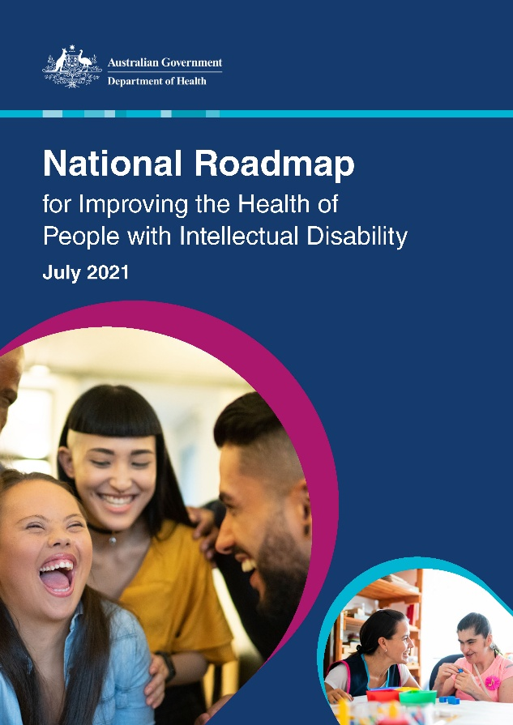
The National Roadmap for Improving the Health of People with Intellectual Disability aims to address serious health inequities faced by people with intellectual disability. The Australian Government has invested a total of $47 million, to date, to support priority actions under the Roadmap. Key achievements during 2023–2025 include:
- Establishment of the National Centre of Excellence in Intellectual Disability Health in October 2023. The Centre provides national leadership in intellectual disability health.
- Publication of the Intellectual Disability Health Capability Framework in April 2024 and associated education resources in June 2025.
- Publication of updated versions of both the Adult and Young Person Comprehensive Health Assessment Program (CHAP) tool. The CHAP supports collaboration between a person with intellectual disability, their supporter or carer, and their GP when doing yearly health checks.
- A successful campaign was launched in August 2024 to promote uptake of Annual Health Assessments, helping people with intellectual disability have yearly health checks.
National Roadmap for Improving the Health of People with Intellectual Disability
- Completion of a 4-year pilot of the Primary Care Enhancement Program for People with Intellectual Disability (PCEP), with an evaluation report published in September 2024. The PCEP has been extended for a further 2 years to June 2026.
Annual progress reports for the Roadmap are published on the Australian Government Department of Health, Disability and Ageing website.

Employ My Ability
Australian Government
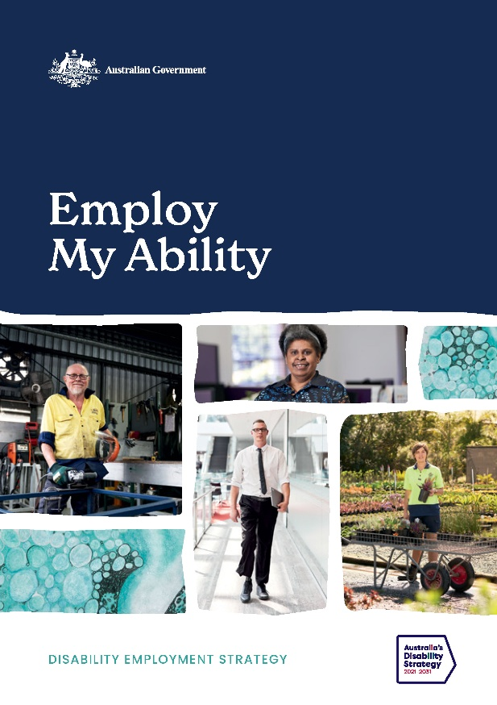
Employ My Ability, the Disability Employment Strategy, acknowledges that people with disability can face specific barriers to employment, preventing their full social and economic participation.
Several actions have been taken in line with the priority areas in the Employment Strategy:
- lifting employer engagement
- building employment skills of young people
- improving systems and services for jobseekers and employers
- changing community attitudes.
Inclusive Employment Australia is a new specialist disability employment program that replaced the DES program on 1 November 2025. The design of Inclusive Employment Australia focuses on system improvements which emphasise the strengths of people with disability in the workplace and empowers employers to hire more people with disability. The Centre for Inclusive Employment complements this work by improving the capability of employment service providers to deliver high quality supports.
Employ My Ability
Employment skills of young people with mental ill health are being improved, and other barriers to employment addressed, through the Individual Placement and Support program, and the Digital Work and Study Service.
Under the priority area of Employer Engagement, the Australian Government Department of Social Services delivered 2 employer focused pilots in partnership with industry and peak associations:
- The Tourism Local Navigators Pilot delivered place-based employment outcomes by connecting small and medium businesses in the tourism sector, employment services providers and jobseekers with disability.
- The Career Pathways Pilot worked with the Business Council of Australia, Australian Disability Network and 4 large employers to reduce barriers to employees with disability progressing in their careers.

National Disability Advocacy Framework
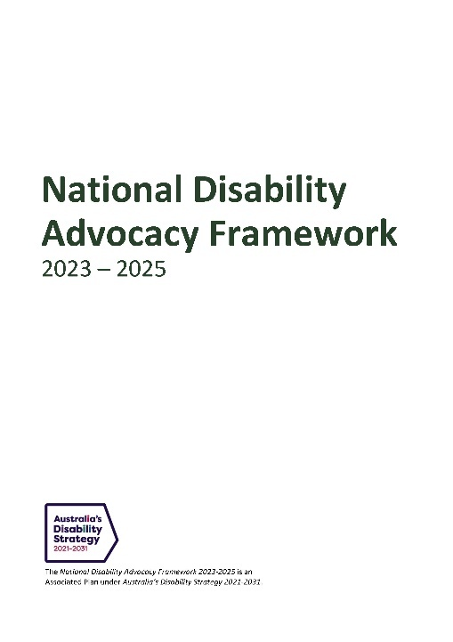
The National Disability Advocacy Framework 2023–2025 and its associated Disability Advocacy Work Plan (Work Plan) represent the beginning of ongoing work by the Australian, state and territory governments, to improve alignment of disability advocacy services by committing to joint work in key areas.
The Work Plan was developed comprising 6 actions to help support the outcomes and implement the goals of the Framework, in consultation with people with disability, families, carers, disability advocacy providers and DROs.
In February 2025, the DRMC agreed to amendments to the Work Plan in response to 3 recommendations from the Disability Royal Commission:
- 6.21 Additional funding for advocacy programs
- 6.22 Improved data collection and reporting on met and unmet demand for disability advocacy
National Disability Advocacy Framework 2023–2025
- 6.23 Culturally safe disability advocacy.




Photo credit Jeff Busby, courtesy of Back to Back Theatre

Equity: the Arts and Disability Associated Plan
Australian Government
On 14 November 2024, the Australian Government released Equity: the Arts and Disability Associated Plan (the Plan). The Plan is a 4-year roadmap of activities to build the foundations for equity for artists, arts workers and audiences with disability across Australia, with an $8.1 million investment in actions to drive change. The Plan is being delivered in partnership with Creative Australia, in consultation with Screen Australia. It is an initiative under the National Cultural Policy, Revive: a place for every story, a story for every place and is an Associated Plan under the Strategy.
The Australian Government is providing $8.1 million to fund actions under the Plan including:
- $2.25 million for an Arts and Screen Employment Pathways Pilot Program
- $2.0 million to extend and expand the reach of the current Creative Australia Arts and Disability Initiatives
- $1.2 million for accessibility activities at live music venues and music festivals through the 2024–25 Revive Live program
- $1.0 million for arts and disability services
- $600,000 to continue funding the annual National Arts and Disability Awards and Arts and Disability Fellowship
- $600,000 for a National Arts and Disability Forum and Gathering
- $250,000 for a National Arts and Disability Code of Practice or appropriate guidelines
- $200,000 for First Nations arts and disability needs and projects, to be delivered by Creative Australia’s First Nations Board.
The Plan was developed through meaningful engagement with artists, arts workers and audiences with disability. Additionally, a working group of artists and art workers with disability took part in 6 disability-led and facilitated co-design workshops between November 2023 and January 2024.
Looking ahead, an Implementation Advisory Group was established in September 2025 to guide key aspects of the Plan’s implementation. The Advisory Group is made up of 13 d/Deaf and disabled artists and arts workers from diverse backgrounds who bring a range of experience from across the arts, screen, digital games and cultural sectors. The group will ensure people with disability are a core part of implementing, monitoring and evaluating key activities, bringing Equity to life.

Accessible Information and Communications
Australian Government
Work is underway on a new Associated Plan as part of the Australian Government Response to the Disability Royal Commission. The Australian Government has committed $12.3 million over 4 years to develop an Associated Plan under the Strategy, focused on access to information and communications for people with disability.
The Accessible Information and Communications Associated Plan will set out a shared national approach to improve how governments design accessible information and communication products and services, and ensure the reliability, accessibility and availability of communications services for people with disability. The Associated Plan will deliver common accessible communication standards for all government information products across Australian, states and territory governments. Work under this Plan will build the capability of Australia’s public service agencies to embed accessibility into the design and implementation of government policies, programs and service delivery, and everyday interactions with the community.
In 2025, the Australian Government established an Accessible Communications Technical Advisory Group. This is a time-limited group comprising technical experts and people with lived experience, that has been established to help guide the development of draft standards and the Associated Plan. The role of the Group is to: provide independent, practical, expert research and professional advice to develop the Associated Plan; inform and review procurements outcomes and reports in relation to accessibility of information and communications for people with disability; and represent their communities in discussions about accessible information and communication.

Outcomes Framework
Tracking our progress across
Australia’s Disability Strategy Outcome Areas
One of the key elements under the Strategy to ensure accountability is the Outcomes Framework. The Outcomes Framework allows us to track and report on measures across the Strategy’s 7 Outcome Areas and policy priorities.
The Outcomes Framework measures and reports on outcomes over time in key areas of people’s lives—such as employment, housing, health, and education—letting us show whether the lives of people with disability are improving.
Reporting through the Outcomes Framework is done through:
- A dashboard for all measures, with webpages for individual measures. This also includes background information about the data and related fact sheets.
- Quarterly updates to the data in January, April, July and October each year.
- Annual reporting of progress and activities. The third annual report was published on 30 January 2025.
As of July 2025, there is data for 56 measures reported through the Outcomes Framework, with progress tracking on 44 of these measures. There are 32 future measures that are being worked on, or will be developed, over the life of the Strategy.
Australian Institute of Health and Welfare (AIHW) is an independent statutory Australian Government agency producing authoritative and accessible information and statistics to inform and support better policy and service delivery decisions, leading to better health and wellbeing for all Australians. The AIHW reports on the Strategy's Outcomes Framework, including annual reports and data updates.

The AHRC notes that the Outcomes Framework is a notable improvement from the former National Disability Strategy (2010–2020) and is an important tool to monitor and inform implementation, and to hold governments to account. However, the Strategy’s Advisory Council has expressed scepticism about the Outcomes Framework reporting positive achievements where measures have only improved marginally, as it is unclear if the change represents an incidental shift or actual improvement because of the Strategy.

Australia’s Disability Strategy Survey
Australian Government
Community attitudes towards disability are a key cross-cutting issue for people with disability. These attitudes influence the experiences of people with disability across all areas of their lives. Australia’s Disability Strategy Survey is a key source for information about community attitudes towards people with disability. The Strategy’s Survey captures data from the general Australian population, as well as the experiences of people with disability. The Strategy’s Survey also looks at people working in selected sectors, such as education, health, justice and legal and community support services and employers’ attitudes towards people with disability. Understanding the experiences of people with disability can show us what needs to change.
Wave 1 of the Survey ran across the second half of 2022. It collected information for approximately 18,000 people across Australia. The data collected was used to report against the 7 community attitudes measures in October 2023. A report summarising the results was published on the Strategy's Hub on Disability Gateway in March 2024. As part of the Wave 1 Survey work, the first qualitative report was published in October 2023, with a focus on people with intellectual disability.
Wave 2 of the Survey commenced in the second half of 2024, with around 19,000 people completing the questionnaire. New questions were added to collect data for 8 additional future measures across 5 different Outcome Areas. Consultation with key stakeholders and cognitive testing was done for the new questions. The data from Wave 2 was reported through the Outcomes Framework in October 2025. At the same time, a report presenting additional insights and findings using the Wave 2 data was published on the Strategy’s Hub on Disability Gateway.
Data from Waves 1 and 2 questionnaires are published through the Australian Data Archives, where researchers are able to apply for access.
Other work from Wave 2 of the Survey included 3 qualitative studies examining attitudes surrounding disability and experiences of disability to ensure voices often missed in standard surveys were heard:
- young people aged 16–24
- people from culturally and linguistically diverse backgrounds
- First Nations people.
Each qualitative study was run as a series of focus groups. This let us hear directly from these groups about recommendations for change. Hearing from people with disability about the issues unique to them helps us to see how different parts of a person's identity influences their experience. People with disability were engaged in the design of the qualitative studies, including accessibility, implementation and communication. The findings from these qualitative studies are expected to be published by the end of 2025.

Improving the Data
All governments are committed to improving
the collection and reporting of data,
providing the evidence needed to measure progress,
identify gaps, and inform policy decisions
Australia’s Disability Strategy recognises that high-quality, accessible data is vital for understanding and improving the lives of people with disability. Robust data collection and reporting underpin every aspect of the Strategy’s implementation, providing the evidence needed to measure progress, identify gaps, and inform policy decisions. By tracking experiences across a range of domains, improved data ensures that interventions are tailored, effective, and responsive to the diverse needs of people with disability. Data also enables greater accountability to the community and makes visible the lived experiences of people with disability.
People with disability and their representative organisations broadly acknowledge that improvements in data collection and reporting under the Strategy represent a necessary foundation for meaningful reform, with positive feedback focused on the establishment of the National Disability Data Asset (NDDA) and inclusion of new outcome measures. However, many express persistent concerns about the invisibility of diverse lived experiences—especially for First Nations people with disability, children and young people with disability, and people from culturally and linguistically diverse backgrounds. The Strategy’s Advisory Council notes that while there are improvements in reported data, such as with healthcare and hospitals, this does not necessarily reflect the lived experience of all people with disability.
All governments are committed to improving the collection and reporting of data. The Australian Government, and state and territory governments, are working with the disability community on generating new insights using the NDDA. This will help the government better understand the experiences of people with disability and support people with disability, their carers, and the broader community.
This section outlines how governments have worked collaboratively to enhance the disability data ecosystem in Australia. Additional major initiatives include the Strategy’s Data Improvement Plan, the regular publication of accessible statistics by the Australian Bureau of Statistics (ABS), and the introduction of new, inclusive survey methods such as the Voice of Queenslanders Survey. Collectively, these efforts have strengthened evidence-based decision-making, improved service delivery, and laid the groundwork for ongoing, meaningful change as the Strategy continues to progress.

Survey of Disability, Ageing and Carers
Australian Government
The ABS regularly collects information about people with disability in the Survey of Disability, Ageing and Carers (SDAC). Results from the most recent SDAC (2022) were published on the ABS website in 2024.
Guided by the Strategy’s Guiding Principle of accessibility, for the first time key data was also presented in 3 accessible formats, Auslan, plain language and Easy Read. The main publication text and Excel data files were also updated to enable screen reader users to better access the content.
Between October 2024 and June 2025, the ABS also published 4 articles based on SDAC 2022 data, and these included the same improvements as the main publication:
- Autism in Australia, 2022
- Aboriginal and Torres Strait Islander peoples with disability, 2022
- Children and young people with disability, 2022
- Psychosocial disability in Australia, 2022.
As a result of these improvements, ABS data is accessible to more Australians.



National Disability Data Asset
Australian Government
In June 2023, all governments signed a Memorandum of Understanding that committed them to deliver the NDDA.
The NDDA is co-governed with the Australian, state and territory governments, and members of the disability community.
Researchers were able to submit applications for access to data in the NDDA from 19 December 2024.
Based on initial data in the NDDA, a set of disability flags (or indicators) were designed to be made available to people approved to access data for research or analysis. The flags are types of information about disability, for example, how many people have disability and what disability they have. The flags will aid researchers to consistently include people with disability in their research.
The disability flags were used in 2025 to report on 3 measures under Australia’s Disability Strategy Outcomes Framework. These measures are:
The National Disability Data Asset (NDDA) brings together data from across Australia to better understand and meet the needs of people with disability.

- number of people with disability with GP-type emergency department presentations
- number of involuntary hospitals admissions for people with disability
- number of potentially avoidable deaths in hospital for people with disability compared to people without disability.
Once fully operational, it is expected that several of the Strategy’s Outcomes Framework future measures can be reported on for the first time, and improved reporting on other existing measures.



Australia’s Disability Strategy Data Improvement Plan
Australian Government
Over the life of the Strategy, governments have agreed to work together to make sure data needed to measure outcomes for people with disability is collected, shared and improved.
The Strategy’s original 2022 Data Improvement Plan was developed following the launch of the Strategy. It set out how to improve data needed to track progress against the Strategy’s Outcomes Framework, with a focus on collecting data for future measures.
In 2024, the Australian Government Department of Social Services revised the Data Improvement Plan in consultation with DROs, the Strategy’s Advisory Council, and Australian, state and territory government agencies. The revised Data Improvement Plan was endorsed by Disability Reform Ministers and published on 3 December 2024.
The revised 2024 Data Improvement Plan outlines tangible next steps to support ongoing improvements of disability data and reporting over 2025–2026. The plan includes an Action Plan outlining actions to progress, address and implement some of the data-related recommendations from the Disability Royal Commission.

Key Data Improvements
Some key data improvement efforts over the reporting period include:
- Addressing the Disability Royal Commission’s recommendations 12.5–12.7 to build a more nationally consistent approach to measuring disability. The ABS has developed a short standard set of questions for the collection of data on disability status. Further consultation and testing with the disability community and data experts are required to fine-tune and implement this approach.
- Working with select Australian Government agencies to progress and develop data collection for future measures relating to the Disability Standards for Accessible Public Transport and Disaster Management Services. This work includes co-design with governments, industry experts, people with disability and their representatives.
- Reviewing some of the Strategy’s Outcomes Framework measures as outlined in the 2024 Data Improvement Plan. Targeted workshops have been held with select DROs to discuss the value and possible changes to future measures using a ‘Theory of Change’ approach.
- Working with AIHW to modernise data collection and improve the reporting of intersectionality of the current measures in the Strategy’s Outcomes Framework.
It is important to recognise that people with disability have diverse needs, and the disability data ecosystem is constantly evolving to meet those needs. Ongoing monitoring, tracking and reporting disability data-related improvements will continue to identify and address those needs.
In 2025–26, the first major Independent Evaluation of the Strategy will look closely at how well the Strategy’s Outcomes Framework measures are working.

Travellers with accessibility needs data report
Australian Government
In May 2024, Tourism Research Australia published its first report on the characteristics and spending value of travellers with accessibility needs. For the June quarter of 2023, accessible travel groups made up 23% of all domestic trips (overnight and day trips) and accounted for an estimated $6.8 billion spend for the quarter (approximately 21% of total spend). The Travellers with accessibility needs in Australia report was the first time that Tourism Research Australia publicly released an analysis of this data to provide insights on domestic travellers in Australia with accessibility needs.
Improved communication of data on the value of travellers with disability to Australia’s visitor economy has led to improved disability awareness and confidence within the tourism industry. Tourism Research Australia data is regularly used by tourism stakeholders at industry events to highlight the value of offering more inclusive and accessible experiences. The publication of Tourism Research Australia’s report was a significant improvement on the publicly available data on the size, value and characteristics of the accessible tourism market to Australia’s visitor economy.
Following the interest in this data, Tourism Research Australia has commissioned a report that captures data over a full year period (2024). The Accessible Tourism 2024 report was published in July 2025, with more than one in 5 trips in Australia being made by travellers with accessibility needs and their travelling companions in 2024, spending over $29 billion.

Voice of Queenslanders Survey
Queensland Government
Queensland is committed to improving disability data collection and analysis to achieve better outcomes for people with disability. A key initiative is the annual Voice of Queenslanders Survey, delivered in partnership with Griffith University and QDN.
The Voice of Queenslanders Survey captures both quantitative and qualitative data.
Survey participation has grown from 442 participants in 2023 to over 700 in 2025, reflecting increased engagement from Queenslanders with disability.
It provides a comprehensive understanding of the lived experiences of people with disability, their families, and carers.
Participants reflect on what is working well, what is not, and areas for improvement.
The survey enables the Queensland Government to identify key challenges and service gaps.
.

The annual survey has enhanced Queensland’s ability to track trends over time, offering a clearer picture of shifts in experiences and outcomes. While not longitudinal, this analysis has already highlighted critical issues, such as widening disparities between Queensland urban and regional residents with disability and barriers faced by people with intersectional identities in accessing funding, services, and support.
In 2024, Griffith University and QDN trained and supported 7 paid citizen scientists with disability to contribute to the survey’s delivery, ensuring lived experience informed data collection. This approach reflects Queensland’s commitment to ensuring data improvement aligns with the principle of ‘nothing about us without us.’

Health disability liaison officers
Victorian Government
Effective data and outcomes reporting is one of the systemic reforms in Inclusive Victoria: state disability plan 2022–2026.
Consistent collection of data relevant to disability helps the Victorian Government to better target policies and programs and be more accountable for outcomes.
The Disability Liaison Officer in health services program Is leading systems improvement projects, including data enhancement initiatives, to improve healthcare accessibility of people with disability.
One of the program’s projects, led by the Parkville Precinct Hospitals and Austin Health, aimed to better identify people with disability early in the hospital intake or admission process. The project co-designed a set of questions which allows patients to share if they have a disability and what support they might need. This data is included in the health service electronic medical record system to help staff make adjustments in how care is provided.
During the period 1 July 2023 to 30 June 2025, around 78,000 patients answered the questions and around 18% of patients identified as having a disability.
A project evaluation showed that patients, carers, and health staff responded positively to this option. Patients and carers felt the questions helped them share their needs and made the health service more inclusive. Clinicians also recognised the benefits of the questions in improving patient-centred care and disability awareness.

Harnessing data to drive inclusive outcomes
New South Wales Government
The NSW Government is delivering measurable improvements for people with disability by embedding data-driven decision-making into policy, program, and service design. Guided by the NSW Government Data Strategy, agencies are adopting a coordinated and strategic approach to data use, ensuring that insights translate into tangible outcomes.
A key achievement has been the development of a common data sharing agreement across NSW agencies, streamlining collaboration and aligning with Australian Government data sharing frameworks. This has enabled more efficient, secure, and targeted use of data to inform inclusive policy development.
Data has played a critical role in emergency coordination and public health responses, particularly during bushfires and the COVID-19 pandemic, where timely insights supported tailored interventions for people with disability. These efforts ensured that accessibility and inclusion remained central to crisis response and recovery planning.
By leveraging data as a strategic asset, NSW is building a more responsive, inclusive, and equitable system—one that reflects the lived experiences of people with disability and delivers services that meet their needs.

Evaluation and Research
Continuous learning on how to do things better
The successful implementation of the Strategy relies on robust evaluation and research to ensure policies, programs, and services are genuinely meeting the needs of people with disability. Evaluations provide essential evidence about what is working and where improvements are needed, while research uncovers emerging challenges and opportunities for innovation. Together, these mechanisms enable all levels of government, service providers, and the disability community to make informed decisions, continually adapt strategies, and remain accountable to the outcomes Australians with disability expect and deserve.
The Strategy itself will be independently evaluated in 2025–2026. While the 2024 Review of the Strategy focused on practical improvements to the Strategy’s implementation processes, the upcoming Independent Evaluation will focus on outcomes against the policy priorities and the vision of the Strategy. The AHRC recognises the opportunities presented by the Strategy’s first major Independent Evaluation and proposes for the evaluation to consider the effectiveness of the Strategy on realising the rights of people with disability and move the Strategy towards a rights-based approach to policy development.

Across Australia, governments and organisations have embedded a wide range of evaluation and research activities to drive continual improvement under the Strategy. This section highlights collaborative projects such as co-designed research partnerships and new tools to support inclusive evaluations and research. From national initiatives like the National Disability Research Partnership (NDRP) and the development of toolkits for engaging people with disability in evaluation, to state-based research agendas, inclusive education research, and targeted health studies, all jurisdictions are committed to using evidence and lived experience to guide reform. These efforts ensure that the implementation of the Strategy remains transparent, responsive, and aligned with the voices and priorities of people with disability.

Funding needs to be better tracked, and actions need to be driven by appropriate and unbiased data and evidence.
—Australia’s Disability Strategy Advisory Council

Australia’s Disability Strategy First Independent Evaluation
Australian Government
Australia’s Disability Strategy will be evaluated twice, in the midpoint (starting 2025) and in 2029. In 2025 an independent evaluator will be selected to undertake in-depth engagement with people with disability and the disability community. The Independent Evaluation will take a mix methods approach and to outline where the Strategy has been effective, and support learning to identify any aspects of the Strategy which need to be adjusted mid-implementation. The final report of the Independent Evaluation will be presented in late 2026. The second evaluation (to be completed by end of 2030) will build on the first Independent Evaluation to assess impact.
The Toolkit for Engaging People with Disability in Evaluation will be used to inform the planning and implementation of the Independent Evaluation.



Toolkit for Engaging People with Disability in Evaluation
Australian Government
The Australian Government has developed a Toolkit for Engaging People with Disability in Evaluation (the Toolkit), which builds on the existing Evaluation Good Practice Guide Checklist. The Toolkit was published in September 2025 ahead of the commencement of the Strategy’s first major Independent Evaluation.
The Toolkit is one of 3 guides committed under the Strategy. The other 2 are the Good Practice Guidelines for Engaging with People with Disability and the Guide to Applying Australia’s Disability Strategy.
The Toolkit will shape how government, business and communities’ support people with disability, their families and allies to know what to expect in evaluations. It will support evaluators and evaluation commissioners to plan and run inclusive and accessible evaluations.
The Toolkit has been tested with people with disability, representative organisations, and evaluation experts within the Australian Public Service, including the Australian Centre of Evaluation in Department of Treasury.

National Disability Research Partnership
Australian Government
The NDRP is undertaking a $1 million project under its $13.7 million Commonwealth grant, on the theme ’Supporting transitions from education/training into employment.’
The project will pilot the NDRP commissioning research approach. The NDRP commissioned research model differs from traditional commissioning by involving people with disability in all aspects of the process, from setting research priorities to actively participating in research itself.
The NDRP starts with a priority identified by government and then works with people with disability, DROs, and researchers to refine and prioritise specific research questions. Only then will it invite applications from research groups to undertake research that is led by and with people with disability.



Monitoring, Evaluation and Learning Framework
Australian Capital Territory Government
The ACT Government has commenced development of a Monitoring, Evaluation and Learning (MEL) Framework to monitor and track the progress and performance of ACT Disability Strategy and ACT Disability Health Strategy. The MEL Framework is to be co-designed with the ACT Disability Advisory Council, the ACT Disability Health Reference Group, and the ACT Government.
The implementation of the MEL Framework will build upon initial project work undertaken in 2023, which explored how co-design processes can effectively inform the development of the MEL Framework for the ACT Disability Strategy. This work was led collaboratively by the ACT Office for Disability and the Disability Reference Group, and its findings will play a key role in guiding the ongoing rollout and refinement of the Framework.

Queensland Disability Research Agenda
Queensland Government
Queensland is embedding disability-inclusive research, evaluation, and lived experience in decision making. A key step forward in 2024 was the co-design of the Queensland Disability Research Agenda and internal Departmental Disability Research Strategy for the Queensland Department of Families, Seniors, Disability Services and Child Safety. Led by the Queensland Disability Research Network in partnership with QDN, this process brought together government agencies, the disability sector, and people with lived experience.
Published in February 2025, the Research Agenda outlines emerging priorities for disability research in Queensland. Complementing this, the internal strategy seeks to guide inclusive departmental planning and resource allocation. A Disability Research and Evaluation Advisory Committee provides oversight, supporting implementation over a 5-year period.
Another initiative is the annual Voice of Queenslanders with Disability Survey delivered in partnership with Griffith University and QDN. The survey, involving citizen scientists, gathers insights from people with disability, their families, and carers. It identifies barriers and opportunities for inclusion, aligning closely with the Strategy’s Outcome Areas.



State Disability Plan Review
Northern Territory Government
The Northern Territory undertook a review of the Northern Territory Disability Strategy Action Plan 2022–2025 in late 2024 to determine the extent to which actions have been delivered as intended, identify areas of success and lessons learnt relating to the development, reporting and governance, and identify data gaps for measuring success against outcomes.
This is the first Action Plan under the Northern Territory Disability Strategy 2022–2032 and key findings from the review will inform the development, implementation, governance and reporting of the second Action Plan under the strategy, due for release early 2026.
Strengths of the first Action Plan included thorough stakeholder consultation during its development, considerable progress against the actions, and alignment of actions with their respective priorities. However, reporting focused on inputs and activities rather than defined outputs and measurable outcomes. Key opportunities for improvement in the next Action Plan include the development of an outcomes framework, informed by national strategies and commitments; strategic prioritisation of fewer targeted actions; and stronger collaboration with people with disability during implementation.

Disability Inclusion Research in Kindergartens
Victorian Government
The Victorian Department of Education is leading the Disability Inclusion Research in Kindergartens project to better understand how to support children with disability, developmental delay and complex medical needs to access and participate in high-quality early childhood education.
This 2-year project is testing a new tool – the Kindergarten Inclusion Support (KIS) Profile. The project is:
- Helping teachers identify and respond to children’s functional support needs in Victorian kindergartens.
More action in Victoria:
In 2022–23, the Victorian Government allocated $18.1 million over 4 years to support children with disability, developmental delay or complex medical needs to engage in kindergarten. This funding supported:
- Preschool Field Officer Program
- Kindergarten Inclusion Support Program
- Kindergarten Inclusion Support Specialised Equipment Program.

- Involving over 100 services and more than 250 children, to ensure the tool is informed by the lived experiences of teachers and families supporting children with additional needs.
- Collecting data on the type and level of support needs across Victorian kindergartens through a Disability Inclusion Needs Survey, to provide a picture of inclusion needs that will help guide further reform.



BreastScreen research
New South Wales Government
BreastScreen NSW was involved in a research project led by the University of NSW to identify strategies to ensure accessible breast screening for people with intellectual disability.
Evidence shows that women with intellectual disability experience barriers to accessing breast screening services. These barriers mean they are less likely to participate in breast screening than people without intellectual disability.
The research project worked with clinical and academic health experts to come up with 52 agreed strategies for improving access to breast screening. The strategies are grouped into 5 key action areas:
- decision making and consent
- accessible information
- engagement of peer mentors
- service navigators
- equipping key stakeholders.
The project presented the agreed strategies to BreastScreen NSW service directors to inform health policy and quality improvement practices.

State Disability Strategy Evaluation
Western Australian Government
In 2023, an independent Year Three Process Evaluation (Process Evaluation) was undertaken for A Western Australia for Everyone: State Disability Strategy 2020–2030 (State Disability Strategy). The Process Evaluation assessed whether the State Disability Strategy’s processes and methods were working to achieve the State Disability Strategy’s vision.
The Process Evaluation was co-designed with an Oversight Sub-Committee of the Disability Services Commission Board. Interviews, surveys and targeted focus conversations were held with people with disability, government and disability sector organisations.
Overall, the Process Evaluation found that people with disability believe the State Disability Strategy’s strategic priorities remain important to them. It also identified people with disabilities’ overall priority was finding suitable services such as health, housing and education.
The Process Evaluation concluded that after 3 years, the State Disability Strategy remained a trusted framework that is critical to advancing the inclusion of people with disability in WA.
Evaluation is ongoing over the 10-year life of the State Disability Strategy, with further opportunities for people with disability and sector organisations to be involved. The next evaluation process will take place in 2026.

Profile of disability in First Nations peoples
A collaboration between Dr Scott Avery, Professor of Indigenous Disability Health and Wellbeing in the School of Public Health, University of Technology Sydney, and the ABS led to a co-authored paper on the prevalence and profile of disability in the First Nations disability population, published in February 2025.
This paper provides insights into disability in the Aboriginal and Torres Strait Islander community and the best available survey data on the prevalence of disability for the Aboriginal and Torres Strait Islander population.
Following the release of the prevalence and profile of disability paper, Dr Avery and the ABS co-hosted an intergovernmental workshop attended by representatives across Australian Government agencies.

Digital Disability Inclusion: design lessons from COVID-19
Curtin University
The COVID-19 pandemic resulted in many innovations in how we interact digitally—and a Curtin University research project won significant funding to ensure people with disability can benefit from what’s been learned.
In 2024, the Australian Research Council (ARC), Curtin University, and the Inclusive Design Collective (IDCo) invested $1 million over 4 years through Professor Katie Ellis' ARC Industry Fellowship.
The fellowship project identifies and evaluates COVID-19 era digital innovations for long-term inclusive design implementation, working collaboratively with people with disability to build knowledge and policy frameworks guiding inclusive digital communication strategies across Australia.
Commencing in 2025, the project employs a collaborative, participatory approach positioning people with disability as co-researchers, embedded within an industry environment fostering collaboration across academia, industry, and community sectors. This project has reviewed COVID-19 communications across 3 Australian states (WA, NSW, and Victoria) and conducted analysis of disability experiences through policy reviews and partner survey research.
Drawing from IDCo's inclusive design methodology, the project recognises 3 critical inclusion stages: locating relevant information, successfully accessing that information, and maintaining safety and support throughout the entire experience. Future stages will involve in-depth interviews with 20 diverse participants and disability advocates, followed by a Delphi panel of experts to evaluate innovative digital communication strategies. The project will culminate in annual knowledge exchange forums and capacity building through post-doctoral and PhD positions, establishing sustainable frameworks for inclusive design implementation.

Governance
Strengthening outcomes through robust
governance structures
Disability Representative Organisations (DROs) provide systemic advocacy and representation for people with disability. They also provide advice to the Australian Government on breaking down barriers and improving participation of people with disability.

Effective governance forms the backbone of Australia’s Disability Strategy. It helps make sure people with disability are involved, and that things are done in a fair and open way. Governance means listening to people with disability and including their experiences when planning, running, and checking how the Strategy is working.
During the 2024 Review of the Strategy, people with disability said we need to strengthen the Strategy’s governance structures and oversight, to make sure everyone is doing what they promised. Oversight helps turn plans into real actions. It makes sure progress is tracked and that different voices are heard. Good governance helps governments work together and keeps them responsible for their commitments and actions. It also supports us to respond to emerging challenges and opportunities as they arise.
Three main groups form the core of the Strategy’s governance, and each one has a different but connected role:
- The Disability Reform Ministerial Council (DRMC) brings together government ministers from across Australia who are responsible for disability policy. They work together to lead national change on disability reforms including delivering the Strategy, Disability Royal Commission recommendations and NDIS Reform. During the reporting period, the DRMC commissioned and approved important Strategy work, including the 3 new TAPs, the 2024 Review of the Strategy, updates to the Strategy, and the Strategy’s reporting.
- Australia’s Disability Strategy Advisory Council delivers independent advice to governments and ministers on the implementation, monitoring, and evaluation of the Strategy. The Advisory Council makes sure that the voices and experiences of people with disability are at the heart of decision-making.
- The Disability Representative Organisations Forum brings together groups that represent people with disability. During the reporting period, DROs contributed to disability legislation and reforms, as well as the Strategy’s implementation, including the updated Strategy Data Improvement Plan, the Guide to Applying the Strategy, the 3 new TAPs, the 2024 Review of the Strategy and other Strategy publications.
Together, these groups ensure that governance is collaborative, inclusive and effective.

Australia’s Disability Strategy Advisory Council
Australia’s Disability Strategy Advisory Council (the Advisory Council) provides independent advice to Australian governments and disability ministers on the implementation, monitoring and evaluation of the Strategy. The Advisory Council represents diverse voices from across Australia’s disability community, and all members have lived experience of disability and bring a deep expertise in relation to disability issues to their advice. The Advisory Council is made up of 6 core members, including the Chair, who are all persons with disability, 4 rotating representatives from state and territory disability advisory groups, and up to 2 special advisers. Ms Jane Spring AM was appointed Chair of the Advisory Council in July 2023.
During the reporting period, the Advisory Council formally met 8 times. Through its meetings, the Advisory Council has advised governments on the Strategy’s TAPs, strengthening evaluation activities, the Strategy’s implementation progress, development of the Good Practice Guidelines for Engaging with People with Disability, and engaging in the Review of the Strategy in 2024.
In 2025, the Advisory Council implemented a more structured Work Plan to include out-of-session meetings (workshops) to support its provision of informal advice to government officials. The Advisory Council participated in 3 workshops between February and June 2025 focused on reporting and accountability, strengthening evaluation activities across the Strategy, and considerations of the cross-cutting disability outcome, including the work being done to develop options for a First Nations Disability Forum. These workshops are delivered by subject matter experts from across Australian Government agencies and precede formal Advisory Council meetings. The structured Work Plan with dedicated workshops provide the Advisory Council an opportunity to engage deeply with topics of significance to the disability community and the Strategy and enhance its capacity to develop informal advice that is considered, strategic and impactful. Advisory Council Communiques provide details on the matters discussed at each Advisory Council meeting, and the Advisory Council’s Annual Report summarises the Advisory Council’s work over the year.

Jurisdictional Overviews

New South Wales
NSW continues to lead with purpose in implementing Australia’s Disability Strategy, driving inclusive reform through legislative, strategic, and community-based initiatives.
Under the Disability Inclusion Act 2014 (NSW), all NSW public authorities are required to develop and implement Disability Inclusion Action Plans (DIAPs), with annual reporting that provides critical insights into progress and challenges. The NSW Public Authorities Disability Inclusion Action Plan 2022–2023 Progress Report Card, tabled in Parliament on 15 August 2024, showcases a whole-of-government commitment to embedding accessibility and equity across services and workplaces.
Achievements include:
- Transport for NSW’s Safe Accessible Transport program, which completed access upgrades at 15 railway stations, with upgrades underway at 29 stations and 2 ferry wharfs.
- State Library NSW’s publication of People Places: A guide for planning public library buildings, embedding accessibility into public infrastructure.
- Destination NSW’s release of Quick Tips for Creating Accessible and Inclusive Experiences, empowering tourism operators to better serve people with disability.
NSW’s disability policy is shaped by lived experience and strong governance. The Minister for Disability Inclusion is advised by the Disability Council NSW and supported by the NSW Disability Board and the NSW Disability Directors Forum.

Victoria
A key commitment in Inclusive Victoria: state disability plan 2022–2026 was to report on progress after the first 2 years, 2022 to 2024. The Midway Report was tabled in the Victorian Parliament in November 2024 and published on 6 December 2024.
The plan’s period of operation has been extended to 2027. A final report on Inclusive Victoria will be released in 2027, outlining progress in the remaining years of the plan.
Key achievements already delivered through Inclusive Victoria include:
- Employment opportunities—Implementing programs to attract and support diverse talent, such as the Neurodivergent Employment Toolkit, aimed at supporting recruitment and workplace adjustments for neurodivergent people.
- Transport upgrades—Applying universal design principles and co-design approaches to planned upgrades of the transport network system to improve whole-of-journey experiences for people with disability.
- Inclusive health services—Investing $6.5 million over 3 years to continue the Disability Liaison Officers program to support people with disability have timely access to the health care they need.
- Inclusive education—Implementing significant disability inclusion reform in Victorian government schools, including a new strengths-based funding and support model for students with disability.
- Disability and Social Services Regulation Amendment Act 2023 (Vic) —Strengthening rights and protections for people with disability living in specialist disability accommodation. This includes allowing Community Visitors to visit more types of accommodation.
Complementing portfolio-specific actions, the Victorian Government is driving systemic reform in 6 areas, representing inclusive practice:
- co-design with people with disability
- Aboriginal self-determination
- intersectional approaches
- accessible communications and universal design
- disability confident and inclusive workplaces
- effective data and outcomes reporting.
Victorian Government departments have embraced these 6 reform areas.
Of particular importance, all Victorian Government departments are seeking to actively involve people with disability in shaping new or revised policies, programs and services. There is promising practice of co-design in some areas.
Inclusive Victoria also outlined a commitment to refresh the state disability plan outcomes framework. In consultation with the Victorian Disability Advisory Council, Melbourne Disability Institute streamlined the outcomes framework and produced a state disability plan Midway Outcomes Report, applying the refreshed outcomes framework.
The Outcomes Report showed:
- Improved outcomes in areas like educational engagement and employment satisfaction.
- Poorer results for people with disability in areas like food insecurity and psychological distress.
The refresh of the state disability plan outcomes framework and the Midway Outcomes Report formed part of Inclusive Victoria’s Midway Report.
The Victorian Disability Advisory Council plays a significant role in overseeing and supporting the implementation of Inclusive Victoria. The Council’s advice has informed a range of policy and legislative reforms across the Victorian Government and facilitated better engagement with people with disability.

Queensland
In Queensland, more than one in 5 people—or approximately 1.2 million people—identify as having a disability. As of June 2025, there were 159,258 active NDIS participants in Queensland, having increased by 11.9% since June 2024.
Queensland’s Disability Plan 2022–2027: Together, a better Queensland has been Queensland’s key mechanism for implementing the Strategy and focuses on creating an inclusive, accessible, and equitable society for people with disability. The plan aligns with the principles of the Disability Services Act 2006 (Qld), aiming to ensure people with disability can participate fully in all aspects of life.
Queensland’s Disability Plan includes performance measures, regular progress reporting, and embedding disability inclusion into broader government strategies for long-term impact.
Government departments contribute to inclusion and support the delivery of Queensland’s Disability Plan by implementing and monitoring actions through their disability service plans, which ensure progress towards a more inclusive Queensland. The Queensland Government invests over $2.5 billion annually in the NDIS, reflecting its commitment to supporting people with disability in accessing necessary services and achieving social and economic participation. This investment in turn, boosts Queensland's economy, creating jobs in the disability sector.
The Queensland Disability Advisory Council plays a vital role in advising the Queensland Government on issues affecting people with disability. The core purpose of the Council is to consider key disability issues and generate high-quality, evidence-informed advice. With a diverse member base, including individuals with lived experience of disability and representatives from the disability sector, the Council ensures the voices of people with disability, their families, carers, and the broader community are heard in shaping policies, programs, and services.
Comprised of 12 members from a range of backgrounds, the Queensland Carers Advisory Council similarly provides strategic advice to the Queensland Government on work to promote the interests of carers and make recommendations to support carer recognition.

Western Australia
In February 2024, the Disability Division was formally established within the WA Government Department of Communities to consolidate the disability services functions to strengthen support for disability services as the WA Government worked through significant reform agendas. The Disability Division has responsibility for delivering targeted services, leading policy and reform, and empowering the voice of people with disability. The Disability Division holds monitoring and coordination responsibilities for A Western Australia for Everyone: State Disability Strategy 2020–2030.
Action Plans supporting the State Disability Strategy are reviewed and renewed every 2 years to ensure actions remain responsive to, and reflective of, the needs and priorities of West Australians with disability. The progress of Action Plans are publicly reported annually.
In 2023, an independent Year Three Process Evaluation of the State Disability Strategy assessed the effectiveness of the processes and methods used to progress the State Disability Strategy’s vision and objectives. The Evaluation concluded that after 3 years, the State Disability Strategy remained relevant and critical to advancing the inclusion of people with disability in WA and provided a trusted means to elevate and respond to the issues, needs and priorities of people with disability.
The State Disability Strategy is monitored by the Disability Services Commission Board, comprising of people with disability, have a relative with disability, or have recent experience as a carer or an advocate for people with disability.
In addition, the Ministerial Advisory Council on Disability reports and provides high-level strategic advice directly to the WA Government Minster for Disability Services on matters impacting the lives of West Australians with disability.
Lived experience is critical to policy development, however government can struggle to obtain timely and specific input on the nuances of reforms. For this reason, the WA Government Department of Communities established a Disability Lived Experience Advisory Panel (LEAP), consisting of people with disability, family members and carers. LEAP ensures that policy, strategy and program considerations within the Disability Division are informed by a lived experience voice. LEAP members provide specific and timely advice on issues where the department has a role in influencing change.

South Australia
South Australia continues to advance the implementation of the Strategy through a whole-of-government commitment to access, inclusion, and equity. During this reporting period, South Australia delivered several major cross-Government initiatives, including:
- State Disability Inclusion Plan: Development of the new State Disability Inclusion Plan 2025–2029 commenced in 2023. Drawing on extensive consultation, including input from Aboriginal Community Controlled Organisations and disability service providers, it was released in August 2025.
- Legislative Reform: In 2024, the Disability Inclusion Act 2018 (SA) passed South Australian Parliament, strengthening the State’s commitment to access and inclusion, and improving alignment between the State Disability Inclusion Plan and state authorities’ (including local government) Disability Access and inclusion Plans.
- State Autism Strategy: The South Australian Autism Strategy was co-designed with Autistic people and the autism community and was launched in June 2024. The strategy is the first of its kind to be delivered and implemented in South Australia. It sets out a 5-year roadmap for the government to help improve the lives of Autistic people of all ages and their families. An Action Plan has also been developed to guide priority activities and initiatives across government.
- Disability Minister’s Advisory Council: The 14-member Council has commenced its second term (2025–2027) and continues to provide lived-experience advice to government and contribute to local and national strategies.
South Australia’s implementation is supported by a strong governance and advisory structure. The South Australian Disability Reform Intergovernmental Committee continues to provide coordinated oversight and collaborative action across government agencies. The Disability Engagement Group, established in 2021, continues to provide co-design and consultation opportunities with people with disability for agencies developing inclusive policies and programs. The Minister’s Advisory Councils, including the Disability, Youth, and LGBTIQA+ Councils, offer direct advice to the Minister for Human Services on intersectional issues, including those affecting people with disability.
In 2024, agencies reported many milestone activities across all 7 Outcome Areas of the Strategy. Examples included the Department for Infrastructure and Transport’s co-designed Disability Community of Practice and Autism Action Plan and the South Australian Housing Trust’s accessible housing and employment pathways for tenants with disability.
South Australia also contributes to national reform through intergovernmental collaboration, such as participation in the review of the Disability Standards for Accessible Public Transport. Together, these efforts reflect a coordinated, inclusive, and evolving approach to improving outcomes for people with disability in South Australia, with the perspectives and aspirations of people with lived experience at the centre.

Tasmania
The Tasmanian Government remains committed to delivering the outcomes of the Strategy through system-level reform and person-centred, inclusive practices. Tasmania’s Disability Strategy 2025–2027 guides whole-of-government action and prioritises embedding the voices of people with disability across policy and program design.
The establishment of the Tasmanian Disability Commissioner and commencement of the Disability Rights, Inclusion and Safeguarding Act 2024 (Tas) represent landmark reforms. This legislation provides a dedicated framework for oversight of restrictive practices and introduces new safeguarding measures, positioning Tasmania at the forefront of rights-based disability reform.
The Act establishes the formal inclusion of people with disability in leadership through the creation of a Disability Inclusion Advisory Council.
Cross-government collaboration has also strengthened. Agencies are co-designing a Disability Services Framework to improve service access and coordination for people with disability in justice and custodial settings. In parallel, the Youth Justice Blueprint 2024–2034 outlines a therapeutic, multidisciplinary model to better meet the needs of children with disability.
Ongoing engagement with people with disability is central to implementation efforts. Consultations have informed key initiatives such as Tasmania’s Disability Health Strategy, the Educational Adjustments Disability Funding Model review, and the Emergency Preparedness Project, which embeds lived experience in planning and delivery.
The Tasmanian Government hosted the second Australia’s Disability Strategy State and Territory Forum on Friday, 30 August 2024 in Hobart. Tasmania’s Forum event, ‘Your Say, Your Way,’ was designed to bring together people with disability, their families, carers, advocacy groups, support providers and government representatives to share latest developments, celebrate achievements, and discuss future projects under the Strategy. A focus for the Forum was to explore good practice disability-inclusive communication and engagement. An outcomes report summarising key themes from the Forum is available on the Strategy’s Hub on Disability Gateway.
Tasmania continues to report on progress under the Strategy. Further information, including Tasmania’s Disability Strategy 2025–2027 which sets out a whole-of-government approach under Tasmania’s commitment to the Strategy, is available on Tasmania's Department of Premier and Cabinet website.

Australian Capital Territory
In April 2024, the ACT Government launched the ACT Disability Strategy 2024–2033 and First Action Plan 2024–2026. The strategy consolidates the ACT’s commitment to Australia’s Disability Strategy, guides the development of new initiatives to improve outcomes for people with disability, and brings together work already happening across the ACT Government.
The First Action Plan 2024–2026 sets out the first 2 years of work under the strategy. It starts to address some of the systemic concerns identified during community consultations. Given the multifaceted nature of the identified issues, a whole-of-government collaborative approach has been essential throughout the first year of implementation.
During this reporting period, the ACT also worked in partnership with people with disability to develop and implement:
- ACT Inclusive Education Strategy 2024–2034
- ACT Disability Health Strategy 2024–2033
- Disability Justice Strategy: Second Action Plan (2024–2028).
The ACT Disability Reference Group is an advisory group whose work is underpinned by the principles of Australia’s Disability Strategy. Members draw on their own experience to ensure the ACT Government is aware of the issues which affect people with disability in the ACT.
The ACT Disability Reference Group informed the development of the ACT Disability Strategy and First Action Plan and supported the extensive community consultation and engagement that shaped the development of the strategy. Consultation insights and learnings captured are in the consultation report, Towards an ACT Disability Strategy—A Listening Report.
In March 2025, the Disability Inclusion Act 2024 (ACT) commenced in the ACT. The Act establishes a legislative and policy framework, based on the social model of disability, to tackle the physical, attitudinal, communication and social barriers to full participation and inclusion for people with disability.

Northern Territory
The Northern Territory is a large and unique place that is home to over 250,000 people. One in 8
people—or more than 31,800 people—identify as having a disability. It is one of Australia’s most culturally diverse places, with many different languages and cultures. In the Northern Territory, 51.9% of NDIS participants are of Aboriginal and Torres Strait Islander descent compared to the average of 7.71% for other jurisdictions.
The Office of Disability, in the Department of People, Sport and Culture, is responsible for driving progress against Australia’s Disability Strategy and all elements of the disability reform agenda. Its ongoing championing of inclusion and change across Northern Territory Government agencies is helping to create a future that is accessible and inclusive for all Territorians, no matter where they live.
Key achievements include:
- Increased support for disability service providers provided by Small Business Champions, including building business capability through workforce support and targeted training modules.
- Ongoing funding commitment by the Northern Territory Government to provide the NT Auslan Interpreter Service, ensuring face-to-face Auslan interpreting remains available in the Territory.
- Release of the Northern Territory Public Sector EmployAbility Strategy 2024–2027 which identifies key initiatives to increase workforce participation of people with disability across the Northern Territory Public Sector, including an employment target of 8% by 2027.
- More choice for students with disability to remain in mainstream education with support for schools to build their capability to offer modified subjects and pathways for students to attain their NT Certificate of Education and Training including transition to employment.
- Development of a Northern Territory Disability Directory to connect people with disability, their carers and family, to the services, information and supports they need.
- Innovative programs and services in remote communities to support local providers and enable people with disability to remain on country.
The Northern Territory Disability Advisory Committee (the Committee), established in 2019, continues to provide high-level advice to the Minister for Disability to guide the development and implementation of government policies, services, programs and activities that affect people with disability in the Territory.
The Committee also plays a key role in the oversight and monitoring of the Northern Territory Disability Strategy 2022–2032 and the development of the second Action Plan 2025–2029 under the strategy, which will be aligned to Australia’s Disability Strategy and the recommendations of the Disability Royal Commission and the NDIS Review.
The Northern Territory Government is a partner, with the Australian Government and states and territories, in the NDIS and remains committed to making it work well for Territorians with disability. In addition to those services provided under the NDIS, the Northern Territory Government also provides a broad range of government services for people with disability across housing, health, education, early intervention, transport, justice, family support and employment mainstream services.
The Department of People, Sport and Culture provides grant funding to several disability sector organisations to deliver peak body services, individual, group and systemic advocacy as well as community engagement and education.

Local Government
Local governments play a key role in making communities more inclusive for people with disability. Across Australia, many councils have developed Disability Access and Inclusion Plans (DAIPs) or Disability Action Plans (DAPs). These plans are used to remove barriers, improve access, and make sure everyone feels welcome and included.
DAIPs help councils:
- make buildings, parks, and public places easier to access
- encourage positive attitudes toward people with disability
- use Universal Design, so spaces work for everyone
- help people with disability find meaningful work
- improve access to services and programs.
These plans are flexible, so each council can respond to the needs of their own community.
Disability laws are different in each state. For example, in WA, the Disability Services Act 1993 (WA) requires public authorities, including local councils, to have a current DAIP and use it to guide their work.
To support councils, the Australian Local Government Association (ALGA) created the Disability Inclusion Planning – A Guide for Local Government (the Guide) in 2016. The guide provides information on best practices, legal requirements, and tools like checklists and templates to help councils develop their own plans.
Since 2016, a lot has changed in the disability space. ALGA is now updating the Guide to align with Australia’s Disability Strategy and new laws in each state and territory. The updated Guide will include:
- Links to current legislation and guidance.
- Examples of real council DAIPs.
- Information on common challenges in making spaces and services easy to access for people with disability, and how to overcome them.
- Details on funding opportunities from federal and state governments.
To offer more support, ALGA will also:
- Set up a Disability Network so councils and local government associations can share ideas and learn from each other.
- Create a booklet showcasing council-led disability inclusion projects, to be launched in 2026.
- Run webinars and a national workshop to help councils raise issues, share feedback, and shape future plans and policies.
These activities will give councils practical support to build communities that are fair, inclusive, and accessible for all Australians.

Key Terms

Term | Meaning
Ableism | Ableism refers to attitudes and behaviours that label people with disability as different, less than or inferior to people without disability, incapable of exercising choice and control and a burden on society. Ableism, like other forms of discrimination, can manifest both personally and structurally.
ABS | Australian Bureau of Statistics  ABS is Australia’s national statistical agency and an official source of independent, reliable information. They collect, analyse and publish statistical information on economic, demographic, environmental, and social issues.
Accessible Australia | The Australian Government Accessible Australia initiative provides funding to make it easier for people with disability to access their communities. This includes both the built and natural environment.  From 2025, Accessible Australia replaces the Changing Places initiative.
Advisory Council | Australia’s Disability Strategy Advisory Council  The Advisory Council advises Australian governments and Disability Ministers on the implementation of the Strategy.
AHRC | Australian Human Rights Commission  The AHRC is an independent body that promotes and protects human rights in Australia. The Disability Discrimination Commissioner is a statutory position within the AHRC, responsible for protecting and promoting the rights of people with disability, and for promoting an understanding of the UN CRPD in Australia.
AIHW | Australian Institute of Health and Welfare  The AIHW is an independent statutory Australian Government agency producing authoritative and accessible information and statistics to inform and support better policy and service delivery decisions, leading to better health and wellbeing for all Australians. The AIHW reports on Australia’s Disability Strategy Outcomes Framework, including annual reports and data updates.
APS | Australian Public Service  The APS is the public sector of the Commonwealth of Australia. The APS is responsible for the public administration, public policy, and public services of the departments and agencies of the Government of Australia. The APS is one of Australia's biggest employers.
Associated Plan | Australia’s Disability Strategy Associated Plans  Associated Plans have a longer-term focus (generally 3 to 10 years) on high-level priorities for specific cohorts. Associated Plans clearly identify how they contribute to achieving the outcomes of the Strategy and may include the Strategy’s branding.
Australia’s Disability Strategy Survey | Australia’s Disability Strategy Survey is a key source for information about community attitudes towards people with disability. The Strategy’s Survey captures data from the general Australian population, as well as the experiences of people with disability. The first Survey wave was run in 2022, while the second Survey wave was run in 2024.
Autism | Autism is a lifelong neurodevelopmental difference. Autistic people experience differences in the way they process information and interact with their environment compared to non-Autistic people. This means the way that Autistic people communicate, connect with others, and engage with aspects of day-to-day life are different to those of non-Autistic people.
Carer | Someone who provides unpaid personal care, support and assistance to another person with disability, medical condition, mental illness or is frail and aged. Carers are often family members and can include young people and carers. Some legislation refers to ‘carers’ and some people with disability prefer the term over ‘support person’.
Co-design | Co-design is a design process where stakeholders are equal partners and take leadership roles in the design of products, services, systems, policies, laws and research.
DAPs,  DAIPs, or  DIAPs | Disability Action Plans  A DAP is an organisation or government plan to improve access to services, information, places and spaces. They help create inclusive communities by providing strategies or actions to improve accessibility and inclusion of people with disability.  Sometimes a DAP is called a Disability Access and Inclusion Plan or a Disability Inclusion Action Plan.
DES | Disability Employment Services  The DES program supported people with disability, injury and/or health condition to gain employment.  The Inclusive Employment Australia program replaced the DES program on 1 November 2025.
DIP | Australia’s Disability Strategy Data Improvement Plan  The DIP sets out how Australian governments will ensure data needed to measure outcomes for people with disability is collected, shared and improved over the life of the Strategy.
Disability Discrimination Act | Disability Discrimination Act 1992 (Cth)  The Disability Discrimination Act is national legislation that makes discrimination based on disability unlawful in a broad range of areas of public life. This includes education, and access to premises, goods, services and facilities.
Disability ecosystem | The disability ecosystem is the range of supports that can be used to meet the needs of people with disability. The disability ecosystem includes:  - mainstream supports, such as services or programs available to all people. This can mean government-funded services (like health and education), private services and community services  - informal supports, such as family, friends. neighbours, kin and community  - formal supports, such as NDIS or Home Care Packages.  The disability ecosystem also includes policies, standards and frameworks that uphold the rights of people with disability and ensure people with disability are safe and included. Culture and attitudes toward disability also play an important role in shaping the disability ecosystem.
Disability Gateway | Disability Gateway includes a website, a dedicated 1800-phone number and social media channels, to assist people with disability, their families and carers, to find and access trusted information and services.
Disability Royal Commission | Royal Commission into Violence, Abuse, Neglect and Exploitation of People with Disability  The Disability Royal Commission was established in April 2019 in response to community concern about widespread reports of violence against, and the neglect, abuse and exploitation of, people with disability. The Final Report was delivered to the Australian Government on 29 September 2023. In this report, the Disability Royal Commission recommended how to improve laws, policies, structures and practices to ensure a more inclusive and just society.
Disability SSP | Disability Sector Strengthening Plan  The Disability SSP outlines high-level priorities and actions at a national level to build the community-controlled disability sector, focusing on improving outcomes for First Nations people with disability. All parties, through the Joint Council on Closing the Gap, agreed to this plan in-principle in August 2022.
DRMC | Disability Reform Ministerial Council  The DRMC is the forum for Australian Government and state and territory ministers with responsibility for disability policy in Australia. The DRMC discusses ways to improve and implement policy through the Strategy and the NDIS. Major decisions on the Strategy are approved by DRMC.
DROs | Disability Representative Organisations  DROs provide systemic advocacy and representation for people with disability. They also provide advice to the Australian Government on breaking down barriers and improving participation of people with disability.
Engagement Plan | Australia’s Disability Strategy Engagement Plan  The Engagement Plan outlines the ways people with disability will be involved in the implementation of the Strategy over its life.
Foundational Supports | Foundational Supports  Governments are working together to design and deliver additional supports in the community for people with disability. Foundational Supports will be specific supports outside the NDIS. They will be in addition to services offered by mainstream systems, like education and health.
Guiding Principles | Australia’s Disability Strategy Guiding Principles  The Guiding Principles reflect the principles of the UN CRPD. Governments have agreed to use these Guiding Principles when developing policies, programs, services and systems.
IDPwD | International Day of People with Disability  IDPwD a United Nations observed day held on 3 December each year. It’s a day to promote community awareness, understanding and acceptance of people with disability.
ILC | Information, Linkages and Capacity Building Program  ILC funds projects to create connections between people with disability and their communities. Projects aim to build knowledge, skills and confidence. They improve access to community and mainstream services.
Implementation mechanisms | Australia’s Disability Strategy implementation mechanisms  The Strategy’s implementation mechanisms are the activities that support the delivery of the Strategy. The Strategy’s implementation mechanisms include:  - Intersectionality  - Guiding Principles  - Targeted Action Plans  - Associated Plans  - Outcomes Framework and Data  - Reporting  - Evaluation and Research  - Governance  - Engaging People with Disability  - Roadmap  - Online Presence.
Inclusive Employment Australia | Inclusive Employment Australia is a new specialist disability employment program. It assists people with disability, injury or health condition to prepare for, find and maintain work and grow their career.  It replaced the Disability Employment Services (DES) program on 1 November 2025.
Independent Evaluation | Australia’s Disability Strategy Independent Evaluation  Evaluation is critical to knowing what is working well and what needs improvement. Under the Strategy, there are major evaluations planned for 2025 and 2029. Independent reviewers will undertake these evaluations.
Intersectionality | Intersectionality refers to ways in which different aspects of a person’s identity can expose them to overlapping forms of discrimination and marginalisation based on attributes, such as age, disability, ethnicity, gender identity, race, religion, and sexual orientation. Intersectionality recognises that the causes of disadvantage or discrimination do not exist independently, but intersect and overlap, resulting in compounding impacts.
Livable Housing | The Livable Housing Design Standard was introduced as part of the National Construction Code 2022. This standard provides a set of technical provisions that if complied with will enable dwellings to better meet the needs of the community, including older people and people with mobility limitations.
NDDA | National Disability Data Asset  The NDDA brings together data from across Australia to better understand and meet the needs of people with disability.
NDIS | National Disability Insurance Scheme  The NDIS is Australia’s first national Scheme for people with disability. It supports people with a permanent and significant disability that affects their ability to take part in everyday activities.
NDIS Commission | NDIS Quality and Safeguards Commission  The NDIS Commission is an independent agency that oversees the quality and safety of NDIS supports and services. It registers and regulates NDIS providers. It also works with people with disability to improve the quality and safety of their NDIS support and services.
NDIS Review | National Disability Insurance Scheme Review  Since it began in October 2022, the NDIS Review looked into the design, operations and sustainability of the NDIS. It also looked at how to make sure the NDIS and the broader disability supports around it work well for the people with disability who depend on them. The Final Report of the NDIS Review was released on 7 December 2023.
NDRP | National Disability Research Partnership  The NDRP is a key initiative under the Strategy. The NDRP will fund research led by and with people with disability. It will facilitate a collaborative and inclusive disability research program that builds evidence for successful policy and practice.
Outcome Areas | Australia’s Disability Strategy Outcome Areas  The Strategy’s Outcome Areas set out where governments at all levels will focus on delivering change. The 7 Outcome Areas are:  - Employment and Financial Security  - Inclusive Homes and Communities  - Safety, Rights and Justice  - Personal and Community Support  - Education and Learning  - Health and Wellbeing  - Community Attitudes.
Outcomes Framework | Australia’s Disability Strategy Outcomes Framework  The Strategy’s Outcomes Framework measures, tracks and reports on outcomes for people with disability. This includes measuring the contribution key systems such as healthcare, housing, education and employment are making to achieve outcomes.
Public sector | The public sector is the departments, agencies and organisations owned and operated by government.
Restrictive practice | Restrictive practice is any action, approach or intervention that has the effect of limiting the rights or freedom of movement of a person. Restrictive practices include physical restraints, chemical restraints, mechanical restraints, environmental restraints and seclusion.
Review of the Strategy | In 2024, the Australian Government did a review of Australia’s Disability Strategy to make sure it was working to get the outcomes we want. The review included consultation with people with disability. The review’s final report included new actions for the Strategy.
Social housing | Social housing is a form of housing assistance. Social housing programs are rental housing owned or managed by the government, such as public housing or state owned and managed Indigenous housing, or by a community organisation (community housing, or Indigenous community housing.
Social model of disability | The social model of disability recognises attitudes, practices and structures can be disabling and act as barriers preventing people from fulfilling their potential and exercising their rights as equal members of the community. The social model seeks to change society to accommodate people with disability. It does not seek to change people with disability to accommodate society. It supports the view that people with disability have the right to be fully participating on an equal basis with others.
Strategy | Australia’s Disability Strategy 2021–2031  The Strategy is Australia’s national disability policy framework. It is driving action at all levels of government to improve the lives of people with disability. The Strategy launched on 3 December 2021.
TAPs | Australia’s Disability Strategy Targeted Action Plans  TAPs apply an intensive focus over 1 to 3 years to achieve specific deliverables which improve outcomes for people with disability.
UN CRPD | United Nations Convention on the Rights of Persons with Disabilities  The UN CRPD is an international human rights convention which sets out the fundamental human rights of people with disability. Its purpose is to promote, protect and ensure the full and equal enjoyment of all human rights and fundamental freedoms by all persons with disabilities, and to promote respect for their inherent dignity.
VET | Vocational Education and Training  VET offers workplace skills, technical knowledge and qualifications. Australia’s TAFE (Technical and Further Education) institutes are the largest provider of VET.

Resources and References
In June 2025, responsibility for the Australian Government’s implementation of Australia’s Disability Strategy transferred from the Social Services portfolio to the Health, Disability and Ageing portfolio. This was part of a broader transition, where the administration of policy and services for people with disability (excluding disability employment) transferred to the Department of Health, Disability and Ageing.
Australian Bureau of Statistics, Disability
https://www.abs.gov.au/statistics/health/disability
Australian Bureau of Statistics, Survey of Disability, Ageing and Carers 2022
https://www.abs.gov.au/statistics/health/disability/disability-ageing-and-carers-australia-summary-findings/2022
Australian Government Department of Health, Disability and Ageing, Disability and Carers
https://www.health.gov.au/topics/disability-and-carers
Australian Human Rights Commission, Disability Rights
https://humanrights.gov.au/our-work/disability-rights
Australian Institute of Health and Welfare, Australia’s Disability Strategy Outcomes Framework
https://www.aihw.gov.au/australias-disability-strategy
Australian Local Government Association, Disability Inclusion Planning – A Guide for Local Government
https://www.mav.asn.au/__data/assets/pdf_file/0003/41673/ALGA-Disability-Inclusion-Planning-A-Guide-for-Local-Government-Oct-2016.pdf
Disability Gateway, Australia’s Disability Strategy
https://www.disabilitygateway.gov.au/ads
National Disability Insurance Scheme
https://www.ndis.gov.au/
National Disability Insurance Scheme, Participant Outcomes Report
https://dataresearch.ndis.gov.au/reports-and-analyses/outcomes-and-goals/participant-families-and-carer-outcomes-reports?_gl=1*1ga69fo*_gcl_au*NTA0MzAxMzI4LjE3NjQ1NTgzMDY.#participant-outcomes-reports-to-30-june-2024
National Disability Insurance Scheme Review
https://www.ndisreview.gov.au/
Royal Commission into Violence, Abuse, Neglect and Exploitation of People with Disability, Final Report
https://disability.royalcommission.gov.au/publications/final-report
United Nations, Convention on the Rights of Persons with Disabilities
https://social.desa.un.org/issues/disability/crpd/convention-on-the-rights-of-persons-with-disabilities-crpd

State and Territory Governments
 | Lead Disability Agency | Disability Plan
Australian Capital Territory | Australian Capital Territory Office for Disability | Australian Capital Territory Disability Strategy 2024–2033
New South Wales | New South Wales Communities and Justice | New South Wales Disability Inclusion Plan 2021–2025
Northern Territory | Northern Territory Office for Disability | Northern Territory Disability Strategy 2022–2032
Queensland | Queensland Families, Seniors, Disability Services and Child Safety | Queensland's Disability Plan 2022–2027: Together, a better Queensland
South Australia | South Australian Human Services | South Australian Disability Inclusion Plan 2025–2029
Tasmania | Tasmanian Premier and Cabinet | Tasmania's Disability Strategy 2025–2027
Victoria | Victorian Families, Fairness and Housing | Inclusive Victoria: state disability plan 2022–2026
Western Australia | Western Australian Department of Communities | A Western Australia for Everyone: State Disability Strategy 2020–2030

End Notes

National Disability Insurance Agency (2025). Quarterly Report Q4 2024–25 Summary Report Part A, p. 8.
3DN (2024). Breast screening can be more inclusive for people with intellectual disability – here’s how, UNSW Medicine, University of New South Wales.
Weise J, Cvejic R, Trollor J. (2024). ‘Strategies for Accessible Breast Screening for People With Intellectual Disability’, Journal of Primary Care & Community Health, 2024;15. doi:10.1177/21501319241251938
Australian Bureau of Statistics (2025). National, state and territory population.
Australian Bureau of Statistics (2024). ‘Data Downloads’, Disability, Ageing and Carers Australia.
National Disability Insurance Agency (2025). Quarterly Report Q3 2024–25 Full Report, p. 103.

