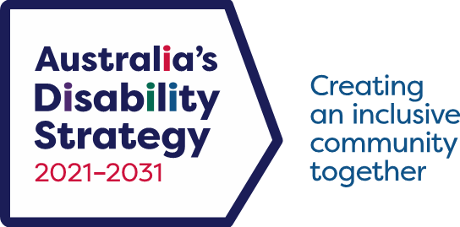

‘We support’ Brand Guidelines

Introduction

Disability in Australia
In 2018, 17.7% of all Australians had disability. That is 4.4 million people or about 1 in 4 people. The prevalence of disability increases with age. Of all people with disability, 1.9 million were aged 65 years and over.
Chances are you know someone with a disability. And if you do not have a disability now, it is highly likely you will at some stage of your life.
All levels of government are working to make society more accommodating for people with disability and to support them to participate in society. A key driver for change has been having a national disability strategy.

Australia’s Disability Strategy 2021-2031
Australia’s Disability Strategy 2021-2031 (ADS) is Australia’s overarching policy framework for disability reform.
The Department of Health, Disability and Ageing has responsibility for overseeing the ADS. The ADS supersedes the original National Disability Strategy 2010-2020.
More information on Australia’s Disability Strategy 2021-2031 is available at www.disabilitygateway.gov.au/ads
For further information on branding contact Australia’sDisabilityStrategy@health.gov.au



‘We support’ brand
The ADS ‘We support’ brandmark has been designed for use by associations or organisations who wish to show their support.
Several versions with shape and colour alternatives are available.

‘We support’ brand
Examples of the range of ‘We support’ assets are shown here. Use the versions most applicable to your needs.
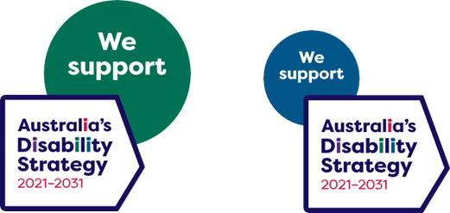
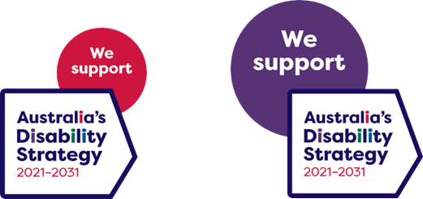



Brandmark misuse
When using the ‘We support’ branding, the brandmarks must only be used in their original format and colours.
Always use the files available for download on the ADS website when reproducing the brandmark.
Do not rotate, distort or change the brandmark from its original format.
Here are some examples of what would be considered misuse of the brandmark.
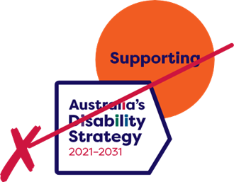
Do not alter the colours of the brandmark. Use the supplied files in their original format and colours only.
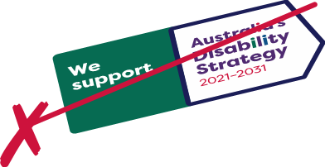
Do not rotate, distort or change the brandmark.

‘We support’ brand
Examples of how the ADS ‘We support’ brand assets can be used by organisations and associations are shown here.
The ‘We support’ branding can be used in smaller digital applications including social media tiles or websites, and in larger applications including shopfront window decals and banners.
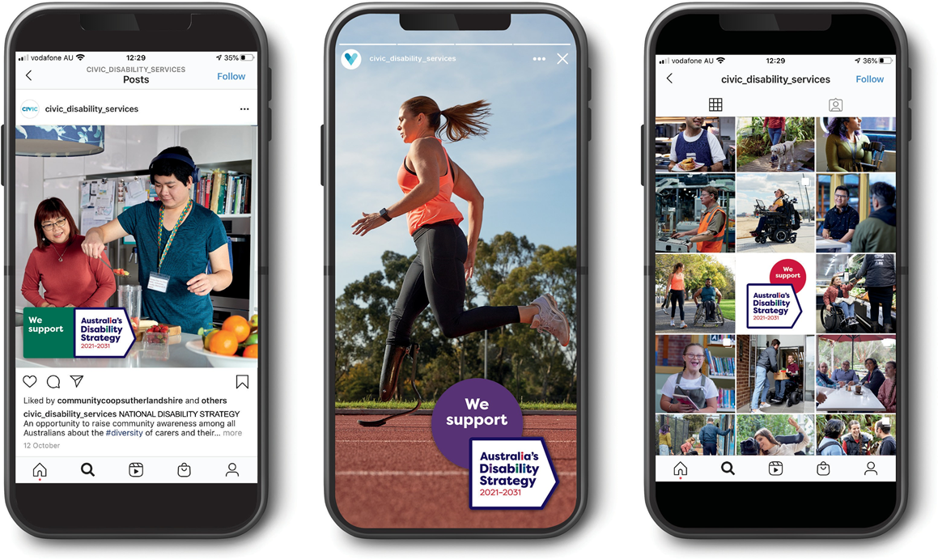

‘We support’ brand
