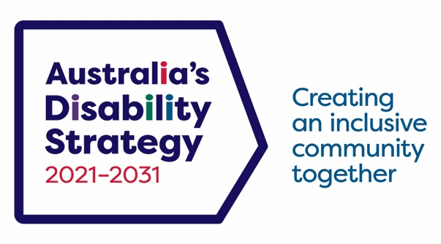

Australia’s Disability Strategy 2021-2031

Advisory Council 2025 Annual Report
Table of Contents

A word from the Chair 3

2025 in a snapshot 5

Key Achievments 7

2025 Advisory Council Meetings 7

March 2025 7

June 2025 7

August 2025 9

November 2025 11

2025 Advisory Council Workshops 12

Workshop One: Reporting for the next round of Targeted Action Plans (TAPs) 12

Workshop Two: Strengthening Evaluation practices in the Strategy 12

Workshop Three: First Nations Disability Forum – intersections with the Strategy and other relevant frameworks and strategies 13

Workshop Four: The Strategy 2025 Implementation Report 14

Workshop Five: The Strategy Engagement Plan 14

Workshop Six: Aviation Disability Standards – DITRDCSA 15

Workshop Seven: 2026 Work Plan 16

Workshop Eight: Housing 16

Other Meetings 17

Jurisdictional Disability Advisory Council Leads Meetings 17

The Strategy Advisory Council Housing Working Group 18

2025 Members 19

Key Priorities for 2026 20

Appendix 22

Formal Meetings 2025 22

Virtual Workshops 2025 22

Jurisdictional Disability Advisory Council Leads Meetings 22

Membership 2025 22

A word from the Chair
Jane Spring AM, Chair of Australia’s Disability Strategy Advisory Council

IMAGE 1: Photograph of Jane Spring

As Chair of Australia’s Disability Strategy (the Strategy) Advisory Council (the Council), I would like to acknowledge the significant contributions made by Council members over the past year and extend appreciation to both current and former members for their dedication and hard work.
In 2025, the Council focused on identifying where its work could have the greatest impact in advancing the Strategy and shaping broader national disability reforms. This included leveraging key findings from the Disability Royal Commission (DRC), the NDIS Review, and the refreshed Strategy to guide strategic advice and advocacy. The review of the Disability Discrimination Act 1992 (DDA) presented a critical opportunity to align legislative reform with the Strategy’s principles, particularly through the push for an enforceable positive duty that could shift the DDA from a reactive to a proactive framework. These developments enabled the Council to strengthen its role in promoting inclusion, preventing discrimination, and driving systemic change across government and society.
As Chair of the Council, 2025 offered me a wide range of opportunities to promote the Strategy across national and international platforms. Highlights included the launch of the refreshed Strategy in Geelong and the National Autism Strategy in Perth, participation in the 18th Session of the Conference of States Parties on the United Nations Convention on the Rights of Persons with Disabilities in New York, and engagement with key forums such as the Jurisdictional Disability Advisory Leads meetings, the National Disability Research Partnership (NDRP) event Mobilising disability research and evidence for policy impact, and co-presenting the Toolkit for Engaging with People with Disability in Evaluation at the aes25 International Evaluation Conference in a session: “Nothing about us without us”.
In September, I spoke at the Sydney Focus on Ability Film Festival, highlighting a key Strategy priority: changing community attitudes by celebrating the creativity, humour, and talent of people with disability sharing our own stories.
I’m proud of the Council’s work in 2025 to advance Australia’s Disability Strategy and drive meaningful reform. We remain committed to promoting inclusion, strengthening rights, and ensuring the voices of people with disability continue to shape policy and practice.

Jane Spring AM

2025 in a snapshot
The Council provides high-level advice to the Australian, state and territory Disability Ministers and governments (including local governments) on the implementation, monitoring, and evaluation of the Strategy. Guided by its annually endorsed Work Plan and Terms of Reference (ToR), the Council’s primary role is to offer ongoing recommendations to support the Strategy at a national level.
Following the 2025 federal election, the Labor Government restructured disability policy responsibilities. The National Disability Insurance Scheme (NDIS) and Disability and Carers portfolio moved from Social Services to the new Department of Health, Disability and Ageing (DHDA), under Senator the Hon Jenny McAllister. This aims to better integrate disability and health outcomes and strengthen the care and support sector.
In 2025, the Chair presented the 2024 Annual Report, 2025 Work Plan, and ToR updates to the Disability Reform Ministerial Council (DRMC), highlighting three new Targeted Action Plans (TAPs) designed to focus government action and improve accountability. The Council’s priorities included strengthening evaluation, shaping future TAPs, enhancing community engagement, and improving data and research through the National Disability Data Asset, the National Disability Research Partnership (NDRP), and the Strategy’s Outcomes Framework. The Council also promoted accessible communications, positive public attitudes, and cross-portfolio application of the Strategy.
Beyond regular meetings, the Council held seven workshops to address priority issues such as inclusive evaluation, establishing a First Nations Disability Forum, and improving the Strategy’s Implementation Report and Engagement Plan. The Council worked closely with key stakeholders, including Minister McAllister, the Disability Discrimination Commissioner, Rosemary Kayess, the National Disability Research Partnership CEO Mary Sayers, NDIS Reform Advisory Committee Co-Chairs Dougie Herd and El Gibbs, and officials from relevant government departments. These collaborations ensured the Strategy’s principles were embedded across sectors and informed practical policy and legislative change.
Council members also represented the Strategy at public events, such as the Focus on Ability Film Festival and the International Day of People with Disability at Parliament House, promoting inclusion and practical advice, hosted by Minister McAllister. These occasions gave the Council a platform to represent the Strategy, share insights, and promote inclusive, practical advice to help embed the Strategy into everyday policies and legislation.
In its submission to the Review of the Disability Discrimination Act, the Council advocated for stronger protections, including an enforceable positive duty to prevent discrimination, a no-cost complaints process, cultural safety for First Nations people, a clearer definition of ‘unjustifiable hardship’, and improved accessibility standards.
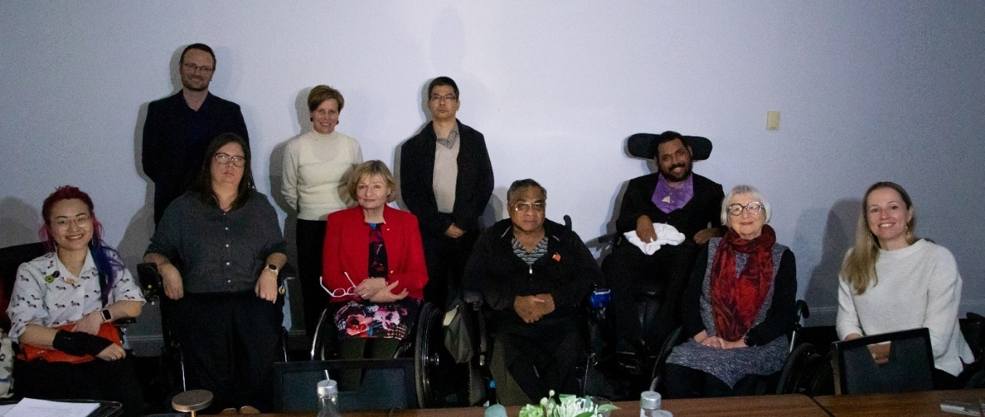

Image 2: Photograph of Council members at face-to-face June meeting
Mx Akii Ngo (Core Member); Mr Chris Varney (Victorian Representative); Ms Kelly Cox (New South Wales Representative); Minister McAllister, Minister for the National Disability Insurance Scheme; Ms Jane Spring AM (Chair); Mr Sisaleo Philavong (South Australian Representative); Uncle Wilfred Prince (Core Member); Mr Seriako Stephen (Core Member); Dr Keran Howe OAM (Core Member); Ms Sarah Skopellos (Northern Territory Representative).

Key Achievments

2025 Advisory Council Meetings
The Council had four formal meetings in 2025, occurring on 13 March, 17 & 18 June, 26 August and 28 November.

March 2025
In March the Council met online to endorse its informal advice to government officials on the Evaluation of the Strategy (Phase One) and Targeted Action Plan (TAP) Reporting. Council also discussed the planned development of a First Nations Disability Forum (the Forum) in response to the DRC recommendation 9.10.

Topics of discussion
- Endorsing informal advice on the Evaluation of the Strategy, with members reflecting on the importance of an effective, inclusive process to procure an independent evaluator of the Strategy, and the need for information and engagement approaches that are in-line with the disability community.
- Endorsing formal advice on TAP Reporting. Council sought opportunities for members to support the Chair to engage with officials in relation to the TAP Report and asked that government consider how public sector agencies are resourced to implement TAPs.
- On the Forum, Council discussed the roles of different organisations, the Forum’s proposed purpose and its connection to the Strategy, the importance of involving First Nations people with disability in evaluation, and the value of hearing from Indigenous organisations about how the Council could support the Forum.

June 2025
In June the Council met in Sydney over two days, where members met Minister McAllister, Minister for the NDIS. It was a full agenda for the two-day meeting, with key presentations from Mary Sayers (Chief Executive Officer of the NDRP), El Gibbs and Dougie Herd (Co-Chairs of the NDIS Reform Advisory Committee), Rosemary Kayess (Disability Discrimination Commissioner, Australian Human Rights Council), and Brendon Buckley (Assistant Secretary, Transport Accessibility and Future Fuels Branch, the Department of Infrastructure, Transport, Regional Development, Communications, Sport and the Arts – DITRDCSA).
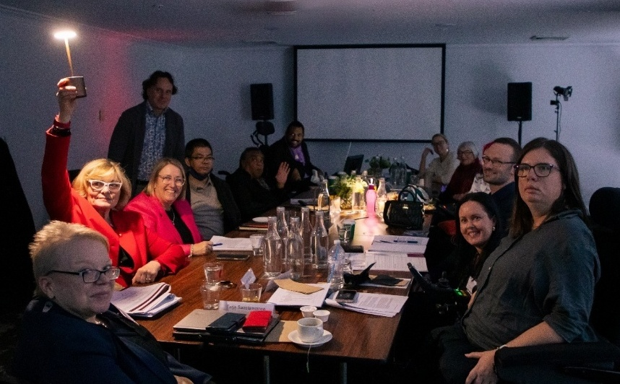

IMAGE 3: Photograph of Council members sitting around a table in a dark room
The meeting was eventful, with a large-scale, all-day power outage near the meeting location that impacted on the first day of the meeting (no lighting, heat or elevators). Special thanks to all members and their support workers for persevering under difficult circumstances and choosing to go ahead with the meeting despite the barriers. Council members showed their commitment and resilience, managing in less-than-ideal meeting conditions.

Topics of discussion

Day 1 – 17 June
- Following the 3 May 2025 federal election, responsibility for all disability functions including the Strategy, but excluding Disability Employment shifted from the Department of Social Services to the newly established Department of Health, Disability and Ageing. The Council endorsed its amended advice on the First Nations Disability Forum, emphasising the need to represent First Nations people with disability regardless of whether the Forum is established.
- The Council highlighted the importance of culturally appropriate data, stronger support for remote communities, and ensuring the Strategy reflects intersectionality, aligns with the UNCRPD and Closing the Gap, and addresses the perspectives of Torres Strait Islander peoples. Targeted Action Plans should embed intersectionality and address regional, early childhood, housing, and justice issues. Co-design must involve First Nations people with disability, and progress should be tracked through improved data and aligned indicators across frameworks.
- Council discussed Strategy Outcomes and Accountability and improvement mechanisms under the Strategy Outcomes Framework, the Data Improvement Plan and the Strategy reporting processes, and the National Disability Data Asset and NDRP. Members discussed access to Strategy Outcomes data, which is currently limited to people affiliated with an organisation accredited by the National Data Commissioner (government agencies and universities). Members also noted gaps in data, particularly from non-government service providers and advocacy organisations, and emphasised the need for inclusive, community-engaged data collection using a diversity, intersectionality, and equity lens. It was also noted that NDRP research grants require Australian Business Number-holding organisations to demonstrate researcher partnerships, and concerns were raised about low remuneration for researchers with disability.
- The Council discussed its engagement with the NDIS Reform Advisory Committee, focusing on amplifying messaging and ministerial engagement. Members recommended a public survey and direct feedback from NDIS participants to assess the impact of reforms. While Cabinet has announced Foundational Supports, members noted ongoing uncertainty about their delivery and the timing of the Committee’s formal announcement.
- During the scheduled time with Minister McAllister, Council discussed concerns around NDIS reform and Foundational Supports, suggesting an advisory role alongside the Strategy. Members noted issues including poor communication on reform timelines, limited services for Torres Strait Islander people, and the complexity and cost of accessing NDIS funding. Council also highlighted the need for stronger intersectional approaches, especially for LGBTIQA+ people with disability, and recommended leveraging employees with lived experience to strengthen policy. Opportunities were identified in accessible housing and improving support for people with disability outside the NDIS, including migrants and refugees.

Day 2 – 18 June
- Council members raised concerns about the accessibility of the Associated Plan on Accessible Information and Communications, especially for people with disability whose first language is not English. They stressed the need for ongoing feedback, effective evaluation, and two-way communication with government. Key challenges include the absence of national Easy Read guidelines, limitations of AI and assistive technology, and the non-binding status of Associated Plans. Members also emphasised the importance of supported decision-making and sustaining accessible communication over the long term, drawing on lessons from the pandemic and the Disability Royal Commission.
- Council engaged with the Disability Discrimination Commissioner on challenges in implementing fairness and equity in legislation, particularly in the absence of specific diversity policies. Members emphasised the need to use the UNCRPD to drive change and raise concerns about recent NDIS cuts, especially their impact on carers and service access in regional areas. Issues included high provider overheads, market instability, and the complexity of NDIS requirements. Council also highlighted the importance of supported decision-making and called for clearer federal responsibility for disability support following the shift from state and territory systems.
- Council provided feedback on the Toolkit for Engaging with People with Disability in Evaluation, highlighting the need to reflect the diversity and multi-intersectionality of people with disability, and to ensure evaluations are inclusive, accessible, and ethically sound. Members recommended clearer audience targeting, culturally and age-appropriate formats, and stronger emphasis on accessible communication and supported decision-making. They also suggested including case studies, such as the White Box Enterprises trial, and using video stories to capture lived experiences. Concerns were raised about the term ‘reasonable adjustment’ and the need for fair remuneration for people with disability involved in evaluation.
- Council discussed the Aviation White Paper, raising concerns about the enforceability of aviation disability standards and the need for stronger compliance mechanisms beyond fines. Members advocated for involvement in co-design workshops, facilitated by people with lived experience, and called for clearer complaint pathways and alignment with the DDA. They also highlighted the importance of gender-neutral communication, culturally sensitive practices, and addressing systemic barriers such as limited mobility equipment access and medication checks at security.

August 2025
In August the Council met online and received a presentation from the Attorney-General’s Department on the DDA review and consultation. During the meeting, Council endorsed its informal advice on the Strategy Engagement Plan, received updates on TAP reporting and the Disability Data Measure (DDM) Project, and heard from department officials on the latest reporting related to the implementation of recommendations from the DRC.

Topics of discussion
- Department officials provided an update on TAPs reporting progress, noting that Council’s formal advice informed the report, which is planned for publication by the end of 2025. Council expressed interest in reviewing the report once available to see how its advice has been reflected.
- The Council strongly supported bold reforms through the Review of the DDA, advocating for an enforceable positive duty, a no-cost complaints mechanism, and clearer definitions around unjustifiable hardship. Members emphasised the need for culturally safe processes, inclusive accessibility standards, and recognised this review as a critical opportunity to strengthen protections for people with disability. The Council endorsed the development of a joint submission and remains committed to promoting consultation and driving meaningful legislative change.
- Council noted concerns about the lack of a clear disability definition in the DDM Project, preferring a focus on barriers to participation over medical models of disability. Members supported functional approaches like the Washington Group Short Set and emphasised cultural safety and intersectionality. They stressed the importance of including people with lived experience in project teams, recommended further testing through paid community consultation, and highlighted the need to learn from international and state-level research.
- In relation to the DRC reporting to 30 June 2025, Council welcomed the proposed website format for hosting reports and suggested improvements, including clearer status updates on consultations and links to open submissions. Members also noted concern over the lack of visible leadership in implementing the Commission’s recommendations.
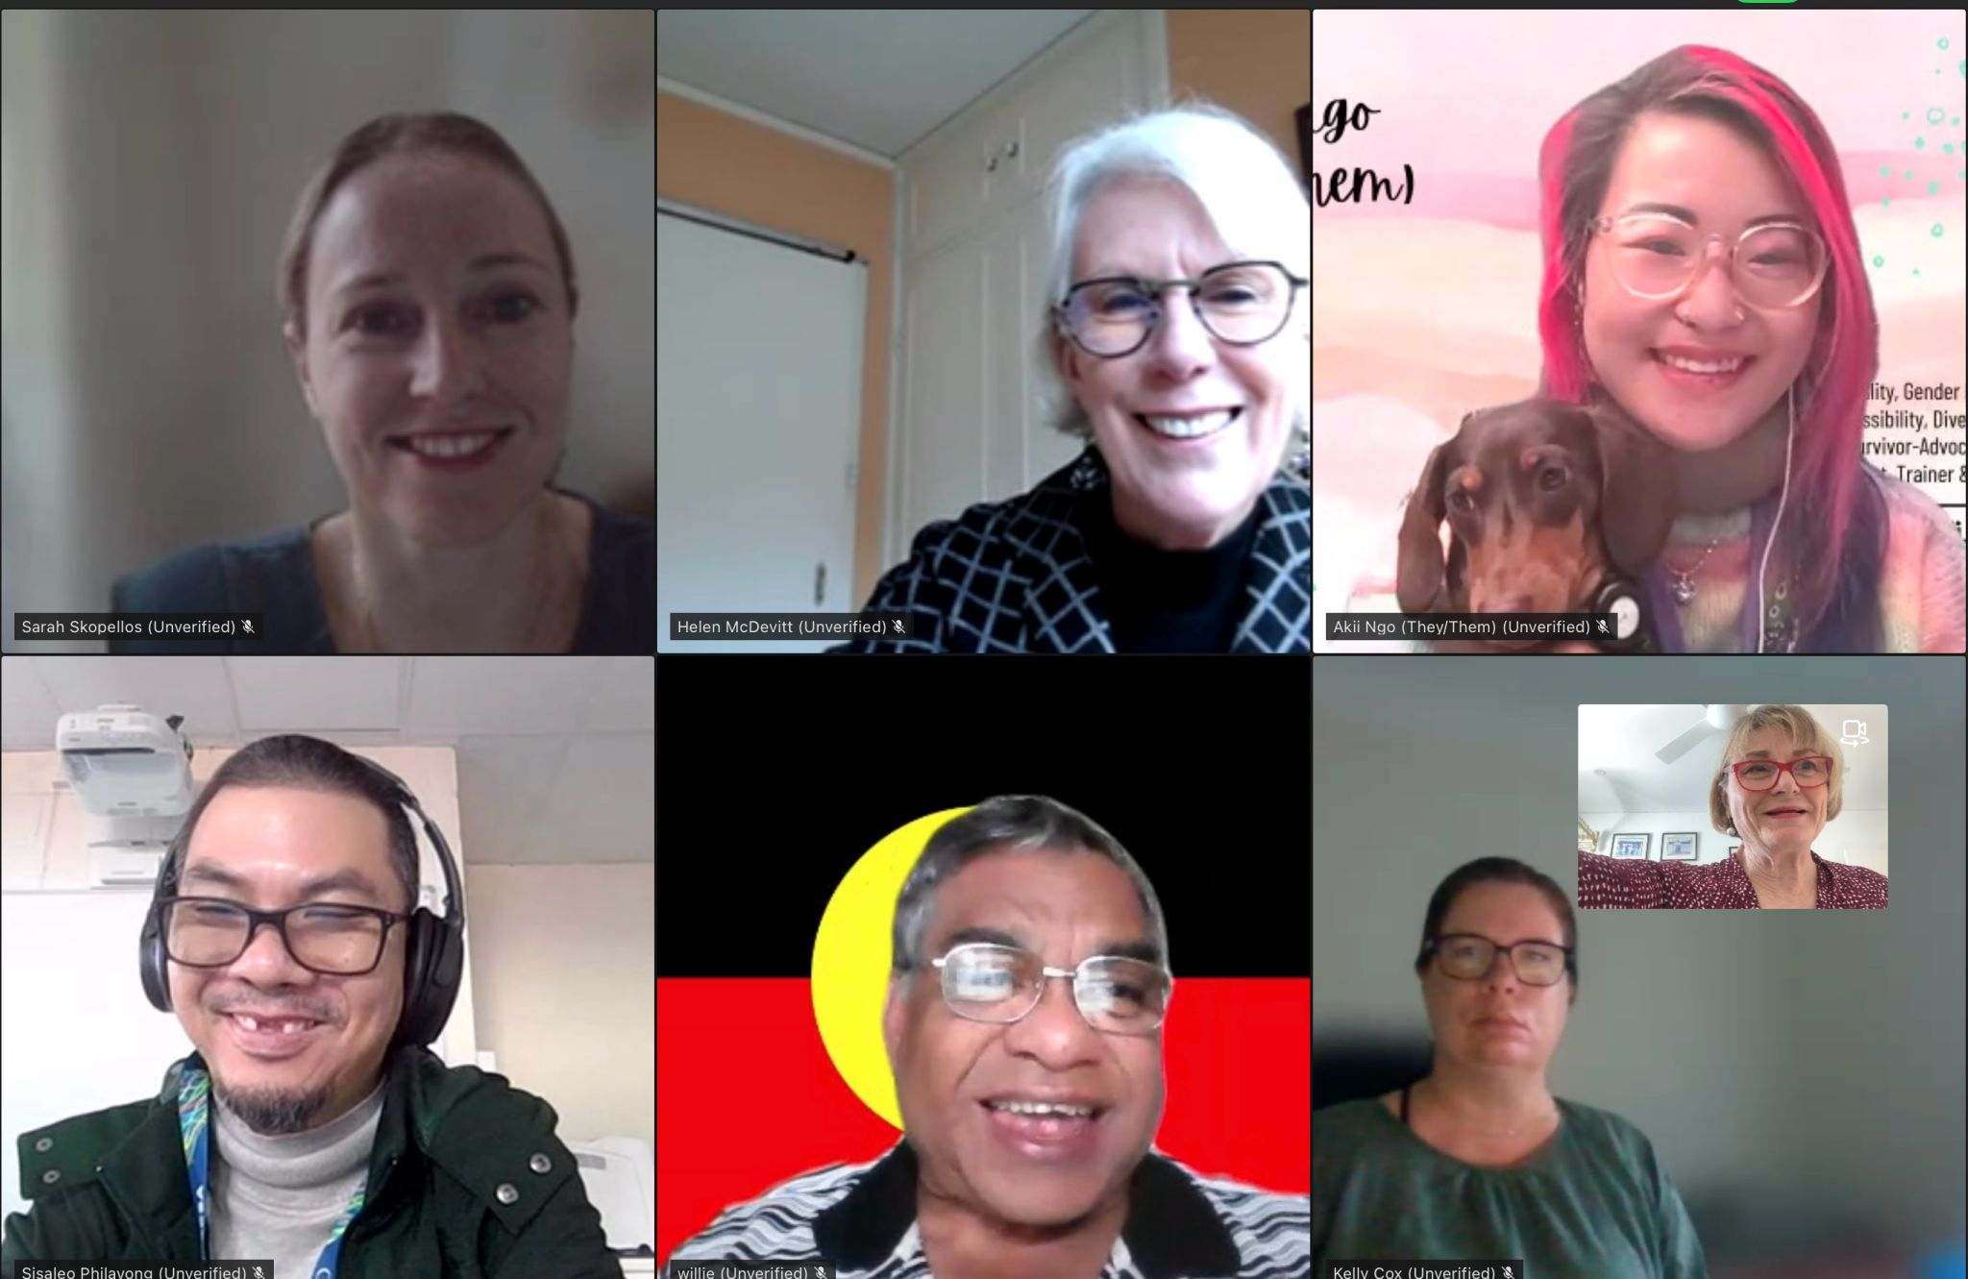

IMAGE 4: Photograph of seven members in a Council virtual Teams meeting

Ms Sarah Skopellos (NT Representative), Ms Helen McDevitt PSM (Special Advisor), Mx Akii Ngo (Core Member), Mr Sisaleo Philavong (SA Representative), Uncle Wilfred Prince (Core Member), Ms Kelly Cox (NSW Representative), Ms Jane Spring AM (Chair).

November 2025
The November virtual meeting did not go ahead. Instead, members received a written update and agreed to key documents out of session:
- Members endorsed:
  - Their informal advice to government officials on housing.
  - Governance documents including this Annual Report and the 2026 Work Plan.
- Members received updates on:
  - Progress on the Inclusion and Accessibility Fund to shift attitudes and reduce harm.
  - Reforms to improve outcomes for First Nations people with disability, aligning with Closing the Gap and other frameworks.
  - Status of the Disability Discrimination Act review consultation.
  - Planning for the Australia’s Disability Strategy National Forum, scheduled for February 2026.

2025 Advisory Council Workshops
2025 saw the introduction of a new way of working for the Council, based on the Council’s desire to focus on some key parts of Australia’s Disability Strategy to strengthen accountability and more closely monitor implementation. To assist in developing advice, eight workshops were organised for the Council across the year. Separate from the Council’s formal meetings, the workshops allowed Council members to engage more deeply with government officials leading work on priority topics under the Strategy.

Workshop One: Reporting for the next round of Targeted Action Plans (TAPs)
- The workshop on 17 February 2025 highlighted the importance of using Targeted Action Plans (TAPs) to drive real change and improve accountability for people with disability. Members stressed that people with disability should be involved throughout the entire TAPs process, from designing actions to evaluating their success. This involvement could take many forms, such as co-design with disability organisations, community workshops, or advisory groups, and must prioritise accessibility and inclusion of diverse voices, especially those who may not find current actions effective.
- Members also discussed the need to improve how actions and their outcomes are measured. They called for clearer indicators that focus on real change for the disability community, rather than just outputs like the number of training sessions delivered. Members suggested including baseline data, expected improvements, and disaggregation by region or cohort to better understand impact. They also emphasised the importance of linking measures to the Strategy Outcomes Framework and identifying data gaps to ensure no group is left out.
- Finally, members called for more transparent and accessible reporting. They want TAPs reports to evolve over time, reflecting lessons learned and improvements made. Reports should explain why actions were chosen, how they’re being implemented, and what impact they’re having. Sharing case studies, challenges, and successes - especially from underrepresented communities - could help improve future actions. Accessible formats and clear language are essential so people with disability can engage with the reports, track progress, and provide feedback.

Workshop Two: Strengthening Evaluation practices in the Strategy
- The workshop on 18 February 2025 focused on how to make evaluation processes more inclusive for people with disability, especially in the context of the Guide to Involving People with Disability in Evaluation and the independent evaluation of the Strategy. Council emphasised the importance of involving people with disability throughout the evaluation process, not just as subjects but as contributors and decision-makers. They also highlighted the potential for the Guide to be used by state and territory disability councils to promote inclusive practices across all levels of government.
- Four key themes emerged:
  - Members shared strategies to ensure meaningful inclusion, such as using citizen juries, applying trauma-informed and accessible practices, targeting communication to the right cohorts, and compensating participants fairly. They stressed the need to build on existing inclusive evaluation work and ensure evaluations are safe, respectful, and representative.
  - Members identified barriers to participation, including communication challenges, geographic isolation, and over-reliance on familiar voices like advocacy organisations, which can limit diversity in feedback.
  - Members discussed how the scope of evaluations should reflect co-design principles, cultural safety, and inclusive language. Evaluations should be designed with input from people with disability and tailored to meet diverse needs, including those with intellectual or developmental disabilities.
  - When selecting an independent evaluator, members stressed the importance of choosing providers with lived experience, cultural competence, and a commitment to inclusive and trauma-informed practices. They also recommended involving people with disability in the selection process and governance of the evaluation.

Workshop Three: First Nations Disability Forum – intersections with the Strategy and other relevant frameworks and strategies
- At the workshop on 15 April 2025, Council members explored how they could engage with a potential First Nations Disability Forum and what their role might be if the Forum was not established. They discussed the importance of aligning their work with existing frameworks like the National Agreement on Closing the Gap and the Strategy, particularly in areas such as justice and service access in remote communities. Members stressed the need to use culturally safe and appropriate data sources, like the NDRP and the National Disability Data Asset, while avoiding duplication and ensuring efforts are well-targeted.
- Council also considered how to collaborate with the NDIS Independent Advisory Council First Nations Reference Group and the proposed Forum. They highlighted the need for shared priorities, strong partnerships, and clear communication to avoid overlapping work. If the Forum is not created, Council would need more resources to engage directly with First Nations-led initiatives and ensure meaningful representation of First Nations people with disability. They also emphasised the importance of culturally respectful engagement, capacity-building, and creating leadership pathways within First Nations communities.
- In follow-up discussions, Council reinforced the need for better communication of the Strategy to First Nations communities, especially in remote areas. They called for culturally safe messaging, realistic timelines, and dedicated resources to support intersectional approaches. Council also stressed the importance of co-designing policies with First Nations people with disability, using lived experience to shape early intervention and long-term support. They recommended aligning data and reporting between the Strategy and the National Agreement to improve visibility and outcomes for First Nations people with disability, while also recognising the distinct perspectives of Torres Strait Islander peoples.

Workshop Four: The Strategy 2025 Implementation Report
- In the workshop on 9 July 2025, Council highlighted the need for reporting to focus more on the real-life impact of the Strategy on people with disability, rather than just policy changes. While some positive outcomes have been observed, Council noted that not all improvements are directly linked to the Strategy, and lived experiences—especially around accessibility and safety—don’t always match the data. They stressed the importance of reporting both positive and negative impacts and ensuring that practices are inclusive and trauma informed.
- Council acknowledged some achievements under the Strategy, particularly in education and employment. There have been improvements in school completion rates and access to vocational and tertiary education, as well as better access to government buildings and jobs. However, members were cautious about celebrating small improvements without clear evidence that they were driven by the Strategy. They called for more detailed reporting on reasonable adjustments in education and questioned whether some reported gains reflect meaningful change.
- Key areas needing improvement include air travel, housing, discrimination, and social participation. Council recommended better tracking of funding, stronger use of evidence and data, and improved coordination between governments. They also urged the inclusion of intersectionality—especially the voices of First Nations people with disability—in future reports. To make the Strategy Implementation Report more accessible and useful, they suggested using case studies, offering content in diverse formats, and clearly linking the report to broader disability reforms and international commitments.

Workshop Five: The Strategy Engagement Plan
- At the workshop on 12 August 2025, Council discussions on improving community engagement with people with disability focused first on identifying the right communication channels. Members suggested mapping existing forums and networks across all levels of government to avoid duplication and better coordinate efforts. They also recommended using a broader range of engagement partners—such as land councils, community health organisations, and state advisory bodies—to reach beyond traditional disability organisations. Transparency in how and why changes are made to policies and programs was seen as essential to building trust and encouraging participation.
- The second theme centred on the methods of engagement. Council emphasised the importance of using a mix of approaches that are inclusive, culturally safe, and accessible to all, including hard-to-reach groups. While digital tools like surveys are useful, they often lack depth and personal connection. More interactive and responsive methods—such as focus groups, community report cards, and two-way online forums—were recommended. Council also highlighted the value of showing how community input leads to real change, and suggested that compensating participants could improve both engagement and data quality.
- Finally, Council stressed the need for stronger accountability and feedback mechanisms. They called for regular updates on how community feedback is being used, especially in relation to major reforms like the NDIS and DRC. Feedback should be built into policy and service design, with senior leaders made aware of community insights. Council also recommended making community engagement a requirement in funding and procurement processes and introducing a positive duty for organisations to listen and respond to feedback. Access to reliable data sources, like the National Disability Data Asset, was seen as key to tracking progress and impact over time.

Workshop Six: Aviation Disability Standards – DITRDCSA
- The workshop on 2 September 2025 included Council discussions on regional aviation focused on improving accessibility, consistency, and support for passengers with disability. Members highlighted the need for airlines to provide clear information about aircraft limitations for mobility equipment and to plan when using smaller aircraft. They stressed that passengers with disability should not bear the cost or inconvenience when accessibility issues arise and called for government intervention where airlines cannot meet accessibility needs. Better boarding processes, accessible airport design, and improved handling of mobility aids were also key priorities, along with making online booking systems more inclusive.
- Council also encouraged the use of technology to enhance travel experience, such as storing accessibility needs in travel profiles, GPS tracking for mobility equipment, and guided travel simulations. They emphasised the importance of training for airline staff and equipment providers to ensure mobility aids are handled safely and respectfully. Clear communication about aircraft cargo limits and safeguards against discriminatory policies were also recommended. Overall, Council called for a more inclusive, respectful, and coordinated approach to regional air travel for people with disability.
- In follow-up discussions, Council members emphasised the need for enforceable Aviation Disability Standards to counteract financial pressures that may undermine accessibility. They called for stronger compliance measures and a more robust complaints process, including enforcement mechanisms under the DDA like those in the U.S. Americans with Disabilities Act 1990. Members also highlighted the importance of respectful, gender-neutral communication by airline staff, and urged government and industry to engage in genuine, co-designed consultation with people with lived experience of disability. Additionally, they recommended improvements to airport security processes to ensure people with disability are not unfairly burdened, particularly when travelling with essential medications.

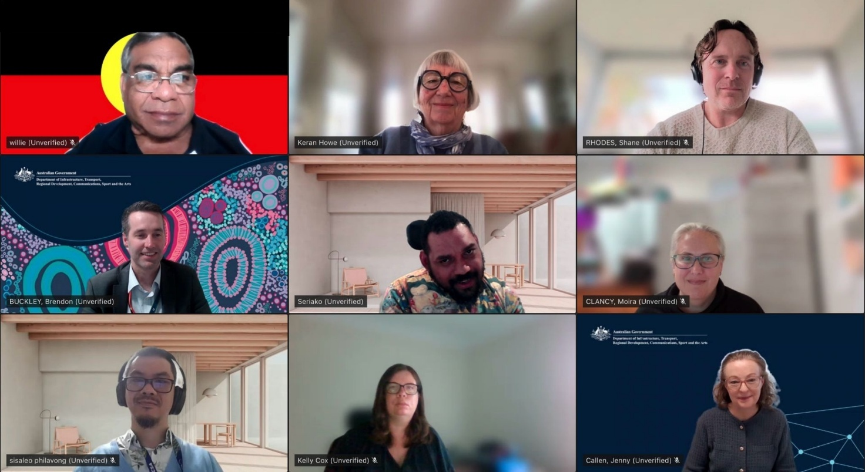

IMAGE 5: Photograph of participants in a Council virtual Teams meeting

Uncle Wilfred Prince (Core Member), Dr Keran Howe OAM (Core Member), Mr Shane Rhodes (Secretariat), Mr Brendon Buckley (Assistant Secretary for the Transport Accessibility and Future Fuels Branch at the Department of Infrastructure, Transport, Regional Development, Communications, Sport and the Arts), Mr Seriako Stephen (Core Member), Ms Moira Clancy (Secretariat), Mr Sisaleo Philavong (SA Representative), Ms Kelly Cox (NSW Representative) and Ms Jenny Callen (Director, Aviation Accessibility, Transport Accessibility and Future Fuels Branch, DITRDCSA)

Workshop Seven: 2026 Work Plan
- On 22 October 2025, the Council met to discuss priority topics for consideration next year, for inclusion in the 2026 Work Plan.
- The Council agreed that the area of formal advice to DRMC in 2026 will be the Strategy TAPs report.
- Proposed areas for Council informal advice to government officials in 2026 target the monitoring and implementation of the Strategy, as well ensuring the Strategy is reflected broadly in cross-portfolio work undertaken across government.
- As a part of this work, the Council will also participate in six workshops to ensure associated informal advice is meaningful, strategic and impactful. Further detail is provided under Key Priorities for 2026.

Workshop Eight: Housing
- On 7 November 2025, the Council met to discuss government housing initiatives and provide feedback to inform the housing reform agenda. Member discussion focused on suggestions to improve housing outcomes for people with disability through setting clear and consistent national accessibility standards and embedding universal design in building codes. Council noted that incentives can drive architects and builders to create affordable, attractive, accessible homes. Policies should support cost-effective upgrades for existing housing and ensure people with disability are involved in reviews and decision-making.
- Members called for improved funding for the training of public housing staff and stressed that education for architects, builders, and providers is essential to improve accessibility and cultural safety. Stronger enforcement of discrimination rules and programs that show the benefits of accessible design will help shift practice. Social housing providers need disability specific knowledge and skills to oversee inclusive projects.
- Council noted that governments need better, consistent data on housing, homelessness, and aged care for people with disability (inclusive of young people with disability). Reporting should include gender, disability type, and location. Monitoring compliance and sharing advice nationally will support alignment and track progress on accessibility reforms.
- In closing, Council highlighted that housing policy must address systemic barriers that lead to homelessness and institutionalisation. Women and children escaping violence, First Nations people, and those leaving prison face unique challenges. Some suggestions identified by council included accessible refuge housing, housing on Country, and learning from successful overseas models to improve long-term outcomes.

Other Meetings

Jurisdictional Disability Advisory Council Leads Meetings
In 2025, the Advisory Council Chair hosted three Jurisdictional Disability Advisory Council Leads Meetings, bringing together representatives from state and territory advisory groups to share updates, discuss policy developments, and strengthen cross-jurisdictional collaboration.
These meetings foster open communication, expand the disability leadership network, and ensure the Council remains informed on emerging issues and good practice across Australia.
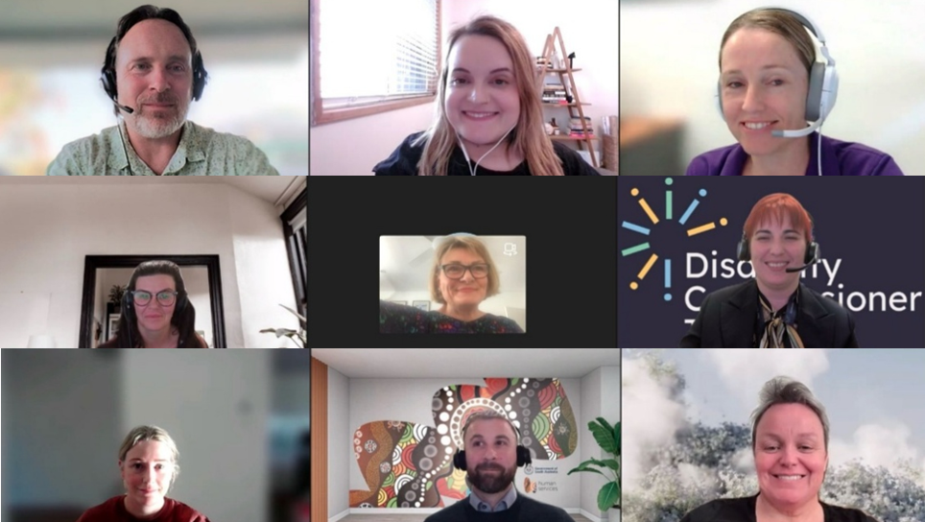

IMAGE 6: Photograph of participants in a Jurisdictional Disability Advisory Council virtual Teams meeting

Mr Shane Rhodes (Council Secretariat), Ms Belle Owen (South Australian Minister's Advisory Council on Disability), Ms Sarah Skopellos (Deputy Chair, Northern Territory Disability Advisory Committee), Ms Raigan Miller (Council Secretariat), Ms Jane Spring AM (Council Chair), Ms Catherine Whitington (Disability Commissioner for Tasmania), Ms Eve Young (Council Secretariat), Mr Daniel Stuart (Policy Officer, Department of Human Services, South Australia), Ms Clare Gibellini (Chair, Western Australia Ministerial Advisory Council on Disability).

The Strategy Advisory Council Housing Working Group
The Terms of Reference for Council’s Housing Working Group (HWG) expired in mid-2025.
With changes to the landscape of housing and disability since the HWG was established, the creation of the Targeted Action Plan for Inclusive Homes and Communities and advances with the Outcomes Framework for inclusive homes and communities, Council agreed to disband the HWG and to fold housing concerns back into the overall work of the Council.

2025 Members
Outgoing Core Member – The Advisory Council would also like to acknowledge the contributions of core member, Mr Seriako Stephen, whose term ended in December 2025. A member of the Advisory Council since December 2021, Seriako contributed his unique perspectives as a Torres Strait Islander and person with disability throughout his tenure. Seriako’s contributions have been deeply appreciated, and his wonderful sense of humour will be missed by Council members.
Outgoing State and Territory Representative Members – In 2025, the Advisory Council saw the 18-month terms end for Ms Kelly Cox (from the Disability Council New South Wales), Ms Sarah Skopellos (from the Northern Territory Disability Advisory Committee), Mr Sisaleo Philavong (from the Disability Minister’s Advisory Council of South Australia) and Mr Chris Varney (from the Victorian Disability Advisory Council). These four state and territory representative members brought a wealth of knowledge, expertise and lived experience to helping shape how governments implement the Strategy in driving better outcomes for people with disability.
Outgoing Special Advisor – in December 2025, the membership term for Special Advisor Helen McDevitt PSM concluded. Ms McDevitt brought a strong public service lens to the work of Council, drawing on her extensive experience in social policy, Commonwealth–State relations, and leadership in major reforms such as the transition to the National Disability Insurance Scheme. Her insights have strengthened the Council’s focus on inclusion and equity, ensuring our advice reflects both strategic policy considerations and the lived experience of people with disability.
New Advisory Council members were announced in early 2026.

Key Priorities for 2026
The Strategy Advisory Council 2026 Work Plan supports the Advisory Council Chair to determine appropriate agendas, priorities, guests and focus for each meeting, and enables DRMC to consider the outcomes of the Advisory Council’s activities and meetings.
The Advisory Council has the following topics of focus for 2026, under the following three categories:
- Formal advice to the Disability Reform Ministerial Council for the consideration of disability Ministers:
- Development of the TAPs report for 1 July 2025 to 30 June 2026, ensuring it is fit for purpose and adequately reflects Council advice to date.
- Informal advice on the Strategy deliverables:
- the Independent Evaluation of Australia’s Disability Strategy
- Education and Learning (Inclusive Education Reform) and linkages between Strategy Outcomes and Disability Royal Commission (DRC) recommendations.
- Reflecting the Strategy’s TAP actions relating to disability employment in the Australian Public Service.
- Closing the Gap (CTG) /the Strategy intersections
- Development of set of disability survey questions for Strategy Reporting
- Improving Access to Information and Communications for People with Disability: An Associated Plan under Australia’s Disability Strategy
- Development of Data Improvement Plan including DRC data-related Action Plan
- Information updates on reforms and government work that intersect with the Strategy, for example:
- the Strategy Engagement Plan
- Major Sporting Events and the Brisbane 2032 Games, linking to the Disability Sports Index and National Disability Sports Awards
- the new Aviation Disability Standards as a schedule to the existing Disability Standards for Accessible Public Transport 2002
- the National Accessible Tourism Working Group and intersections with the Strategy
- Women and girls with disability and broader intersectionality and representation across the Strategy
- HumanAbility review of disability support and aged care Vocational Education and Training (VET) qualifications
- Sport - National Integrity Framework (NIF)
- Employment and Financial Security (workforce participation and economic inclusion) - linkages between the Strategy Outcome and DRC recommendations
- Updates/revisions to the Strategy Outcomes Framework outcome measures
- Embedding disability inclusion in Closing the Gap health initiatives and linkages to the Strategy
- Future Strategy Survey Waves
- DRC Progress Report 2026

The 2025 annual review process for the Advisory Council’s Terms of Reference (ToR) has occurred, with agreement to revisions by the DRMC in April 2026. The ToR sets out the Advisory Council’s key purpose, providing high-level advice to the Australian, state and territory Disability Ministers and governments (including local governments) on the implementation, monitoring, and evaluation of the Strategy. This includes a focus on providing independent advice, feedback, and recommendations at a national level on the Strategy.
Several members will conclude their terms in 2026, including my own term as Chair, which is set to end in December next year. While the Council will lose valuable experience, this transition presents a strong opportunity to welcome new members who can bring fresh perspectives, diverse skills, and continued support for the Advisory Council’s work into the future.

Appendix

Formal Meetings 2025
- 13 March 2025 – Virtual
- 17 and 18 June 2025 – two-day face to face meeting held in Sydney
- 26 August 2025 – Virtual
- 28 November 2025 – Virtual

Virtual Workshops 2025
- 17 February 2025 – Targeted Action Plans
- 18 February 2025 – Strengthening Evaluation Practices
- 15 April 2025 – First Nations Disability Forum
- 9 July 2025 – Australia’s Disability Strategy 2025 Implementation Report
- 12 August 2025 – Australia’s Disability Strategy Engagement Plan
- 2 September 2025 – Aviation Disability Standards
- 22 October 2025 – Advisory Council 2026 Work Plan
- 7 November 2025 – Housing

Jurisdictional Disability Advisory Council Leads Meetings
- 25 March 2025 - Virtual
- 29 September 2025 - Virtual
- 8 December 2025 - Virtual

Membership 2025

* Term ended during the 2025 calendar year
Member | Role | Term
Jane Spring AM | Chair  Interim Chair | 27 November 2023 - 31 December 2026  1 July 2023 – 31 December 2023
* Seriako Stephen | Core Member | 23 December 2021 - 23 December 2025
Akii Ngo | Core Member | 26 June 2024 - 26 June 2027
Uncle Wilfred Prince | Core Member | 26 June 2024 - 26 June 2027
Dr Keran Howe OAM | Core Member | 1 February 2025 – 31 January 2028
* Kelly Cox | NSW Representative | 9 May 2024 - 1 September 2025
* Sisaleo Philavong | SA Representative | 8 May 2024 - 1 September 2025
* Sarah Skopellos | NT Representative | 1 May 2024 - 1 September 2025
* Chris Varney | Vic Representative | 30 April 2024 - 1 September 2025
Helen McDevitt PSM | Special Adviser | 20 December 2024 – 31 December 2025  23 October 2022 – December 2024
The Advisory Council is supported by a Secretariat in the Department of Health, Disability and Ageing. For further information, please contact: ADSAdvisoryCouncil@health.gov.au

