Australia’s Disability Strategy Advisory Council

March 2026
Update
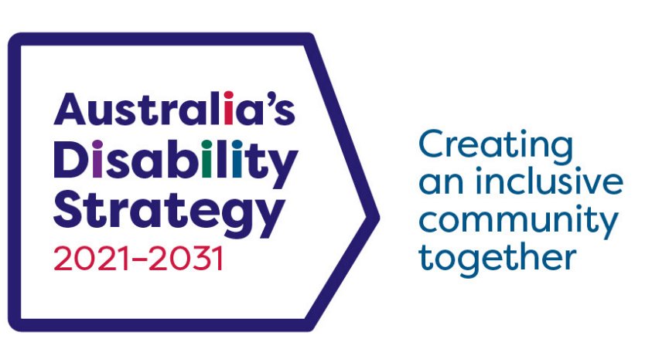
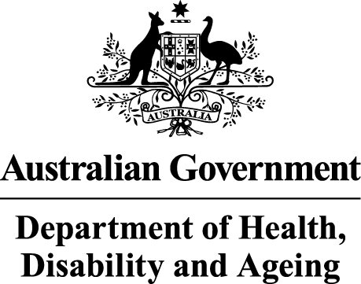 | The Australian Government Department of Health Disability and Ageing wrote this.  We say DHDA for short.  When you see the word we it means DHDA.
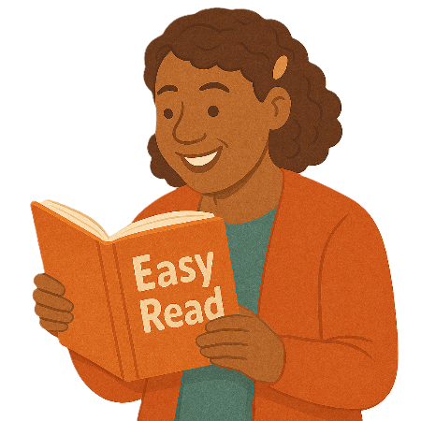 | We wrote this in an easy to read way.  We use pictures to explain some ideas.
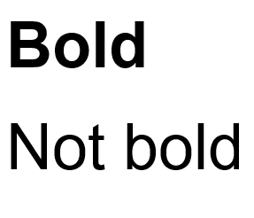 | We have some words in bold.  This means the letters are thicker and darker.  These are important words.
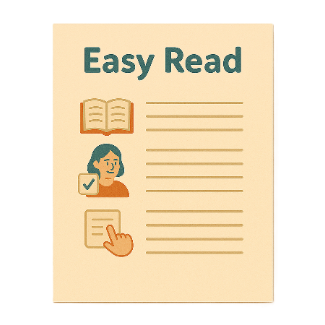 | This is an Easy Read summary of another document.  This means it has the most important ideas.
 | We can answer any questions by email.  Email us ADSAdvisoryCouncil@health.gov.au
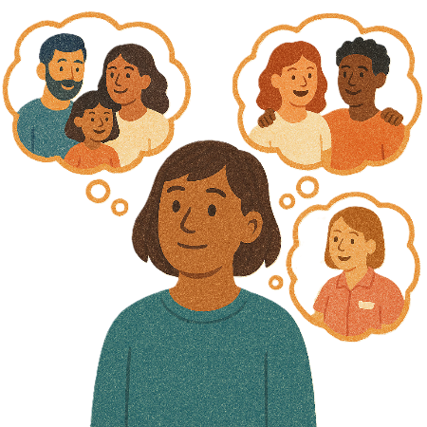 | You can ask for help to read this document.  You can ask  - A friend  - Family members  - A support person.
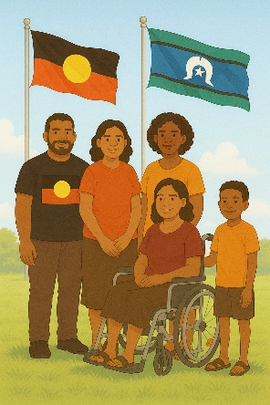 | We recognise Aboriginal and Torres Strait Islander people as the Traditional Owners of the land we live on.
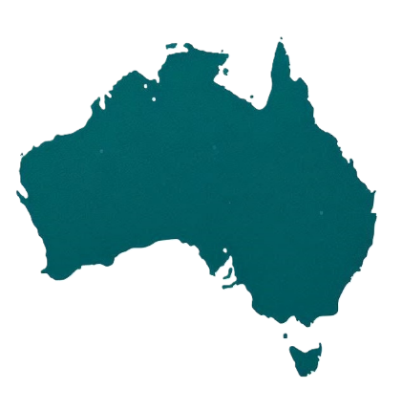 | They were the first people to live on and use the  - Land  - Waters.

Contents

Australia’s Disability Strategy | 5
The Advisory Council | 6
New Council members | 9
Targeted action plans report | 15
Aviation Disability Standards | 17
Evaluation of the Strategy | 22
The next meeting | 23

Australia’s Disability Strategy

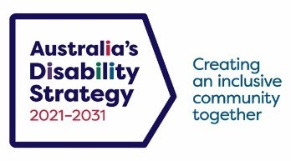 | Australia’s Disability Strategy is a plan to make life better for people with disability.  We call it the Strategy for short.  It is sometimes called ADS.
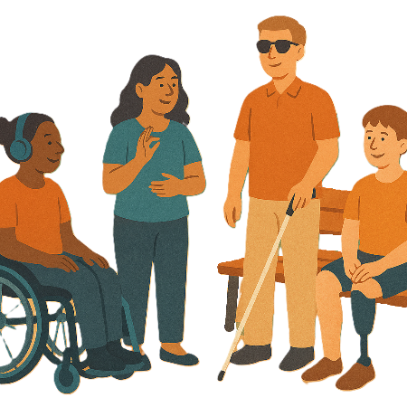 | The Strategy is important for Australia to be more inclusive.  Inclusive means everyone can take part.
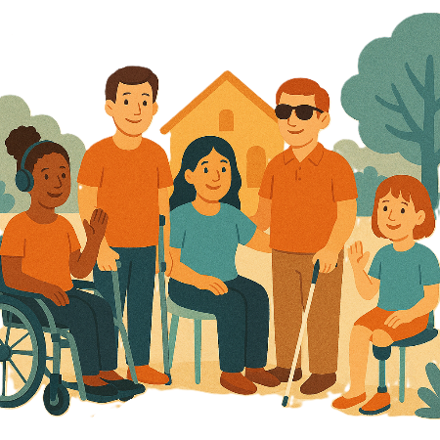 | This makes everyone in our community feel welcome.

The Advisory Council

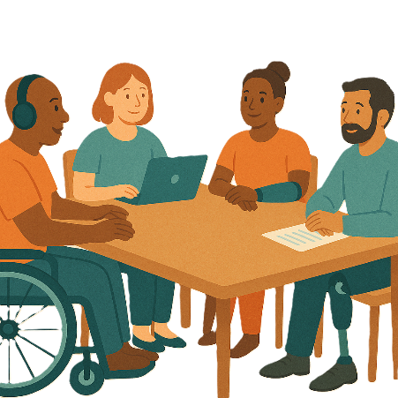 | The Advisory Council gives advice about the Strategy to  - The Australian Government  - State and territory governments  - Local governments.  We call it the Council.
 | The Council is not part of the government.
The Council helps governments understand how to

- Use the Strategy
- Share reports about the Strategy
- Work towards the goals of the Strategy.

Goals are things you want to do.

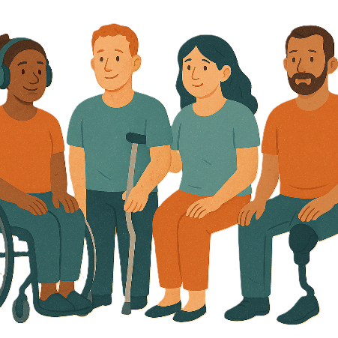 | The Council includes people  - With disability  - Who understand barriers for people with disability.
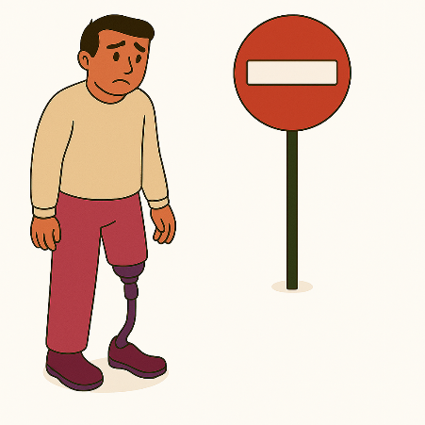 | A barrier is something that stops you from doing what you  - Want  - Need.
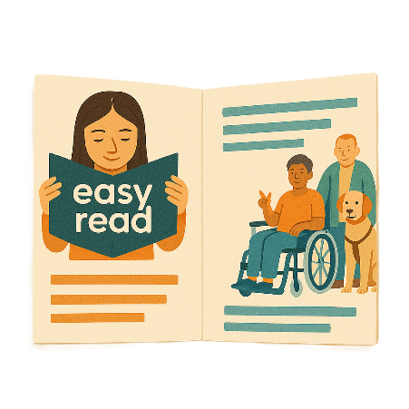 | The Council writes information about what they talked about in their meetings.  It is called a communique.  We share important information with the community.
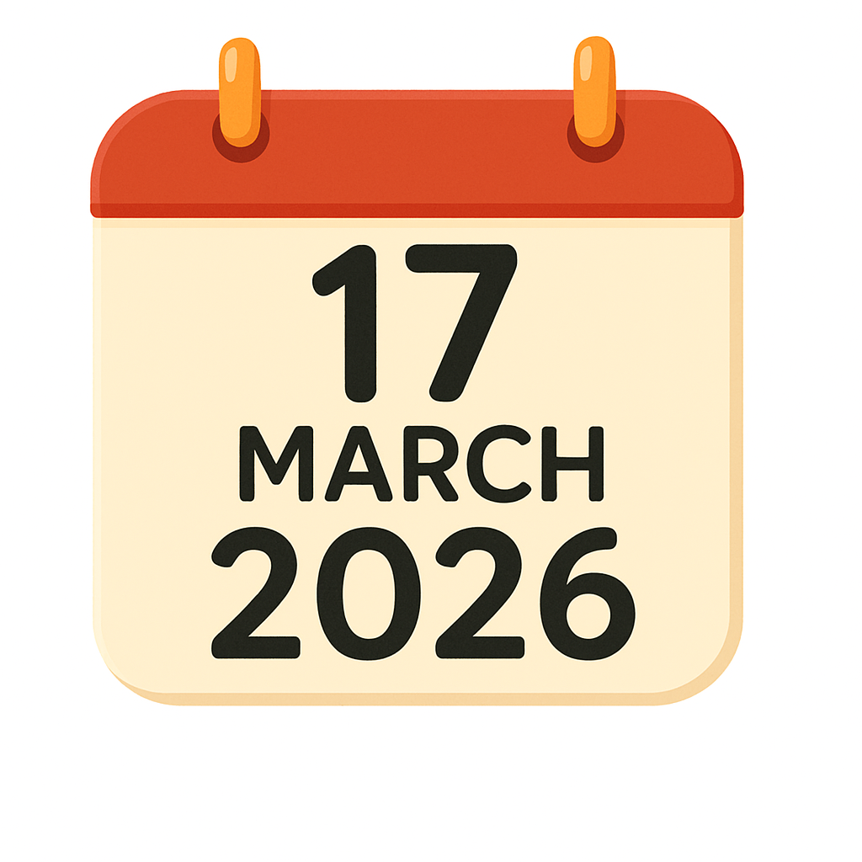 | This information is about the Council meeting on 17 March 2026.

New Council members

 | Jane Spring is the Council Chair.  The Chair is the person who runs the meeting.
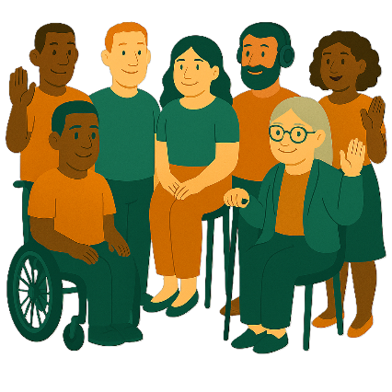 | Jane welcomed the new Council members to their first meeting.
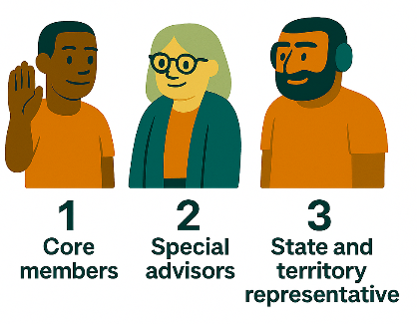 | There are 3 different types of members on the Council  - Core members  - Special advisors  - State and territory representatives.
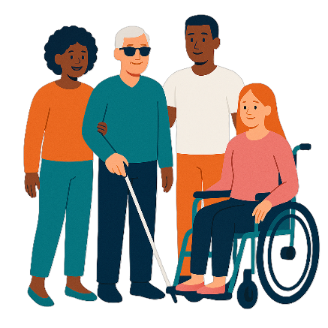 | - Core members  Core members must be a person with disability.  They can represent different disability groups.
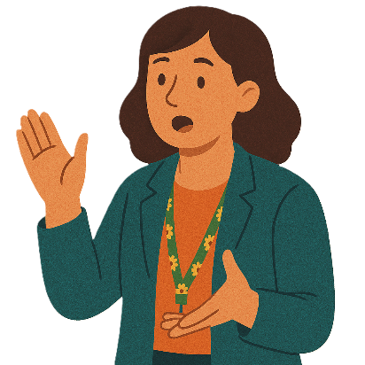 | Represent means to speak up for a group of people.
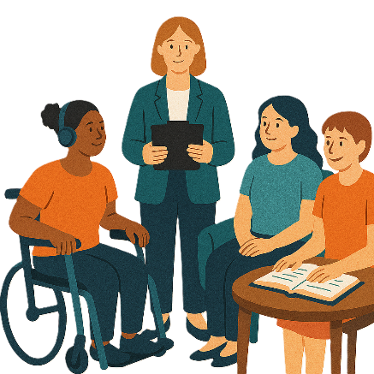 | - Special advisor  They have  - Lived experience  - Lots of knowledge about disability.
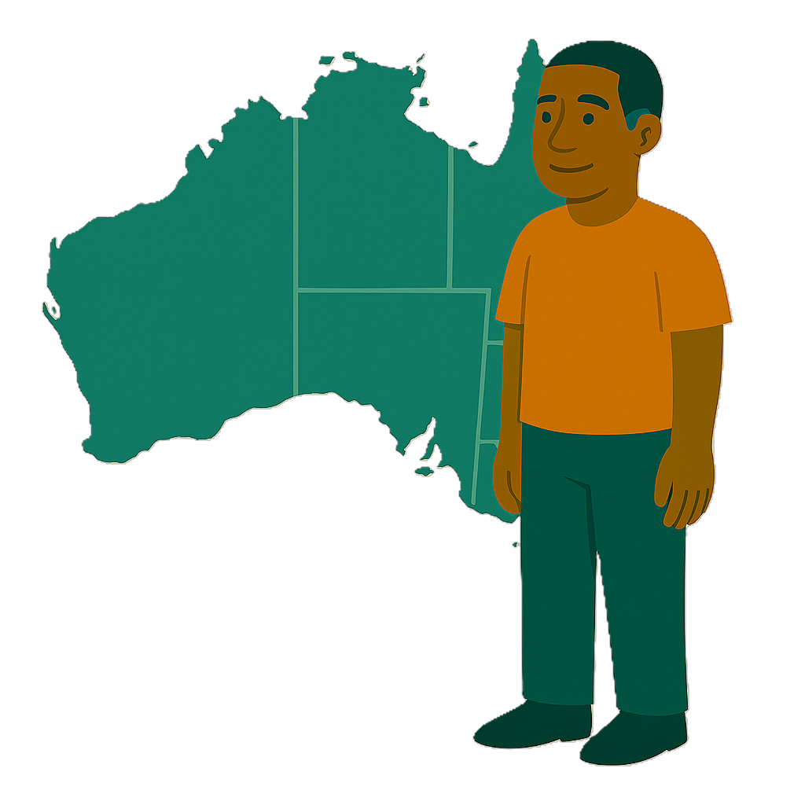 | - State and territory members  These members can have  - A disability or lived experience of disability.  They are chosen by the state or territory government where they live.
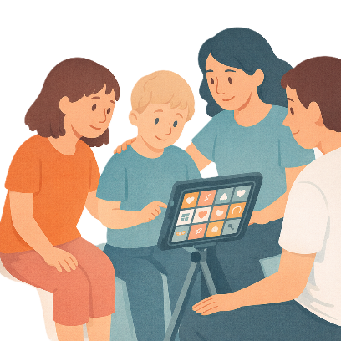 | Lived experience is when you know what  - It feels like to have a disability  - Helps  - Makes it harder.
 | There are 7 new members on the Council.  The new members are  - Ebe Gannon
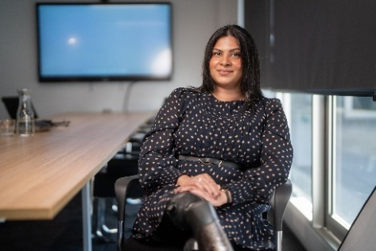 | - Sara Shams.  They are core members.
 | - Dr Nick Hartland  He is a special advisor.
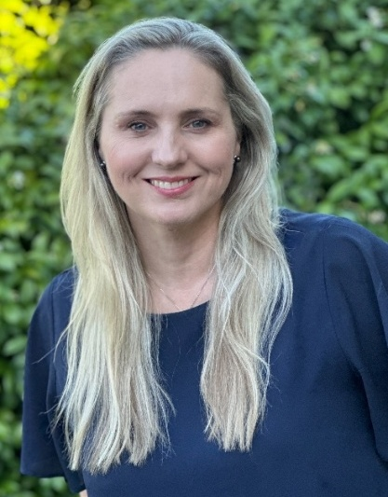 | - Kelly Brown from the ACT
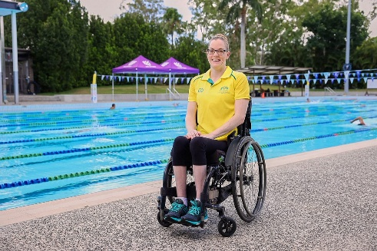 | - Rachael Watson from Queensland
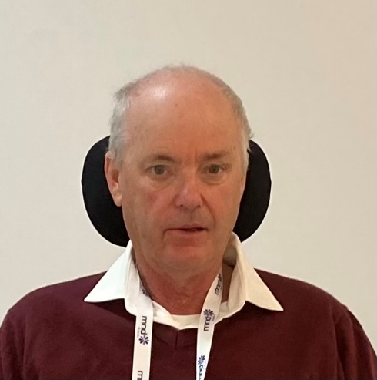 | - Chris Symonds from Tasmania
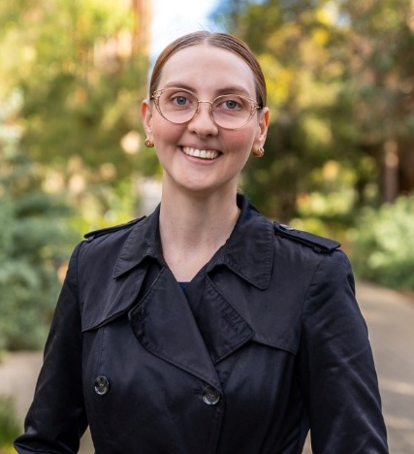 | - Ellie Moir from Western Australia  They are state and territory representatives.
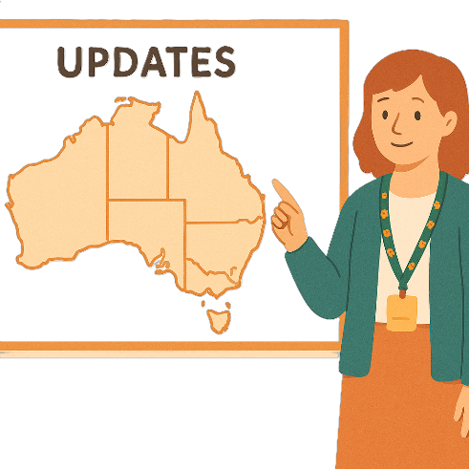 | The 4 new state and territory representatives each gave an update.

Targeted action plans report

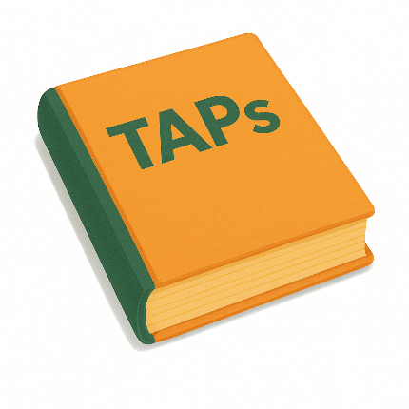 | The Council talked about the  - Targeted action plans report.  Targeted action plans are small plans to help us work on the Strategy.  The small plans are called TAPs.
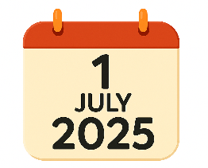  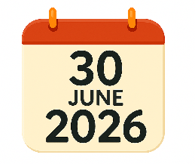 | They talked about the TAPs report for  - 1 July 2025 to 30 June 2026.
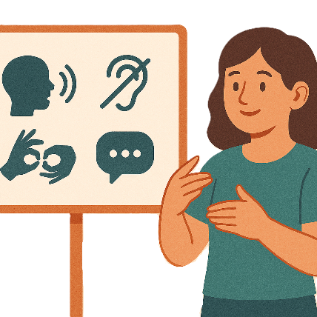 | They gave ideas about how to make the report more accessible.  Accessible means everyone can use it.  Everyone can get it.
 | The Council also talked about how important it is to  - Check what has been done  - Check if it is helping  - Look at what should be done next.

Aviation Disability Standards

 | The Council also talked about the  - New aviation disability standards.
 | Aviation includes all work to do with aircrafts.  - This is when people work with aircrafts.  Aircrafts are  - Planes  - Helicopters.
 | The Department of Infrastructure Transport Regional Development Communications Sport and the Arts are working on these standards.  They are not finished yet.
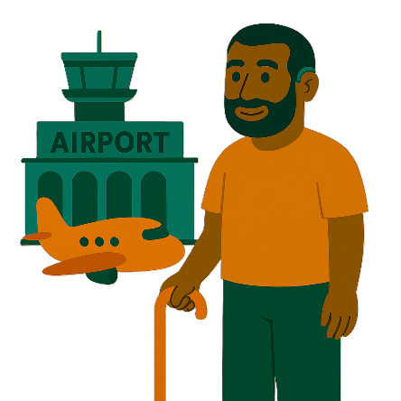 | These standards are about  - Making air travel for people with disability better.  Air travel is when you fly in an aircraft.
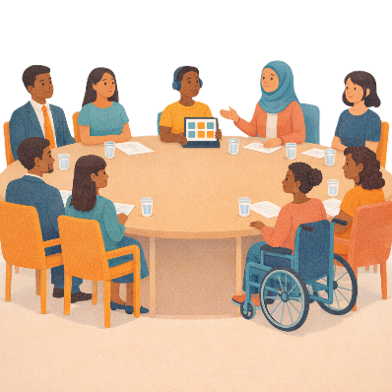 | Council members talked about times they have travelled in planes.
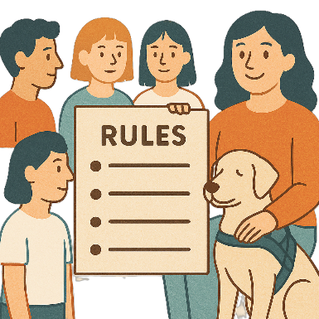 | They talked about needing  - Easy to understand rules
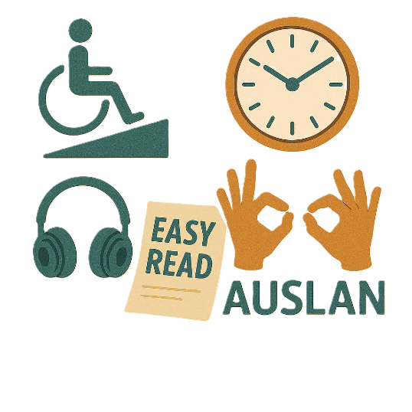 | - Better accessibility
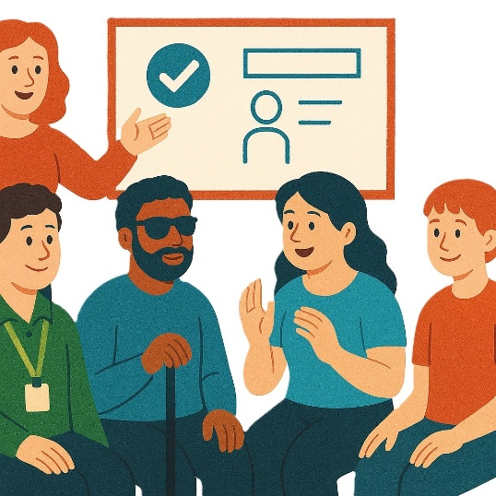 | - Better training for staff
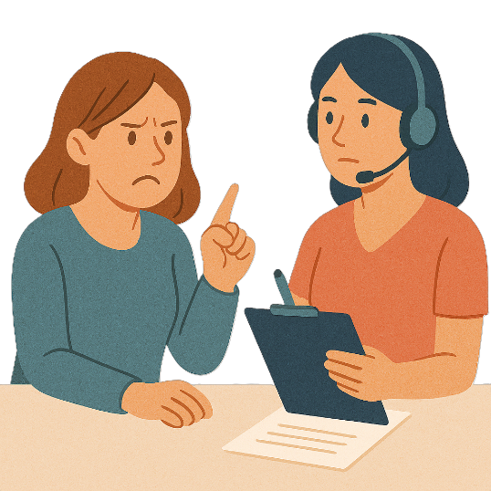 | - Easy ways to make a complaint.
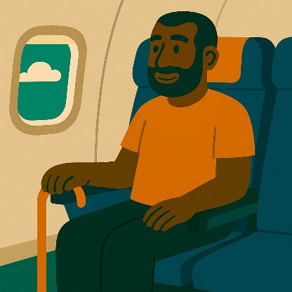 | Members said this would help people with disability to  - Travel safely  - Be independent  - Travel with dignity.
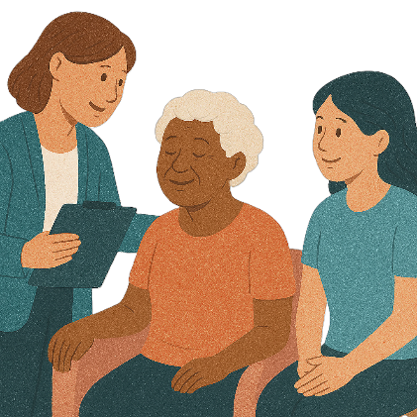 | Dignity means  - Feeling important  - Being listened to  - Being treated with respect.
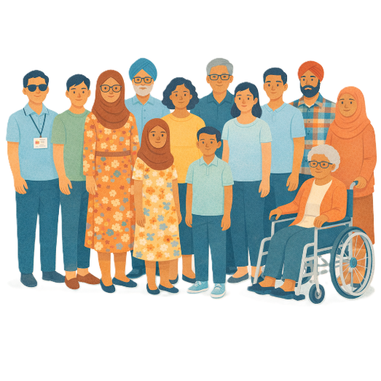 | The aviation standards will be open for public consultation.  Public consultation is when everyone is asked to give their ideas.
 | They will be open for public consultation in the next few months.
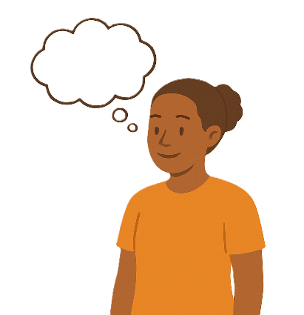 | Council members will be able to give more ideas when the public consultation is open.

Evaluation of the Strategy

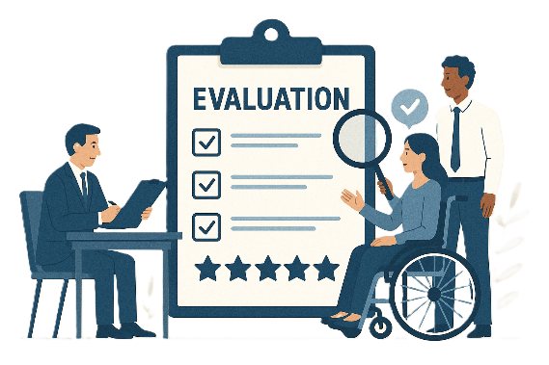 | The Council has given advice on the evaluation of the Strategy.  Evaluation means you look at what  - Went well  - Could be done better.
 | You can do an evaluation of a  - Strategy  - Service  - Program.
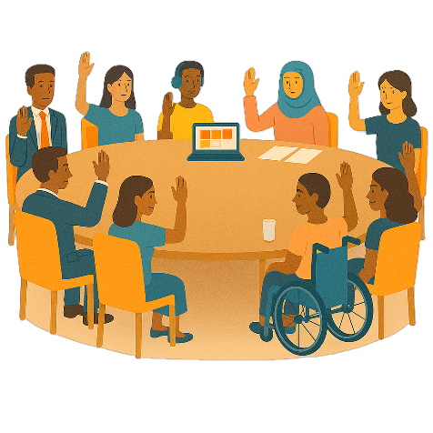 | The Council  - Endorsed their advice on the evaluation of the Strategy.  Endorsed means agreeing with what is written or said.

The next meeting
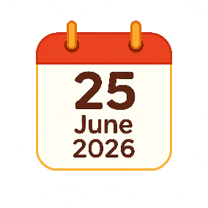  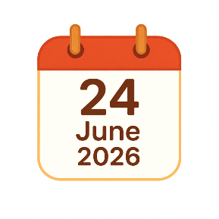   | The next Council meeting will be in person.  It will go for 2 days on  - 24 and 25 June 2026.  The place of the next meeting has not been decided yet.  We will let you know where this meeting will be when it is decided.
 | You can go to the website if you need more information.  www.disabilitygateway.gov.au/ads/advisory-council
 | You can email us.  ADSAdvisoryCouncil@health.gov.au

Some images in this Easy Read were made using AI.
You must not share or copy any of the images without permission.
May 2026

