Attitudes about disability in 4 First Nations Communities

Summary Report
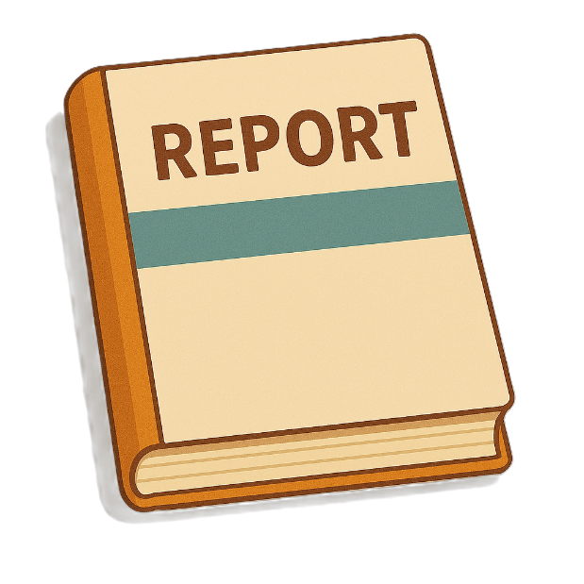
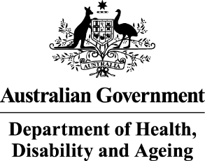 | The Australian Government Department of Health Disability and Ageing wrote this.  We say DHDA for short.  When you see the word we it means DHDA.
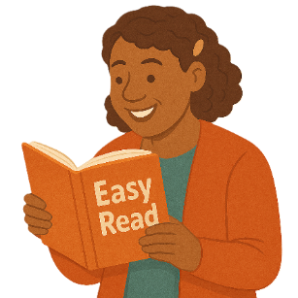 | We wrote this in an easy to read way.  We use pictures to explain some ideas.
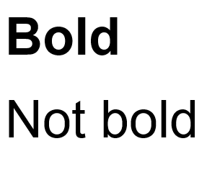 | We have some words in bold.  This means the letters are thicker and darker.  These are important words.
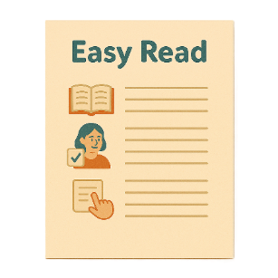 | This is an Easy Read summary of another document.  This means it has the most important ideas.
 | We can answer any questions by email.  Email us ADSDataReporting@health.gov.au
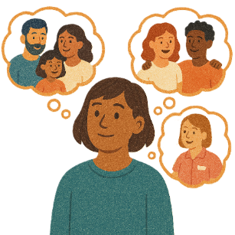 | You can ask for help to read this document.  You can ask  - A friend  - Family members  - A support person.
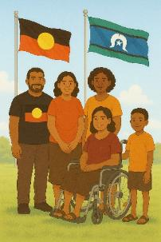 | We recognise Aboriginal and Torres Strait Islander people as the Traditional Owners of the land we live on.  They are called First Nations people in this report.
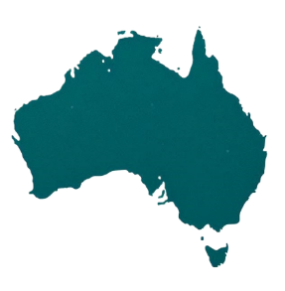 | They were the first people to live on and use the  - Land  - Waters.

Contents

What we did | 5
What we heard | 8
Past laws | 10
First Nations Children | 14
Getting support | 17
Connection to culture | 22
Prison | 24
Recommendations | 26
Who to talk to if you are upset | 32

What we did

 | Australian National University did research for DHDA.  They are called ANU for short.  Research means  - Finding out what people think about things  - Using the information to help others.
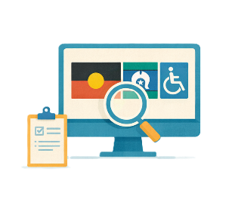 | The research was about how First Nations people think about disability.
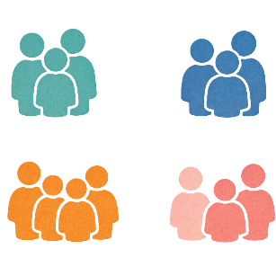 | The research was done with First Nations people from 4 communities.
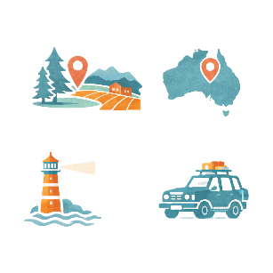 | The communities came from  - Regional areas  - Remote areas.
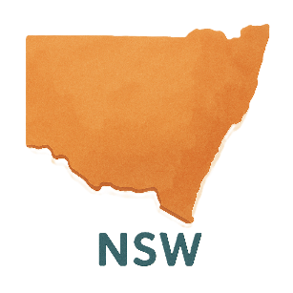 | The communities were in  - New South Wales
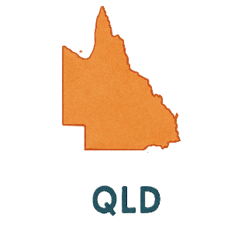 | - Queensland.
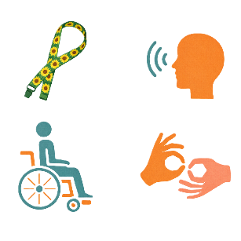 | The research was done with a small number of people who are  - People with disability
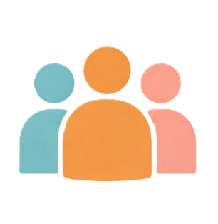 | - People without disability
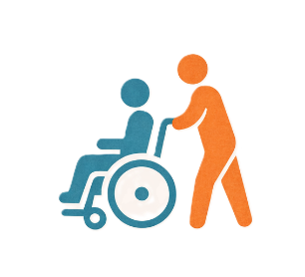 | - Carers
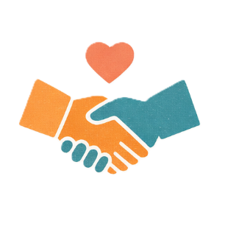 | - People who work for Aboriginal Community Controlled Organisations  We call it ACCO for short.  Community controlled means run by First Nations people and their communities.

What we heard

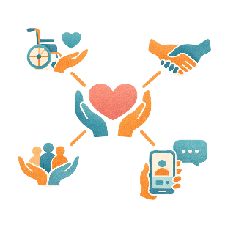 | Some communities  - Have lots of support
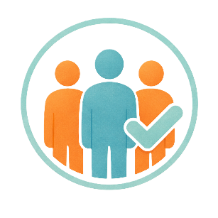 | - Are inclusive  Inclusive is when everyone  - Can take part  - Feels like they belong.
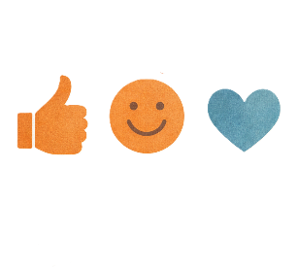 | - Have good attitudes about disability  Attitudes are what people  - Think  - Feel  - Believe.
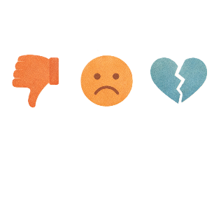 | - Have bad attitudes about disability.
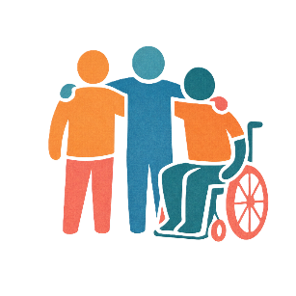 | People said disabilities you can see are more accepted.  Accepted means being okay with someone.  It means to respect them for who they are.

Past laws

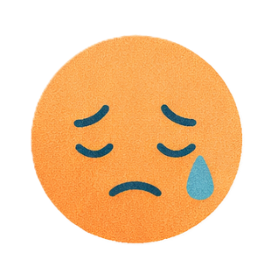 | Some of this information might make you feel  - Upset  - Worried.
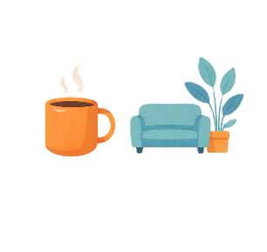 | You can take a break if you need to.
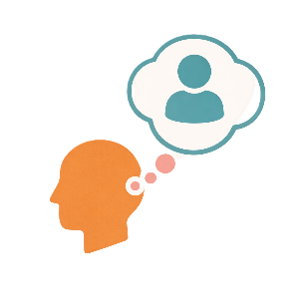 | You can ask someone you trust for support.
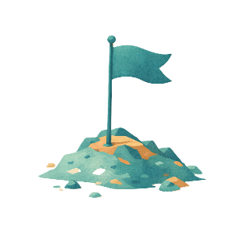 | First Nations people are affected by  - Colonisation  Colonisation is when people take over land and control it.
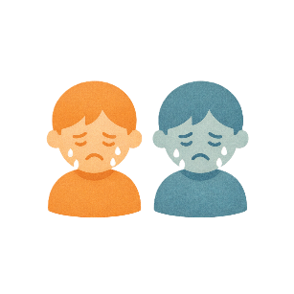 | - The Stolen Generation  This is when First Nations children were taken from their families by governments.
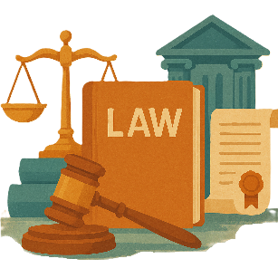 | - Laws from the past.  Laws are rules for how we live.
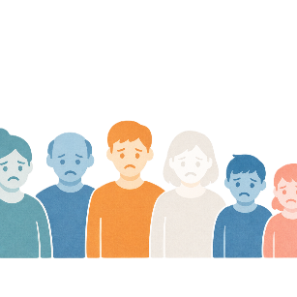 | These experiences have caused lots of pain for First Nations people.  The pain can also be passed down in families.  This means can affect everyone in a family.  This is sometimes called intergenerational trauma.
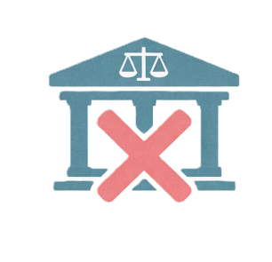 | This can mean First Nations people do not trust government services.
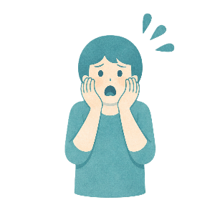 | People said they felt uncomfortable asking for help when services do not  - Feel safe
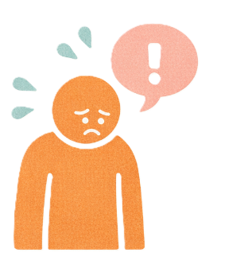 | - Feel respectful
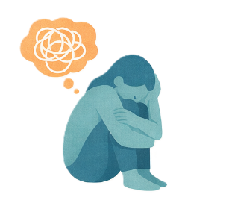 | - Understand trauma  Trauma is when something happens that makes a person feel  - Upset  - Scared  - Unsafe.

First Nations Children

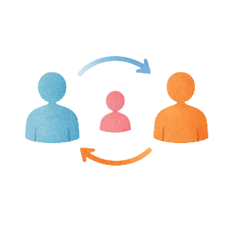 | First Nations children with disability in the child protection system can have changes to  - Carers
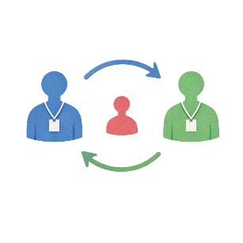 | - Case workers  Case workers help make sure children are safe.
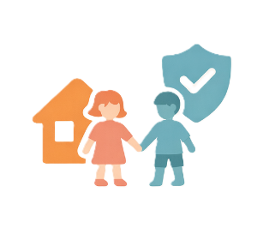 | Child protection is for children who are  - In danger  - Not looked after properly.
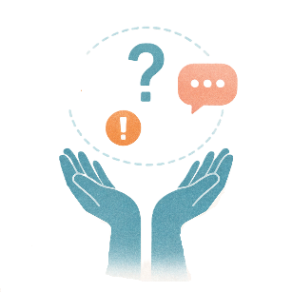 | Lots of changes to caseworkers and carers can make it hard to  - Get the support they need
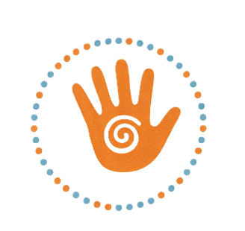 | - Be connected to their culture.
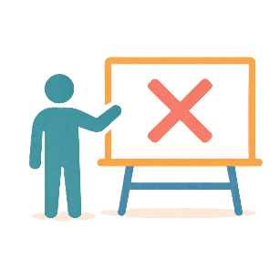 | People who work in schools do not have enough  - Training
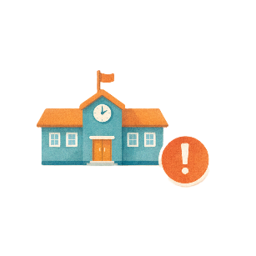 | - Cultural awareness  This is knowing and respecting different cultures.
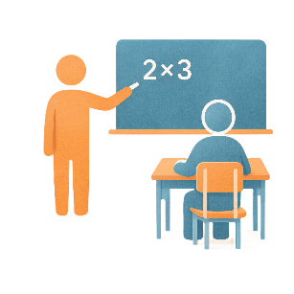 | This can be for  - Teachers  - People who support teachers.
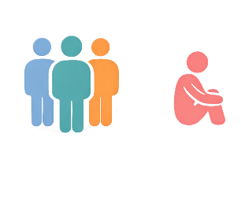 | Sometimes children with disability are  - Left out
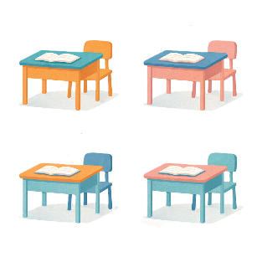 | - Not supported in mainstream classrooms.  These are classrooms most children can go to.

Getting support

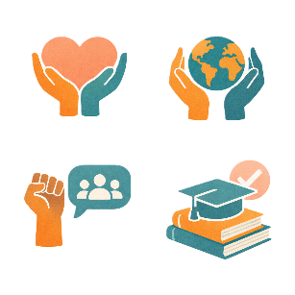 | Lots of people said it was hard to get disability services that  - Are culturally responsive  Culturally responsive means respecting peoples  - Rights  - Cultures  - Traditions.  This helps people feel safe to be themselves.  It can also be called culturally safe.
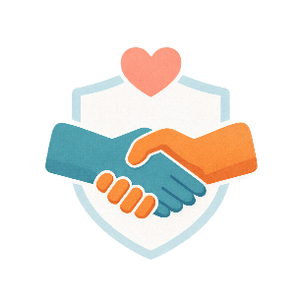 | - Are reliable  This means you can trust them to turn up when they say they are going to.
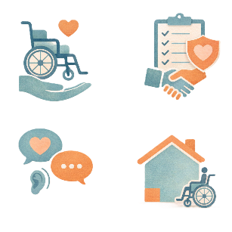 | - Work well for them.
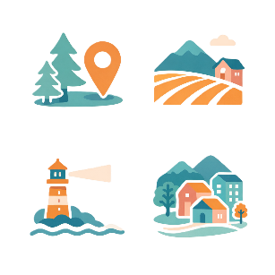 | There are not enough specialists in  - Regional areas
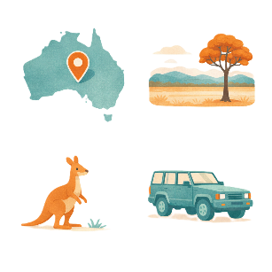 | - Remote areas.
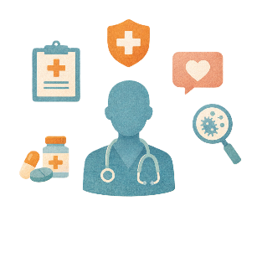 | Specialists are doctors with extra skills in 1 area of health.  Like a paediatrician.  This is a doctor for children.
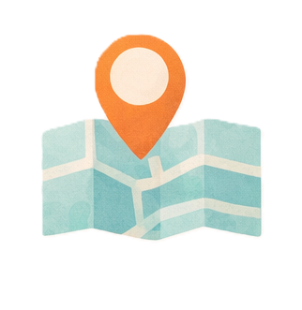 | It is hard for families when supports and services  - Are a long way from them
 | - Cost a lot of money.
 | It is hard for families when services and hospitals do not have  - Clear communication
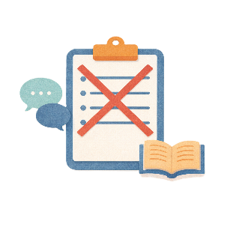 | - Information that is easy to understand.
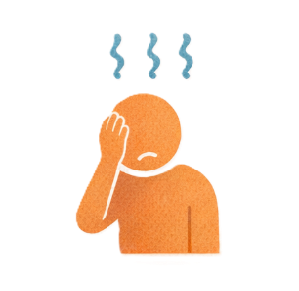 | Carers do not get much respite.  Respite is a short break to rest.  Some carers get no respite.
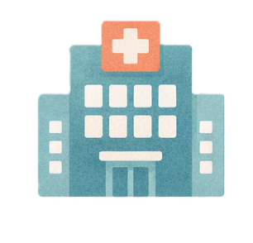 | People said it was important to be  - Connected to their local Aboriginal health and community services.
These services are not able to support everything people need in

- Regional areas
 | - Remote areas.

Connection to culture

 | It is important for First Nations people to be connected to culture.
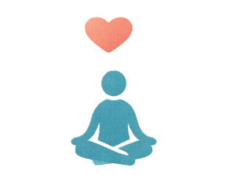 | It is important for  - Wellbeing  Wellbeing means that you are  - Happy  - Healthy.
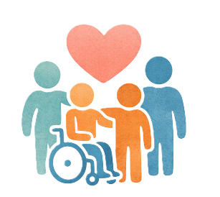 | - Being included.
 | Not being able to use NDIS funding to go to Sorry Business is a big problem.  Funding is money from the government to take part in the NDIS.
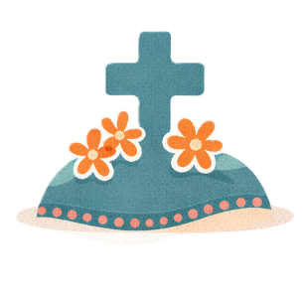 | Sorry Business is a time people come together for special ceremonies when someone dies.
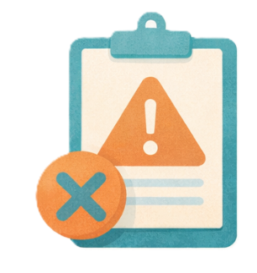 | People from these communities think the NDIS is  - Too strict
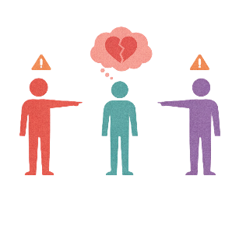 | - Not respectful of cultural needs.

Prison

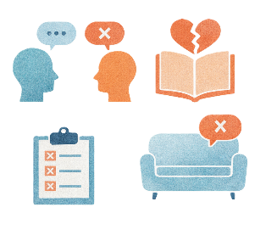 | In prison First Nations people with disability do not always get  - Therapy  Therapy is something to help you  - Feel better  - Grow stronger.  There are lots of different types of therapy.
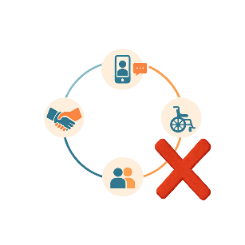 | - Support.
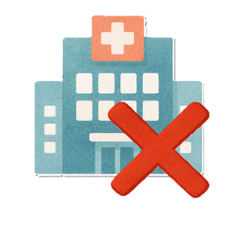 | They do not get enough services when they leave prison for their  - Health
 | - Disability.
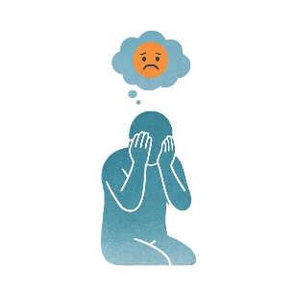 | Feeling judged will stop them from asking for help.  Feeling judged is feeling like people think you are doing something wrong.

Recommendations

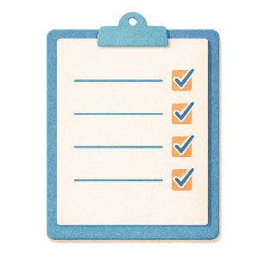 | The research came up with recommendations.  Recommendations are ideas to do things better.
 | - Have culturally responsive services
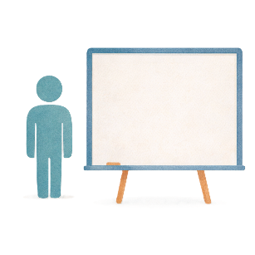 | This includes  - Cultural training
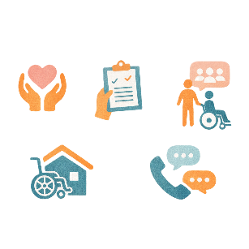 | - Help for services to support First Nations people with disability and their families.
- Have

- Better health and disability services in

  - Regional areas
 | - Remote areas.
 | - More paediatricians.
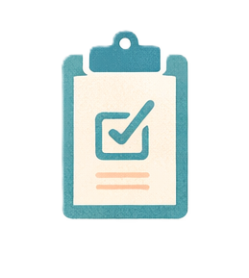 | This will make it easier to get services.
- Have better coordination between systems like

- Child protection
 | - Health
 | - Education
 | - Disability.
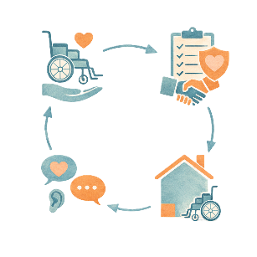 | Coordination means making lots of different things all work together.
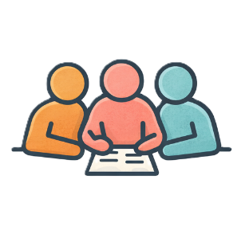 | Systems should work together to support people with disability.
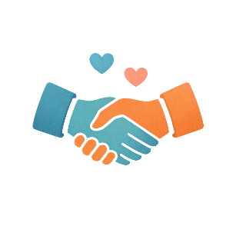 | - Use NDIS funding for cultural activities.
This could include

- Travelling to Country
 | - Going to Sorry Business
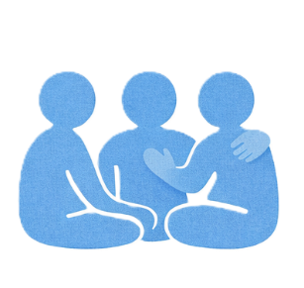 | - Joining cultural healing activities.
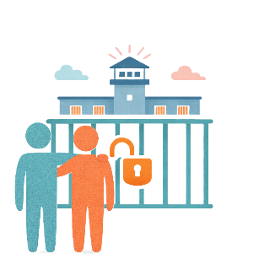 | - Make sure First Nations people with disability in prison get the support they need.
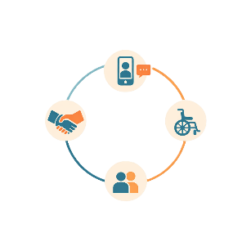 | - There should be ways to connect people with support before they leave prison like
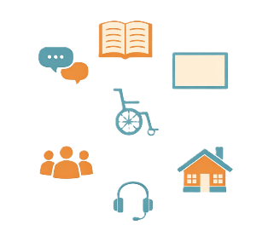 | - Community supports  - NDIS.
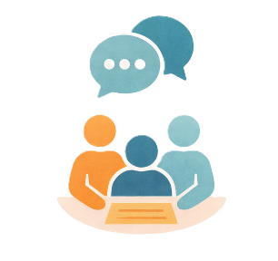 | Aboriginal organisations should  - Always be part of this work  - Sometimes lead the work.

Who to talk to if you are upset

Some of the things in this Easy Read might make you feel

- Upset
- Worried.
There are people you can talk to

Like 13YARN
You can visit their website
www.13yarn.org.au/

You can call them on

13 92 76
 | The Disability Gateway website also has lots of different people you can talk to for help.  www.disabilitygateway.gov.au/safety-help

Some images in this Easy Read were made using AI.
You must not share or copy any of the images without permission.
June 2026.

