Australia’s Disability Strategy

Advisory Council Meeting Summary

24 and 25 June 2026

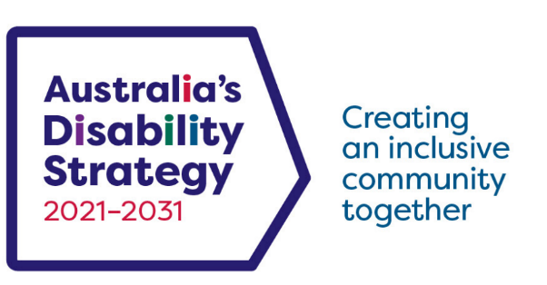

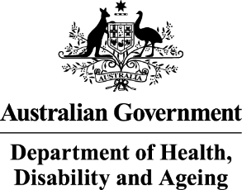 | The Australian Government Department of Health Disability and Ageing wrote this.  We say DHDA for short.  When you see the word we it means DHDA.
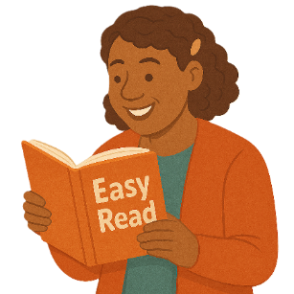 | We wrote this in an easy to read way.  We use pictures to explain some ideas.
 | We have some words in bold.  This means the letters are thicker and darker.  These are important words.
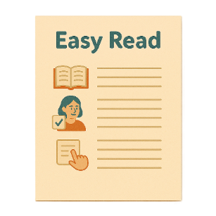 | This is an Easy Read summary of another document.  This means it has the most important ideas.
 | We can answer any questions by email.  Email us  ADSAdvisoryCouncil@health.gov.au
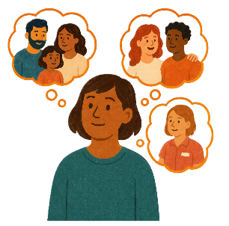 | You can ask for help to read this document.  You can ask  - A friend  - Family members  - A support person.
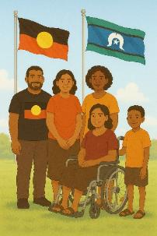 | We recognise Aboriginal and Torres Strait Islander people as the Traditional Owners of the land we live on.
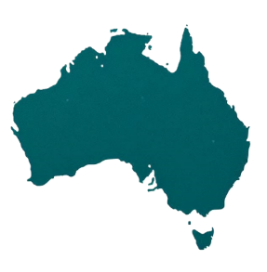 | They were the first people to live on and use the  - Land  - Waters.

Contents

Australia’s Disability Strategy | 5
The Advisory Council | 6
Welcome | 8
APSC advice | 10
ARTD Consultants presentation | 12
AHRC | 14
Olympic and Paralympic Games advice | 17
HumanAbility presentation | 20
Disability data | 22
State and territory representatives | 23
Sport Integrity Australia feedback | 24
The next meeting | 26

Australia’s Disability Strategy

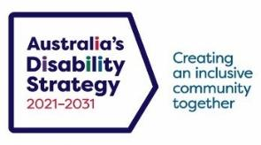 | Australia’s Disability Strategy is a plan to make life better for people with disability.  We call it the Strategy for short.  It is sometimes called ADS.
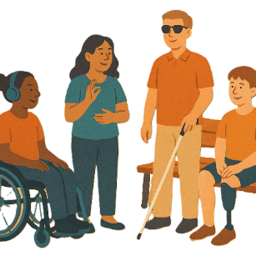 | The Strategy is important for Australia to be more inclusive.  Inclusive means everyone can take part.
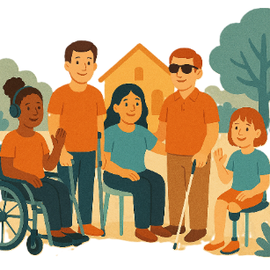 | This makes everyone in our community feel welcome.

The Advisory Council

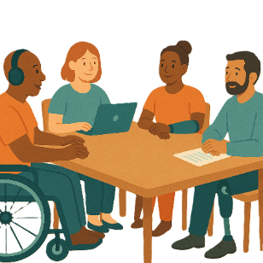 | The Advisory Council gives advice about the Strategy to  - The Australian Government  - State and territory governments  - Local governments.  We call it the Council.
 | The Council is not part of the government.
The Council helps governments understand how to

- Use the Strategy
- Share reports about the Strategy
- Work towards the goals of the Strategy.

Goals are things you want to do.
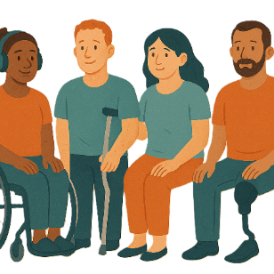 | The Council includes people  - With disability  - Who understand barriers for people with disability.
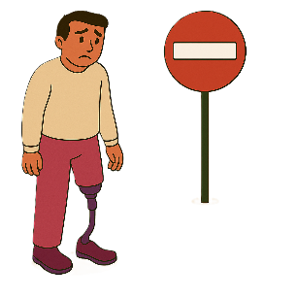 | A barrier is something that stops you from doing what you  - Want  - Need.
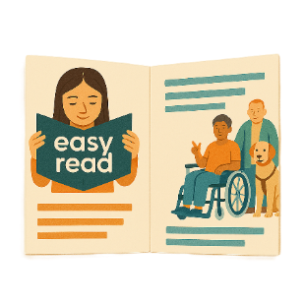 | The Council writes information about what they talked about in their meetings.  It is called a communique.  A communique is how we share important information with the community.
   | This information is about the Council meeting on  - 24 June 2026  - 25 June 2026.

Welcome

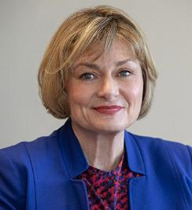 | Jane Spring is the Council Chair.  The Chair is the person who runs the meeting.
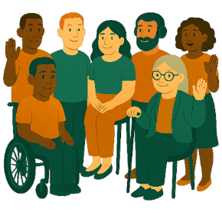 | Jane welcomed the new Council members to their first meeting.
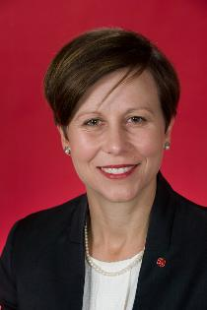 | Minister Jenny McAllister.  - Thanked the Council for all the work that it has done.  Ministers are leaders in an area of the government.
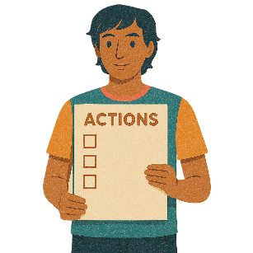 | The Council talked about  - Action items that have been finished since the last meeting.
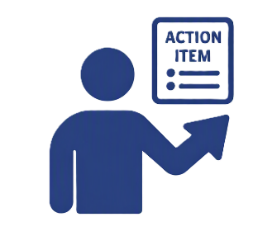 | Actions items are the things that need to be done after a meeting.  They also say who needs to do them.  They can also be called actions.
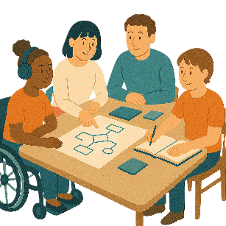 | The Council talked about  - 2026 Council Work Plan.  It says how the Council will do their work.
 | You can go to the website to read the Work Plan  www.disabilitygateway.gov.au/document/13906  It is not in Easy Read.

APSC advice

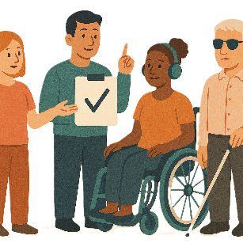 | The Council endorsed advice to the  - Australian Public Service Commission.  We call it APSC for short.
 | Endorsed means the group agrees with what is written.
 | The advice is about disability employment in the Australian public service.
 | Employment is  - Having a job  - Going to work  - Getting money for the work you do.
 | The public service is people who work for  - Australian Government.
You can go to the website to read more about the APSC

www.apsc.gov.au/

It is not in Easy Read.

ARTD Consultants presentation

 | The Council had a presentation from  - ARTD Consultants  Consultants work with people on projects.
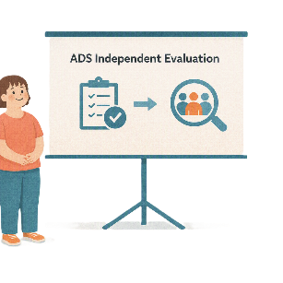 | The presentation was about the  - The Strategy independent evaluation
 | Independent means separate to the government.  This means they  - Make their own decisions  - Choose what work to do.
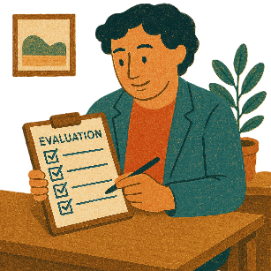 | Evaluation means you look at what  - Went well  - Could be done better.  You can do an evaluation of a  - Service  - Program  - Plan.
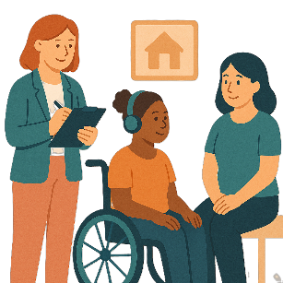 | The Council talked about the Strategy  - Monitoring and Evaluation Framework.  Monitoring means making sure the work is done the right way.
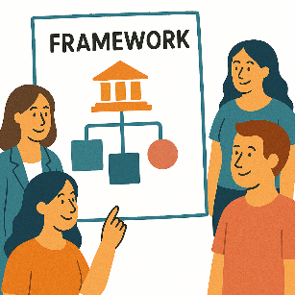 | A framework is how we will do something.

AHRC

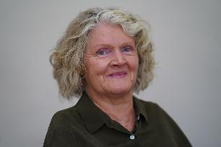   | The Council talked with Rosemary Kayess.  Rosemary works for the  - Australian Human Rights Commission.  We call it AHRC for short.
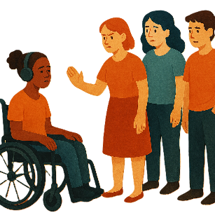  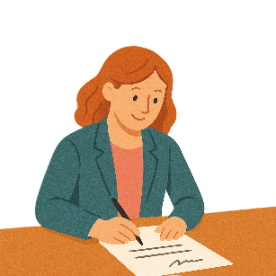 | Rosemary is the Disability Discrimination Commissioner.  Discrimination means treating someone unfairly because of something about them they can not change.  Like they have a disability.  A Commissioner is the person in charge in an area of the government.
 | Rosemary talked about what she thinks about disability reform.  Reform means making changes to make something better.
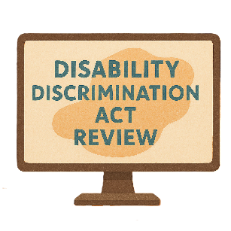 | This includes  - Reviewing the Disability Discrimination Act  We call it DDA for short.
 | A review is when you check what  - Works  - Needs to change.
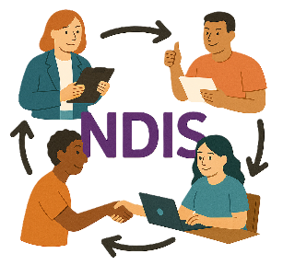 | - Changes to the NDIS.
 | Rosemary talked about the reforms needed for human rights.  Rights are rules about treating everyone  - Fair  - Equal.  Human rights are rights that everyone has.
 | Rosemary talked about how important the Strategy is.
You can go to the website to read more about the AHRC.

humanrights.gov.au

It is not in Easy Read.

Olympic and Paralympic Games advice

  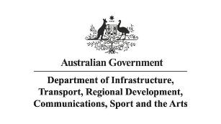 | The Council had a presentation from  - Department of Infrastructure Transport Regional Development Communications Sport and the Arts  We call it DITRDCSA for short.  - Queensland Government Olympic and Paralympic Games Office  They did the presentation together.
 | The Olympic Games is a sports event that happens every 4 years.  People come from all around the world to take part.
 | The Paralympic Games is a sport event that happens after the Olympics.  People with disability come from around the world to take part.
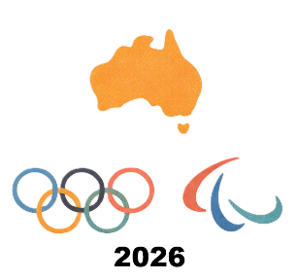 | They talked about  - Brisbane 2032 Olympic and Paralympic Games.
 | The Council gave some advice.  Advice is when experts give their ideas.  There is no agreement that anything else will happen.  Experts are people who know a lot about something.
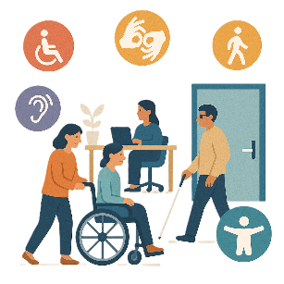 | The advice was about  - Ways to make accessibility better at the Games  Accessibility means everyone can use it.
 | - Disability inclusion at the Games  Disability inclusion is when everyone  - Can take part  - Feels like they belong.

HumanAbility presentation

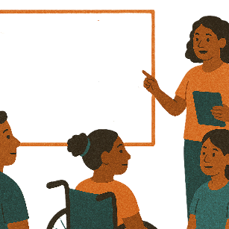 | The Council had a presentation from HumanAbility.
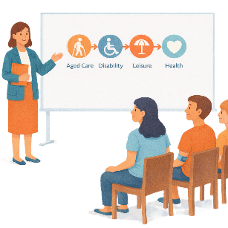 | The presentation was about  - Aged care disability leisure and health qualification review  Leisure is free time to do things you enjoy.
 | Qualifications are proof that you have  - Learned a skill  - Finished training to do a job.
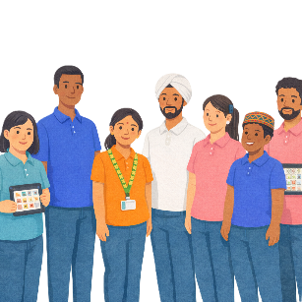 | They also talked about the  - Disability support workforce.  This is the people who work to support people with disability.
You can read more about HumanAbility on their website.

humanability.com.au/

It is not in Easy Read.

Disability data

 | The Council talked about data.  Data is  - Facts  - Information  - Records.
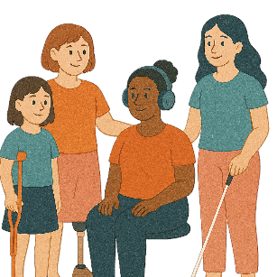 | The data was about  - Women with disability  - Girls with disability.
 | They talked about work they could do on this in the future.

State and territory representatives

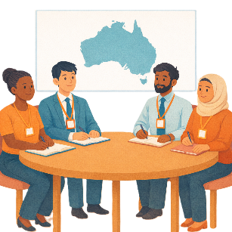 | The Council talked with representatives from  - State and territory disability advisory councils.  Representatives are people who speak up for a group of people.
 | They talked about  - Different work they are doing in states and territories
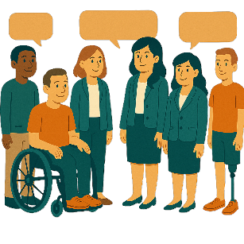 | - How to work together to work on the Strategy
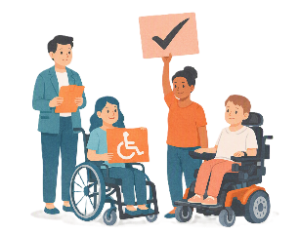 | - How to be part of disability reform.

Sport Integrity Australia feedback

 | The Council gave feedback to Sport Integrity Australia.  Feedback says what you think about something.  It will help  - Find problems  - Make it better in the future.
 | Integrity means doing the right thing even when no one is watching.
 | The feedback was about  - The National Integrity Framework Policies  Policies are plans for how to do things.
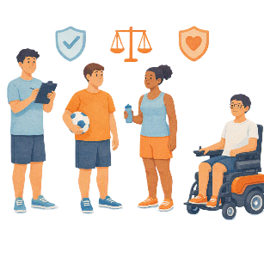 | It was also about making sure sport is  - Safe  - Fair  - Healthy  For everyone including people with disability.
You can read more about Sport Integrity Australia on their website.

www.sportintegrity.gov.au/

It is not in Easy Read.

The next meeting

 | The next Council meeting will be online.  It will be in  - August 2026.
 | You can go to the website if you need more information.  www.disabilitygateway.gov.au/ads/advisory-council  It is not in Easy Read.
 | You can email us.  ADSAdvisoryCouncil@health.gov.au

Some images in this Easy Read were made using AI.
You must not share or copy any of the images without permission.
August 2026.

