Attitudes about disability from different cultures and languages

Summary Report
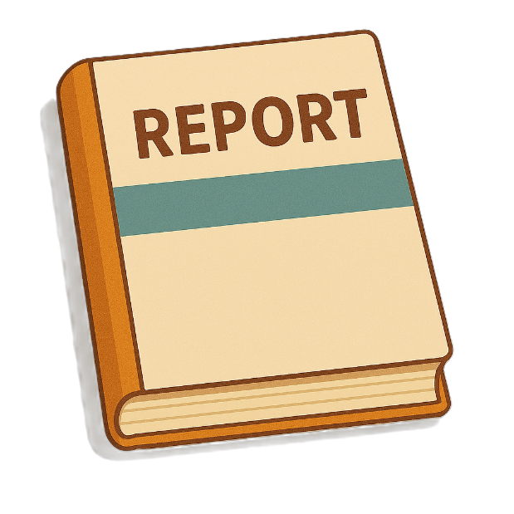
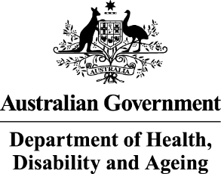 | The Australian Government Department of Health Disability and Ageing wrote this.  We say DHDA for short.  When you see the word we it means DHDA.
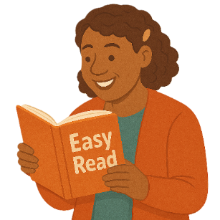 | We wrote this in an easy to read way.  We use pictures to explain some ideas.
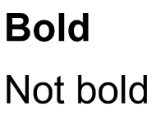 | We have some words in bold.  This means the letters are thicker and darker.  These are important words.
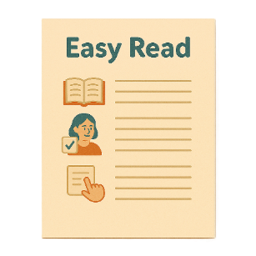 | This is an Easy Read summary of another document.  This means it has the most important ideas.
 | We can answer any questions by email.  Email us  ADSDataReporting@health.gov.au
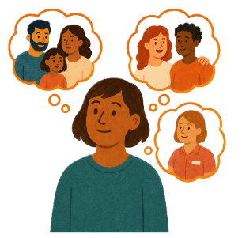 | You can ask for help to read this document.  You can ask  - A friend  - Family members  - A support person.
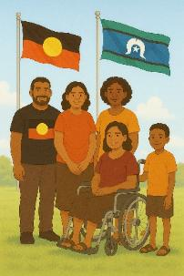 | We recognise Aboriginal and Torres Strait Islander people as the Traditional Owners of the land we live on.
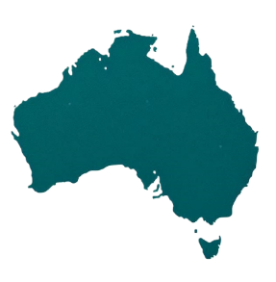 | They were the first people to live on and use the  - Land  - Waters.

Contents

What we did | 5
What we heard | 7
Community attitudes | 10
Experiences with services | 14
Experiences with healthcare services | 18
Experiences with education | 20
Experiences with work | 22
Better attitudes | 24
Recommendations | 30

What we did

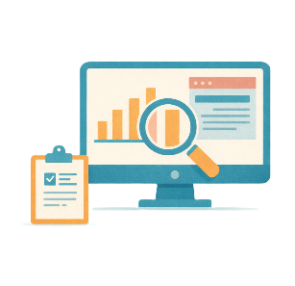 | - Australian National University  - JFA Purple Orange  Did research for DHDA.  Research means  - Finding out what people think about things  - Using the information to help others.
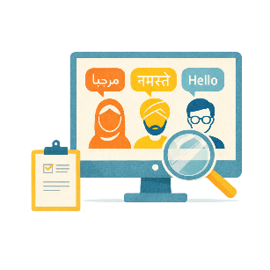 | The research was about how people  - Who speak different languages  - From different cultures  Think about disability in Australia.
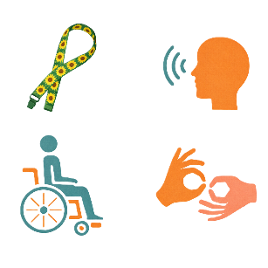 | The research was done with a small number of  - People with disability  - Who speak different languages  - From different cultures
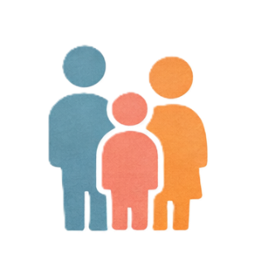 | - Family members of people with disability  - Who speak different languages  - From different cultures.

What we heard

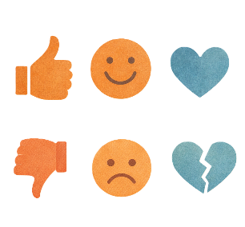 | People said they had experiences that were  - Good  - Bad.
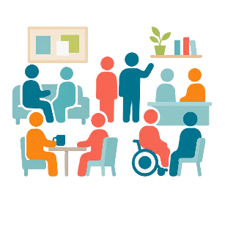 | The experiences could be with people  - In the community
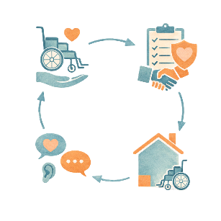 | - Doing services for them.
 | They had good experiences when they were  - Given information about services
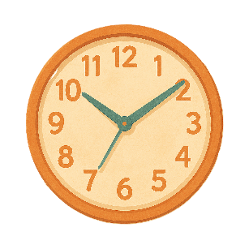 | - Given time to understand them
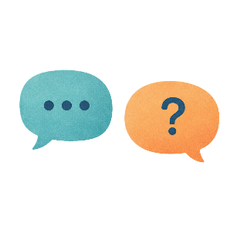 | - Able to ask questions.
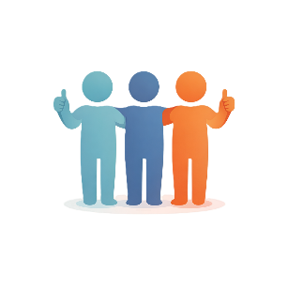 | They had bad experiences when  - Their rights were not respected  Rights are rules about treating everyone  - Fair  - Equal.
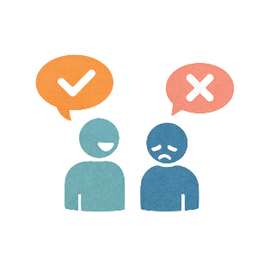 | - People decided to do something without asking them first
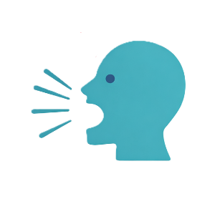 | - There was yelling
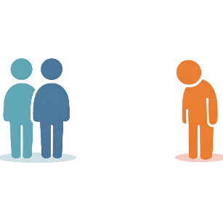 | - They were ignored
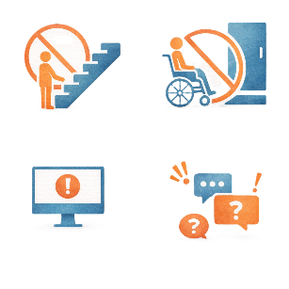 | - Their accessibility needs were not met.  Accessibility needs are things that support people to take part.

Community attitudes

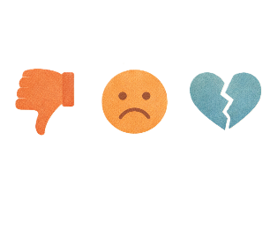 | Some groups of people have more bad experiences in the community.
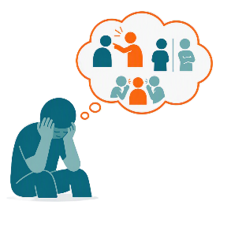 | They had bad experiences with  - People from their culture
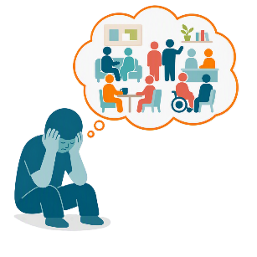 | - Other people in the community.
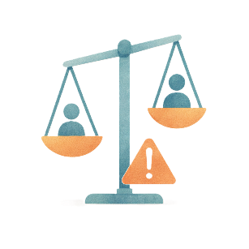 | They could be treated unfairly.  This happens when people from different cultures do not know a lot about disability.
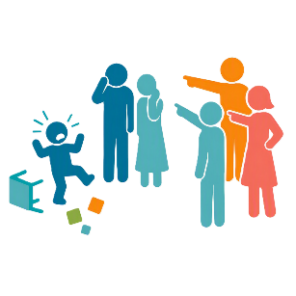 | Some people think bad behaviour from a child is from parents not doing a good job.
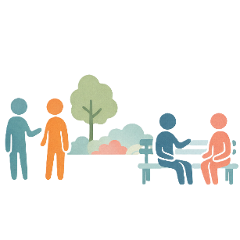 | People in some cultures  - Do not see people with disability as individuals
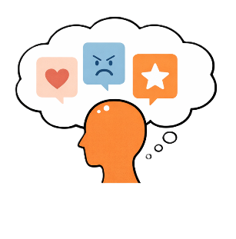 | - Have strong ideas about how people should behave
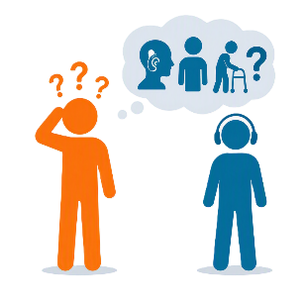 | - Do not understand disability.
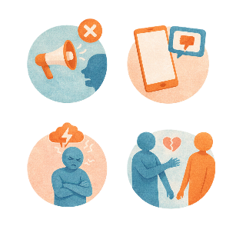 | People from different communities can have bad attitudes about disability.  Attitudes are what people  - Think  - Feel  - Believe.
 | This can make people feel like they are being treated unfairly.
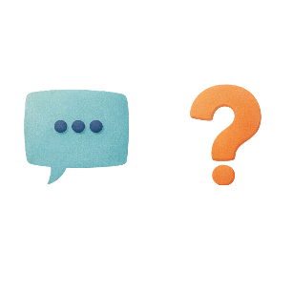 | Things that can make these feelings worse could be  - Not understanding accents  Accents are the way people talk in different countries or areas.  The way they say words might be different to you.
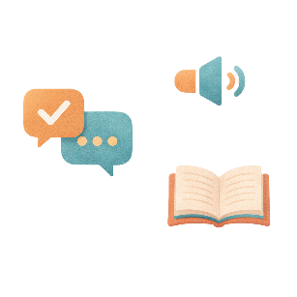 | - How well you speak and understand English
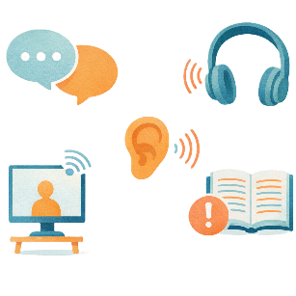 | - Ways to help you communicate  This can be called communication needs.
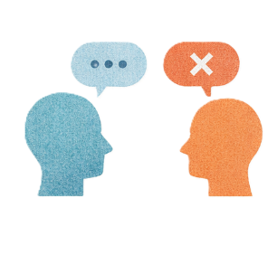 | - People thinking they know what you need without asking you.

Experiences with services

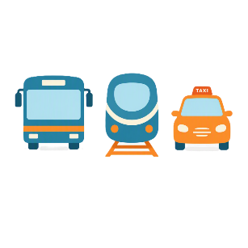 | People talked about their experiences with  - Public transport  Public transport is  - Buses  - Trains  - Taxis.
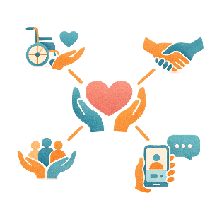 | - Community services
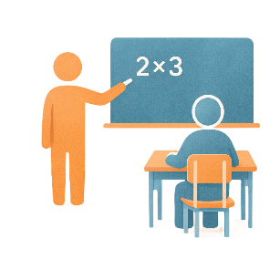 | - Education
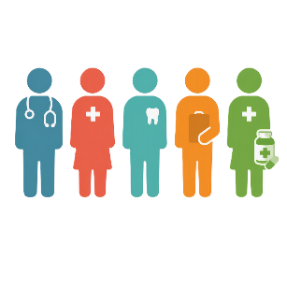 | - Healthcare.
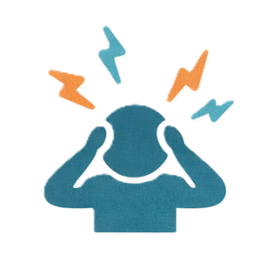 | People said some services were  - Stressful
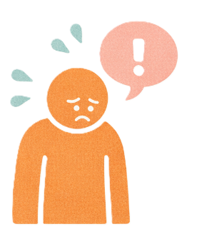 | - Hard to use.
 | There needs to be more information about services.
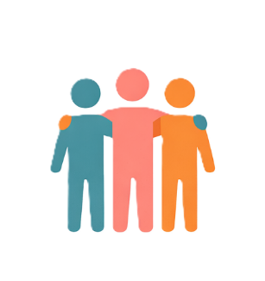 | People said they found about services from  - Friends
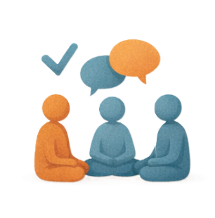 | - Their cultural community
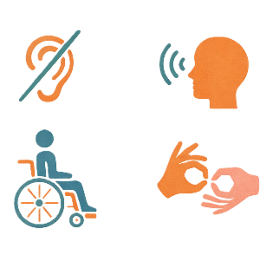 | - Other people with disability.
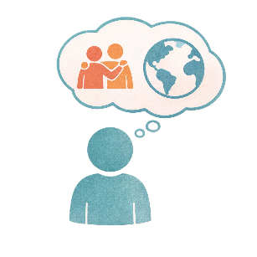 | People talked about things they do not have in their home country like  - Lots of services  - Disability supports.  They are happy there are services in Australia.
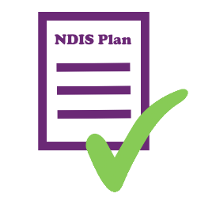 | Some people said the NDIS has made their life easier.
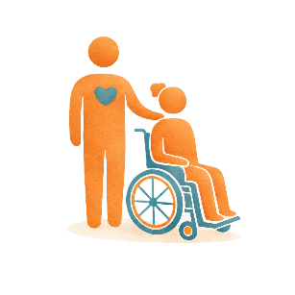 | It helped to have a support worker from the same  - Language  - Culture.
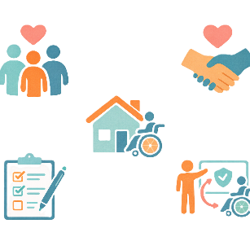 | It made it easier to get the support they needed.

Experiences with healthcare services

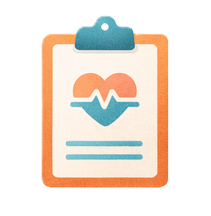 | Healthcare services can be  - Hard to understand when you speak a different language.  Healthcare services are places you go to make sure you are healthy like  - Your local doctor  - Hospitals.
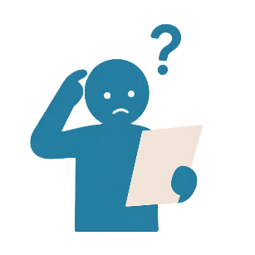 | Medical words can be hard for people who speak English too.
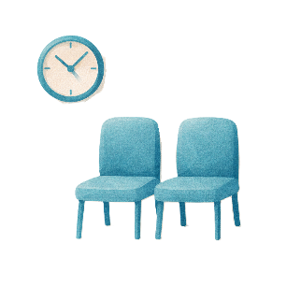 | People said that healthcare services can have barriers.  This could be  - Long wait times
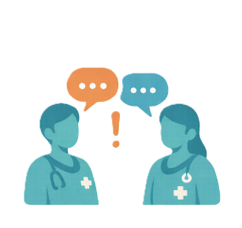 | - Staff with bad attitudes
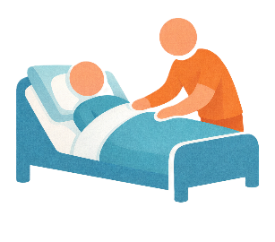 | - Family members needing to help to make sure they get good care.

Experiences with education

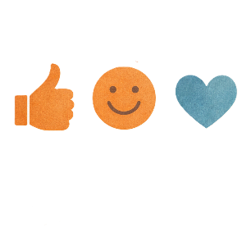 | Attitudes in schools were mostly good.
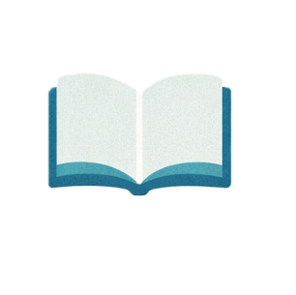 | Having a good education can help people with  - Being able to learn
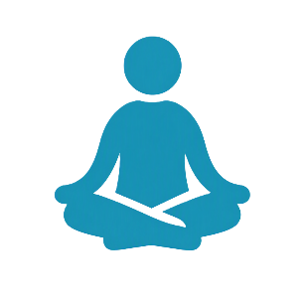 | - Have good wellbeing  Wellbeing is about your mental and physical health.  Physical health is about your body.
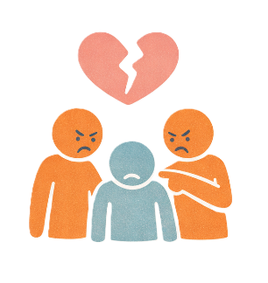 | Bullying was a problem in schools.  This is when a person or people tries to  - Hurt  - Upset  - Scare  Someone more than 1 time.

Experiences with work

Work can be hard when English is not your first language.

It can be hard to talk to people you work with.
This can make work stressful.
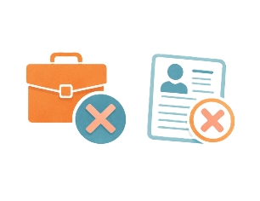 | It can be hard for older people with disability to get work.
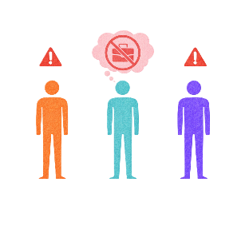 | Some people with disability can not get work.  This can make people in the community think they are not trying to get work.
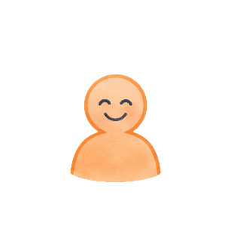 | Working is not just about making money.  It is also about  - Having a good life  - Being able to work if they want to.
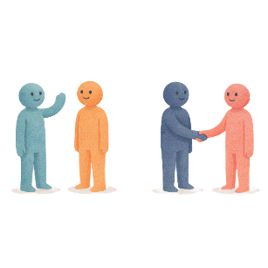 | For people who are new to Australia work can help them  - Meet people  - Build community.

Better attitudes

 | People had ideas for helping communities have better attitudes.
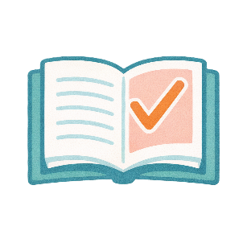 | Ideas to help have better communication are having  - Information that is easy to understand  This can be things like  - Having short documents  - Writing in plain language  - Using big font.
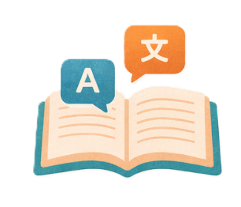 | - Information in different languages
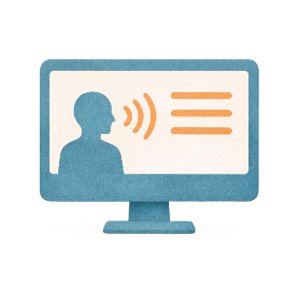 | - Information that can be used by screen readers  Screen readers change words that are written down to being spoken.
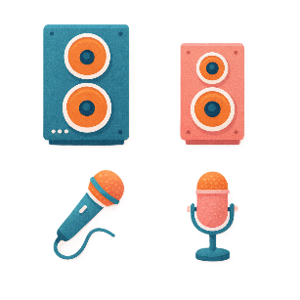 | - Speakers or microphones in meetings  This supports people with low hearing.
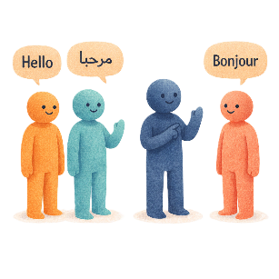 | - Interpreters  Interpreters are people who change what someone is saying into the words of another language.
Ideas for asking questions are

- Finding out about where people come from

This also includes the language they speak.
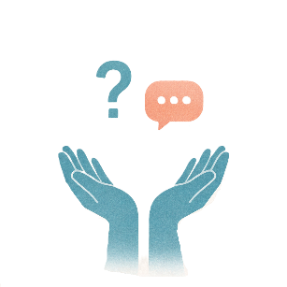 | - Asking what their support needs are  They might need to know what support they can get.
- Giving them extra time to

  - Understand questions
  - Say their answer.
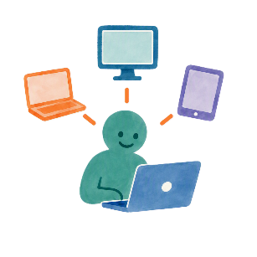 | Ideas for communities being included are  - Being able to use technology  Technology is things like computers.
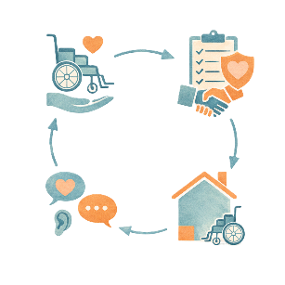 | - Knowing what services there are
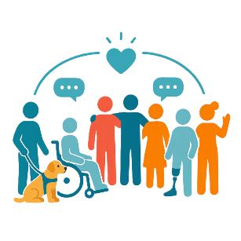 | - Joining groups with people from the same background as them
 | - Learning skills to help speak up for themselves.
People learning more about disability and including people in

- Schools
 | - Workplaces
 | - Healthcare services
 | - Community supports
 | - Transport
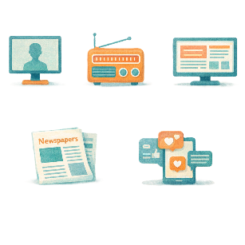 | - Media.  Media is  - TV  - Radio  - Newspapers  - Websites  - Social media.

Recommendations

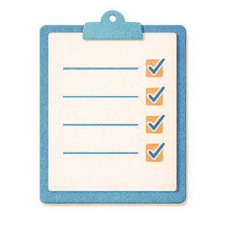 | The research came up with recommendations.  Recommendations are ideas to do things better.
 | - Having better information for people from different cultural communities
 | - Using interpreters
- Services must have better attitudes about people with disability

- Who speak different languages
- From different cultures
Like

- Healthcare services
 | - Public transport
 | - People who work in shops.
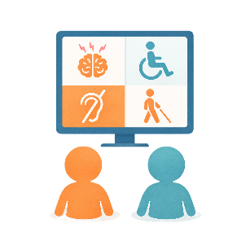 | - Communities having better attitudes about disability.  Children need to learn about disability when they are young.
 | - Include people with disability from different cultures in community activities.
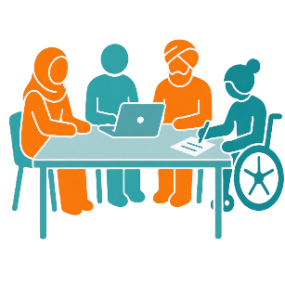 | - Community leaders treating people with disability well who  - Speak different languages  - Come from different cultures.

Some images in this Easy Read were made using AI.
You must not share or copy any of the images without permission.
August 2026.

