Attitudes about disability from young people

Summary Report
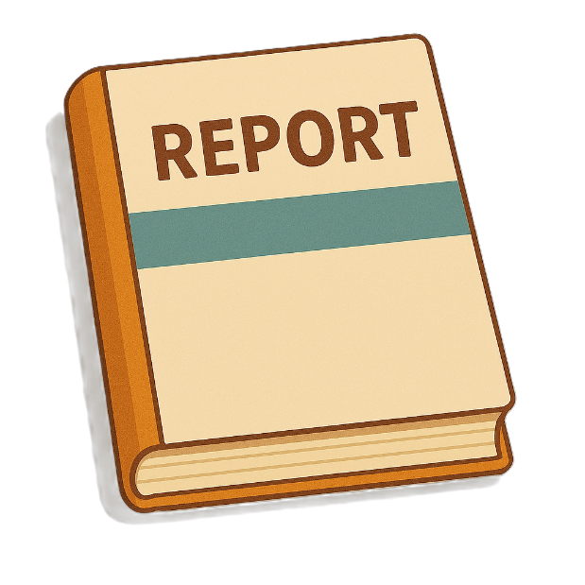

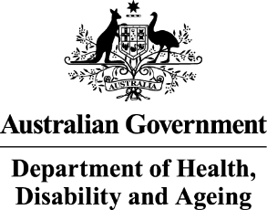 | The Australian Government Department of Health Disability and Ageing wrote this.  We say DHDA for short.  When you see the word we it means DHDA.
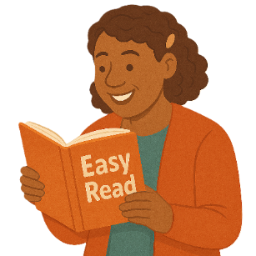 | We wrote this in an easy to read way.  We use pictures to explain some ideas.
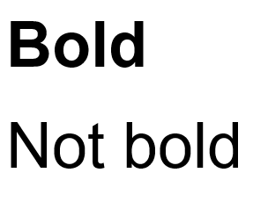 | We have some words in bold.  This means the letters are thicker and darker.  These are important words.
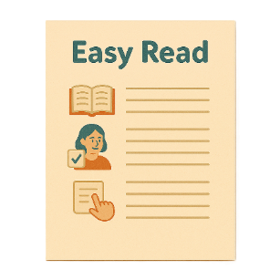 | This is an Easy Read summary of another document.  This means it has the most important ideas.
 | We can answer any questions by email.  Email us  ADSDataReporting@health.gov.au
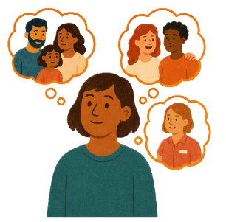 | You can ask for help to read this document.  You can ask  - A friend  - Family members  - A support person.
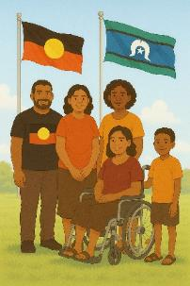 | We recognise Aboriginal and Torres Strait Islander people as the Traditional Owners of the land we live on.
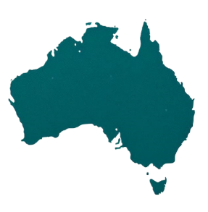 | They were the first people to live on and use the  - Land  - Waters.

Contents

What we did | 5
What we heard | 7
Disability pride | 10
Things that affect attitudes | 12
Bad attitudes affect people with disability | 14
Having better attitudes | 18
Social media | 21
Support services | 23
Recommendations | 25

What we did

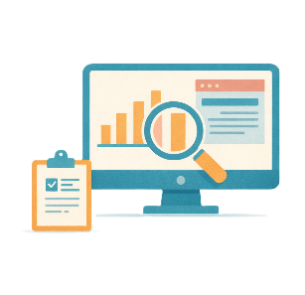 | Australian National University did research for DHDA.  They are called ANU for short.  Research means  - Finding out what people think about things  - Using the information to help others.
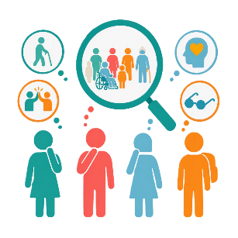 | The research was about how young people think about disability.
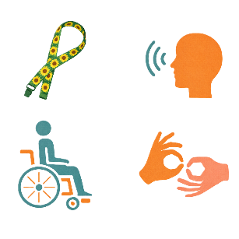 | The research was done with a small number of young people  - With disability
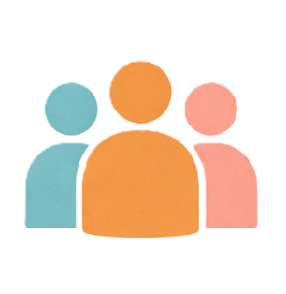 | - Without disability
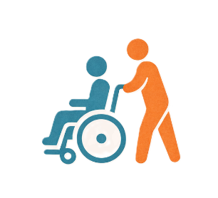 | - Carers
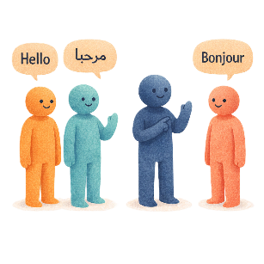 | - Who speak different languages  - From different cultures  Sometimes they are called CALD.

What we heard

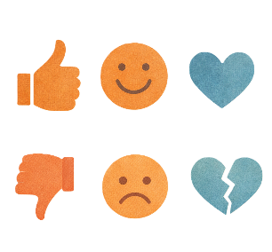 | Young people said they had experienced attitudes that were  - Good  - Bad.
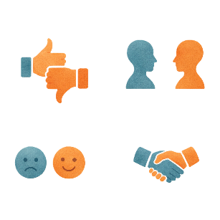 | Attitudes are what people  - Think  - Feel  - Believe.
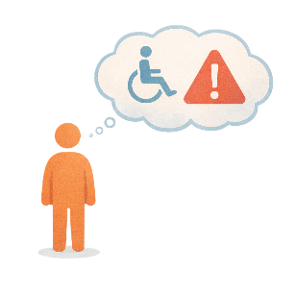 | Bad attitudes can be when people  - Think having disability is a problem
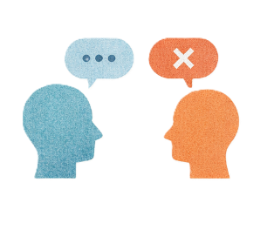 | - Only see what people can not do  Rather than what they can do.
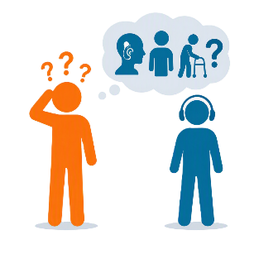 | - Do not understand disability.
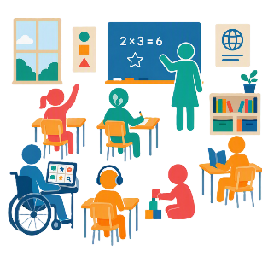 | Bad attitudes can make it hard for young people with disability to take part in  - Education
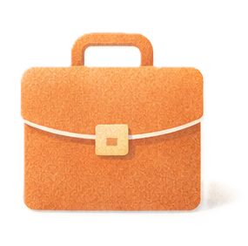 | - Work
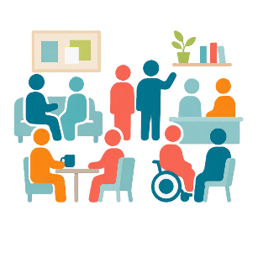 | - Community events.
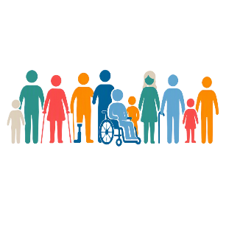 | Young people with disability said being different is not a bad thing.
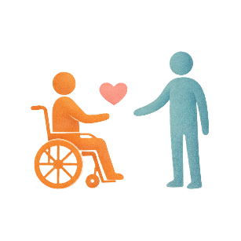 | Disability is not something  - Wrong  - Needing to be fixed.

Disability pride

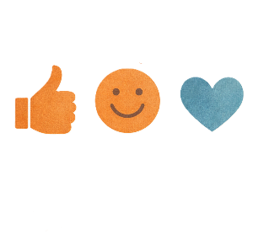 | Young people said disability pride was a good way to make attitudes better.
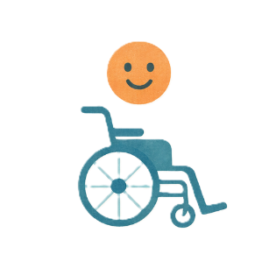 | Disability pride is feeling good about being a person with disability.
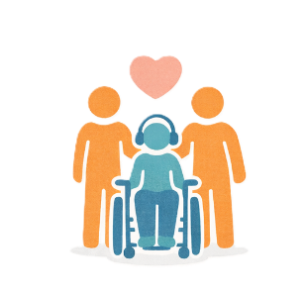 | Lots of young people  - Have pride in themselves
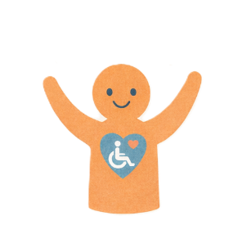 | - See their disability as part of who they are.
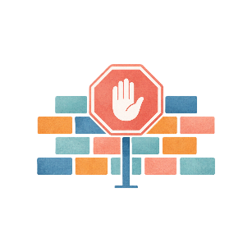 | This helps them with barriers in their life.  A barrier is something that stops you from doing what you  - Want  - Need.
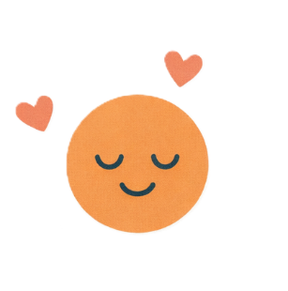 | Young people said disability pride helps them  - Be themselves  - Feel good about themselves.

Things that affect attitudes

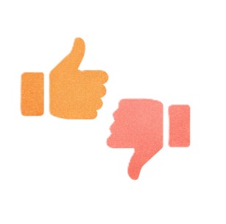 | Young people said there are lots of things that can affect attitudes about disability.  Like
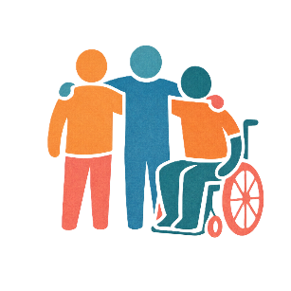 | - Having real life experience with people with disability
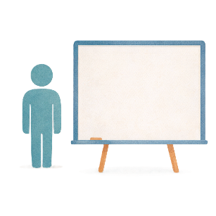 | - Learning about disability at a young age
 | - How schools understand supporting young people with disability
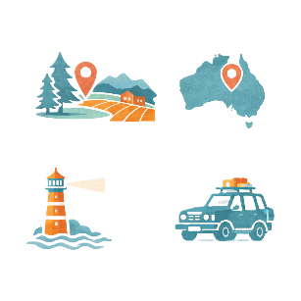 | - Where you live like  - Regional areas  - Remote areas
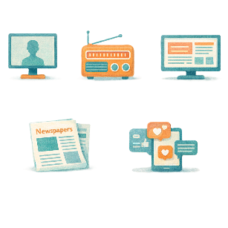 | - How the media talks about disability  Media includes  - TV  - Radio  - Newspapers  - Websites  - Social media.
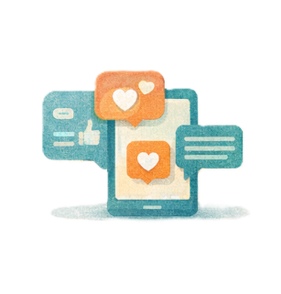 | - Social media that shows people with disability  - In everyday life  - Being included.

Bad attitudes affect people with disability

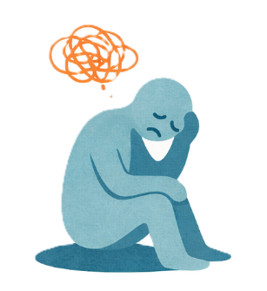 | Bad attitudes can make young people with disability have  - Bad mental health  Mental health is about how you  - Think  - Feel.
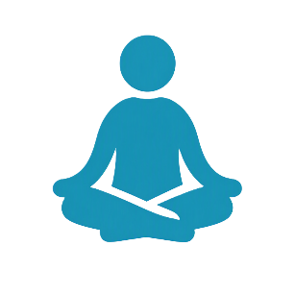 | - Poor wellbeing  Wellbeing is about your mental and physical health.  Physical health is about your body.
 | Disability rights have got better.  Rights are rules about treating everyone  - Fair  - Equal.
But there are still lots of barriers.

The barriers could be

- Wrong ideas about disability
- The places around them

This makes it hard for people with disability to take part in their community.
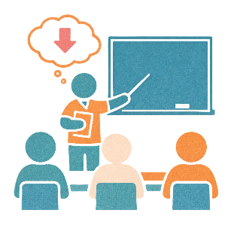 | Schools might think young people with disability can not do as much as people without disability.
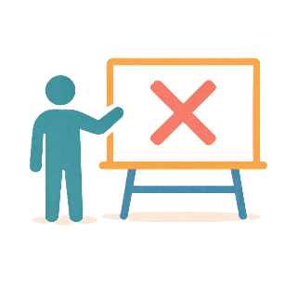 | Teachers do not  - Get enough training
 | - Have enough ways to support young people with disability.
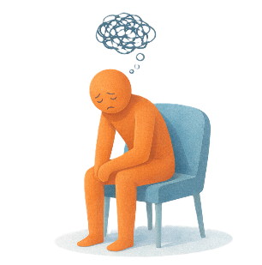 | It can also be hard for young people with disability to get support at work.
Young carers talk about it being hard to

- Go to school or university
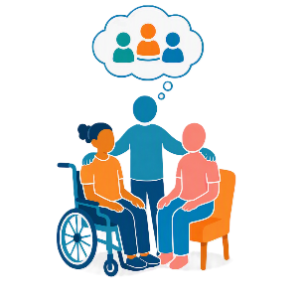 | - Spend time with friends.
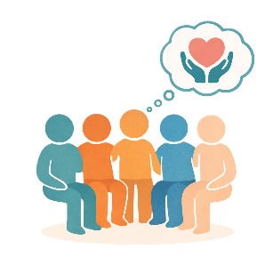 | Young carers said it was hard because people did not know about their caring responsibilities.

Having better attitudes

 | Young people had ideas for how communities can think better about disability.
Young people think

- Communities should work on awareness activities with

- People with disability
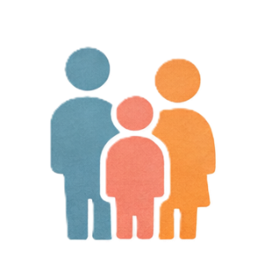 | - Their families
 | - Carers.
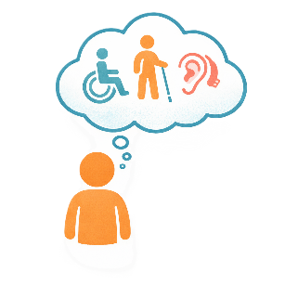 | Awareness means more people know about something.
- There should be better training about disability in schools

This will help

- Teachers
- Staff
- Other children at school.
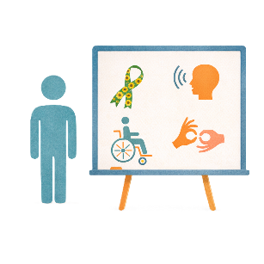 | - Schools should teach everyone about disability
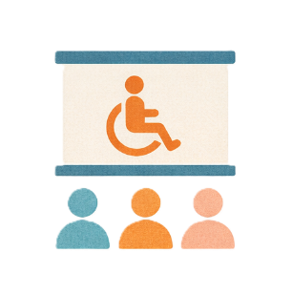 | - Workplaces should have more training about disability  This should be for  - All workplaces  - Health  - Transport.
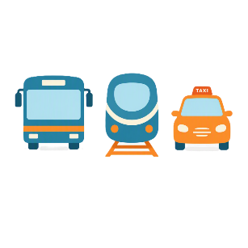 | Transport is how people move from one place to another.  You can use  - Cars  - Buses  - Trains.
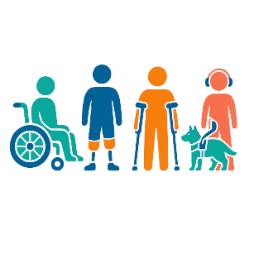 | - Young people with disability should have more ways to connect with other people like them.

Social media

 | Lots of young people use social media like  - Instagram  - TikTok.
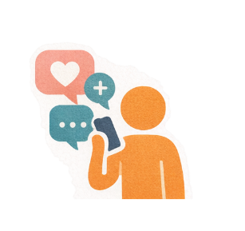 | It can be used to help people change their ideas about disability.
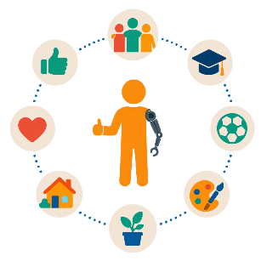 | It can show people with disability and  - The good things in their life
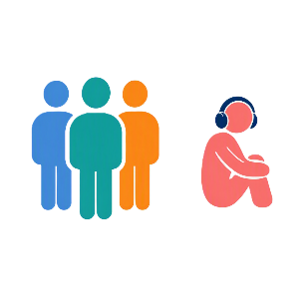 | - The hard parts of their life
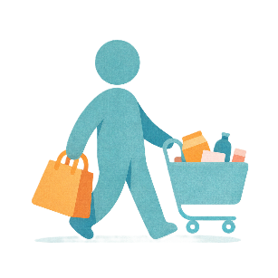 | - What their life is like every day.
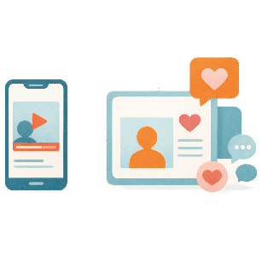 | Seeing stories on social media from people with disability can help change attitudes.
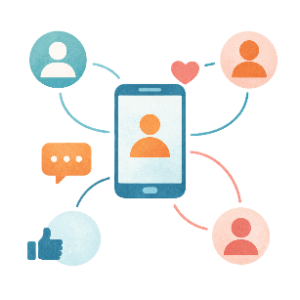 | Social media can also help young people with disability connect with other people.

Support services

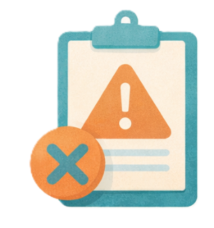 | It can be harder for young people with disability to take part if supports do not meet their needs.
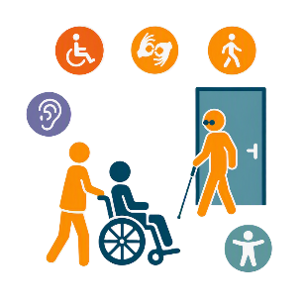 | Disability services need to be more  - Accessible  Accessible means everyone can use it.
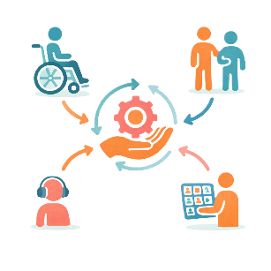 | - Flexible  Flexible means something that can change easily for different people.
Support services should also help

- Families
 | - Carers.

Recommendations

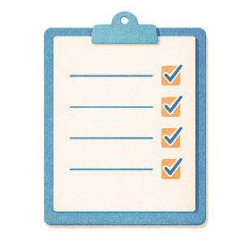 | The research came up with recommendations.  Recommendations are ideas to do things better.
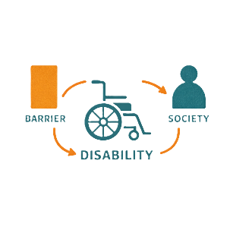 | - Use the social model of disability  The social model of disability is about barriers that happen because of the  - Environment  - Community  - Attitudes.  It does not try to fix your disability.
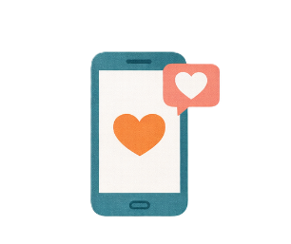 | - Have more awareness activities on social media
- Have more ways for connecting for

- Young people with disability
 | - Families.
- Support the needs of young people with disability in

- Schools
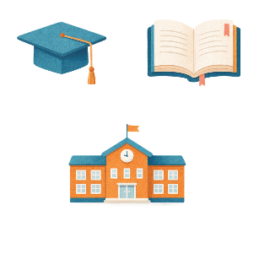 | - University
 | - Workplaces.
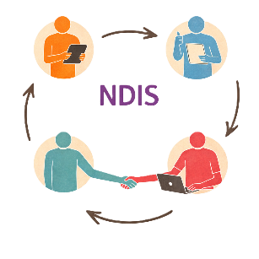 | - Make systems like the NDIS better for young people with disability.

Some images in this Easy Read were made using AI.
You must not share or copy any of the images without permission.
August 2026.

